ADV-DEVOPS EXPERIMENT-10

Aim: To install and deploy Nagios.

Theory:

1. Introduction to Nagios:
Nagios is an open-source monitoring system that enables organizations to identify and resolve IT infrastructure problems before they affect critical business processes. It is widely used to monitor system metrics, network protocols, applications, servers, and services. Nagios provides alerts and notifications when issues arise and can automatically resolve problems using event handlers.

2. Purpose of Nagios Installation and Deployment:
The main objective of installing and deploying Nagios is to establish a centralized monitoring system that ensures the health, performance, and availability of IT infrastructure. It helps in:
- Monitoring network services (SMTP, POP3, HTTP, SNMP, etc.)
- Monitoring host resources (CPU load, disk usage, memory, etc.)
- Notifying users when service or host problems occur
- Escalating alerts to appropriate personnel
- Visualizing the status and history of hosts and services

3. Components of Nagios
The main components of a Nagios deployment include:
- Nagios Core: The central engine that schedules checks and handles alerts.
- Plugins: Small executables that perform the actual checks.
- NRPE (Nagios Remote Plugin Executor): Allows monitoring of remote Linux/Unix machines.
- Web Interface: Allows users to view monitoring status, logs, and reports.
- Configuration Files: Define hosts, services, commands, contacts, and notification rules.

Procedure:
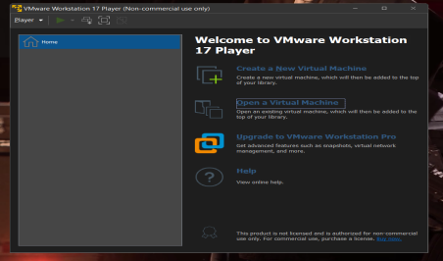
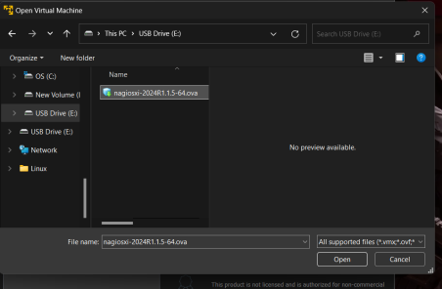
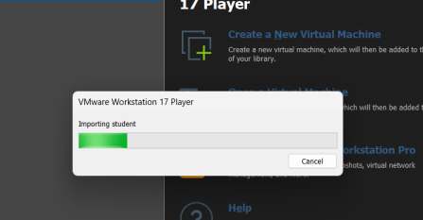
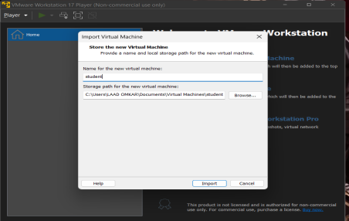
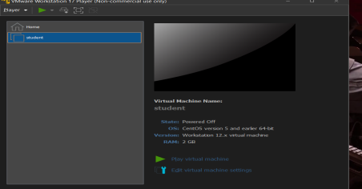
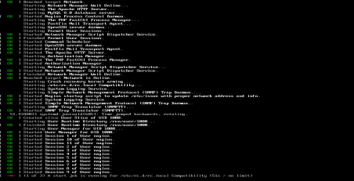
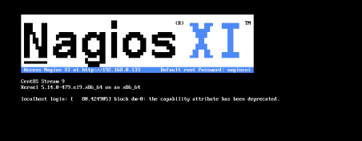
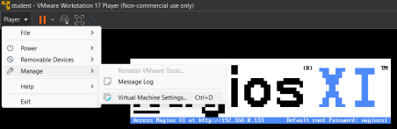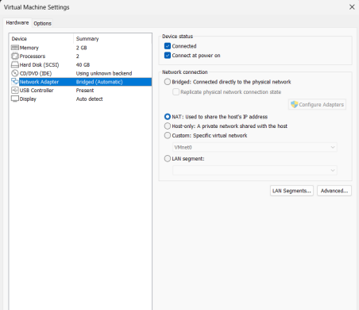
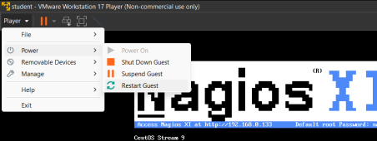
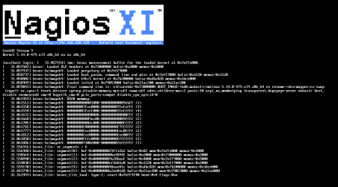
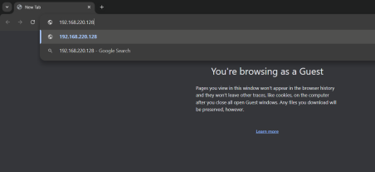
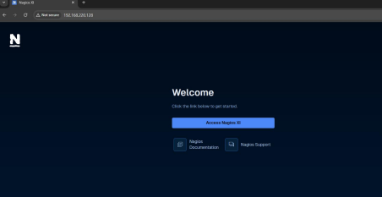
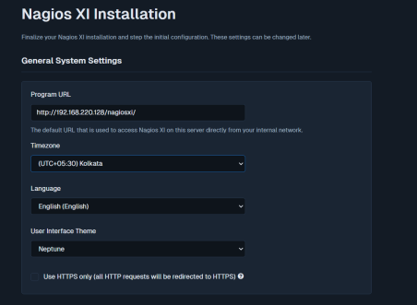
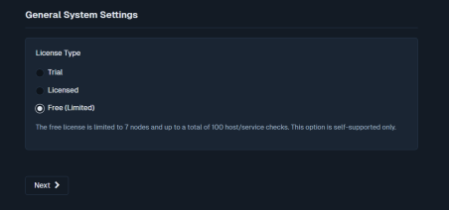

Conclusion:
The installation and deployment of Nagios serve as a critical step in establishing a robust IT monitoring environment. By implementing Nagios, organizations gain real-time visibility into the performance and availability of their network, servers, and services. Its modular architecture, plugin support, and flexible configuration make it a powerful and scalable solution for proactive infrastructure management. Proper deployment ensures timely alerts, minimizes downtime, and enhances overall operational efficiency. Thus, mastering the installation and deployment process of Nagios is essential for any system administrator aiming to maintain a reliable and secure IT environment.

