Experiment no.11
Aim : To understand continues monitoring and installation and Configuration of Nagios

Theory :
1. Introduction to Continuous Monitoring
Continuous monitoring refers to the ongoing process of observing the health, performance, and availability of IT infrastructure, applications, and services in real-time. It allows organizations to proactively detect problems, prevent downtime, and ensure system reliability.
Key aspects of continuous monitoring include:
- Performance Monitoring: Tracking CPU, memory, disk usage, network latency, etc.
- Availability Monitoring: Ensuring servers, applications, and services are online and accessible.
- Alerting and Notifications: Immediate alerts when thresholds are breached or failures occur.
- Reporting and Analysis: Historical data helps in capacity planning and troubleshooting.
Benefits:
- Reduces downtime and improves system reliability.
- Enables proactive problem detection and resolution.
- Helps in maintaining SLAs (Service Level Agreements).
- Supports capacity planning and resource optimization.

2. Introduction to Nagios
Nagios is a popular open-source monitoring tool used for continuous monitoring of systems, networks, and infrastructure. It helps detect problems, alert administrators, and ensure IT services are running smoothly.
Key Features of Nagios:
- Monitoring Capabilities: Monitors servers, switches, applications, databases, and network protocols.
- Alerting System: Sends alerts via email, SMS, or custom scripts when issues arise.
- Visualization: Provides web-based dashboards showing real-time status and trends.
- Plugin Support: Highly extensible using community or custom plugins for specific monitoring needs.
- Reporting: Generates reports for uptime, performance trends, and SLA compliance.
Nagios Architecture:
- Nagios Core: The central monitoring engine that schedules checks, processes results, and triggers alerts.
- Plugins: Scripts or binaries that perform actual checks (e.g., check CPU load, check disk space).
- NRPE (Nagios Remote Plugin Executor): Enables monitoring of remote Linux/Unix systems.
- Web Interface: Provides a graphical view of hosts, services, and alerts.

3. Installation of Nagios
Nagios can be installed on Linux servers (commonly Ubuntu or CentOS). Steps usually include:
- Install required dependencies (Apache, PHP, GCC, GD library).
- Download Nagios Core source files.
- Compile and install Nagios.
- Install and configure Nagios Plugins.
- Start the Nagios service and enable it at boot.
- Access the Nagios web interface via browser.

4. Configuration of Nagios
After installation, Nagios must be configured to monitor hosts and services. Key configuration steps include:
- Defining Hosts: Specify IP addresses or hostnames of systems to monitor.
- Defining Services: Specify what to monitor on each host (e.g., HTTP service, disk usage, CPU load).
- Defining Contacts: Specify who receives alerts.
- Defining Notification Rules: Set thresholds and conditions for alerts.
- Testing and Reloading Configuration: Ensure Nagios correctly monitors all specified hosts and services.

5. Benefits of Using Nagios for Continuous Monitoring
- Proactive Problem Detection: Alerts administrators before small issues become critical.
- Centralized Monitoring: Monitor multiple hosts and services from a single dashboard.
- Flexibility and Extensibility: Supports custom plugins and scripts for tailored monitoring.
- Improved Reliability and Uptime: Ensures IT systems are always operational.
- Historical Reporting: Tracks trends over time to optimize resources and plan upgrades.

Procedure :
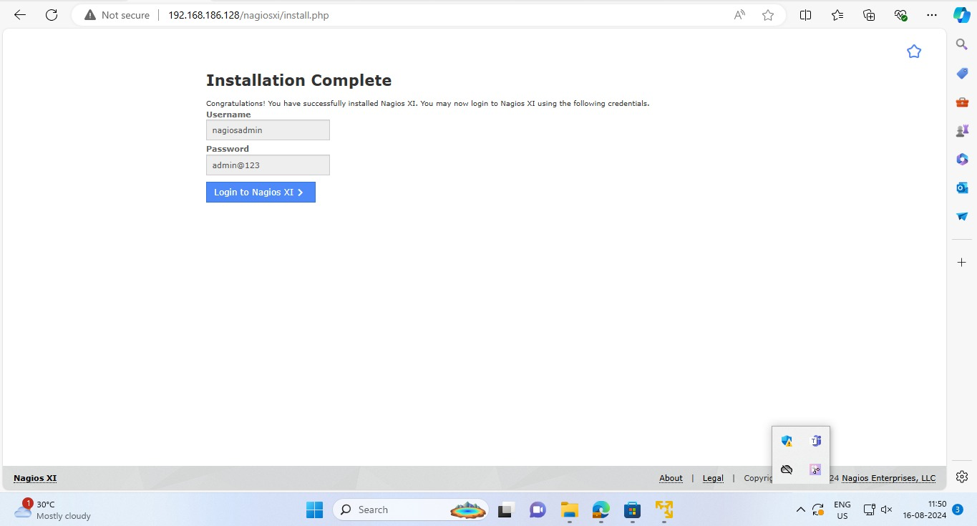

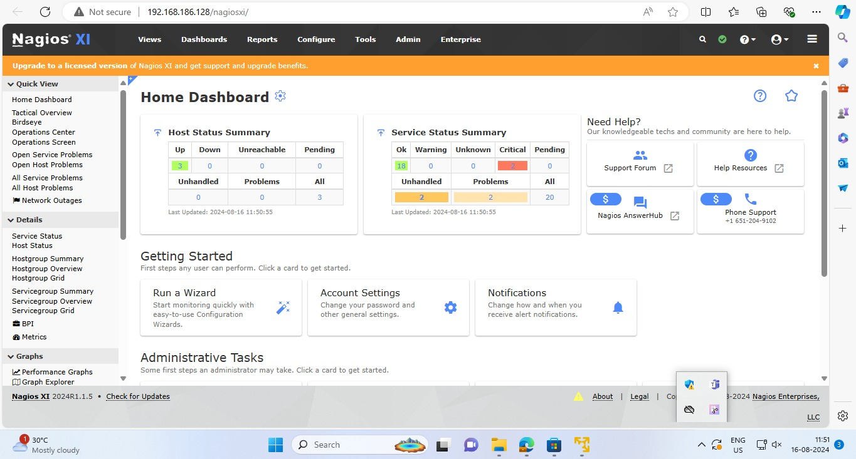
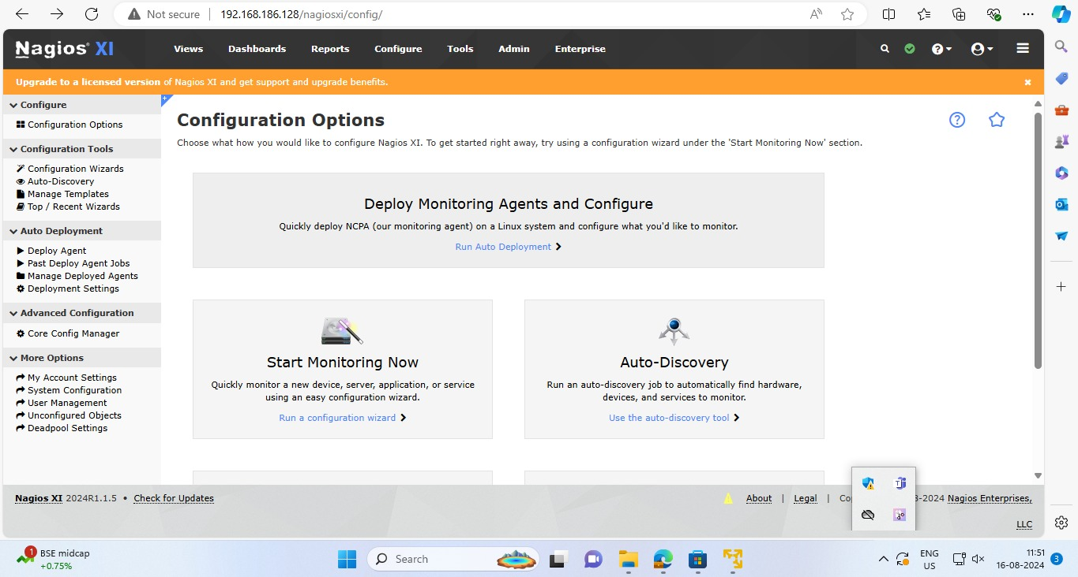

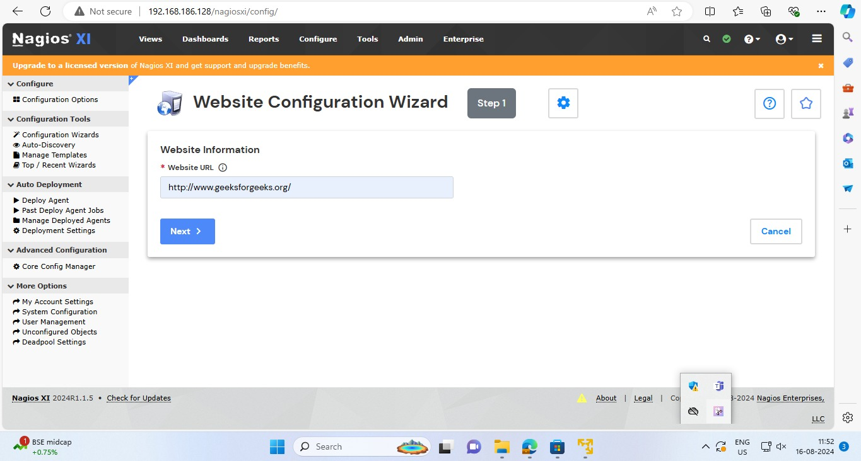
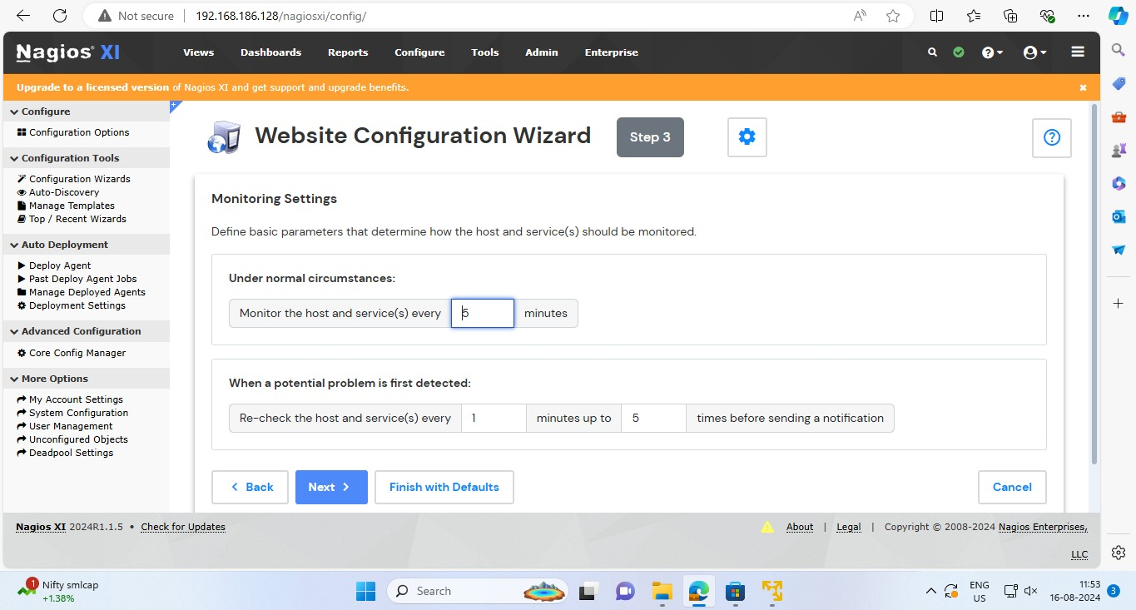

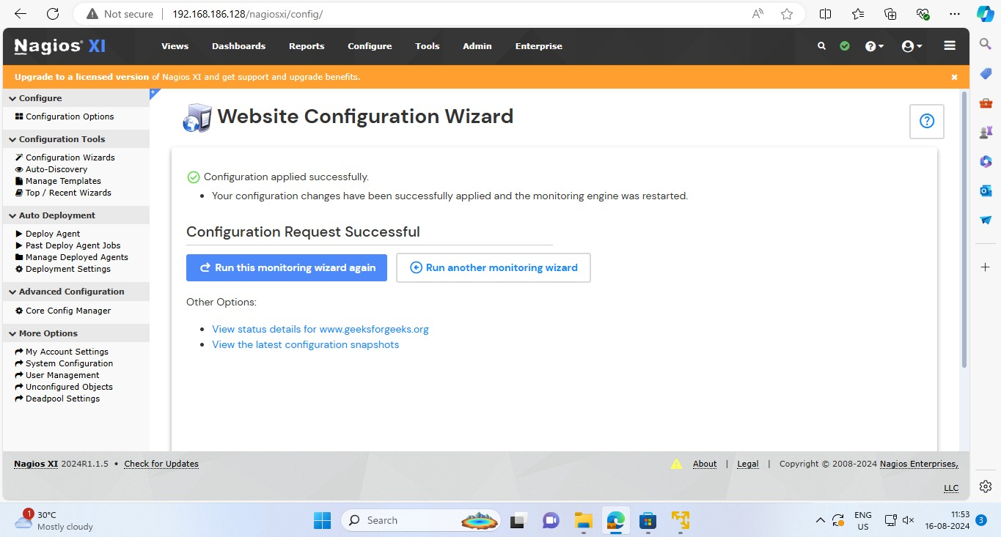
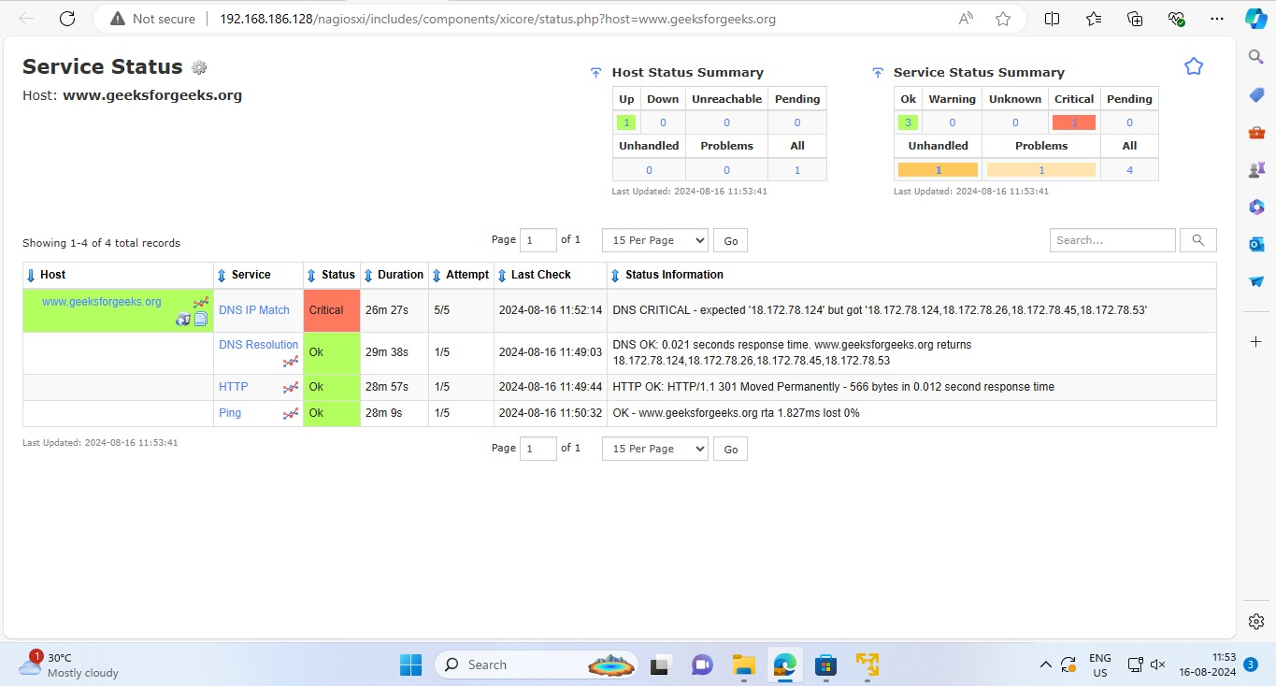

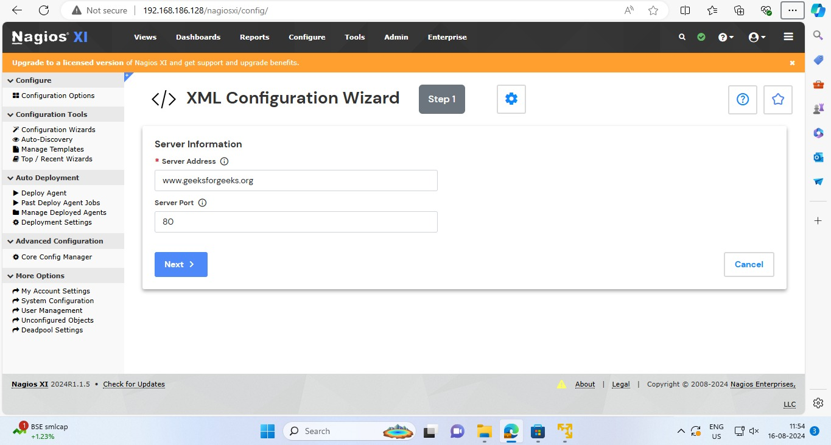
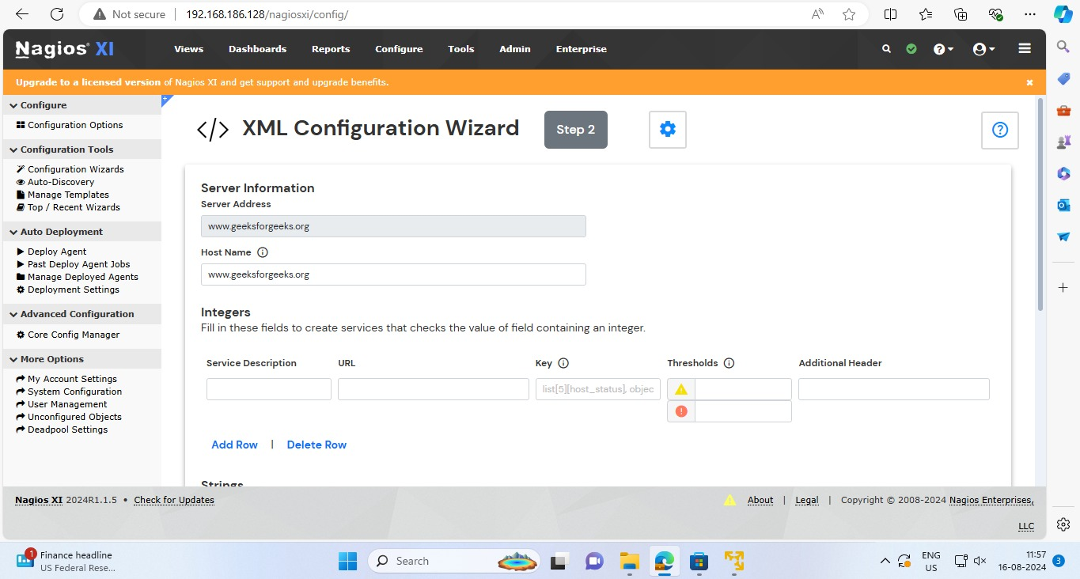

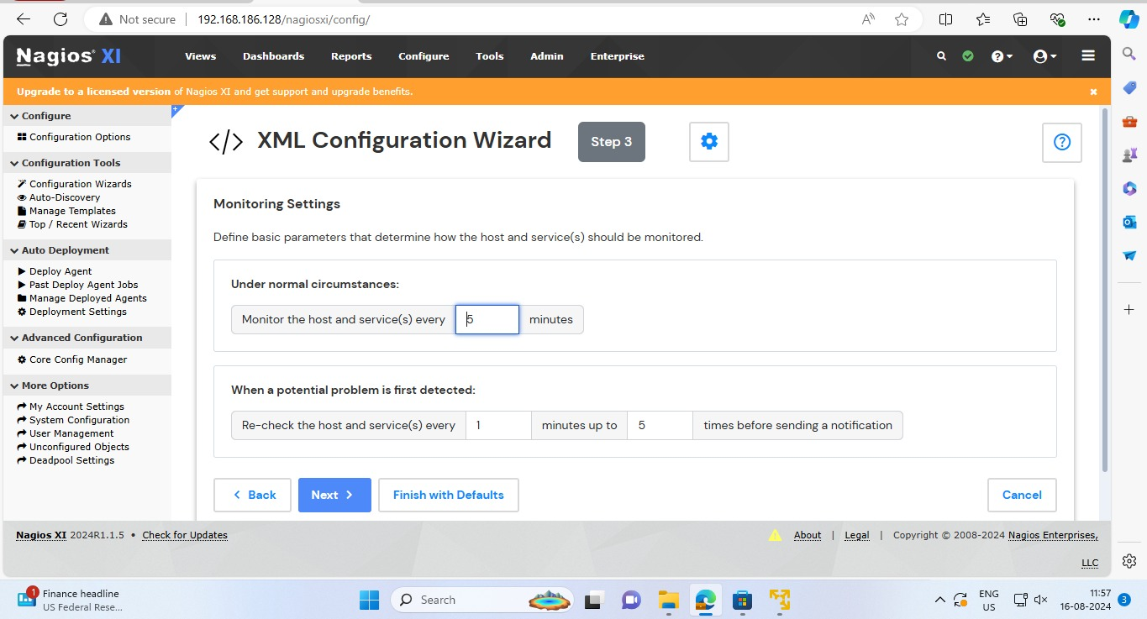
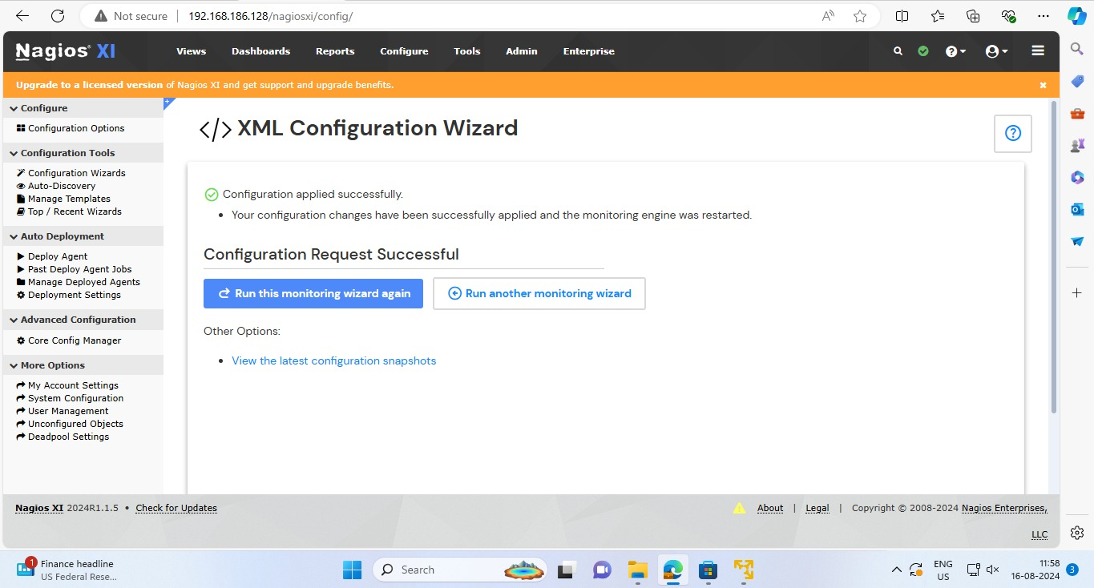

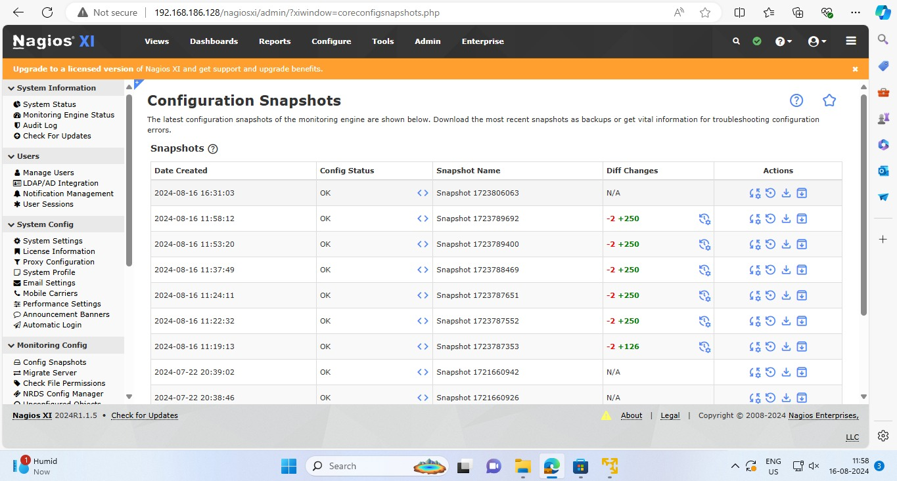
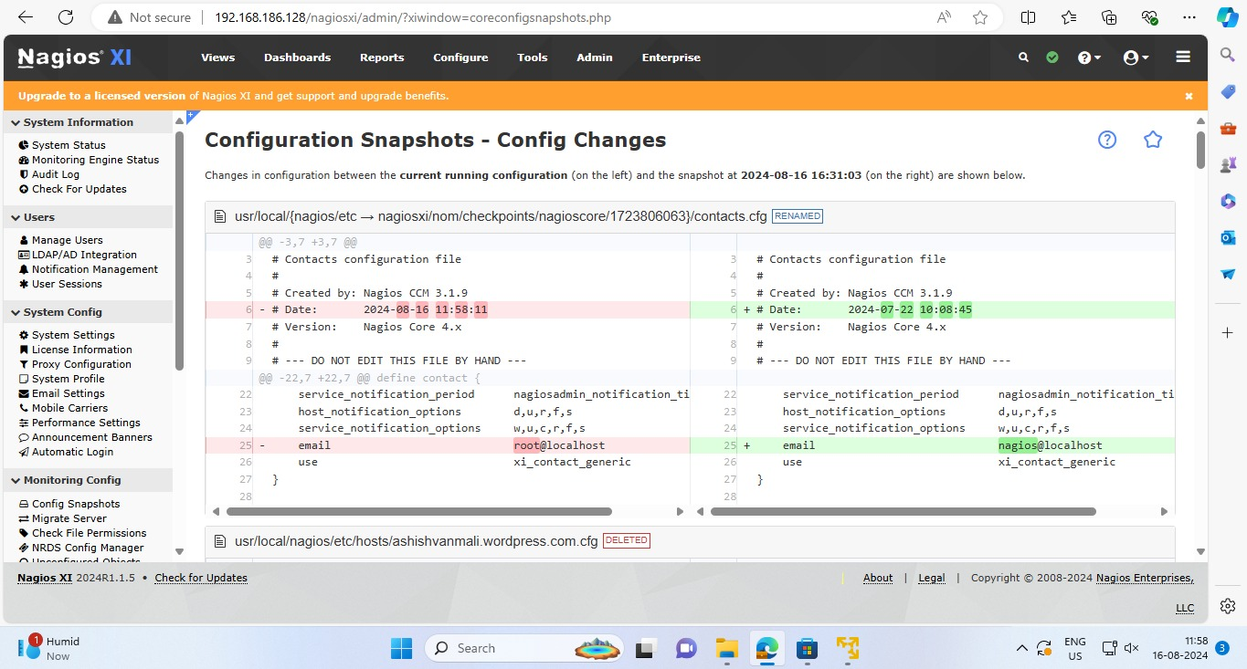

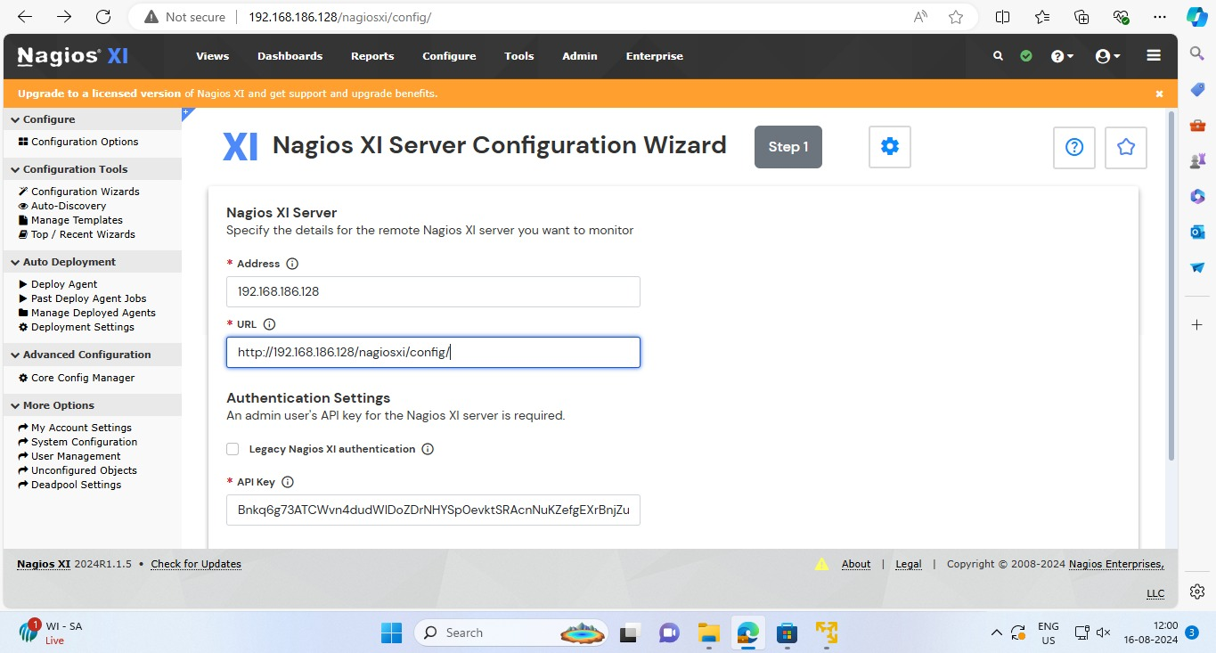
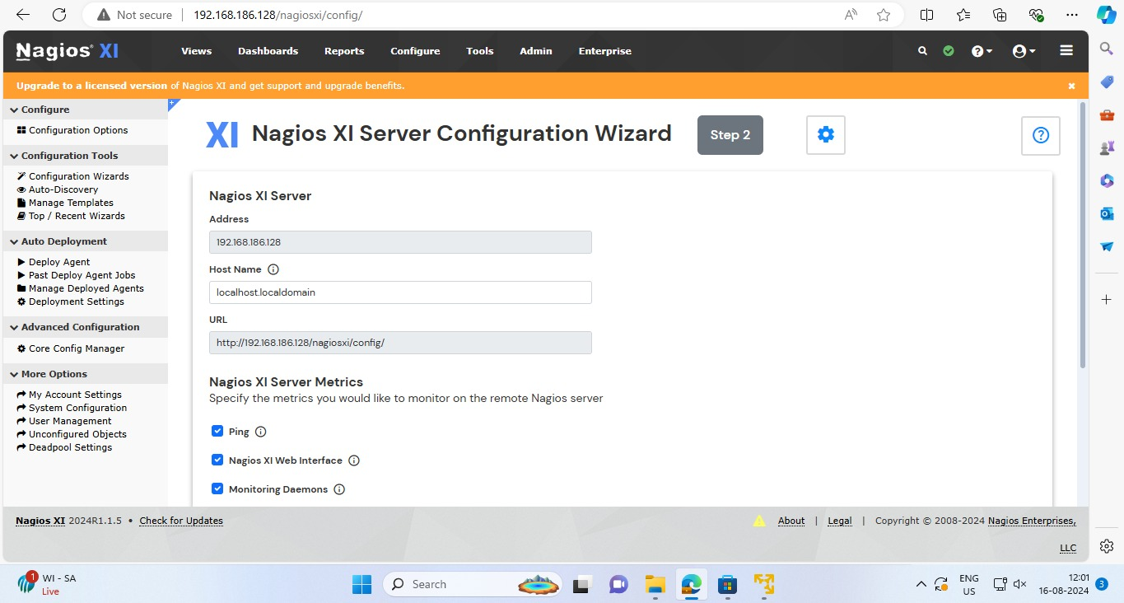

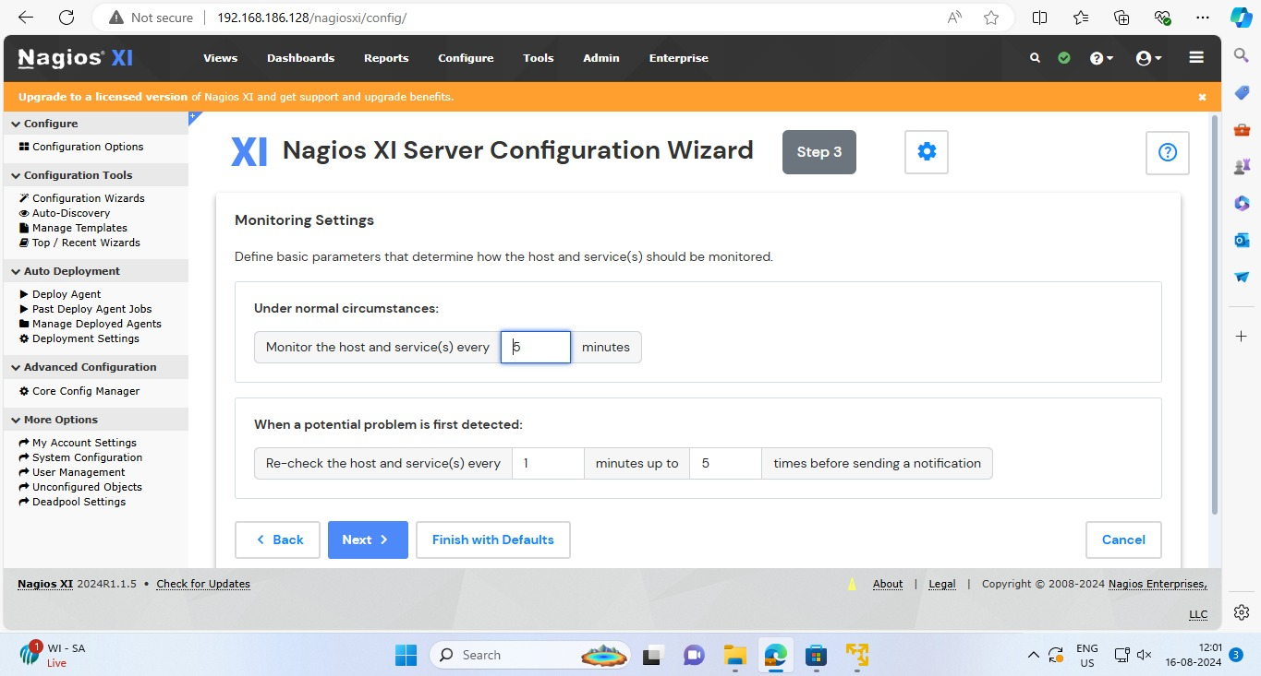
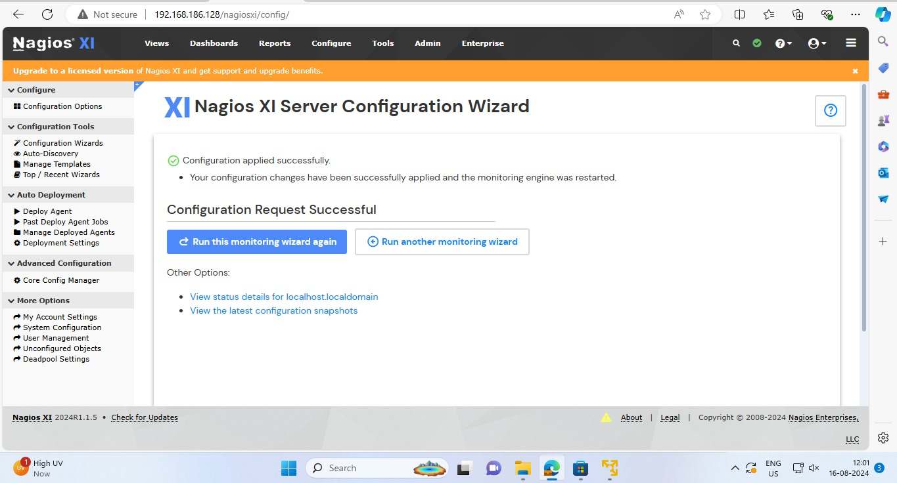

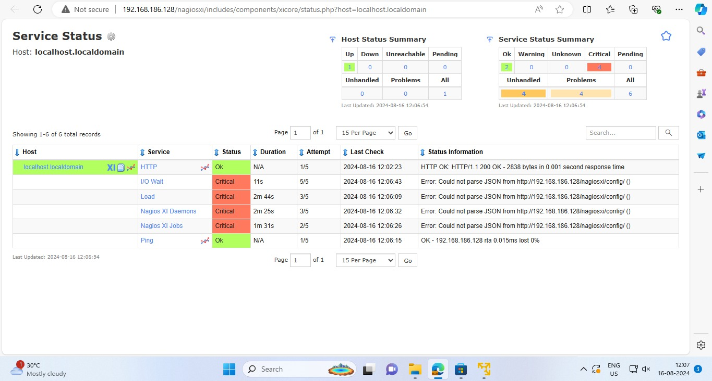

Conclusion :
Continuous monitoring is essential in modern IT environments to maintain reliability, prevent downtime, and improve performance. Nagios is a powerful tool that enables such monitoring by providing real-time visibility, alerting, and reporting. Understanding its installation and configuration allows IT administrators to maintain robust, highly available infrastructure.

