ADV-DEVOPS EXPERIMENT-12
Aim: To Understand AWS Lambda and Its Workflow.
Theory:
AWS Lambda is a serverless computing service provided by Amazon Web Services that allows developers to run code without provisioning or managing servers. It executes code in response to events and automatically manages the computing resources required.

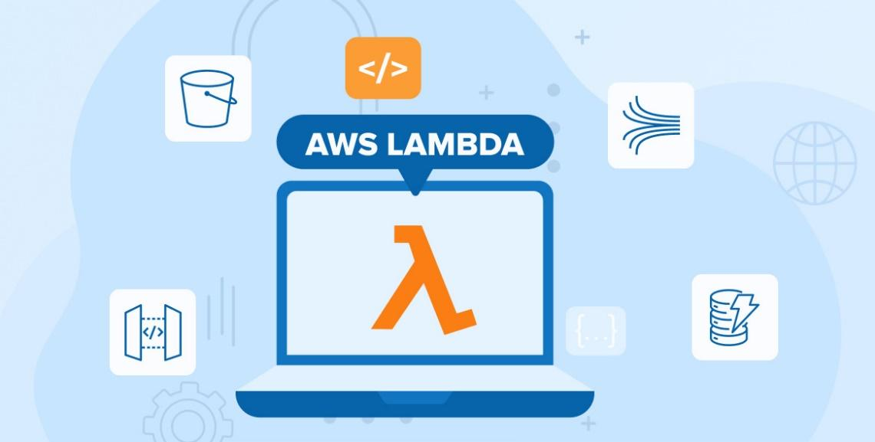

Background
Traditional server-based applications require setting up, maintaining, and scaling servers. AWS Lambda removes this overhead by offering a pay-as-you-go model where code is executed only when triggered by an event.
Key Concepts of AWS Lambda
- Serverless: No need to manage infrastructure.
- Event-driven: Executes code in response to triggers (HTTP requests, S3 bucket changes, DynamoDB updates, etc.).
- Scalable: Automatically scales based on demand.
- Stateless: Functions are stateless; each invocation is independent.
- Pay-per-use: Charges based on execution time and resource consumption.

Workflow of AWS Lambda
- Create a Lambda Function:
  - Write code in supported languages (Python, Node.js, Java, etc.).
  - Define the function handler that AWS Lambda will invoke.
- Configure Triggers:
  - Connect the Lambda function to event sources like S3, API Gateway, CloudWatch, DynamoDB, etc.
- Set Execution Role:
  - Assign an IAM role with permissions required to access other AWS resources.
- Deploy the Function:
  - Upload the code (directly or via zip/package).
  - Configure memory, timeout, and environment variables.
- Invoke the Function:
  - Automatically triggered by events.
  - Or manually invoked via SDK, CLI, or console.
- Execution and Scaling:
  - AWS Lambda runs the code in a managed runtime environment.
  - Automatically scales horizontally to handle multiple concurrent invocations.
- Monitoring and Logging:
  - AWS CloudWatch logs capture execution details and errors.
  - Metrics help track performance and usage.

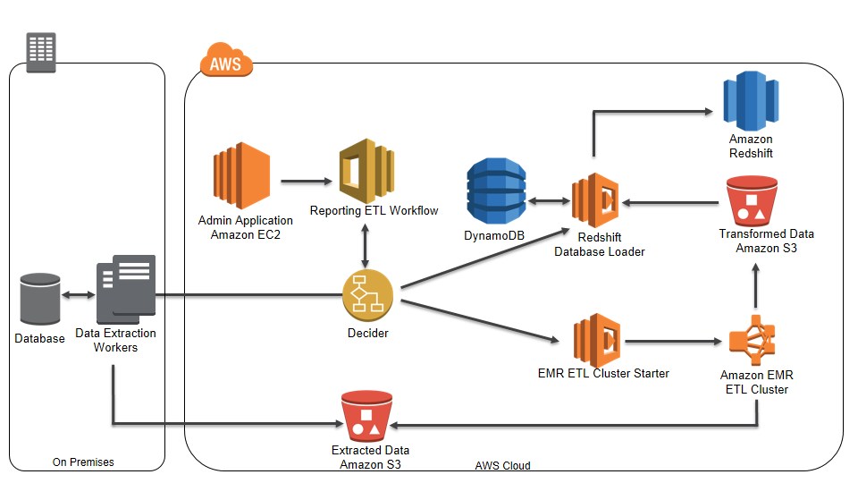

Benefits Observed
- Reduced Operational Overhead: No servers to manage.
- Cost Efficiency: Pay only for the actual execution time.
- Flexibility: Easy to add triggers from multiple AWS services.
- Quick Development: Fast deployment and testing cycle.

Conclusion:
AWS Lambda simplifies application deployment by abstracting server management and enables building scalable, event-driven architectures. Understanding its workflow helps developers design efficient and cost-effective serverless applications.

