ADV-DEVOPS EXPERIMENT-13
Aim: To create serverless applications using AWS Lambda.
Theory:
With the increasing need for scalable, cost-effective, and low-maintenance applications, serverless computing has emerged as a powerful architecture. AWS Lambda, Amazon’s serverless compute service, enables developers to build applications without managing infrastructure, focusing solely on code and business logic.
Background
Traditional applications often require provisioning and managing servers, load balancers, and other infrastructure components. Serverless architecture, powered by AWS Lambda, allows running code in response to events without server management, automatically scaling, and charging only for the compute time consumed.
Workflow
- User Interaction:
  - User fills the feedback form hosted on S3 (static website) and submits.
- API Gateway Trigger:
  - The form submission triggers an API Gateway endpoint.
- Lambda Invocation:
  - API Gateway invokes a Lambda function to process the input.
- Data Storage:
  - Lambda writes the feedback data into DynamoDB.
- Notification:
  - Lambda sends an email notification to the admin using Amazon SNS or SES.
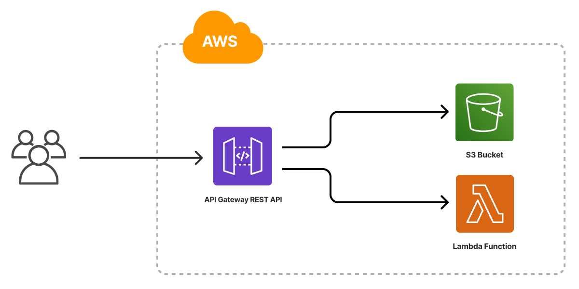
Benefits of Using AWS Lambda
- No Server Management: No need to provision or maintain servers.
- Automatic Scaling: Lambda automatically handles any volume of requests.
- Cost Efficiency: Pay only when the function executes.
- Integration: Seamlessly integrates with AWS services like API Gateway, DynamoDB, and SNS.
- Security: Managed by IAM roles and policies.
Procedure:
1.Open AWS Services
2. Inside compute service click on Lambda
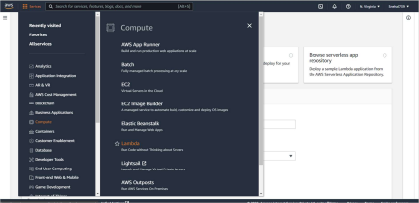
3. After clicking on Lambda you will see the following Dashboard
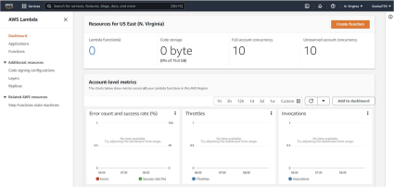
4. Click on Create Function
5. You will see the following for creating a function , Give the function name select the runtime of your choice here I have selected python 3.8
6. And the select the execution role
7. Click on create
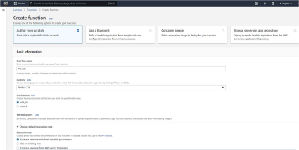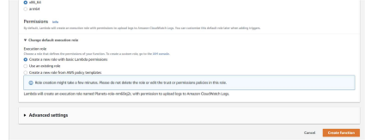8. Following function will be created
9.You can make changes in the code source according to your convenience 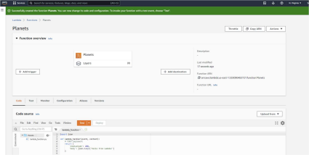
10. Make changes according to your will
11. Click on Deploy
12. Click on Test
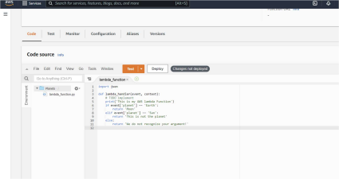13. Make changes based on keys and values
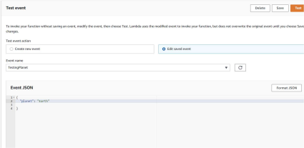14. If planet=Earth following output can be seen
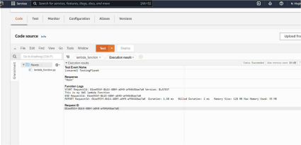15. If planet=Sun
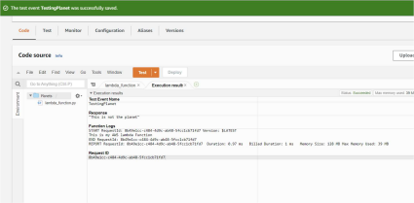

Conclusion:
AWS Lambda empowers developers to create robust, scalable, and cost-effective serverless applications by abstracting server management and enabling event-driven workflows. This case study illustrates how Lambda, combined with other AWS services, can build an end-to-end serverless application efficiently.

