1. This project is built in TestNG, Selenium & Java.
2. Running test cases (via Maven Surefire plugin) under classes that are running parallel
3. Running in Linux Docker container
4. Docker commands and DockerFile are attached with the project
5. CI/CD is achieved through Jenkins & GitHub. As soon as code is pushed to GitHub repo; build will be triggered in Jenkins and it will download the project from GitHub to its Workspace. After that, project will run in Linux Docker container. Generated report will be copied from Docker container to ‘Reports’ folder in Jenkins Workspace.
6. Note- You need to change configuration in Jenkins based on your GitHub account

Screenshots for CI/CD in GitHub and Jenkins:

1. Set up Jenkins in Settings->Webhooks of GithUb:

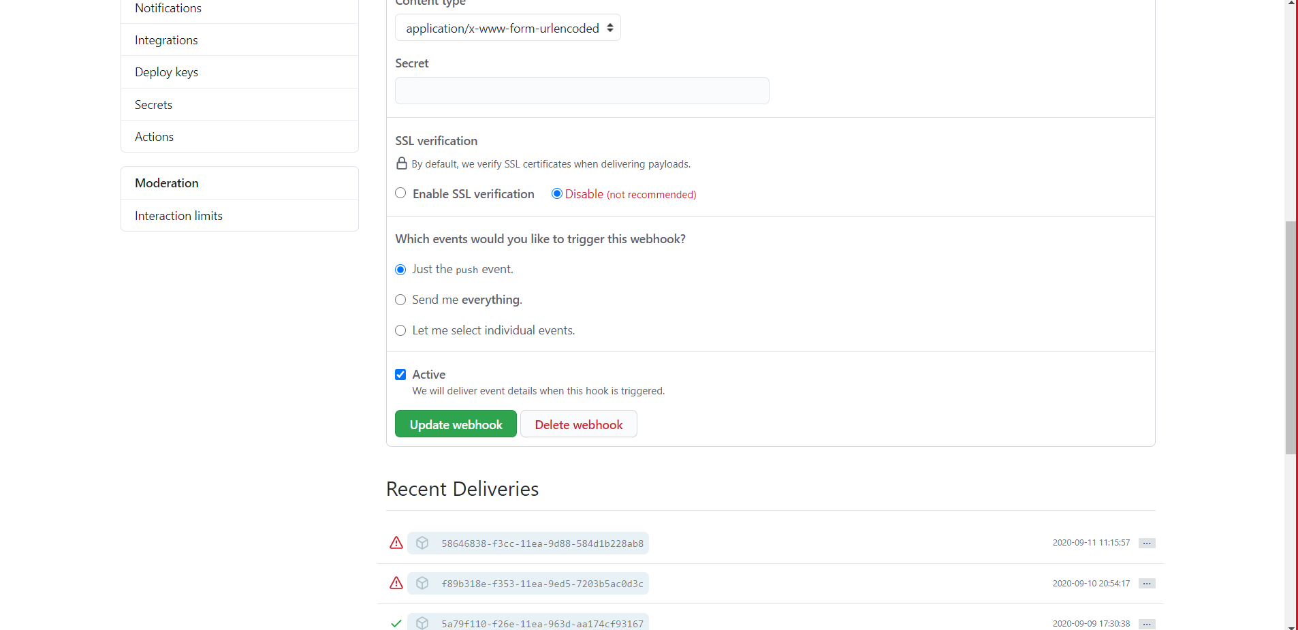

1. Jenkins:

