hi

|  |  |  |
| --- | --- | --- |
| q | q | q |
| q | q | q |
| q | q | q |

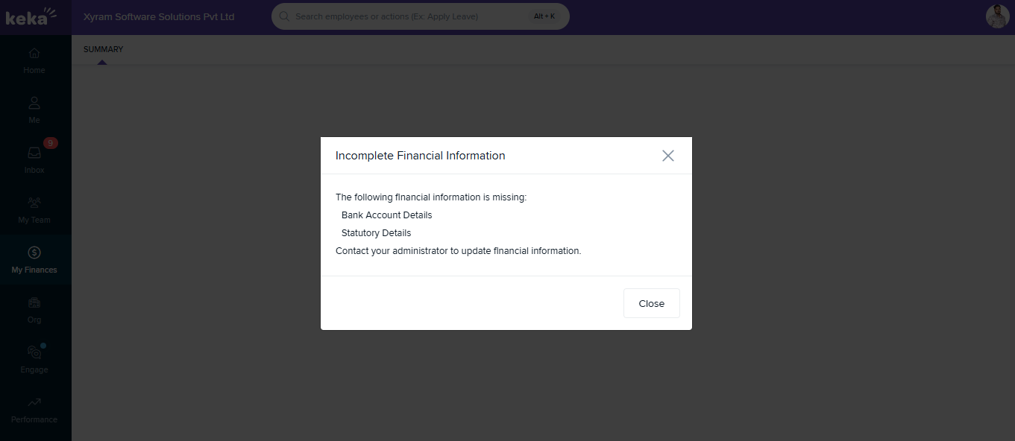

hello