CrowdStrike Falcon – IOA Creation and Assignment Guide
Organization: CrowdStrike Falcon
Author: Rohit Rawat
Date: September 01, 2025

1. Introduction
This document provides a detailed step-by-step guide to creating and assigning a custom Indicator of Attack (IOA) in CrowdStrike Falcon. The example demonstrates creating an IOA rule (blocking whatsapp.com) and assigning it to the previously created prevention policy and host group.

2. Prerequisites
- Access to CrowdStrike Falcon Console
- Administrative privileges to configure IOAs
- An existing prevention policy (e.g., Windows Test Policy)
- Host group(s) assigned to the prevention policy

3. Procedure

Step 1: Navigate to IOA Management
From the CrowdStrike Falcon console, go to 'Endpoint Security' and select 'IOA Management' to view and manage custom Indicators of Attack.
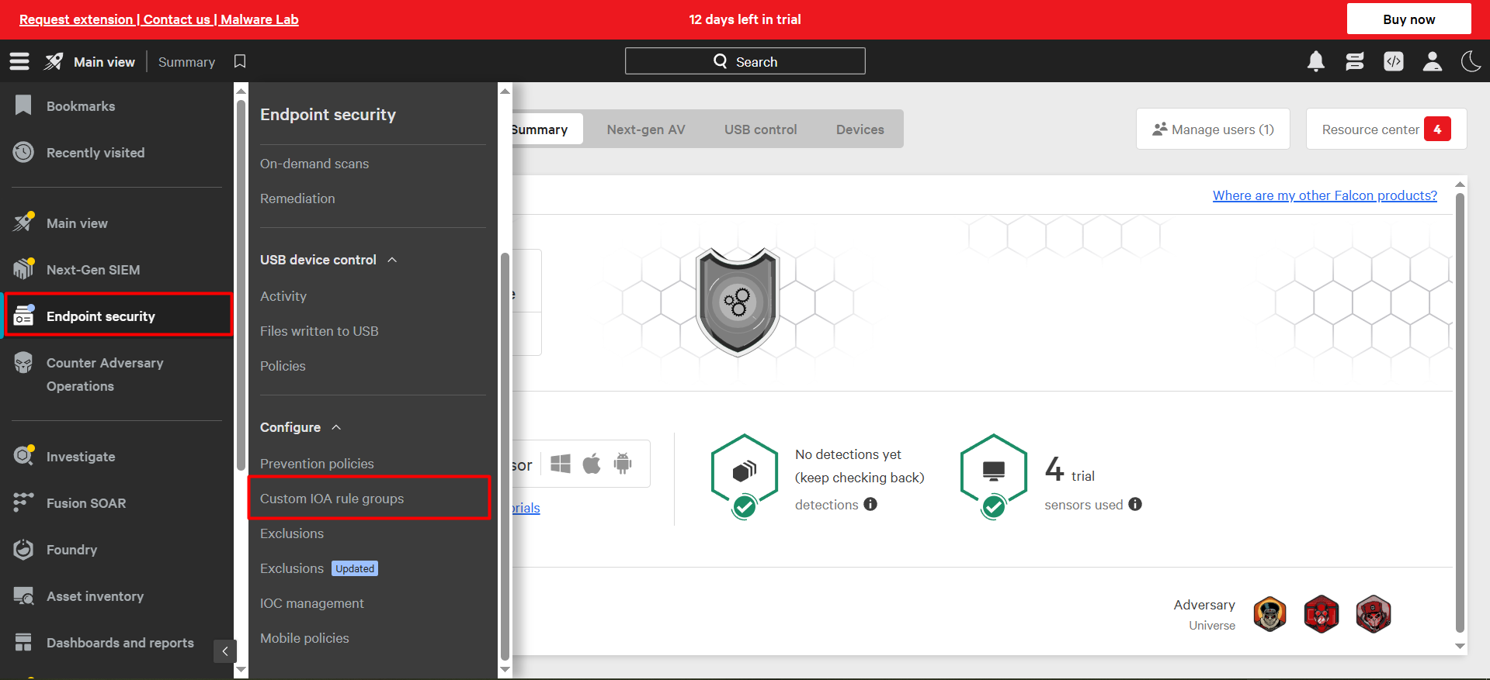

Step 2: Create New IOA
Click on 'Create IOA' to begin adding a new custom Indicator of Attack. You will be prompted to enter IOA details such as type and action.
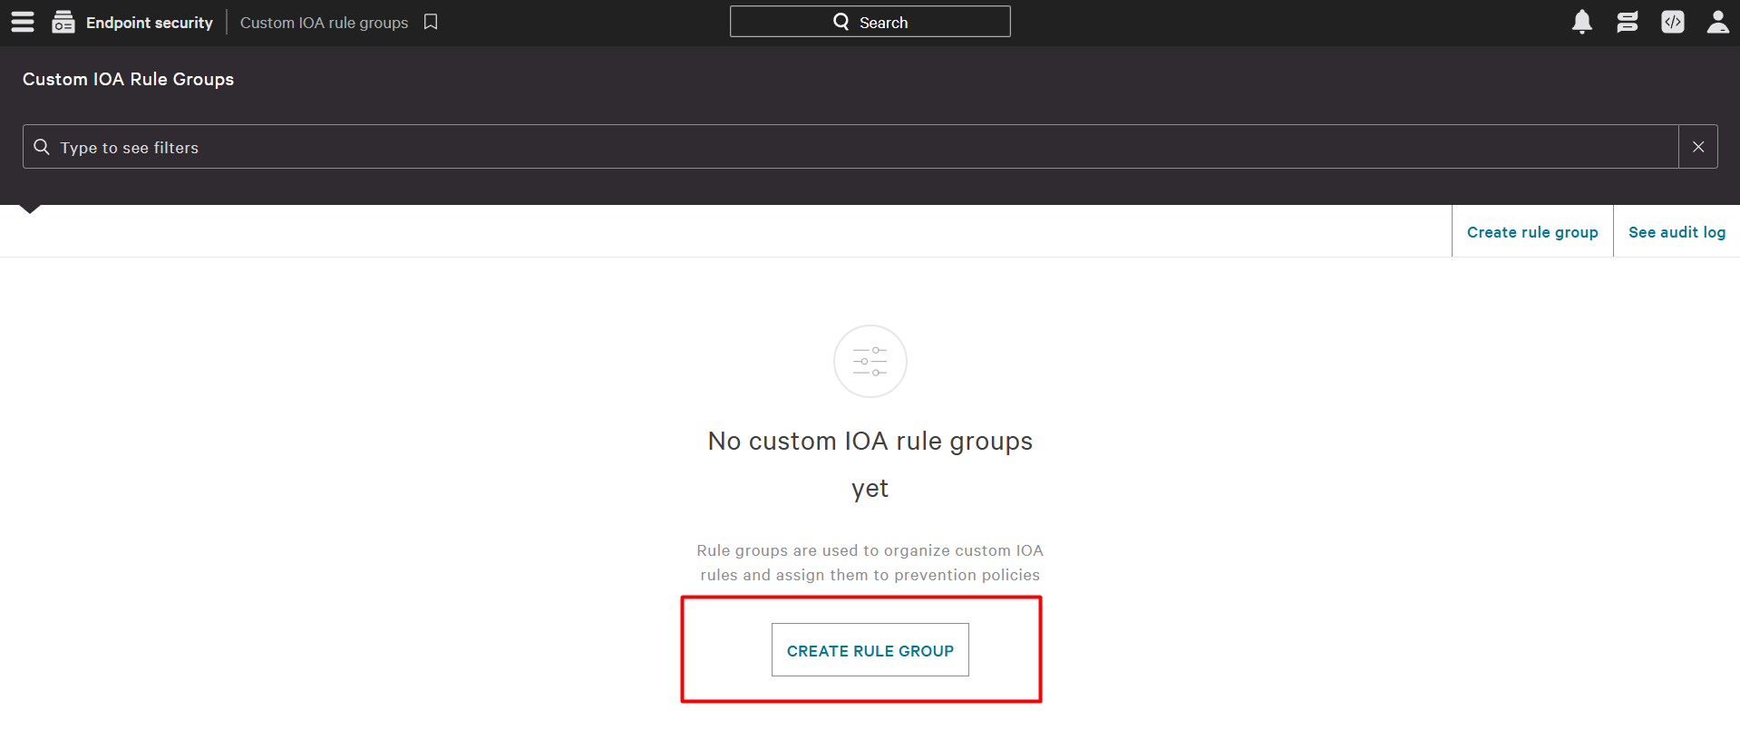

Step 3: Configure IOA Rule
In the IOA creation form:
- Select Indicator Type: Domain
- Action: Block
- Value: whatsapp.com
Add a description if needed, then click 'Save'.
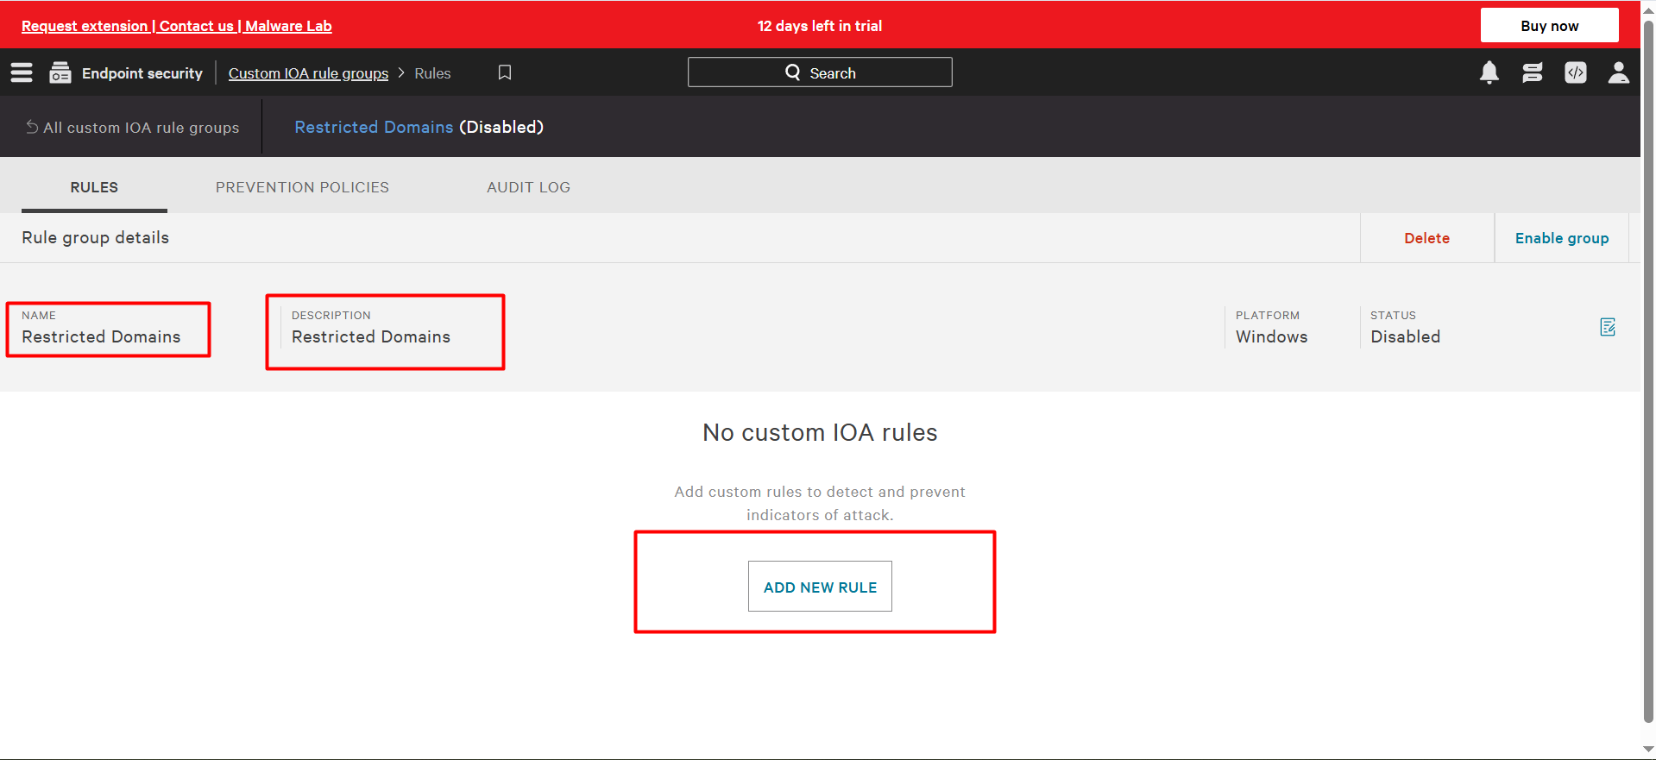

Step 4: Review Created IOA
Once created, the IOA will appear in the list with its type, action, and value clearly displayed. Verify that the IOA is enabled and active.
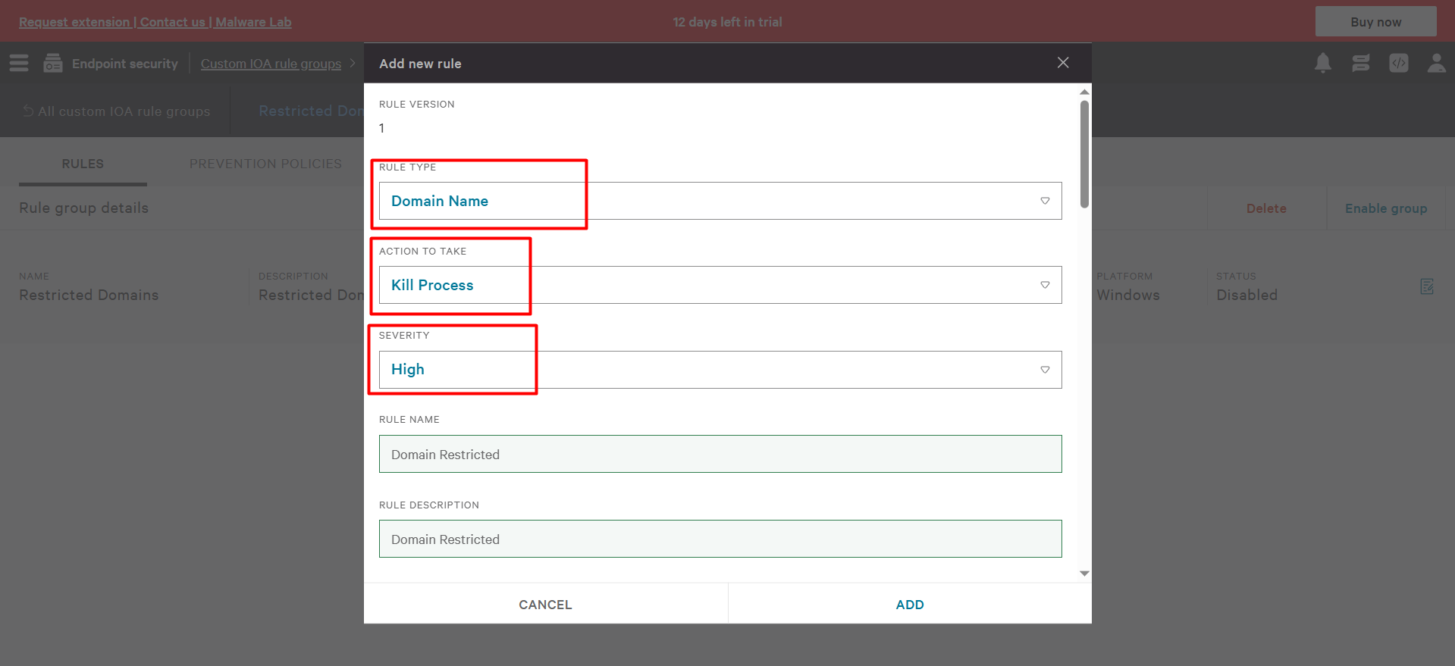

Step 5: Assign IOA to Prevention Policy
Navigate back to 'Prevention Policies'. Select the previously created policy (e.g., Windows Test Policy) and go to the IOA assignments section. Click 'Add IOA'.
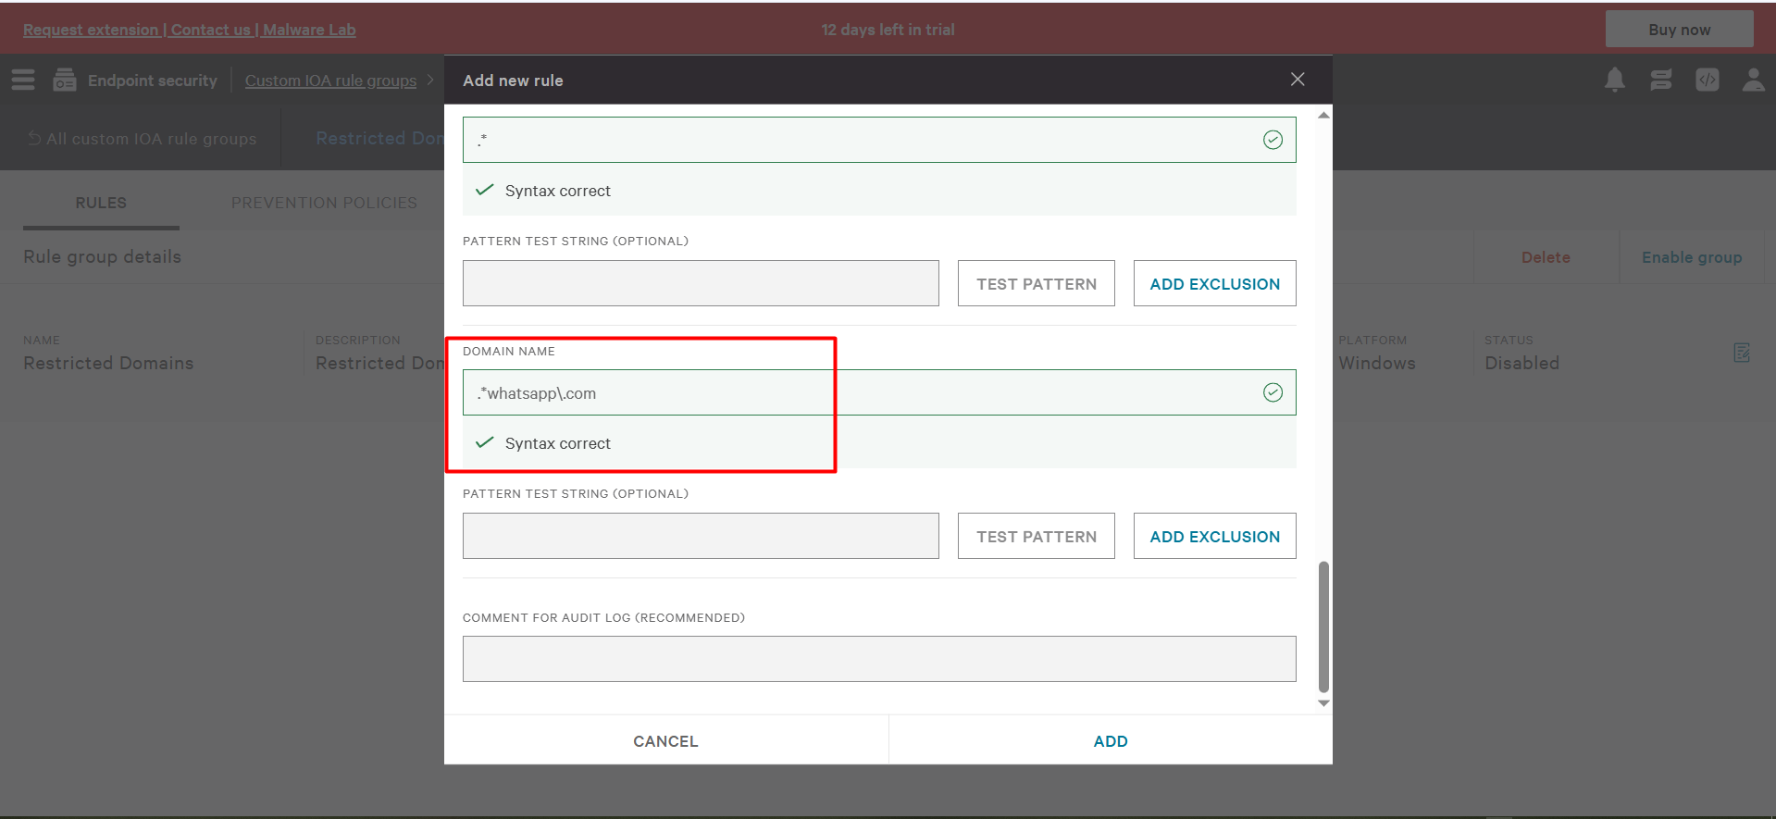

Step 6: Select IOA for Policy
From the list of available IOAs, select the domain IOA created for 'whatsapp.com'. Confirm the selection to add it to the policy.
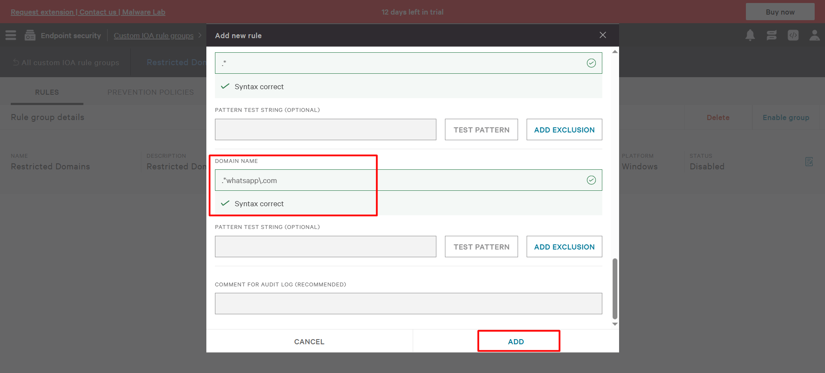

Step 7: Assign Policy to Host Group
Ensure the prevention policy with the assigned IOA is linked to the appropriate host group (e.g., 'win 10'). This enforces the IOA on all hosts in that group.
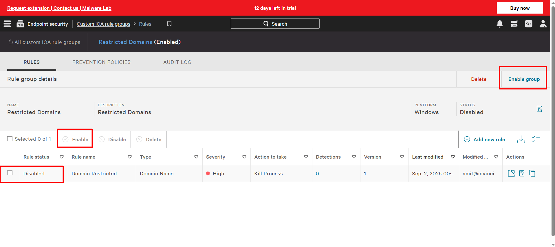

Step 8: Verify Assignment
Confirm that the IOA is now active within the prevention policy and that the host group is correctly assigned. This ensures that attempts to access whatsapp.com will be blocked on the target hosts.
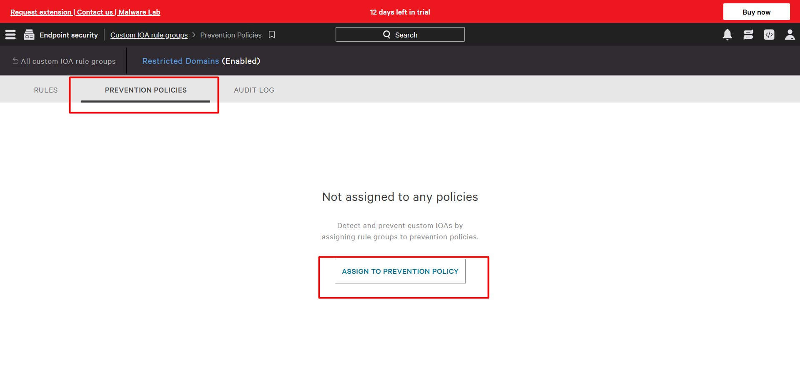

Step 9: Confirmation View
Finally, review the summary of the prevention policy and IOA assignment. The IOA should be listed under the applied rules, and the host group assignment should be visible.
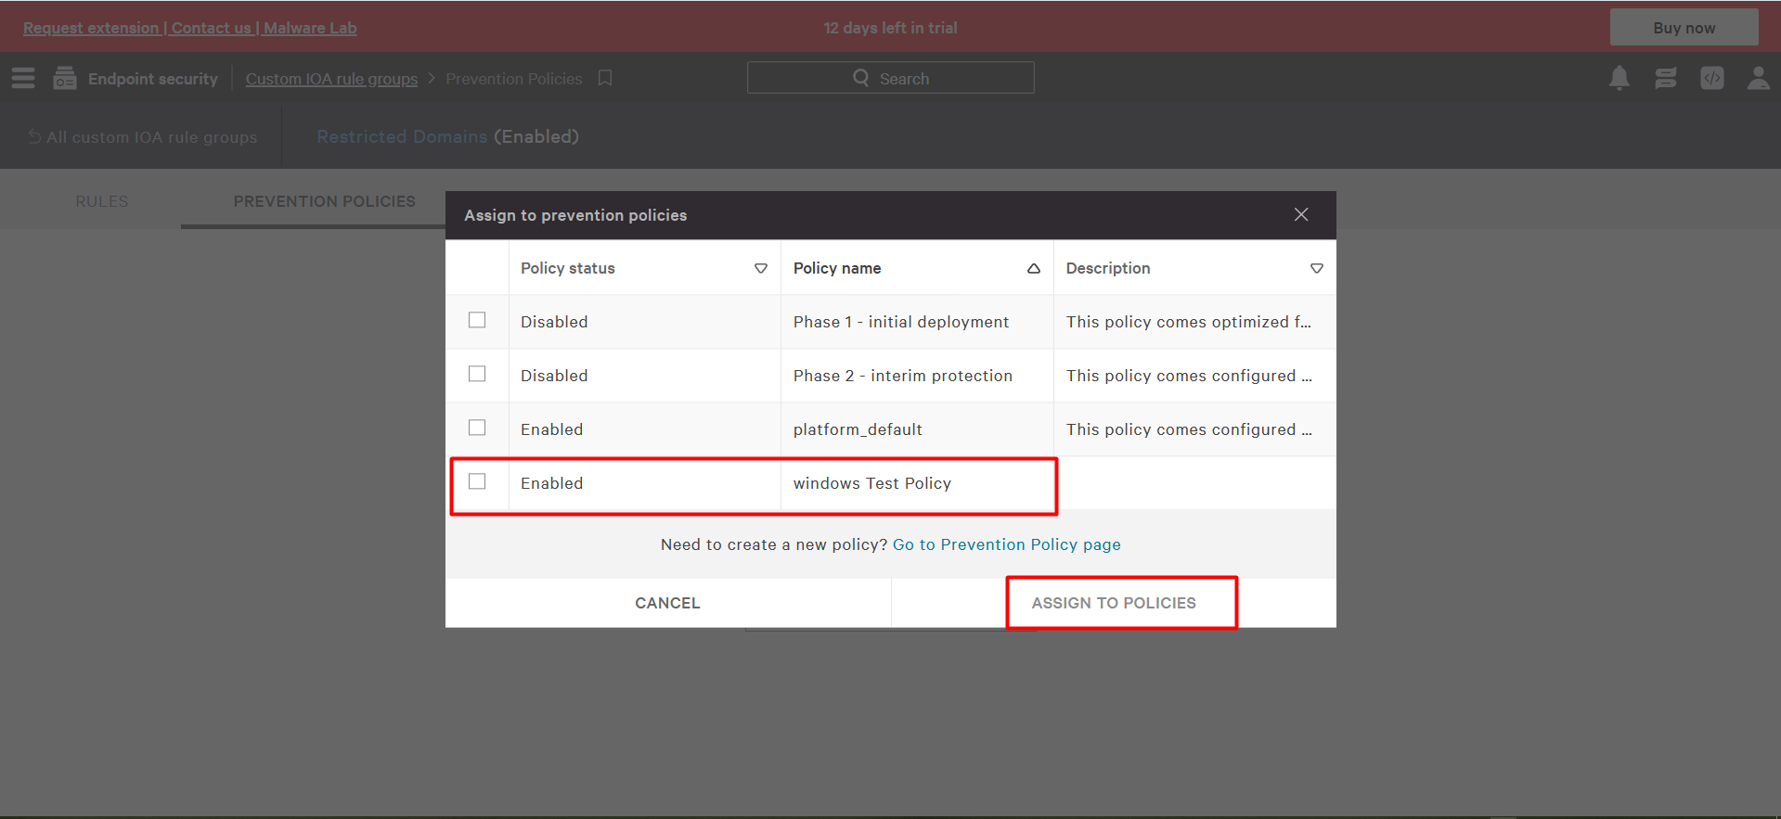

Step 10: Enforcement Confirmation
The IOA enforcement is now complete. Hosts in the assigned group will block access to the specified domain.
