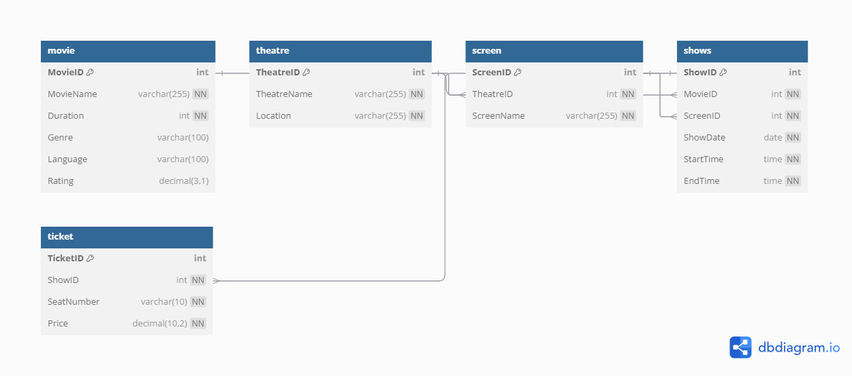

CREATE SCHEMA `bookmyshow` ;

use bookmyshow;

CREATE TABLE movie (

    MovieID INT *PRIMARY KEY*,

    MovieName VARCHAR(255) NOT NULL,

    Duration INT NOT NULL,

    Genre VARCHAR(100),

    Language VARCHAR(100),

    Rating DECIMAL(3, 1)

);

CREATE TABLE theatre (

    TheatreID INT *PRIMARY KEY*,

    TheatreName VARCHAR(255) NOT NULL,

    Location VARCHAR(255) NOT NULL

);

CREATE TABLE screen (

    ScreenID INT *PRIMARY KEY*,

    TheatreID INT NOT NULL,

    ScreenName VARCHAR(255) NOT NULL,

*FOREIGN KEY* (TheatreID) *REFERENCES* Theatre(TheatreID)

);

CREATE TABLE shows (

    ShowID INT *PRIMARY KEY*,

    MovieID INT NOT NULL,

    ScreenID INT NOT NULL,

    ShowDate DATE NOT NULL,

    StartTime TIME NOT NULL,

    EndTime TIME NOT NULL,

*FOREIGN KEY* (MovieID) *REFERENCES* Movie(MovieID),

*FOREIGN KEY* (ScreenID) *REFERENCES* Screen(ScreenID)

);

CREATE TABLE ticket (

    TicketID INT *PRIMARY KEY*,

    ShowID INT NOT NULL,

    SeatNumber VARCHAR(10) NOT NULL,

    Price DECIMAL(10, 2) NOT NULL,

*FOREIGN KEY* (ShowID) *REFERENCES* shows(ShowID)

);

INSERT INTO movie (MovieID, MovieName, Duration, Genre, Language, Rating)

VALUES (1, 'Inception', 148, 'Sci-Fi', 'English', 8.8);

INSERT INTO movie (MovieID, MovieName, Duration, Genre, Language, Rating)

VALUES (2, 'Interstellar', 169, 'Sci-Fi', 'English', 8.6);

INSERT INTO Theatre (TheatreID, TheatreName, Location)

VALUES (1, 'PVR Cinemas', 'MG Road, Bengaluru');

INSERT INTO Theatre (TheatreID, TheatreName, Location)

VALUES (2, 'INOX', 'Orion Mall, Bengaluru');

INSERT INTO Screen (ScreenID, TheatreID, ScreenName)

VALUES (1, 1, 'Screen 1');

INSERT INTO Screen (ScreenID, TheatreID, ScreenName)

VALUES (2, 1, 'Screen 2');

INSERT INTO shows (ShowID, MovieID, ScreenID, ShowDate, StartTime, EndTime)

VALUES (1, 1, 1, '2024-09-29', '18:00:00', '20:30:00');

INSERT INTO shows (ShowID, MovieID, ScreenID, ShowDate, StartTime, EndTime)

VALUES (2, 2, 2, '2024-09-29', '21:00:00', '23:49:00');

INSERT INTO ticket (TicketID, ShowID, SeatNumber, Price)

VALUES (1, 1, 'A10', 300.00);

INSERT INTO ticket (TicketID, ShowID, SeatNumber, Price)

VALUES (2, 1, 'A11', 300.00);

SELECT S.ShowID, M.MovieName, S.ShowDate, S.StartTime, S.EndTime, T.TheatreName, SCR.ScreenName

FROM shows S

JOIN movie M ON S.MovieID = M.MovieID

JOIN screen SCR ON S.ScreenID = SCR.ScreenID

JOIN theatre T ON SCR.TheatreID = T.TheatreID

WHERE S.ShowDate = '2024-09-29' AND T.TheatreID = 1;