2/7/2020

Rohit Suseel

rxs190016

Assignment 4

Power BI

**Question:**   
Open Microsoft excel and paste the screenshot of your file

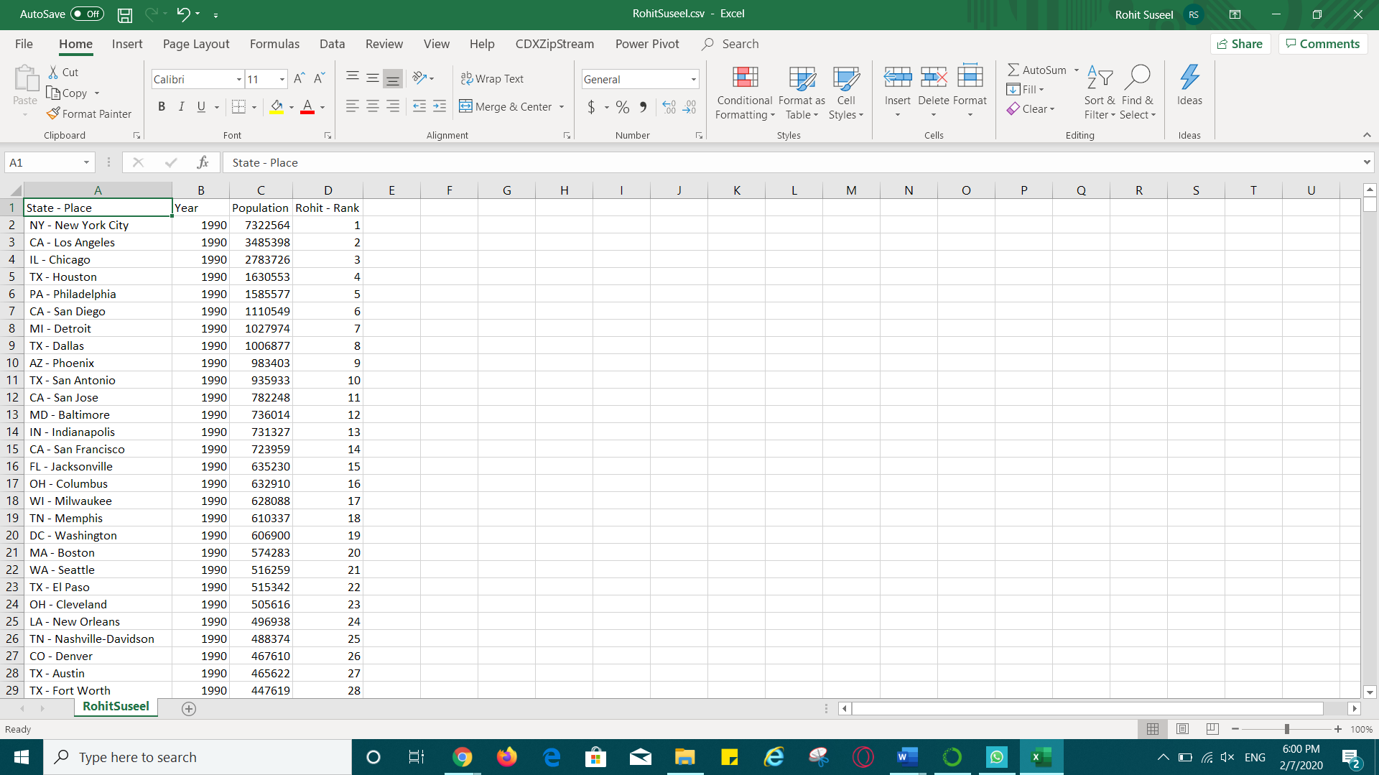

**Question:** Paste the screen shot of the load data screen.

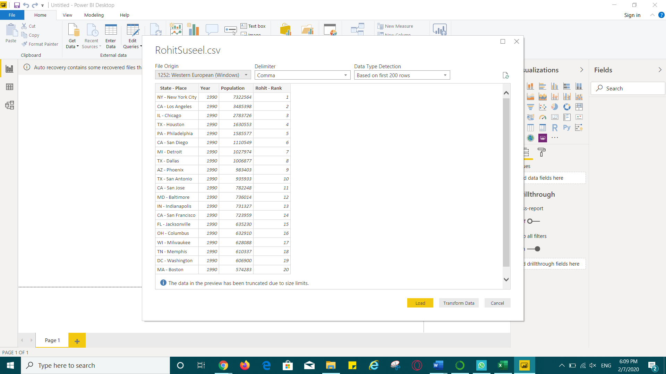

**Question:**

Paste the screen shot of the rank slider

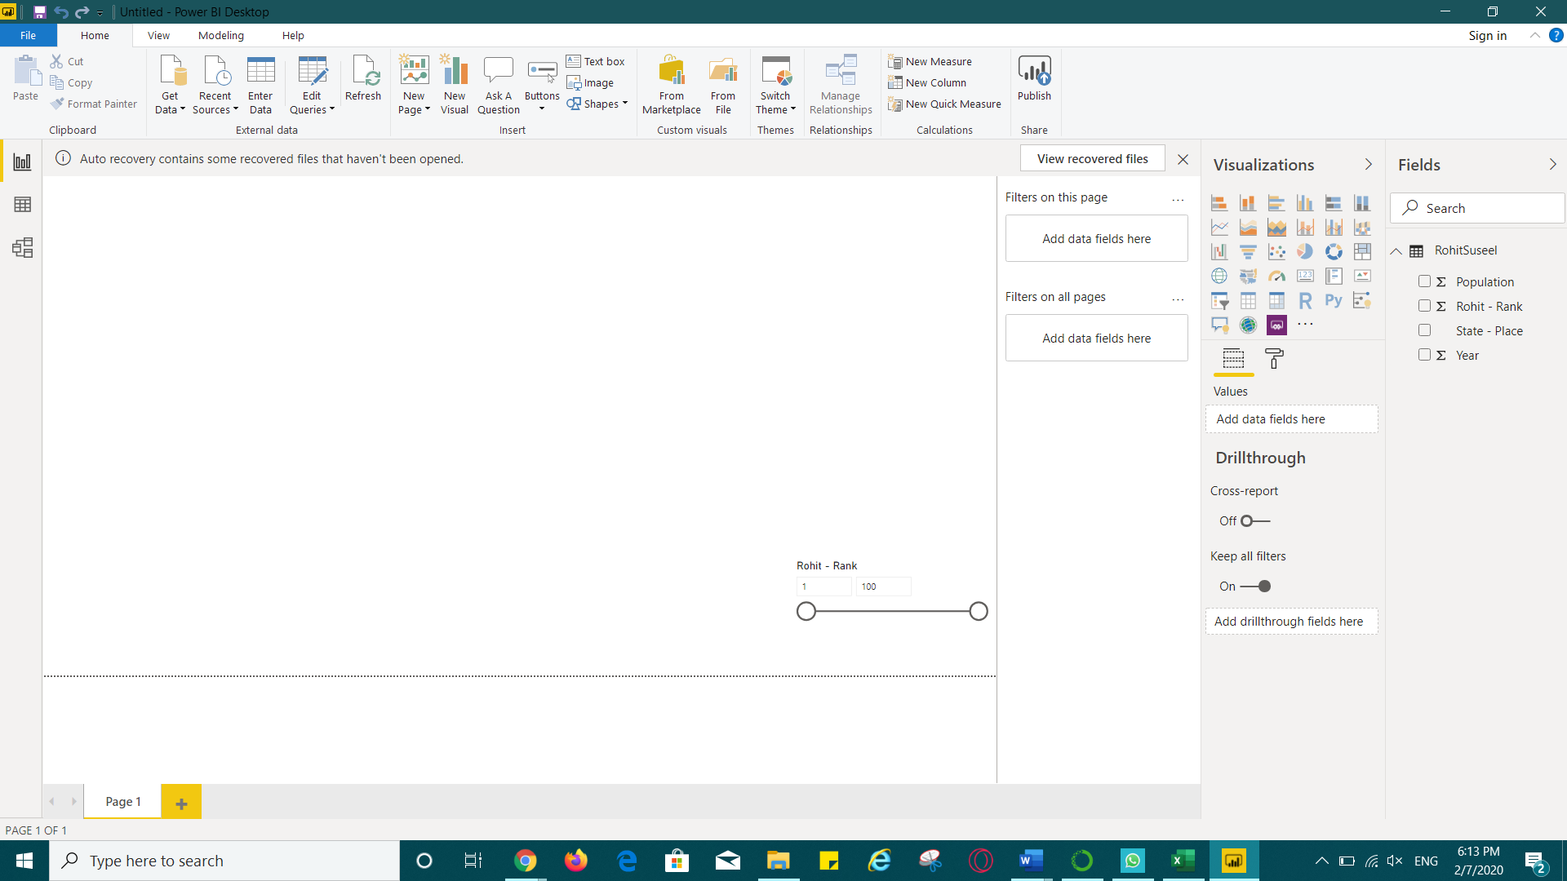

**Question:** Paste the screen shot of the newly created measure

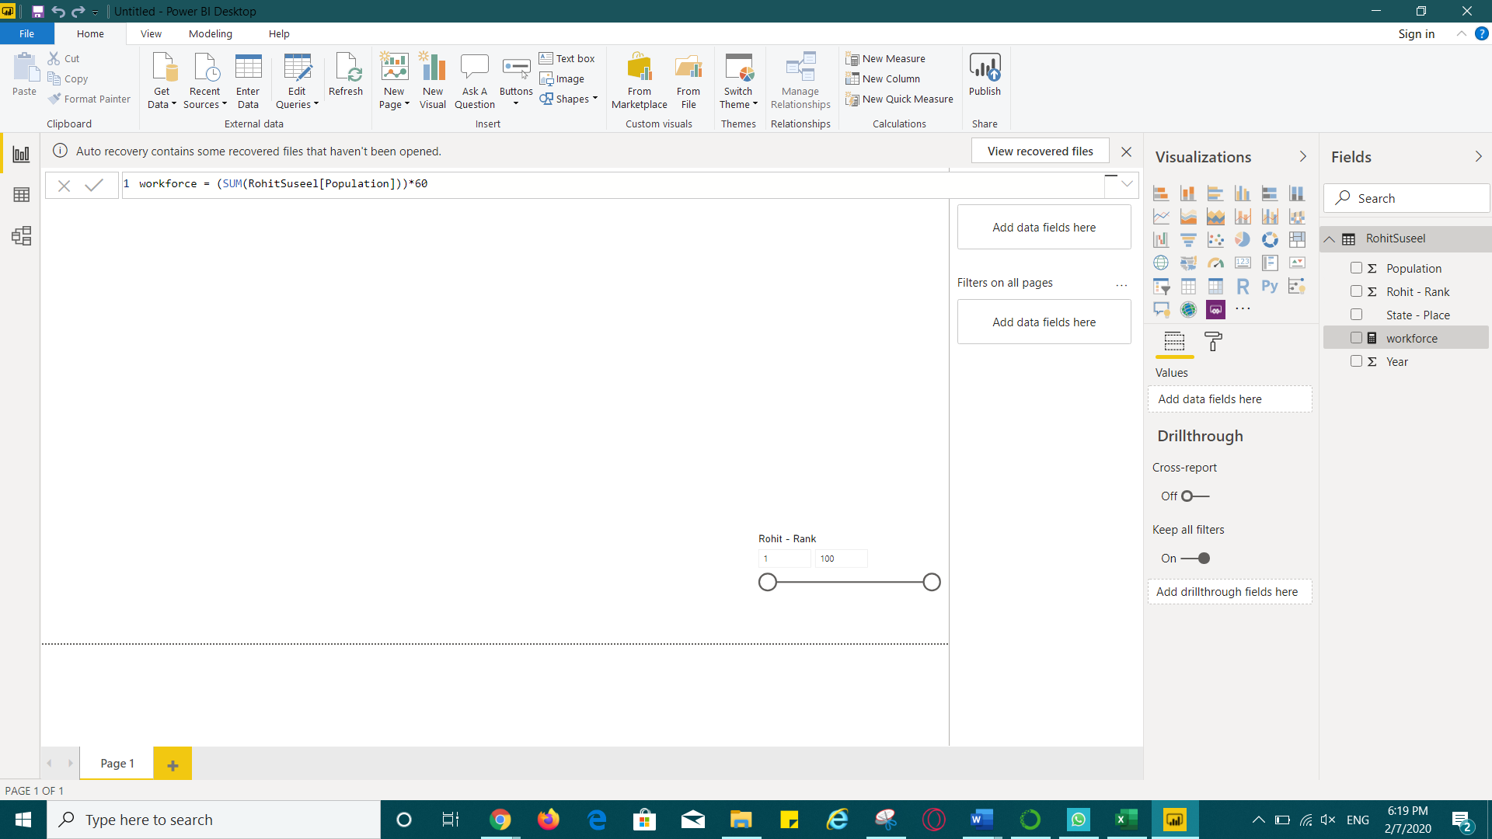

**Question:** Paste the screen shot of the Scatter chart

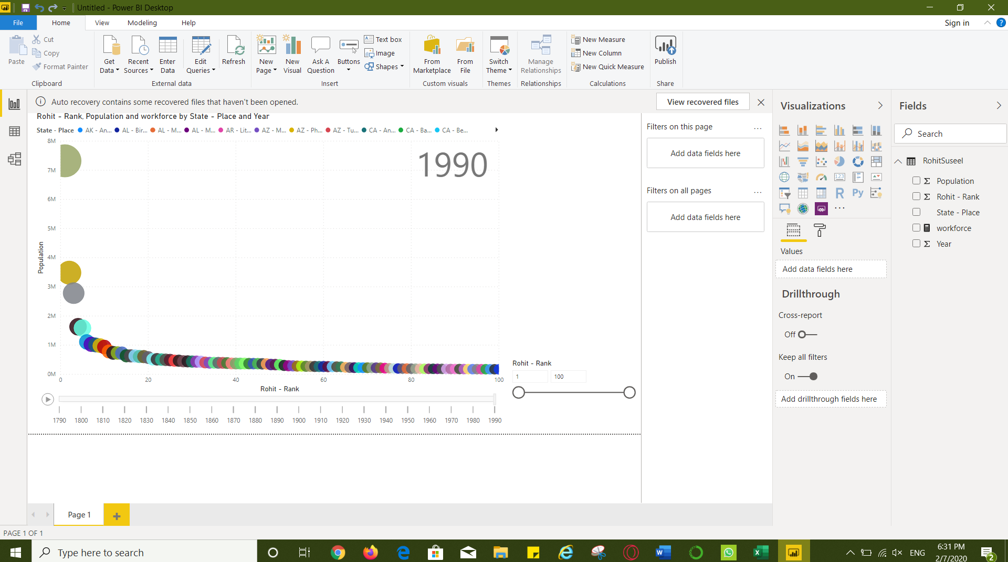

**Question:** Paste the screen shot of the chart- slider and category label

