1/24/2020

Rohit Suseel K

RXS190016

Visualization in Tableau

Assignment 2

Question 1:

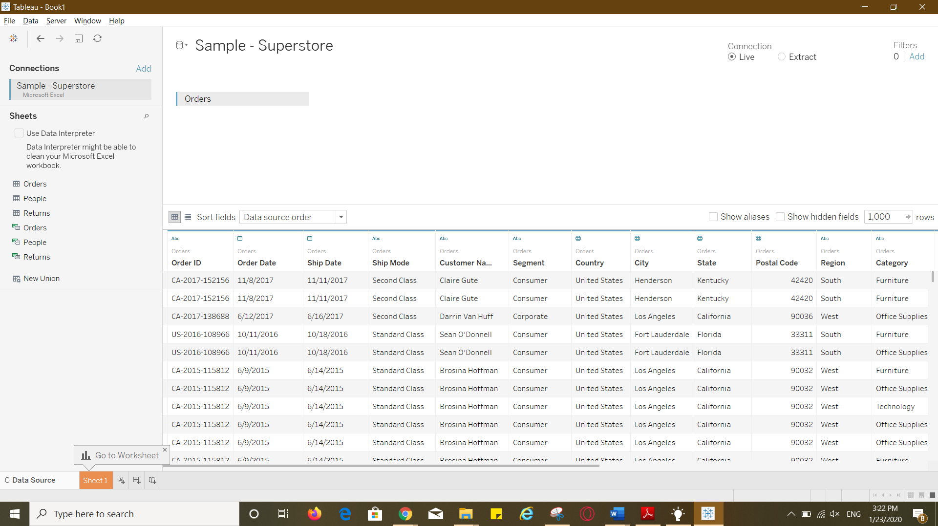

Question 2: Total how many tables are there in the loaded dataset? What is the total number of rows in the orders table? What is the total number of columns in the Orders table?

3 tables

9994 rows or records

21 columns

Question 3:

Inner join of Orders & Returns tables is used here.

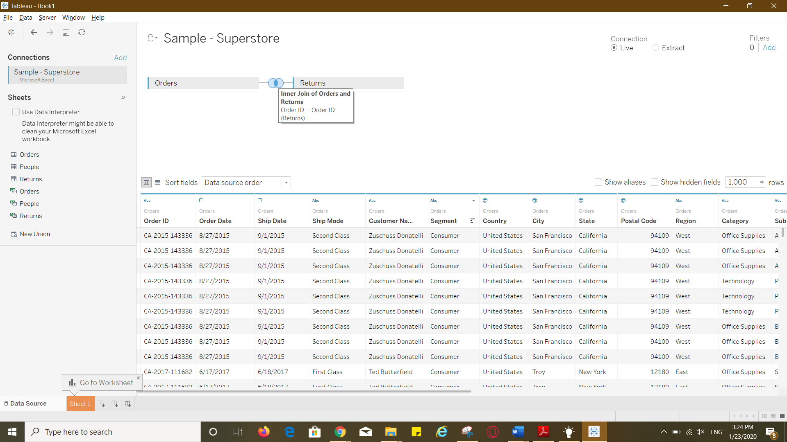

Question 4:

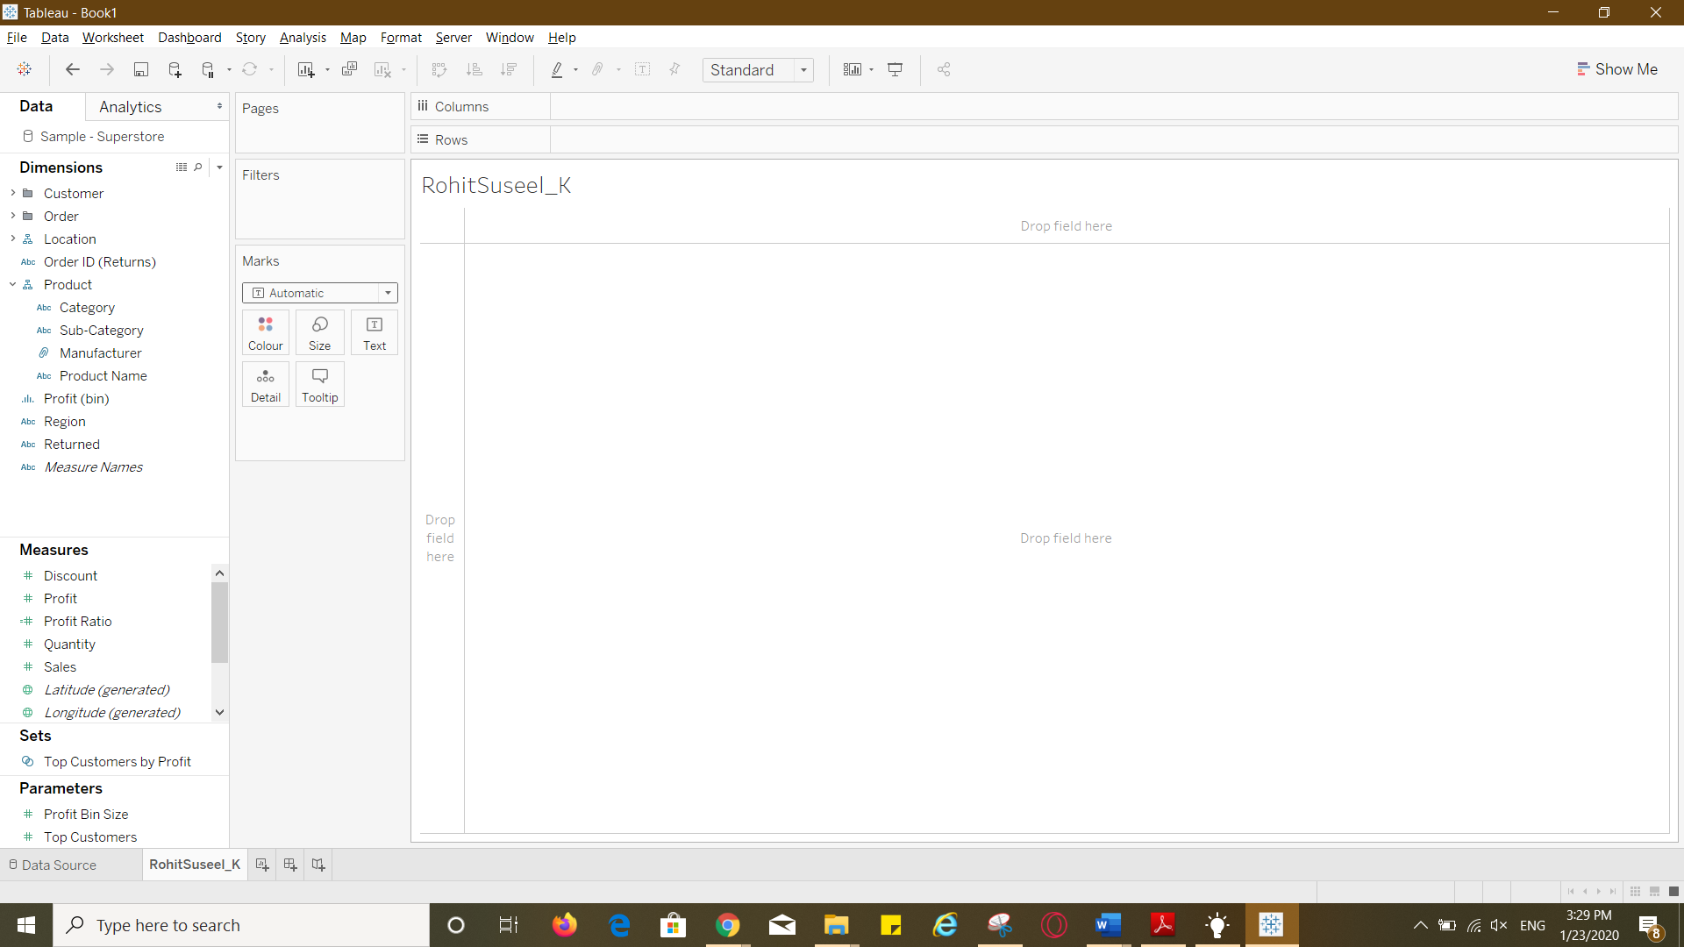

Question 5: What is the default aggregation in Tableau?  
a) Mean  
b) Sum  
c) Median  
d) Count

SUM is the default aggregation in Tableau

Question 6: 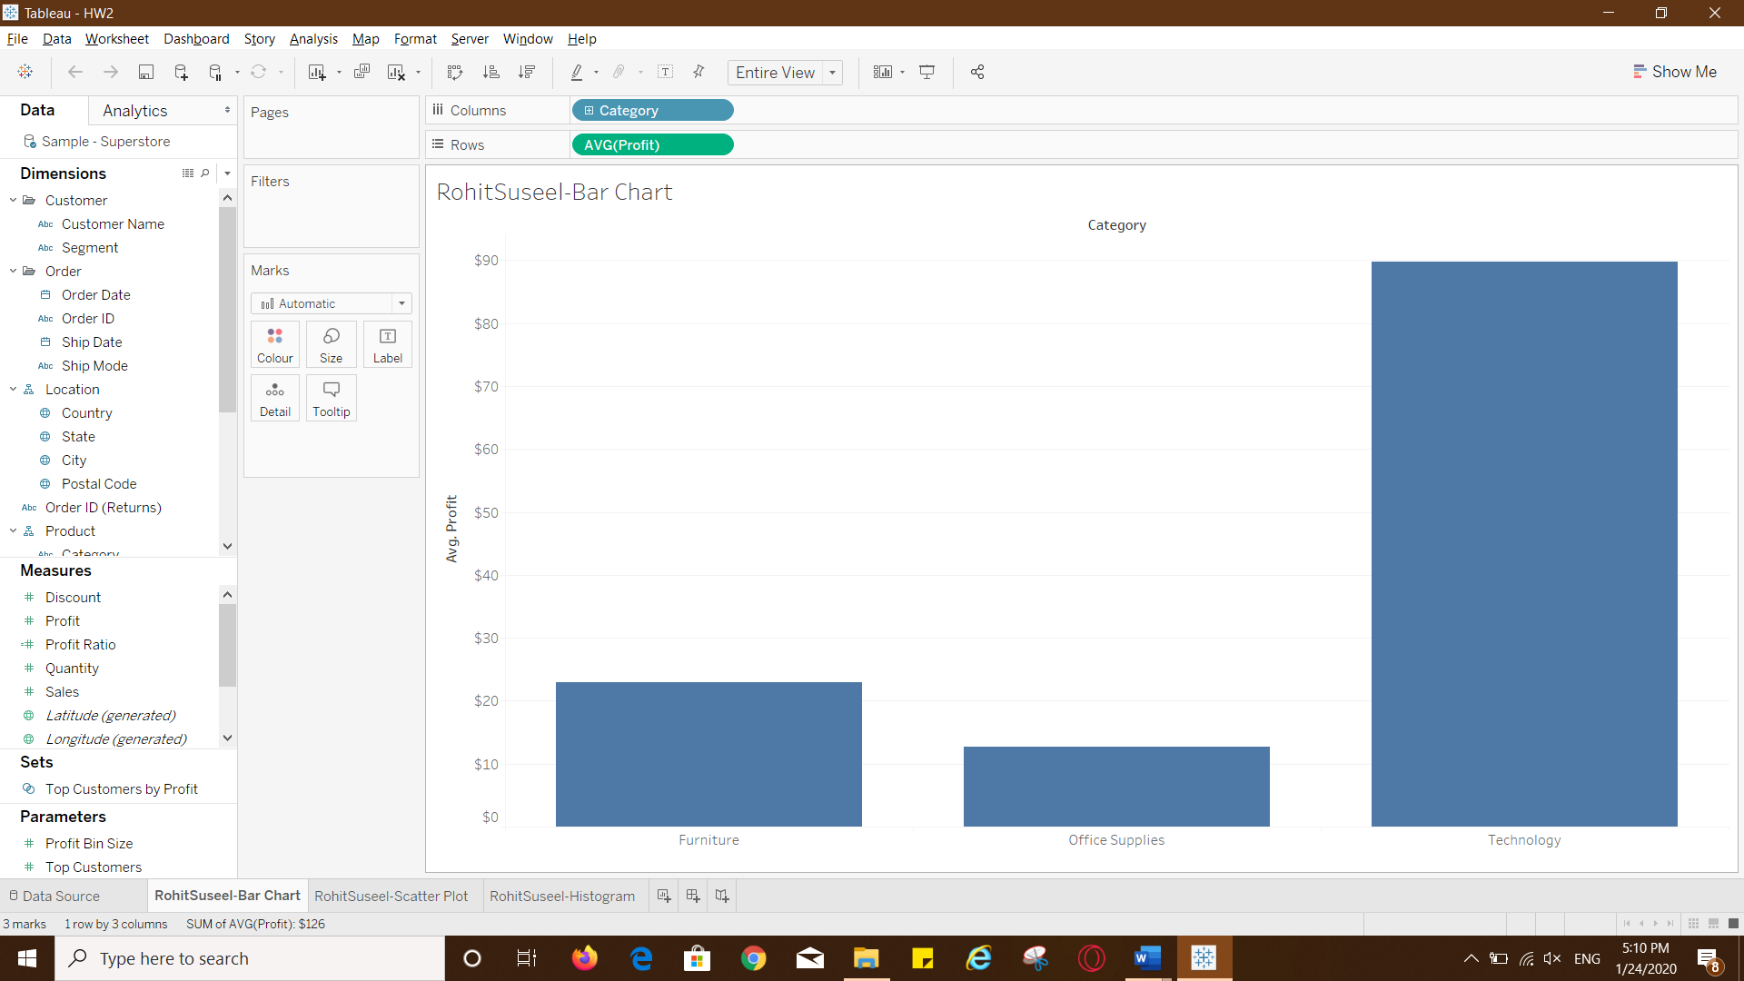

Question 7: What changes were observed in the bar graph when aggregation was changed from sum to average?

The Y axis label changed to Avg.Profit from Sum. The Y-axis values changed and the OFFICE SUPPLIES bar went considerably down when aggregation was changed from sum to average.

Question 8:

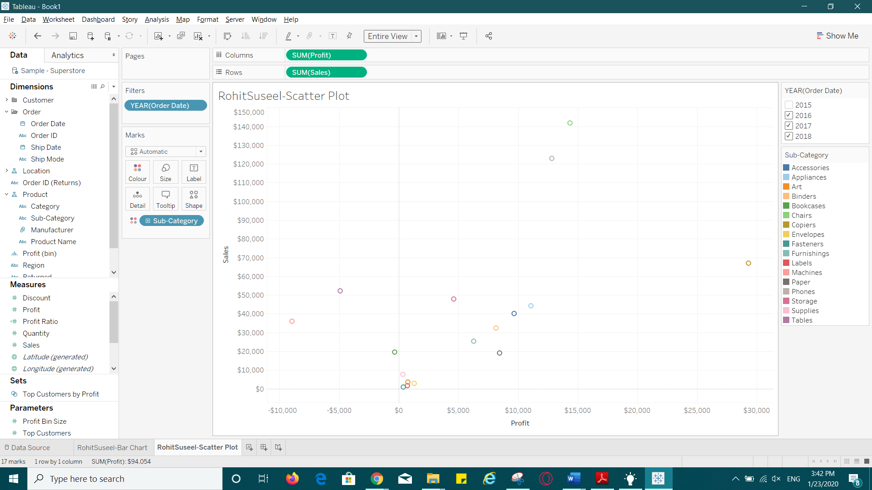

Question 9: Which sub-category has sales greater than $140,000? Which sub-category has Profit greater than $10,000?

Chairs sub-category has sales greater than $140,000.

Appliances, phones, chairs and copiers have profit greater than $10,000

Question 10:

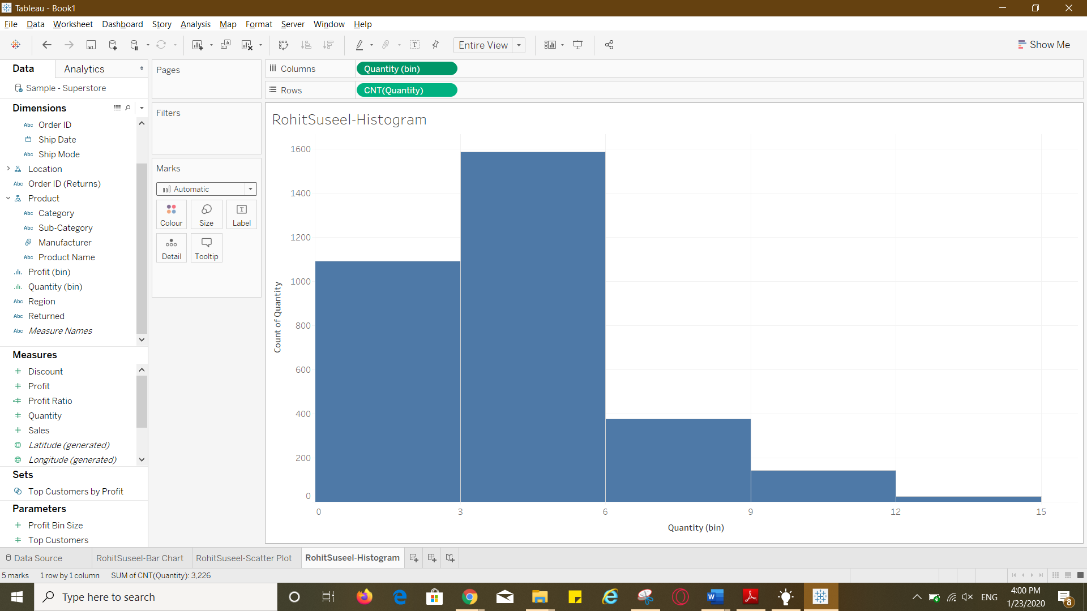

Question 11:

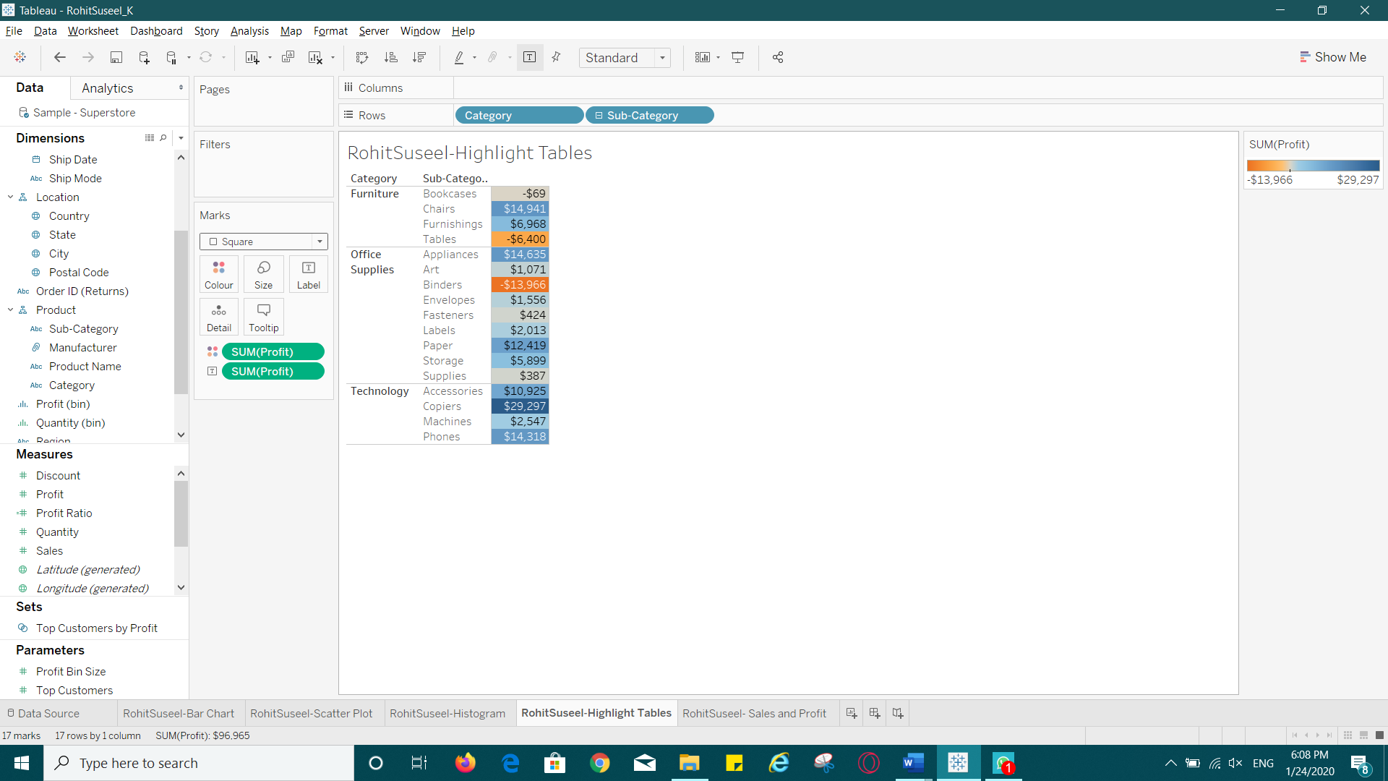

Question 12: Which sub-categories are making the most profit? Which sub-categories are making the least profit? List 3 sub-categories with their corresponding values for each with your answers.

Copiers- $29,297, chairs-$14,941 and appliances-$14,635 are making most profit.

Binders: -$13,966, tables: -$64,00 and bookcases: -$69 are making least profit.

Question 13: 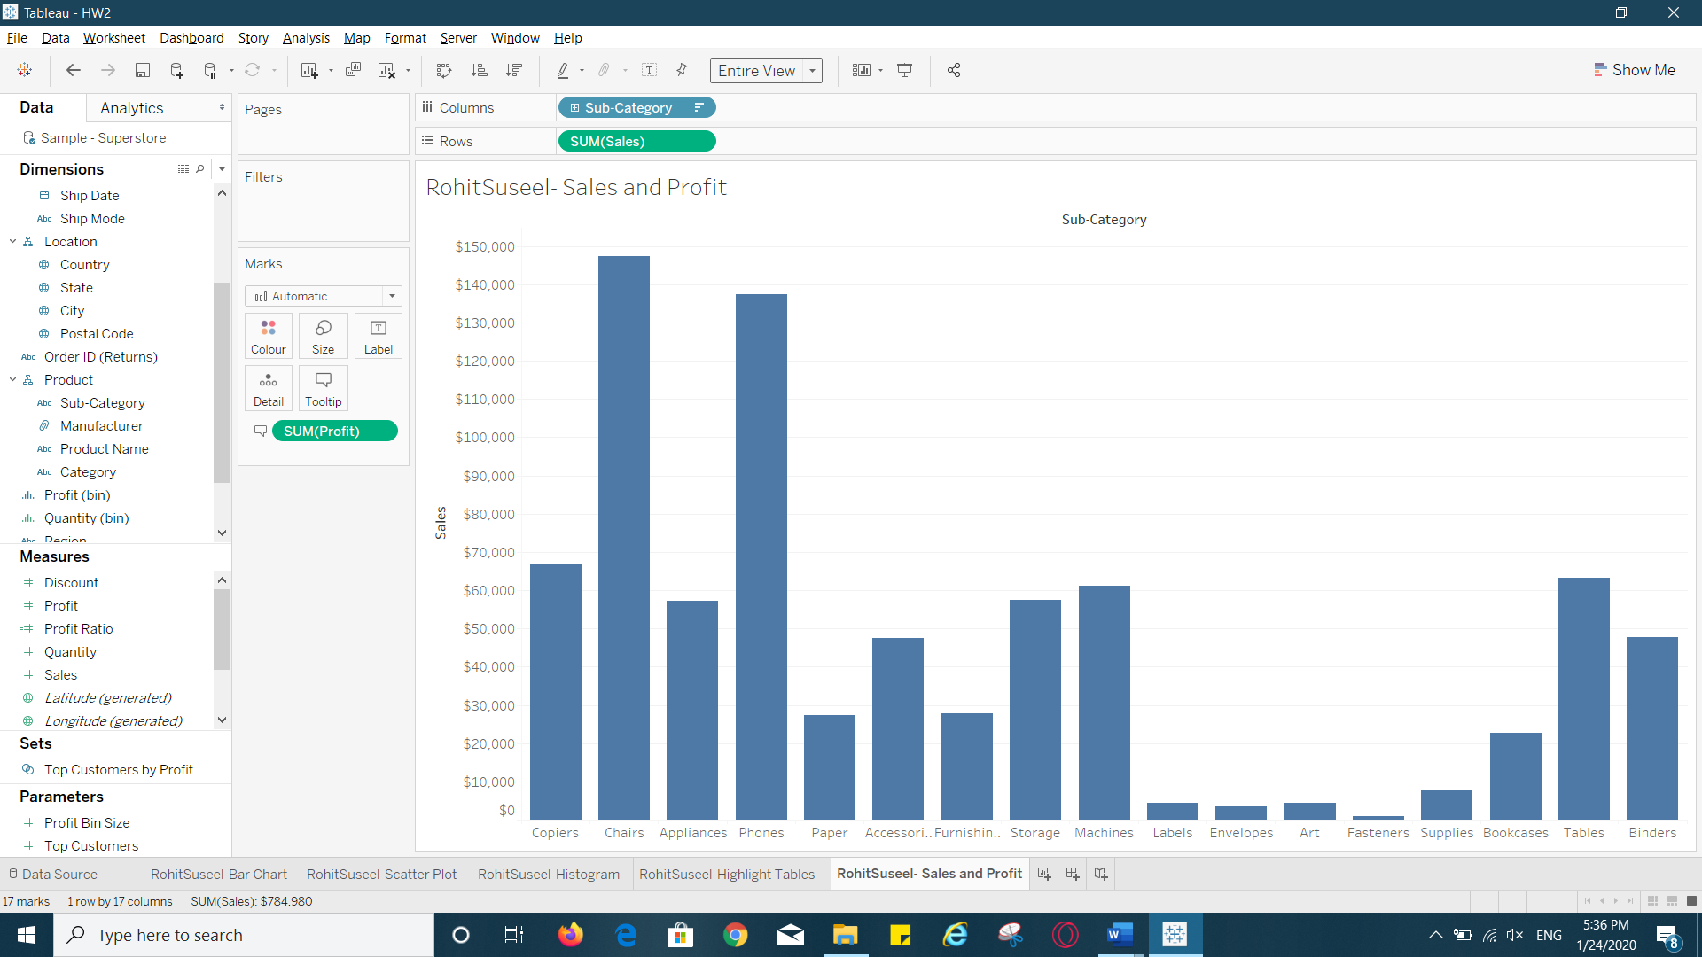

Question 14: Which sub-categories have the highest sales? Which sub-categories have the highest profits? List 3 sub-categories for each with their respective values.

Chairs: Sales - $147,380

Phones: Sales- $137,283

Copiers: Sales- $66,959

Copiers: Profit- $29,297

Chairs: Profit- $14,941

Appliances: Profit- $14,635