**Q. 1 Paste the screenshot of Data Source**

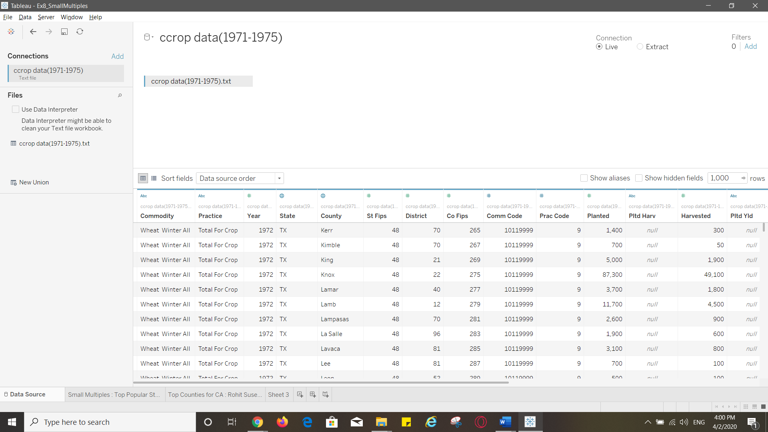

**Q. 2 Paste the screenshot of the whole worksheet**

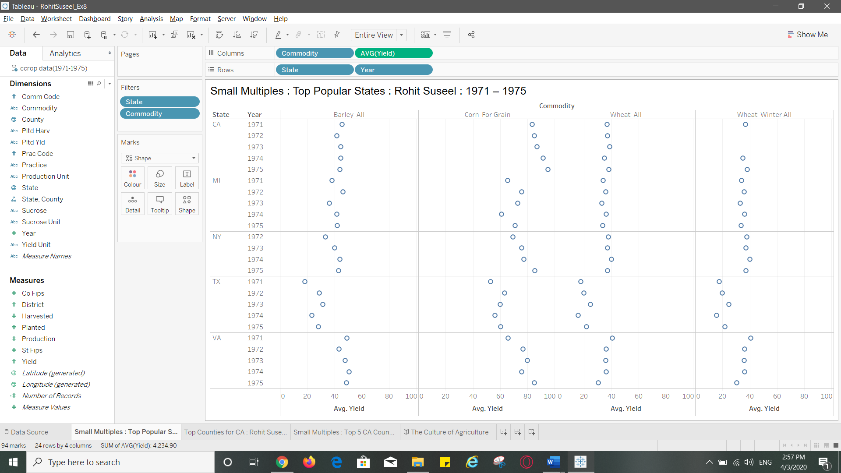

**Q. 3 Paste the screenshot of the whole worksheet**

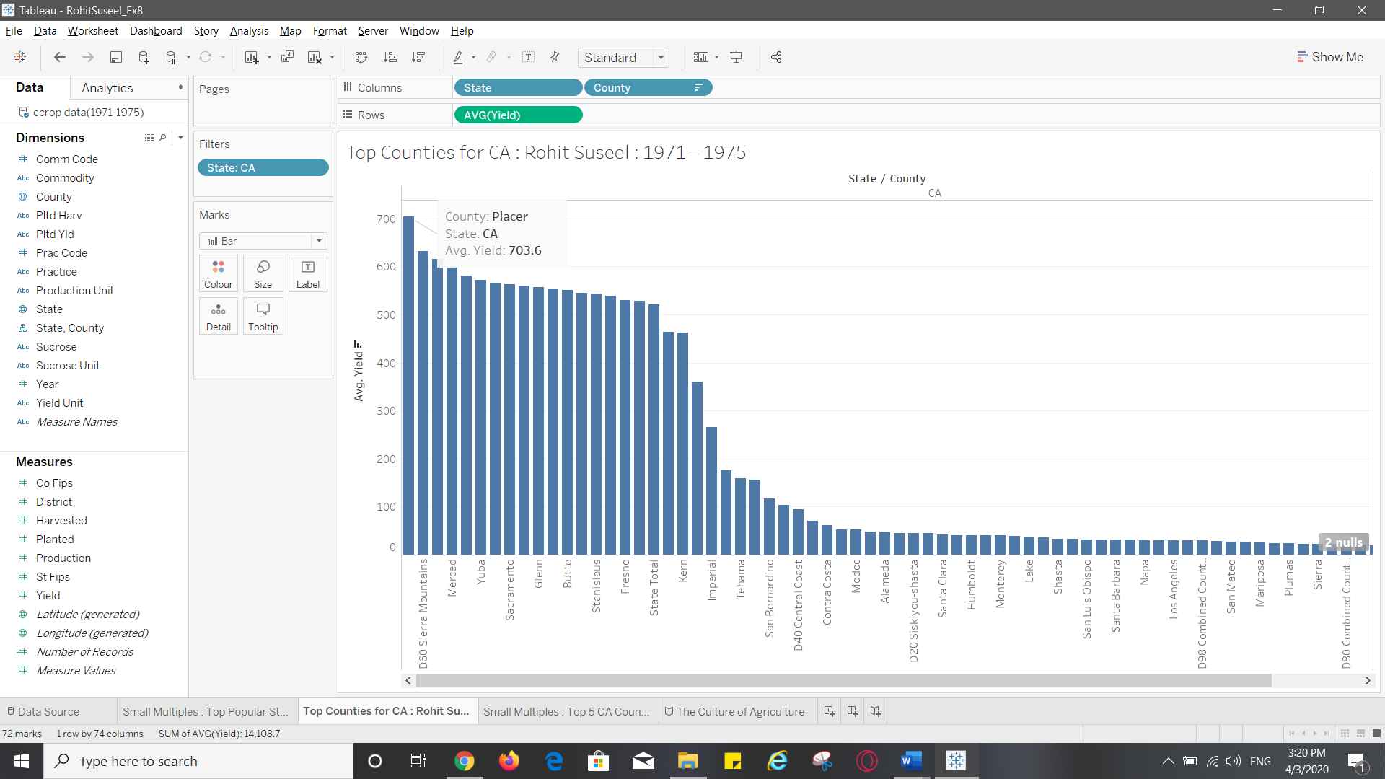

**Q. 4 Write top 5 Counties of California from the visualization**

1. Placer

2. D60 Sierra Mountains

3. Kings

4. Merced

5. San Joaquin

**Q. 5 Paste the screenshot of the whole worksheet**

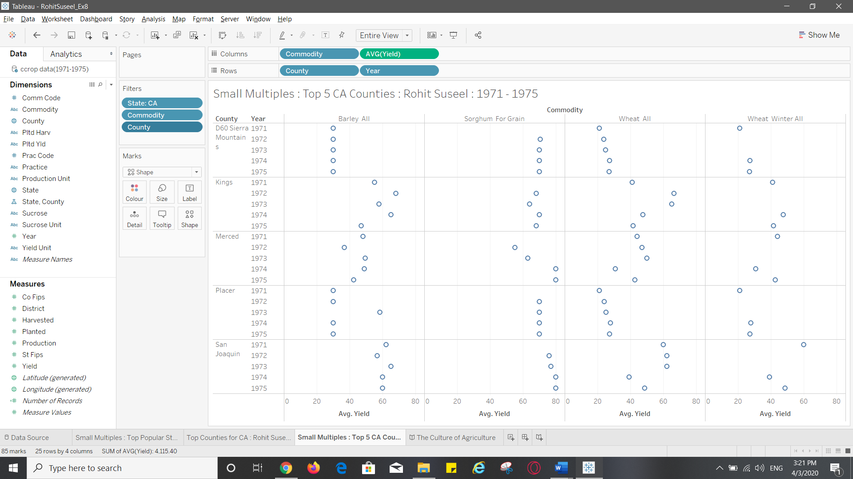

**Q. 6 What insight you can infer from the visualization?**

a. Average yield for the commodity ‘Sorghum for grain’ is higher in the top 5 counties in CA than the other mentioned commodities .

b. The average yield has been consistent for ‘Barley All’ in D60 Sierra Mountains county throughout the years 1971 – 1975

c. There was no yield for Sorghum in the year 1971 in any of the 5 counties.

d. The average yield of Wheat All in D60 Sierra Mountains and Placer counties follow similar pattern in 1971-1975.

e. In Placer after a consistent growth in the yield of Wheat All through the years 1971 to 1973, we can see a staggering drop in the yield in 1974.

**Q. 7 Which County does not show any change in average yield throughout the years for Barley All?**

D60 Sierra Mountains

**Q. 8 Paste the screenshot of your story in Tableau. Make sure to include screenshots of all the data points**

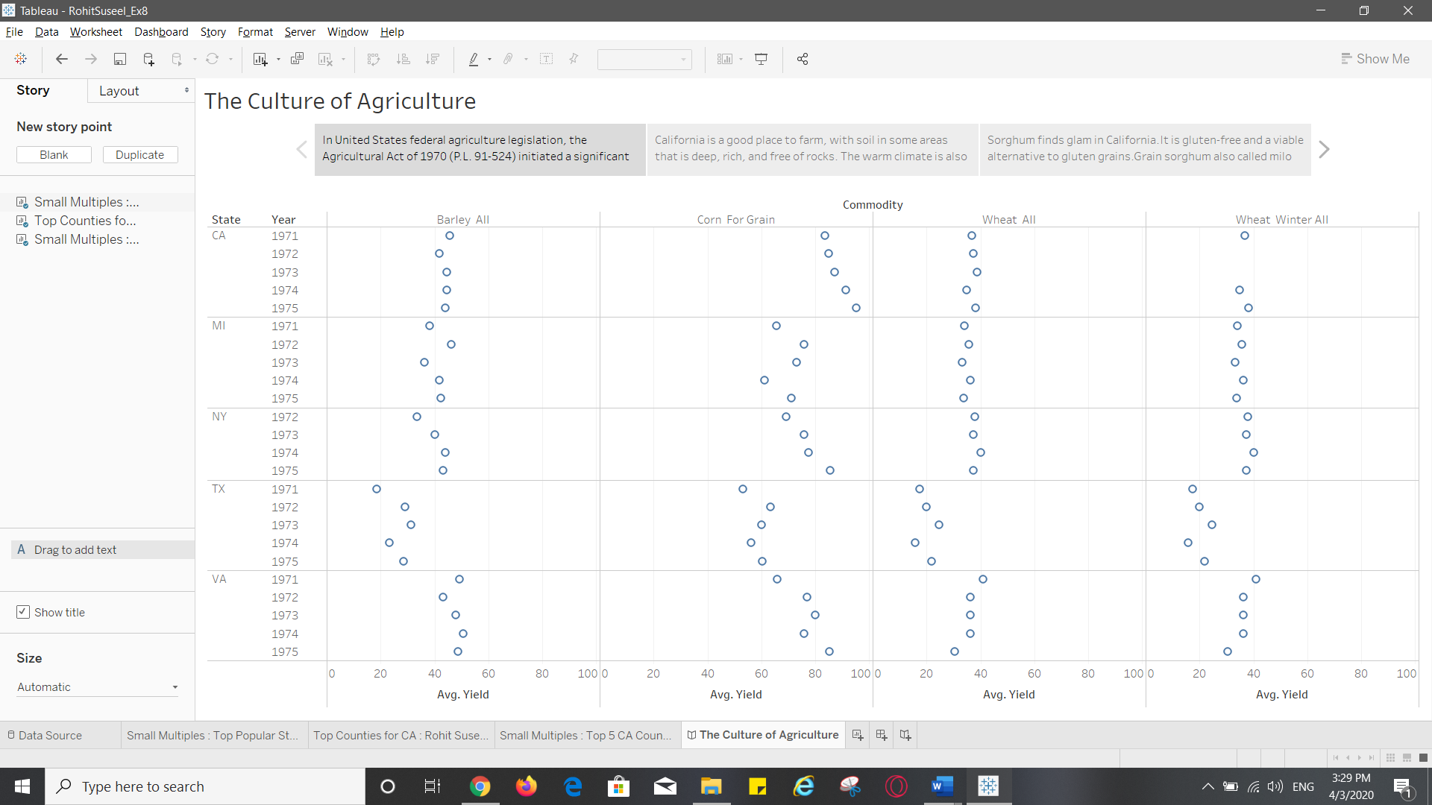

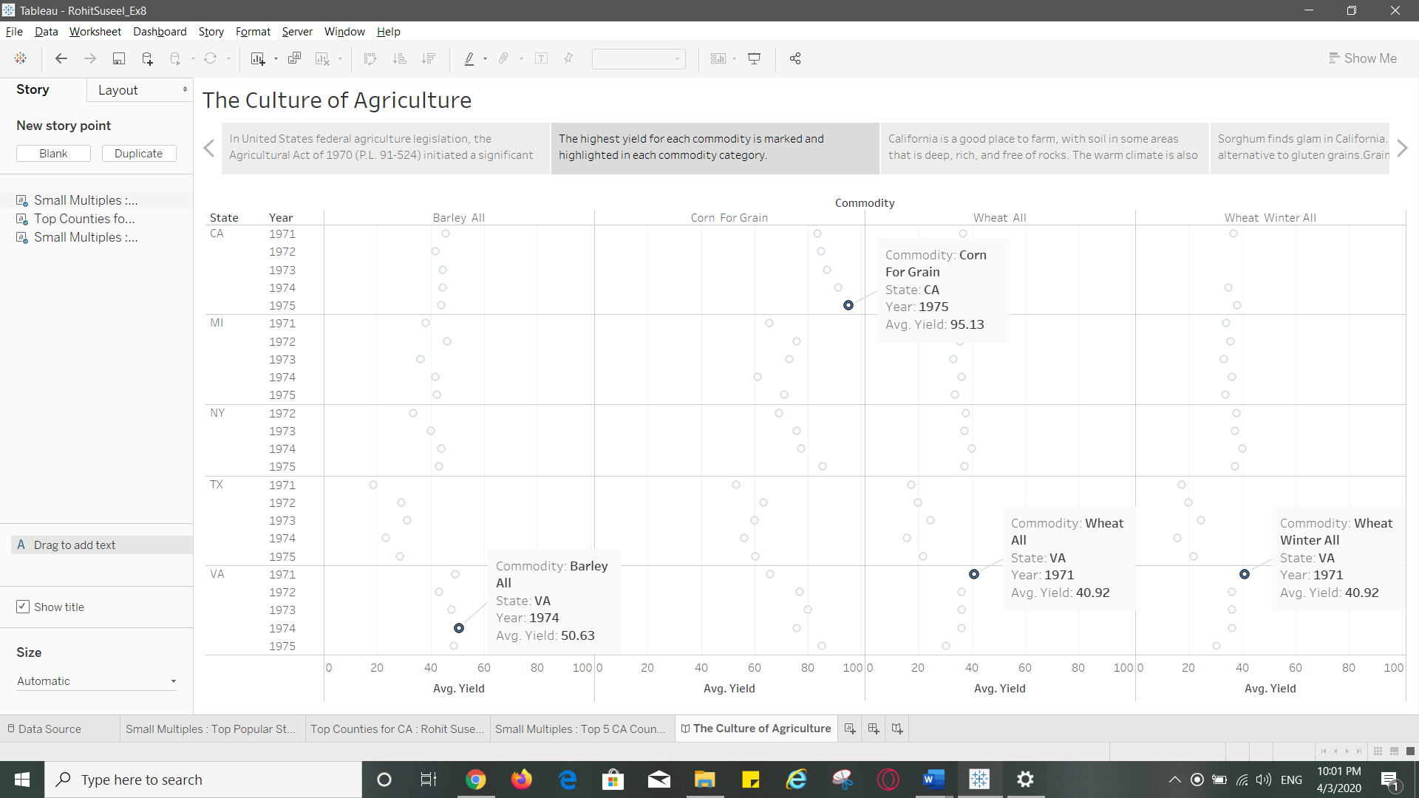

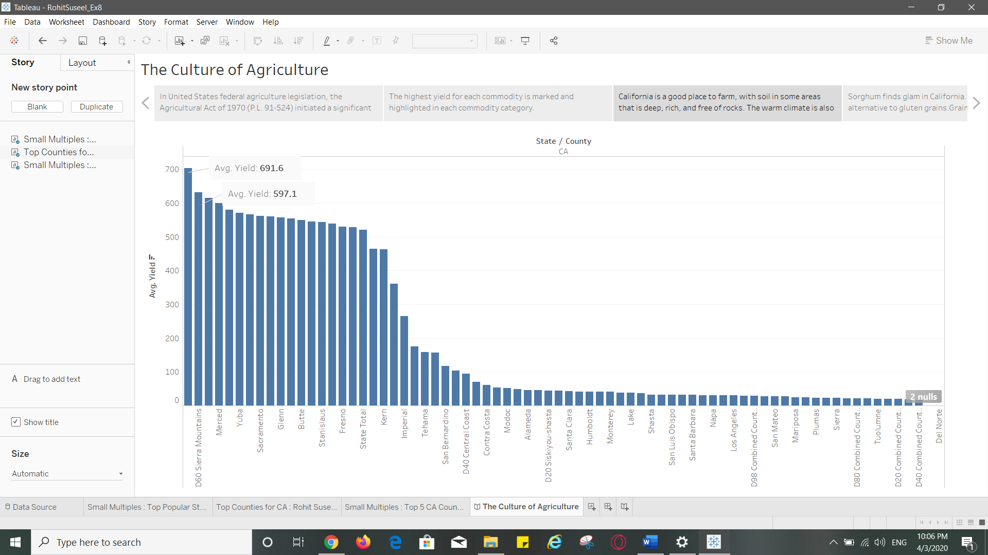

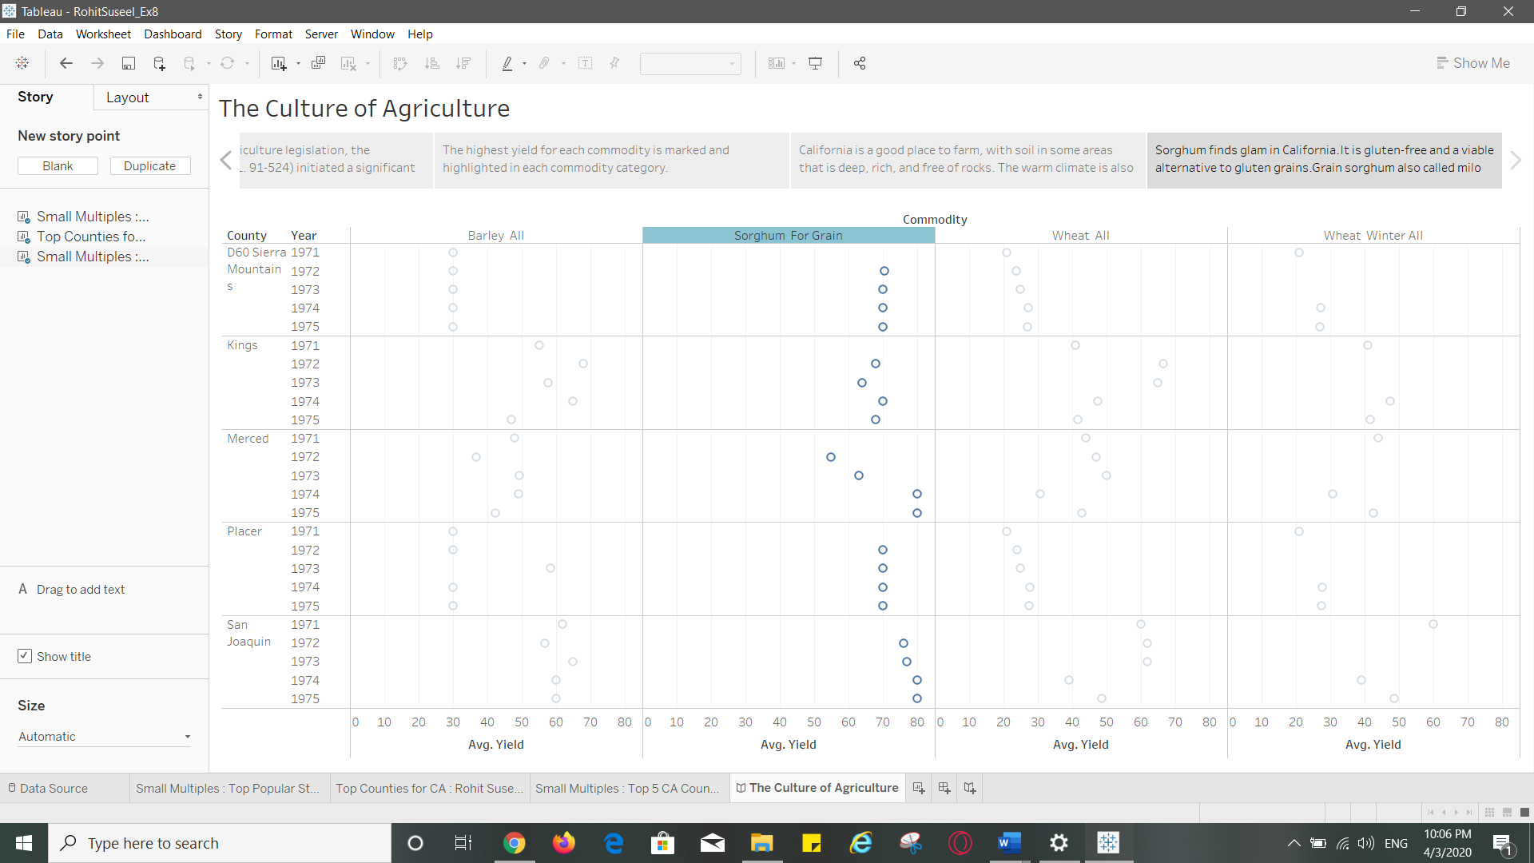

**Q. 9 Explain which rhetoric was used and how you used it. Why the Rhetoric you picked fits the visualization?**

The rhetoric used here is **logical.** The story depicts the yield and top commodities being cultivated in US during 1970s. California is selected because of its rich, deep soil and rock free contour. In California the commodity with highest yield is the gluten-free gold, Sorghum. There is a reason why this grain tops the chart. It could withstand droughts as well as flooding compared to other crops. And it is a viable alternative for other gluten grains.

In early 1970s, it was discovered that the celiac disease could be an autoimmune disorder as opposed to an allergic one. Sorghum is the safe grain for people with celiac disease.