GAMING ANALYTICS INTELLIGENCE PLATFORM

An end-to-end gaming analytics solution for understanding player behavior, engagement, progression, and purchasing patterns.

Project Report

Prepared by: Rohit Thakur
Tools: Excel | MySQL | SQL | Python | Pandas | Power BI | Streamlit

Dara Analytics Portfolio

2026

Contents
1.Project Overview 4
Project Technology Summary 4
Project at a Glance 4
2.Business Problem 4
3.Project Objectives 5
4.Dataset Imformation 5
Dataset Columns 5
5.Data Quality & Cleaning 6
Data Quality Summary 6
7. Tools & Technologies 6
8.Excel Insights 7
1. PLAYER BASE 7
2. PLAYER DEMOGRAPHICS 7
3. ENGAGEMENT 7
4. ENGAGEMENT DISTRIBUTION 7
5. GAME GENRE 7
6. PLAYTIME AND ENGAGEMENT 7
7. MONETIZATION 7
8. LOCATION 7
9.SQL Insights 8
1. Player Distribution by Genre 8
2. Average Playtime by Genre 8
3. Purchase Rate by Genre 8
4. Engagement Analysis 8
10.Python & Pandas Analysis 9
10.1.Purpose 9
10.2.Python Project Structure 9
10.3.Database Connection 9
10.4.Pandas Analysis 9
10.5.Python Workflow 10
11.PowerBI Dashboard 10
11.1.Purpose 10
11.2.Dashboard Components 10
11.3.PowerBI Workflow 10
12.Streamlit Application 11
12.1.Purpose 11
12.2.Application Structure 11
12.3.Application Components 11
13.Chatbot 12
13.1.Purpose 12
13.2.Functionality 12
14.Key Performance Indicatior (KPIs) 12
15.Player Segmentation 12
15.1.Purpose of Player Segmentation 12
15.2.Segmentation Metrics 13
15.3.Player Segment Results 13
15.4.Segment Analysis 13
16.Key Insights 13
17.Business Recommendation 13
18.Challange Faced 14
19.Leaning Outcomes 14
20.Conclusion 14

1.Project Overview
The Gaming Analytics Intelligence Platform is an end-to-end data analytics project designed to analyze player behavior, engagement, progression, game preferences, and in-game purchasing patterns.

The project processes player data through multiple analytical technologies, beginning with data preparation and Excel analysis, followed by MySQL database management and SQL analysis. Python and Pandas are then used for further analytical processing and generation of analytical outputs. Power BI is used to create interactive dashboards, while Streamlit provides an interactive application interface with analytical features and a chatbot.

The platform is designed to demonstrate how different data analytics tools can work together to transform raw player data into meaningful business insights.

Project Technology Summary
Technology | Purpose
Excel | Data preparation and exploratory analysis
MySQL | Database storage
SQL | Data querying and analysis
Python | Analytical processing
Pandas | Data manipulation
Power BI | Interactive dashboard
Streamlit | Interactive analytics application

Project at a Glance
Item | Details
Dataset Size | 40,034 players
Columns | 13
Database | MySQL
Programming | Python / Pandas
Visualization | Power BI
Application | Streamlit
Interactive Feature | Chatbot

2.Business Problem
Gaming companies generate large amounts of player data that can provide valuable information about player engagement, gameplay behavior, progression, and purchasing activity. However, raw player-level data by itself does not provide actionable business insights.

The objective of this project is to transform player data into meaningful analytical information that can help understand how players interact with games, how engagement varies across player groups and game genres, and how player behavior relates to purchasing activity.

The platform brings together data preparation, SQL analysis, Python analytics, dashboarding, and an interactive Streamlit application to provide a centralized analytical view of player behavior.

3.Project Objectives
1.Analyze player demographics and gameplay characteristics.
2.Measure player engagement using playtime, sessions, and session duration.
3.Analyze player progression using player level and achievements.
4.Compare player behavior across game genres and difficulty levels.
5.Analyze in-game purchasing behavior.
6.Identify meaningful player segments based on engagement and gameplay behavior.
7.Calculate important gaming KPIs.
8.Build an interactive Power BI dashboard for visual analysis.
9.Build a Streamlit application for interactive exploration.
10.Provide a chatbot interface for asking questions about the available player data.

4.Dataset Imformation

Attribute Value
Dataset player_statistics.xlsx
Records 40,034
Columns 13
Unique Players 40,034
Missing Values 0

Dataset Columns

Column Description
PlayerID Unique player identifier
Age Player age
Gender Player gender
Location Player location
GameGenre Game genre
PlayTimeHours Player gameplay time
InGamePurchases In-game purchasing value(0/1)
Game difficulty Game Difficulty
SessionsPerWeek Weekly number of sessions
AvgSessionDurationMinutes Average session duration
PlayerLevel Player progression level
AchievementsUnlocked Number of achievements unlocked
EngagementLevel Player engagement category

5.Data Quality & Cleaning
The dataset was reviewed for data quality before analysis. The final dataset contains 40,034 records and 13 columns.

No missing values were identified across the 13 columns. The dataset also contains 40,034 unique PlayerIDs, indicating that each record represents a unique player in the current dataset.

Data types were reviewed to ensure that numerical attributes such as age, playtime, sessions, player level, and achievements could be used for quantitative analysis, while categorical attributes such as gender, location, game genre, difficulty, and engagement level could be used for segmentation and comparison.

Data Quality Summary
Total Records: 40,034
Total Columns: 13
Missing Values: 0
Unique PlayerIDs: 40,034
Game Genres: 5
Locations: 4
Game Difficulties: 3
Engagement Categories: 3

6. Project Workflow

Raw Excel Dataset
↓
Data Cleaning & Validation
↓
MySQL Database
↓
SQL Analysis
↓
Python + Pandas Analysis
↓
Analytical Outputs
↓
Power BI Dashboard
↓
Streamlit Application
↓
Interactive Chatbot

7. Tools & Technologies
Tool Purpose
Excel Data preparation and initial analysis
MySQL Database storage and management
SQL Data querying and business analysis
Python Analytical processing
Pandas Data manipulation and analysis
Power BI Interactive dashboarding
Streamlit Interactive analytics application
Git/GitHub Version control and project presentation

8.Excel Insights

1. PLAYER BASE
Total Players:
There are 40,034 unique player's in the dataset.

2. PLAYER DEMOGRAPHICS
The Average Player level is approximately 49.656.

3. ENGAGEMENT
Average Playtime:
The average playtime of the player's are 12.024 Hrs.

Average Sessions Per Week:
An Average of 9 sessions are played by the player's in a week.

4. ENGAGEMENT DISTRIBUTION
Largest Engagement Category:
Approximately 48% of the player's comes under Medium Engagement Level.

5. GAME GENRE
Genre With Most Players:
The 'Action' Genre has the highest number of players = 8039.

6. PLAYTIME AND ENGAGEMENT
Highest Average Playtime Engagement Group:
High-engagement players have the highest average playtime, suggesting that playtime is strongly associated with player engagement.

7. MONETIZATION
Overall Purchase Rate:
Most Revenue is earned by 'Startergy' Genre with revenue around $1600.

8. LOCATION
Location With Most Players:
Most number of player's are reportedly are from USA.

9.SQL Insights
SQL BUSINESS INSIGHTS
Gaming Analysis Platform
========================================

1. Player Distribution by Genre
--------------------------------

Finding:
[Write the genre with the highest number
of players and its player count.]

Business Insight:
[Explain what this means for the game
audience.]

----------------------------------------

2. Average Playtime by Genre
--------------------------------

Finding:
[Write the genre with the highest average
playtime.]

Business Insight:
[Explain what this tells us about player
engagement.]

----------------------------------------

3. Purchase Rate by Genre
--------------------------------

Finding:
[Write the genre with the highest purchase
rate.]

Business Insight:
[Explain what this could mean for
monetization.]

----------------------------------------

4. Engagement Analysis
--------------------------------

Finding:
[Compare High, Medium and Low engagement.]

Business Insight:
[Explain the relationship between engagement,
playtime, sessions and purchases.]

10.Python & Pandas Analysis

10.1.Purpose
Python and Pandas were used to perform additional data analysis after the player data was stored in MySQL. Python provided a programmatic way to connect to the database, retrieve analytical data, perform calculations, and generate reusable analytical output files.

10.2.Python Project Structure
Python/
│
├── database_connection.py
├── mysql_to_pandas.py
│
└── outputs/
├── engagement_summary.csv
├── genre_summary.csv
└── purchase_comparison.csv

The Python component was divided into separate files for database connectivity and analytical processing. database_connection.py handles the connection to the MySQL database, while mysql_to_pandas.py retrieves data, performs analysis using Pandas, and generates analytical output files.

10.3.Database Connection
The database_connection.py script was used to establish a connection between Python and the gaming_analytics_db MySQL database. The connection was tested successfully during project validation.
Database: gaming_analytics_db
Table: player_statistics
Records: 40,034

10.4.Pandas Analysis
Pandas was used to work with the data retrieved from MySQL in a structured DataFrame format. The analysis focused on player engagement, game genre performance, and purchasing behavior.
-engagement_summary.csv
This output contains aggregated information related to player engagement and was generated from the analytical processing performed in Python.
-genre_summary.csv
This output contains aggregated results by game genre and was used to analyze differences in player activity across genres.
-purchase_analysis.csv
This output contains comparative analysis related to player purchasing behavior.

10.5.Python Workflow
MySQL Database
↓
database_connection.py
↓
Retrieve Data
↓
Pandas DataFrame
↓
Analysis & Aggregation
↓
Analytical CSV Outputs

-This workflow allowed the project to move from database-level analysis to reusable Python-generated analytical outputs that could be used for further reporting and visualization.

11.PowerBI Dashboard

11.1.Purpose
Power BI was used to transform the analyzed player data into interactive dashboards. The dashboard provides a visual overview of player demographics, gameplay behavior, engagement, progression, and purchasing-related metrics.

Figure 1: Power BI Gaming Analytics Dashboard

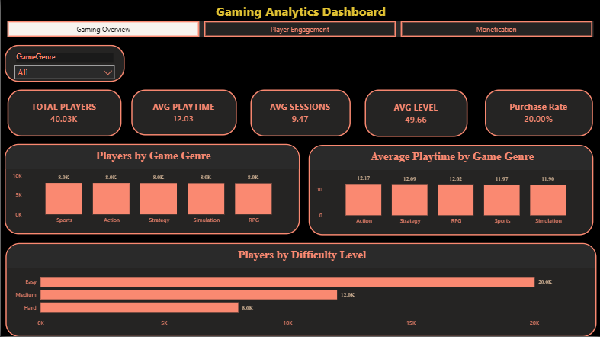

Figure 2: Power BI Detailed Analysis

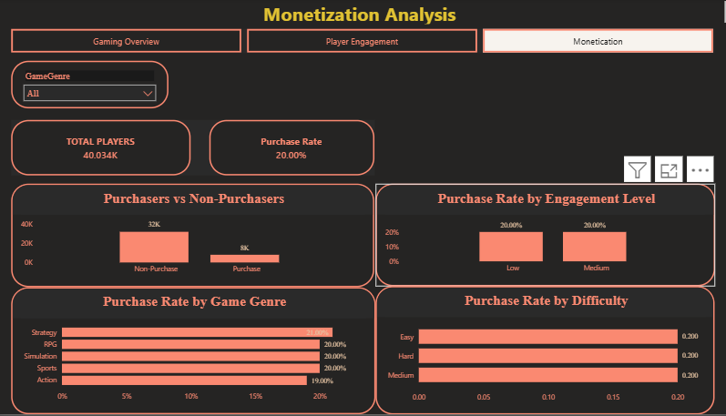

11.2.Dashboard Components
KPI cards
Player analysis
Game genre analysis
Engagement analysis
Gameplay analysis
Purchasing analysis
Interactive filters/slicers

11.3.PowerBI Workflow
Analyzed Data
↓
Power BI
↓
Data Model
↓
Measures / KPIs
↓
Interactive Visualizations
↓
Dashboard

-The Power BI dashboard provides an interactive layer for exploring the analytical results. Users can use available filters and slicers to examine different player groups and identify patterns in gameplay and engagement.

12.Streamlit Application

12.1.Purpose
Streamlit was used to convert the analytical work into an interactive web-based application. The application provides users with a convenient interface for exploring player analytics without directly interacting with the underlying Python scripts or database.

12.2.Application Structure
Streamlit_app/
│
├── data/
│ └── player_statistics_cleaned.csv
│
├── app.py
├── data_loader.py
├── analysis.py
├── charts.py
└── chatbot.py

-The application was separated into multiple Python modules to keep data loading, analysis, visualization, application logic, and chatbot functionality organized.

12.3.Application Components
app.py

-Serves as the main entry point of the Streamlit application and controls the user interface.

data_loader.py

-Handles loading of the cleaned player dataset used by the application.

analysis.py

-Contains analytical calculations used by the application.

charts.py

-Contains visualization logic used to display analytical results.

chatbot.py

-Provides the chatbot functionality for interacting with the available player data.

Figure 3: Streamlit Gaming Analytics Application

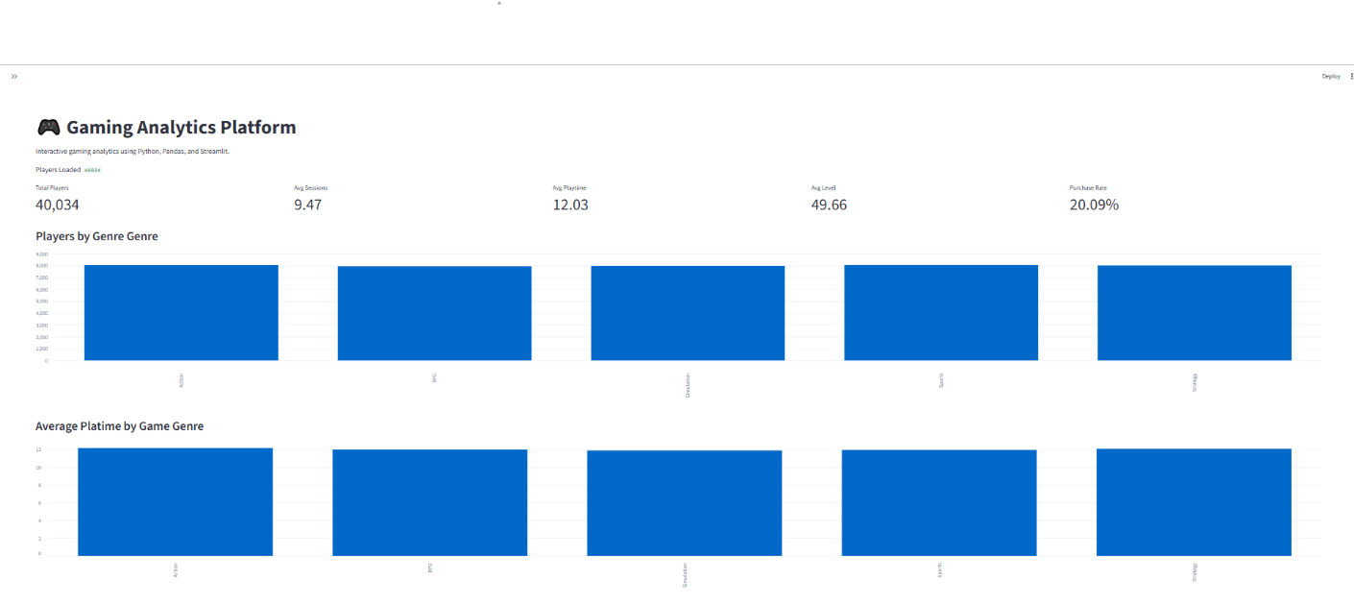

Figure 4: Streamlit Analytical View

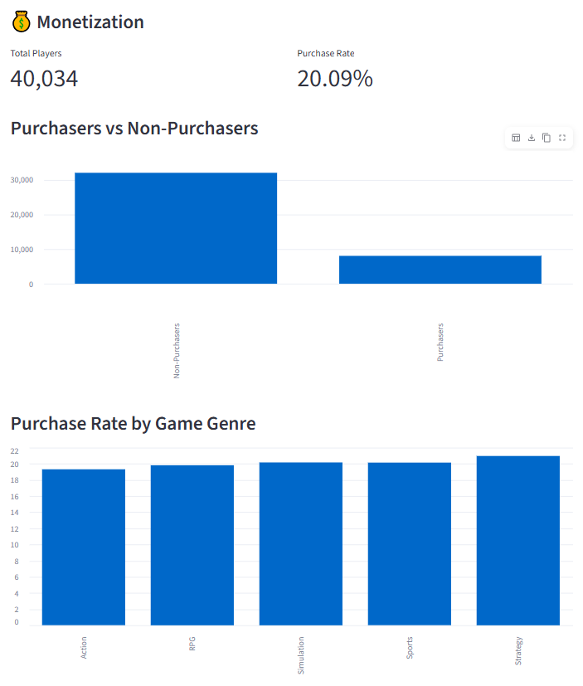

13.Chatbot

13.1.Purpose
A chatbot component was included in the Streamlit application to provide an interactive way for users to ask questions about the player dataset and receive analytical responses.

13.2.Functionality
The chatbot is designed to answer questions related to the available player data and analytical metrics supported by the application.

Figure 5: Interactive Gaming Analytics Chatbot

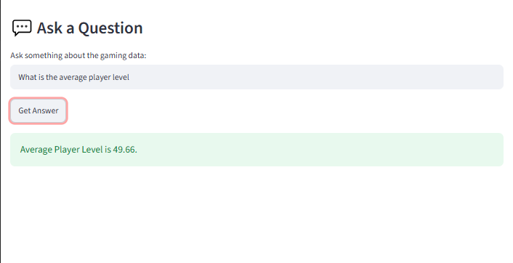

14.Key Performance Indicatior (KPIs)
Key Performance Indicators were calculated to provide a high-level summary of player behavior and gaming activity. These KPIs were used across the analytical outputs and dashboard to support business interpretation.

KPI Value
Total Players 40034
Average Age 31.99
Average Playtim 12.03
Average Player Level 49.66
Average Sessions Per Week 9.47
Average Achievements 24.53
Purchasing Players 8041
Purchase Rate 20.09
High Engagement Players 10336
High Engagement Rate 25.82

15.Player Segmentation
Documentation/
└── Gaming_Analytics_Project_Report.docx

15.1.Purpose of Player Segmentation
Player segmentation was used to group players according to their gameplay time category and compare behavioral characteristics across the resulting player groups. The segmentation helps identify differences in playtime, session behavior, player progression, and purchasing activity.

15.2.Segmentation Metrics
Each player segment was evaluated using multiple metrics to understand differences in player behavior.

Metric Purpose
Player Time Category Groups players according to gameplay TIME
Total Players Measures the size of each segment
Average Playtime Measures typical gameplay time
Average Session Measures average session activity
Average Level Indicates player progression
Purchase Rate Measures purchasing behavior

15.3.Player Segment Results
PlaytimeCategory | TotalPlayers | AVERAGEPLAYTIME | AVERSGESESSIONS | AVERAGELEVEL | PURCHASERATE
Low | 15876 | 5 | 10 | 50 | 20
Medium | 24158 | 17 | 9 | 49 | 20

15.4.Segment Analysis
The player segmentation analysis provides a more detailed view of how player behavior changes across different gameplay-time groups. Comparing the segments across playtime, session activity, progression, and purchasing behavior can help identify groups with different levels of engagement and potential business value.

16.Key Insights

16.1 Player Base and Engagement
The analysis covered 40,034 unique players, providing a large dataset for examining player behavior, engagement, gameplay activity, progression, and purchasing patterns.
The average player completed approximately 9 sessions per week and recorded an average playtime of approximately 12.024 hours. This indicates that the dataset contains measurable variation in gameplay activity that can be analyzed across different player groups.
Approximately 48% of players belonged to the Medium Engagement category, making it the largest engagement group in the dataset. This suggests that Medium Engagement players represent an important segment for monitoring and improving overall player activity.

16.2 Game Genre Insight
The Action genre had the highest number of players, with 8,039 players. This indicates that Action was the most represented game genre within the dataset.
The Excel analysis also reported that the Strategy genre generated approximately $1,600 in revenue, making it an important genre to consider when analyzing monetization performance.

16.3 Playtime and Engagement Insight
High-engagement players recorded the highest average playtime. This finding indicates a strong association between gameplay time and player engagement within the dataset.
This relationship demonstrates the value of analyzing multiple engagement metrics together, including playtime, sessions per week, and engagement category, rather than relying on a single measure of player activity.

16.4 Player Progression Insight
The average player level was approximately 49.656. This provides a benchmark for evaluating player progression and comparing progression patterns across different player groups.
The SQL analysis also included comparisons of player levels across game genres and queries to identify players above the overall average level, demonstrating how player progression can be analyzed at both individual and aggregated levels.

16.5 Geographic Insight
The USA had the highest number of players in the dataset. This indicates that the player population was not distributed equally across all available locations.
The SQL analysis also included a business question to identify which location had the highest number of High Engagement players, providing a framework for further location-based engagement analysis.

16.6 Player Segmentation Insight
Player segmentation was used to divide players according to gameplay-time categories and compare groups using total players, average playtime, average session activity, average player level, and purchase rate.
This approach provides a more detailed understanding of player behavior because it allows different levels of gameplay activity to be compared instead of treating all 40,034 players as a single group. The segmentation results can therefore be used to identify behavioral differences between player groups and support more targeted analysis.

16.7 Overall Insight
The overall analysis demonstrates that player behavior is multidimensional. Engagement, playtime, session activity, game genre, progression, location, and purchasing behavior all provide different perspectives on how players interact with the game.
By combining Excel analysis with SQL queries, Python/Pandas processing, Power BI visualization, and Streamlit interaction, the project provides an end-to-end analytical view of the gaming player dataset.

17.Business Recommendation

17.1 Focus on Medium-Engagement Players
Approximately 48% of players belong to the Medium Engagement category, making this the largest engagement group.
Recommendation:
Gaming teams should investigate the characteristics of Medium Engagement players and identify opportunities to encourage greater gameplay activity. Features such as personalized challenges, rewards, events, or progression incentives could be tested to help move suitable players toward higher engagement.

17.2 Maintain and Study High-Engagement Players
High-engagement players recorded the highest average playtime.
Recommendation:
Analyze the behavior of highly engaged players to understand what may be associated with stronger gameplay activity. Their gameplay patterns can provide useful information for evaluating game content, progression systems, challenges, and retention strategies.

17.3 Analyze Action Genre Player Engagement
The Action genre contains the highest number of players, with 8,039 players.
Recommendation:
Further monitor engagement and retention patterns within the Action genre. Because it represents the largest player group, changes in player behavior within this genre could have a significant effect on overall player activity.

17.4 Investigate Strategy Genre Monetization
The Excel analysis reported approximately $1,600 in revenue from the Strategy genre.
Recommendation:
Further investigate the purchasing behavior of Strategy players, including their engagement, playtime, and progression patterns. This could help identify factors associated with stronger monetization performance.

17.5 Use Location-Based Player Analysis
The USA had the highest number of players in the dataset.
Recommendation:
Compare player engagement and gameplay behavior across locations to identify whether player activity differs geographically. Location-level analysis could support more targeted events, content strategies, or player engagement initiatives where appropriate.

17.6 Monitor Player Progression
The average player level was approximately 49.656.
Recommendation:
Monitor player level and achievement progression across engagement and gameplay segments. Players showing slower progression could be investigated to determine whether game difficulty, progression design, or reward systems create potential barriers to continued activity.

17.7 Use Player Segmentation for More Targeted Analysis
The project includes player segmentation based on gameplay-time categories.
Recommendation:
Rather than evaluating all players using only overall averages, gaming teams should compare behavioral segments separately. Metrics such as average playtime, session activity, player level, and purchase rate can help identify groups with different engagement and potential business value.

17.8 Recommendation Summary
You can add this final table at the end of Section 17:
Analytical Finding | Business Recommendation
Medium Engagement is the largest category at approximately 48% | Investigate and test strategies to improve engagement among this large player group
High Engagement players have the highest average playtime | Study highly engaged player behavior to support retention strategies
Action has the highest number of players at 8,039 | Monitor engagement and retention patterns within the largest genre
Strategy generated approximately $1,600 in reported revenue | Investigate Strategy player behavior and monetization patterns
USA has the highest number of players | Compare behavior across locations for location-based insights
Average player level is approximately 49.656 | Monitor progression and identify potential barriers affecting player advancement
Player segmentation compares behavioral groups | Use segments for more targeted engagement and purchasing analysis

18.Challange Faced
-Connecting Excel/cleaned data with MySQL
-Connecting Python to MySQL
-Organizing SQL and Pandas analysis
-Building the Power BI dashboard
-Structuring the Streamlit application
-Debugging the application
-Organizing multiple analytical outputs

19.Leaning Outcomes
Excel data analysis : Data preparation, explration and analytical reporting.
SQL : Database creation, data storage and data management.
MySQL : Business-oriented quering, aggregation and analysis.
Python : Programmatic data processing and database connectivity.
Pandas : Data manipulation and analytical processing.
Power BI : Intrective dashboard development and data visualization.
Streamlit : Development of an intreactive analytics application.
Data storytelling : Converting analytical results into business-oriented insights.
Project Organization : Structuring a multi-tool analytics project for reproducibility and presentation.

20.Conclusion
The Gaming Analytics Intelligence Platform demonstrates an end-to-end approach to analyzing player data, beginning with data preparation and exploratory analysis and progressing through database management, SQL analysis, Python/Pandas processing, visualization, and interactive application development.

The project brings together multiple data analytics technologies into a single workflow and provides different ways to explore player behavior, engagement, progression, game preferences, and purchasing activity.

The completed platform demonstrates practical skills in data analysis, database querying, programming, visualization, and analytical application development. The project also provides a foundation for further enhancements such as automated data pipelines, advanced predictive analytics, and machine learning-based player modeling.

