Document Control
Document History
Version | Date | Author | Summary of Changes
1.0 | 10-Nov-20 | Ashish Chinchulkar | Initial version

Reviewed By
Reviewer | Date | Role / Responsibility
Jacob Cherian |  | Tech Lead

Table of Contents
1 Introduction 4
1.1 References 4
2 Instructions 5
2.1 Pre-modification Steps 5
2.2 Modify PaaS application integration 5
3 Open and Closed Issues 9
3.1 Open Issues 9
3.2 Closed Issues 9

E

Introduction
The purpose of this document is to:
Describe the steps to modify integrated PaaS application in fusion.

References
The content of this document is to be referenced along with the following reference documents to get a complete technical picture of this object.
Table 1-1 References
Name | Description | Version
GEN_P906_ALNG_Extensions_Technical Design Document_v0.1 | Technical Design Document | 1.0
ALNG_INV_001_VBCS_Application_Instatllation_Document | Installation document | 1.0

Instructions

Pre-modification Steps
Refer “ALNG_INV_001_VBCS_Application_Instatllation_Document” to integrate PaaS (VBCS) application in SaaS.

Modify PaaS application integration
- Login to Fusion
- In home page, on top right hand side click on UserName icon and select “Setup and Maintenance” item from drop down menu.

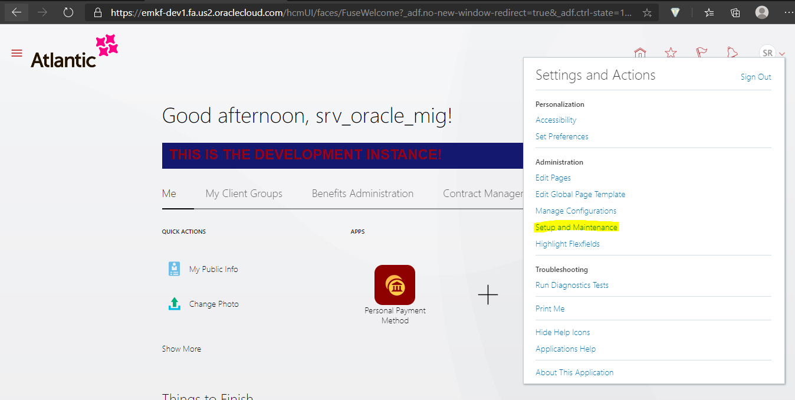

- Then select “Manage Setup content” task from Task List available on right hand side of page.
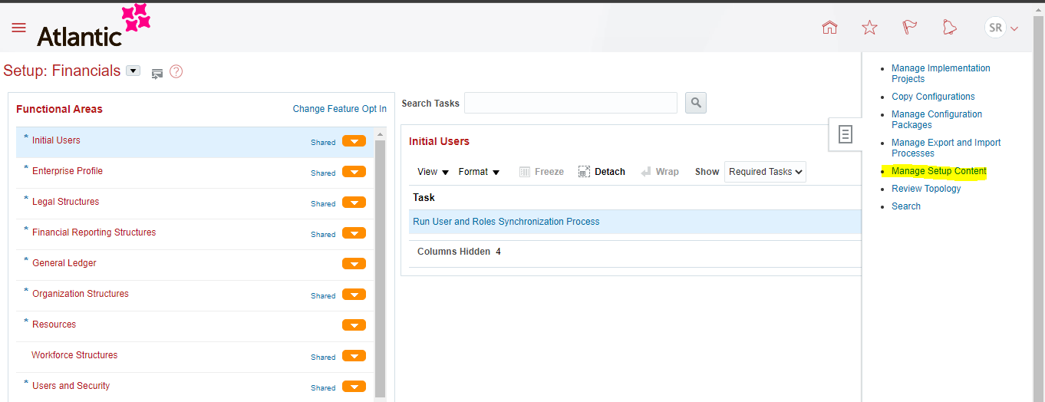

- Then select “Manage Integration of Additional Application”.
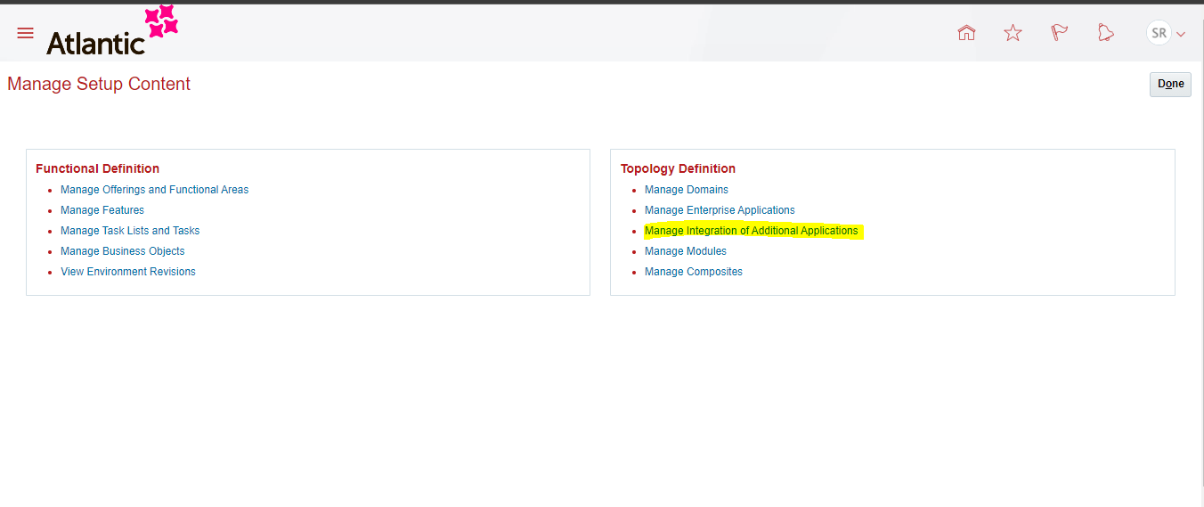

- It will navigate to “Manage Integration of Additional Application” page. In this page select “Atlantic_NS_EXT” application and click on edit option.

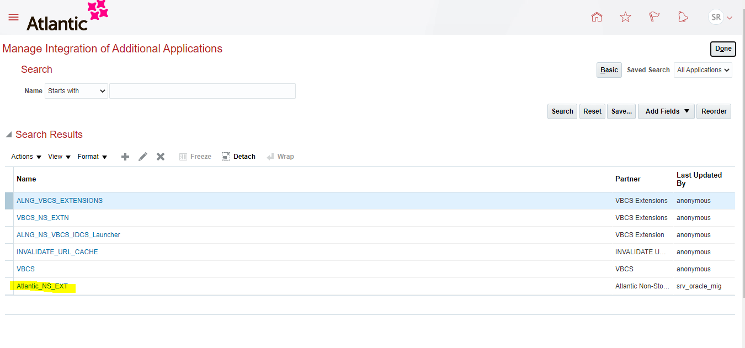

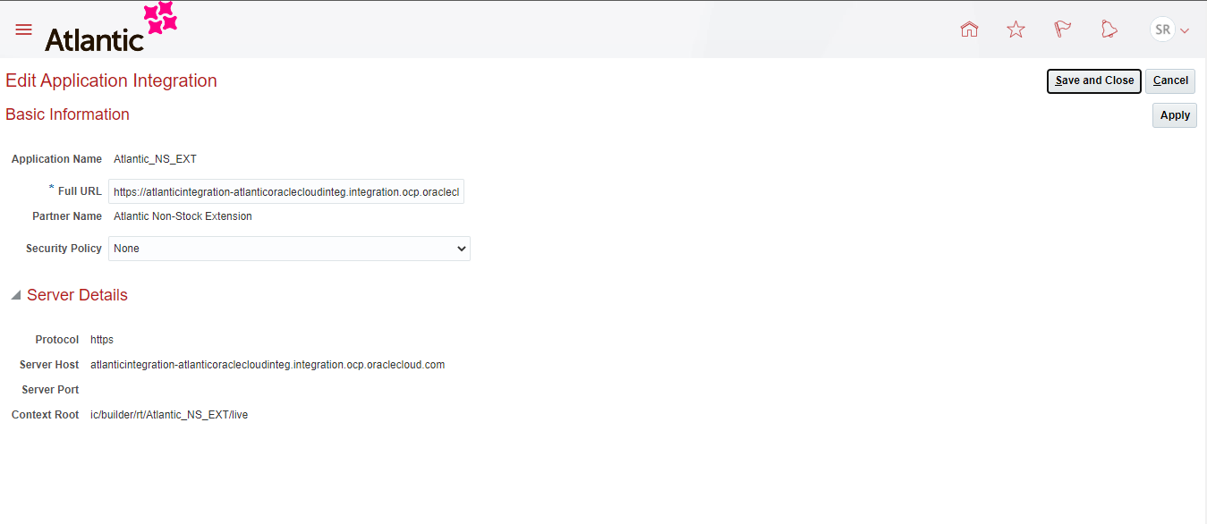

- In edit Application Integration page, replace existing Full URL with new one.
In our case the existing URL is referring to PROD environment which is bellow

https://atlanticintegration-atlanticoraclecloudinteg.integration.ocp.oraclecloud.com/ic/builder/rt/Atlantic_NS_EXT/live

- Replace PROD URL with DEV1 URL which is as follows.

https://atlanticintegrationdev-atlanticoraclecloudinteg.integration.ocp.oraclecloud.com/ic/builder/rt/Atlantic_NS_EXT/live

Note:
For UAT use the OIC UAT URL respectively
https://atlanticintegtest-atlanticoraclecloudinteg.integration.ocp.oraclecloud.com

- After replacing URL click on Apply button and then click on Save and Close button.

Open and Closed Issues

Open Issues

ID | Issue | Resolution | Status | Responsibility | Target Date | Impact Date

Closed Issues
ID | Issue | Status | Responsibility | Resolution

