
Business / Technical Brief

Design Specification

Domino-INT008 WMS INV Shipment Confirmation
13th Jun 2024, Version 1a.
Copyright © 2024, Oracle and/or its affiliates
Confidential – Oracle Restricted

Document Control

Change History
Date | Author | Version | Description
13-Jun-2024 | Harshal Tiwari | 1a | Initial Version
25-Jun-2024 | Amit Sharma | 1b | Updated document with the WMS details
25-Jun-2024 | Pavan Kumar | 1b | Updated document with the Technical Details
24-July-2024 | Girish Karampuri | 1.2 | Updated shipmethod change, Waybill and shipping cost functionaliy

Reviewed By
Date | reviewer | role
Table of contents
Document Control 2
Change History 2
Reviewed By 2
Introduction 5
Purpose 5
Scope 5
Functional Overview 5
Business Objectives 6
Process Overview 7
Pre-Conditions 9
• Sales order lines in SCM Cloud should be in Awaiting shipping status. 9
Risk Matrix 9
Other Integrations Design Dependency 9
Frequency 10
Open Items 10
Business Use Case: 10
Technical Overview 10
Scope 11
Glossary 11
Document References 11
Sample Data & Mapping Template 11
Frequency 11
Assumptions 11
High Level Approach 12
High Level Flow Diagram 12
Pre-Requisites 12
Integration Analysis –XxScmShipmentConfirmationWmsToErp 13
Integration Components 13
Required Connections 13
Integration Outline 13
Migration Steps 23
Unit Testing 23
Open and Closed Issues 23

Introduction

Purpose
The objective of this document is to provide a Design Specification to:
- Provide the necessary information with enough detail so that the Project team, have a clear understanding of the design and functional requirements.

Scope
This document specifies the business context, functional requirements, and details to integrate Oracle Cloud WMS to Oracle Fusion for Sales Order Shipping Process.
A warehouse management system (or WMS) is a software application designed to support warehouse or distribution center management and staff. They facilitate management of available resources to move and store materials into, within, and out of a warehouse, while supporting staff in material movement and storage.
Coordinating the communication with these systems to support purchase order receipts, returns to vendors, internal material transfers, inventory transactions, and sales order shipments is a substantial integration effort.
Inventory Management Cloud supports a central integration framework across Oracle Procurement Cloud, Oracle Order Management Cloud, and Oracle Inventory Management based on web services to support the interactions between WMS and Fusion Cloud.
Using these services, Inventory Management Cloud communicates Sales Order shipment request to Oracle Cloud WMS for processing.

Functional Overview
Domino business process flow requires WMS to send the Shipment Confirmation notification to Oracle Fusion on successfully shipping the sales order in WMS. On receiving the request Shipment Lines of the Sales Order in Fusion should get marked as Shipped to complete the fulfillment process in Fusion. This integration will run as in when an order is shipped in WMS.
Sales order or transfer order documents are created in Oracle fusion cloud. Order orchestration steps take the orders to awaiting shipping and then order will be eligible to interface to WMS cloud.
The delivery ID is generated based on the customer ship to name, ship to country, scheduled ship date and the customer party site number. Order will be interfaced to WMS and Delivery Id will be a sent as Externally planned load number on the WMS Order lines.
Orders will be waved for allocation and task creation. Task will be performed and pick pack will be completed. Load will be shipped from WMS Cloud. This will interface the shipping details to Fusion Inventory cloud to ship confirm the delivery.

Business Objectives
When integrating Oracle Warehouse Management system (or WMS) with Oracle Inventory Management Cloud, there is a requirement to send the Ship Confirmation request of WMS to Fusion Oracle Inventory Management so that Sales Order lines in fusion can be marked as Shipped.

Business Flow:
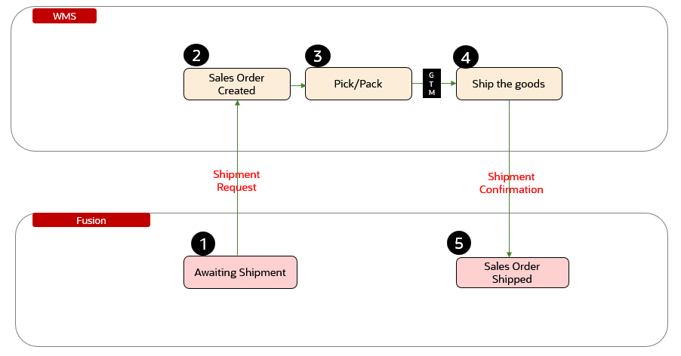

The above picture depicts the process flow as per business requirement. Fusion sales order is interfaced to WMS and a new Sales Order is created in WMS. This sales order will further get Pick, Pack and Ship in WMS. Once a sales order is shipped, Shipment Confirmation integration will be triggered from WMS to Oracle Fusion to notify the Fusion system that the sales order is shipped. On receiving the Shipment Confirmation request from WMS, Sales Order line status will be changed from Awaiting Shipping to Shipped to mark the end of fulfillment.

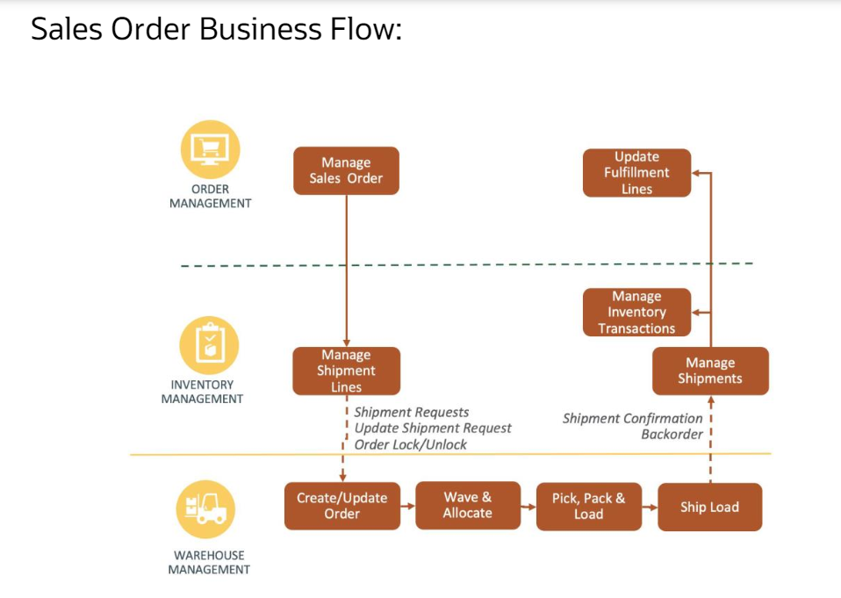
The above picture depicts the general steps in the Sales order business flow. The steps initiate in Fusion Order Management with the creation of a Sales Order. This sales order gets interfaced to WMS via OIC integration to create an Outbound Order. WMS allocates the order and ship it. The shipment details are then interfaced back to Fusion to update the shipment information, decrement the inventory quantities in stock and to update the sales order status.

Process Overview

- The scheduled process Generate Shipment Request enables inventory management users to send shipment lines to the WMS using the task Create Outbound Shipment request using a scheduled process.

- Delivery Id will be created by grouping the order by customer, ship to address and schedule ship date. Order will be interfaced to WMS and Delivery Id will be a sent as External plan load number on the WMS Order lines.

- After the all the lines in the delivery/load is picked and packed and loading operation will be performed using RF transactions.

- Before ship load Waybill no, Shipping charges will be entered on the Obload. In case of the ship method change other than what is there on the sales order, it can be updated by changing ship method on carrier field on Obload screen.

- Load will be shipped from WMS Cloud. The Receive Shipment Confirmation is new web service when initiated with the required input, receives and processes the shipment confirmation messages. This service interprets and transforms the message and creates the necessary records in the shipping open interface tables. This transformation provides the mechanism for the WMS to send the material and shipping details for the shipment lines fulfilled.

- The scheduled process Perform Shipping Transactions processes the pending transaction records received into the open interface tables. The process validates the data on the transaction records received from the WMS before processing them. Any errors from the validation step are recorded, and the transaction records remain in the open interface tables. The interface records with errors are available for users to view, edit, or resolve the errors, or reprocess.

The following is a high-level view of the most relevant information to be considered:

- Facility Code (Inventory Organization in SCM Cloud)
- Company Code (Business Unit in SCM Cloud)
- Order Number
- Shipment line number
- Item code
- Load number (Mapped to Delivery/shipment number)
- Packed Quantity
- Lock code (Mapped to Sub inventory in SCM Cloud)
- Serial Number
- Lot Number
- Weight
- Volume
- Freight cost
- Carrier
- Waybill no

Pre-Conditions
- Fusion Sales Order should be interfaced to WMS.
- Shipment line should cancel or closed in Fusion.
- Sales order lines in SCM Cloud should be in Awaiting shipping status.
- Sales order in SCM Cloud should not be having any shipping hold on it.
- Sales order should be in Open status.

Risk Matrix
Risk | Impact  (1 to 5) | Probability  (1 to 5) | Mitigation
Ship confirmation failure in Fusion cloud due to Order lines in other than awaiting shipping status | 5 | 2 | Rerun the order orchestration and make sure that the order lines in the awaiting shipping status.  Retrigger shipment interface from WMS
Ship confirmation failure in Fusion cloud due to Order on Hold | 5 | 2 | Remove the hold and Retrigger shipment interface from WMS

Other Integrations Design Dependency

Name | Dependency | comments
WMS Items (INT001) |  | Items should be interfaced to WMS from Fusion PDH
Sales Order/TO Interface |  | Sales order/TO should be interfaced to WMS from Fusion Inventory

Frequency
Responsiveness | Frequency | Data volume
 | Outbound Load Export file gets generated once the Load is shipped in WMS.

Open Items
This section is used to summarize any open items related to the design.
No. | open item | data required | status | impact if not closed
001
002
003
004
005
006
007

Business Use Case:
- Pick, pack and ship the Load with Single order having single line with single LPN without Serial and lot no.
- Pick, pack and ship the Load with Single order having single line with single LPN with Serial and lot no.
- Pick, pack and ship the Load with Single order having multiple line with single LPN without Serial and lot no.
- Pick, pack and ship the Load with Single order having single line with multiple LPN with Serial and lot no.
- Pick, pack and ship the Load with Multiple order having multiple LPN without Serial and lot no.
- Pick, pack and ship the Load with Multiple order having multiple LPN with Serial and lot no.

Technical Overview

Scope
The objective of this document is to provide with a Technical Specification of Inbound Integration Shipment Confirmation flow between Warehouse Management System (WMS) and Oracle Fusion Inventory Management.

Glossary
Annotation | Definition
ERP | Enterprise Resource Planning
SCM | Supply Chain Management
OIC | Oracle integration cloud
WMS | Warehouse Management System
REST | Representational State Transfer
XSD | XML Schema Definition
FYI | For Your Information

Document References
Ref No | Name | File location

Sample Data & Mapping Template

Description | File
Data Mapping Template for Fusion to WMS
Sample WMS Response XML Payload

Frequency
Responsiveness | Frequency | Volume
Batch | Planned as daily with Ad Hoc option | Depends on the RMA orders created in the last 24 hours by users

Assumptions
- Inventory organizations of Fusion Inventory should be mapped with WMS Facilities.
- Mapping between WMS Shipment Confirmation Request and ERP Request should be in place for this integration to work effectively.
- In case of any success/error in the integration, a notification email will be sent to the mail list configured in the OIC lookup.

High Level Approach
- Fetch the Shipment Confirmation related information from WMS.
- Invoke “Shipment Service” request and perform “createAndConfirm” operation then run “Perform Shipping Transactions” ESS job operation to create and confirm the Shipment.
- Fields of Shipment Confirmation Request from WMS System are mapped to Oracle fusion to create and confirm Shipment Transaction in Fusion.

High Level Flow Diagram
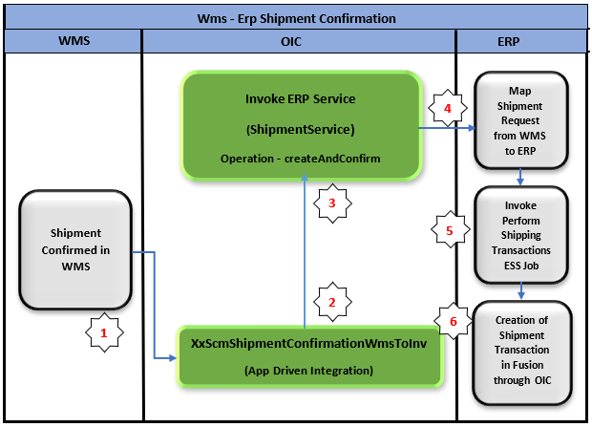

Pre-Requisites
- Send Email Integration ““XxCommonNotificationHandler” should be deployed in the OIC.
- Lookup “XXDominoCommonLookup” should be present with all the required details regarding success/error email notify flag, success and error notify ToEmail Address in OIC.
- Lookup “XxDominoConstantLookup” should be present with all the required details regarding success and error notify FromEmail Address in OIC.
- Lookup “XxDominoWmsSubInvLookup” should be present in OIC.

Integration Analysis –XxScmShipmentConfirmationWmsToErp
This Integration component is responsible for communicating Shipment Confirmation to Fusion Inventory sent by WMS system.

Integration Components
Below are the required components for this integration.

Integration Name | Integration Pattern | Package Name | Lookup Name
XxScmShipmentConfirmationWmsToErp | App Driven Orchestration |  | XXDominoCommonLookup,  XxDominoConstantLookup,  XxDominoWmsSubInvLookup

Required Connections
Connection Name | Connection Type | Connection Role
XxDominoErpCloudConnection | Oracle ERP Cloud | Trigger and invoke
XxOicRestTrigger | REST | Trigger
XxDominoErpCloudSoap | SOAP | Trigger and invoke

Integration Outline

Invoke the ERP Shipment Service –
(createAndConfirm)
to create and confirm the Shipment

Shipment Confirmed in WMS
OIC App Driven
Integration
XxScmShipmentConfirmationWmsToErp
Creation of Shipment Transaction in Fusion through OIC

Fusion ERP Cloud Connection
Invoke the Perform Shipping Transactions ESS Job

The following section explains the step - by- step process of Shipment Confirmation from WMS to ERP:
Integration – XxScmShipmentConfirmationWmsToErp
- postShipmentConfirmation : It uses Rest adapter to fetch the shipment confirmation related information from WMS.
- Global Assignment: The Global variable will be the Integration code which will be fetched from maintained lookup –“XXDominoCommonLookup” with the reference of this lookup all other local variables will fetched which are given below.
Variable name | Data type | Value
IntegrationCode | String | dvm:lookupValue('XXDominoCommonLookup', 'IntegrationCode', ‘XXSCMSHIPMENTCONFIRMATIONWMSTOER’, 'IntegrationCode', '')  IntegrationCode will be fetched from OIC lookup “XXDominoCommonLookup”, with reference to this lookup all other local variables will be fetched.  Value for IntegrationCode variable comes from Integration identifier.

- Local Assignment:
Variable name | Data type | Value
IntegrationID | String | dvm:lookupValue('XXDominoCommonLookup', 'IntegrationCode', $IntegrationCode, 'RiceID', '')  “INT008” – Value is stored in OIC lookup “XXDominoCommonLookup” and will be fetched based on the value of IntegrationCode variable from AssignGlobalVariables Source value.
ErrNotifyEmail | String | dvm:lookupValue('XXDominoCommonLookup','IntegrationCode', $IntegrationCode, 'FailureNotify', '')  This value will be fetched from OIC lookup “XXDominoCommonLookup” to send failure notification, in case integration fails due to any error.
SuccessNotifyEmail | String | dvm:lookupValue('XXDominoCommonLookup','IntegrationCode', $IntegrationCode, 'SuccessNotify', '')  This value will be fetched from OIC lookup “XXDominoCommonLookup” to send Success notification after normal process completion.
EmailFrom | String | dvm:lookupValue('XxDominoConstantLookup', 'ID', 'FromEmailId', 'Value', '')  This value will be fetched from OIC lookup ““XXDominoConstantLookup” which is used to send notification email from OIC service.
checkEssJobStatus | String | NULL

- Scope:
- Invoke Shipment Service : This is oracle ERP cloud adapter connection which will call the Shipment request service to create and confirm the shipment in ERP.
- Business Object – ShipmentService
- Operation – createAndConfirm
- Map Shipment Service: In the map activity, WMS Lgf Data fields are mapped with the ERP Shipment Service Request payload to create and confirm the shipment.
Note: WMS-ERP payload mapping will be as per the mapping document provided in “Sample Data & Mapping Template” section.
- Invoke PerformShippingTrxESSJob : This step will run the “Perform Shipping Transactions” ESS Job to confirm the Shipment in ERP by passing parameter as “ShipmentName” while running the ESS job.
- While : This step will run the ESS Job, following below condition till the Job run is completed -
- checkEssJobStatus not equal to SUCCEEDED
- checkEssJobStatus not equal to WARNING
- checkEssJobStatus not equal to ERROR
- Wait : ESS Job will wait for 10 sec to complete the run and once completed will proceed to next step.
- Invoke PerformShippingTrx : This step will invoke the ERP Integration Service to get the ESS Job Status based on ESS Job Result.
- Switch : This step will check the ESS Job Run Status result, if the ESS Job run completes with Status “Succeeded” it will create and confirm the Shipment in ERP and if fails with Status as “Warning or Error”, it will not create any Shipment.
- InvokeSuccessHandlerNotification : Once the shipment is created and confirmed in Fusion and all the operations in Integration are completed normal then success email notification will be sent to respective team through “XxCommonNotificationHandler”.
With map activity, process will map the below values to common error handler Integration.
Request Parameters | Values
IntegrationCode | $IntegrationCode
IntegrationID | $IntegationID
InstanceID | $self/nsmpr1:metadata/nsmpr1:runtime/nsmpr1:instanceId
ErrorCode | NULL
ErrMsg | NULL
EmailFrom | $EmailFrom
SuccessNotifyEmail | $SuccessNotifyEmail
EmailSub | concat("FYI",":","SUCCESS",":",$self/nsmpr4:metadata/nsmpr4:integration/nsmpr4:name,"(",$self/nsmpr4:metadata/nsmpr4:integration/nsmpr4:version,")",":",$self/nsmpr4:metadata/nsmpr4:runtime/nsmpr4:instanceId )
Logging | Y

- Default Handler: This step is there to capture errors other than API errors.

- In fault handler section, process will call “XxCommonNotificationHandler” local integration which captures the error occurred in the process of integration, if any service exception occurs in ERP cloud adapter or any error in calling the service, it will be handled in scope fault handler though default handler and Email Notification will be sent to concern team.
- In map activity “InvokeErrorHandler”, process will map the below values to error handler Integration.
Request Parameters | Values
IntegrationCode | $IntegrationCode
IntegrationID | $IntegationID
InstanceID | $self/nsmpr1:metadata/nsmpr1:runtime/nsmpr1:instanceId
ErrorCode | $ShipmentServiceScopeFaultObject/nsmpr0:fault/nsmpr0:errorCode
ErrMsg | $ShipmentServiceScopeFaultObject/nsmpr0:fault/nsmpr0:reason
EmailFrom | $EmailFrom
ErrNotifyEmail | $ErrNotifyEmail
EmailSub | concat("FYI",":","ERROR",":",$self/nsmpr1:metadata/nsmpr1:integration/nsmpr1:name,"(",$self/nsmpr1:metadata/nsmpr1:integration/nsmpr1:version,")",":",$self/nsmpr1:metadata/nsmpr1:runtime/nsmpr1:instanceId )
Logging | Y
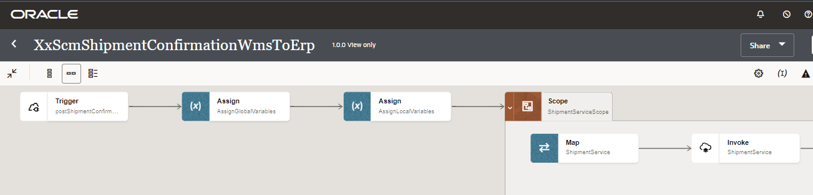
4a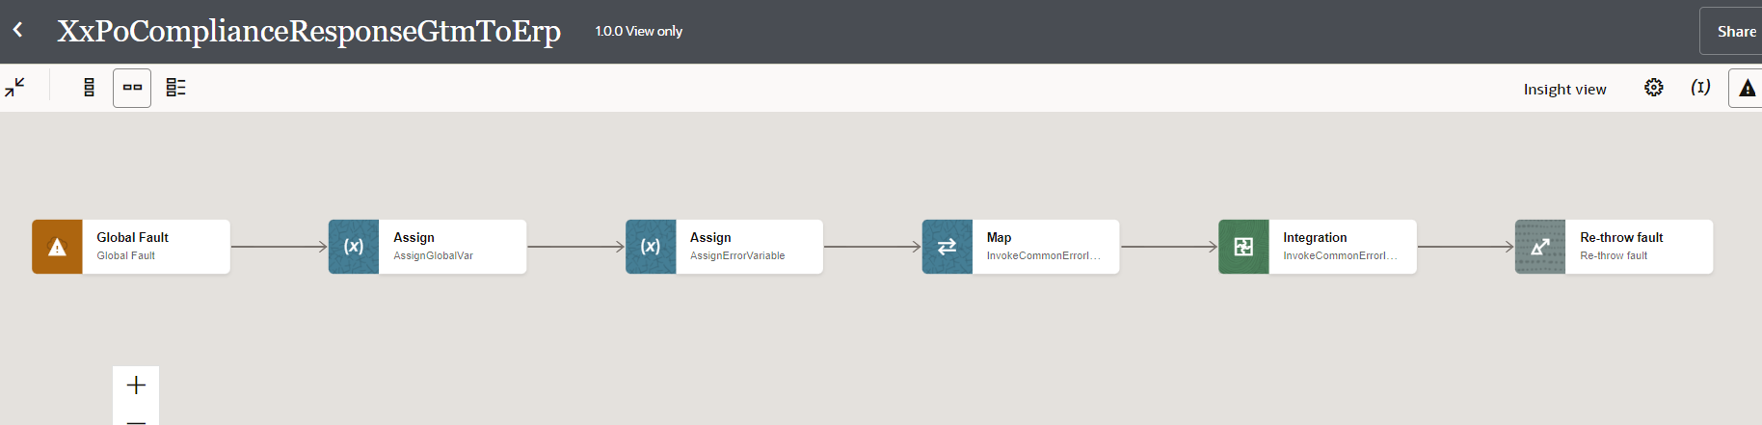
4b
4
3
2
1

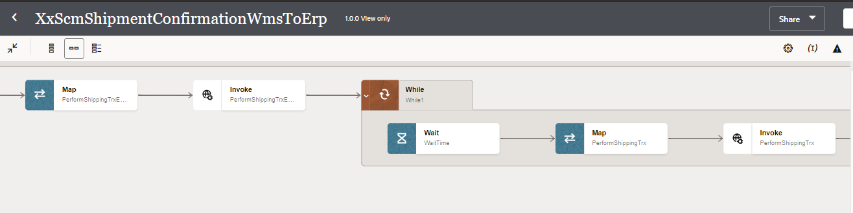
4d
4c

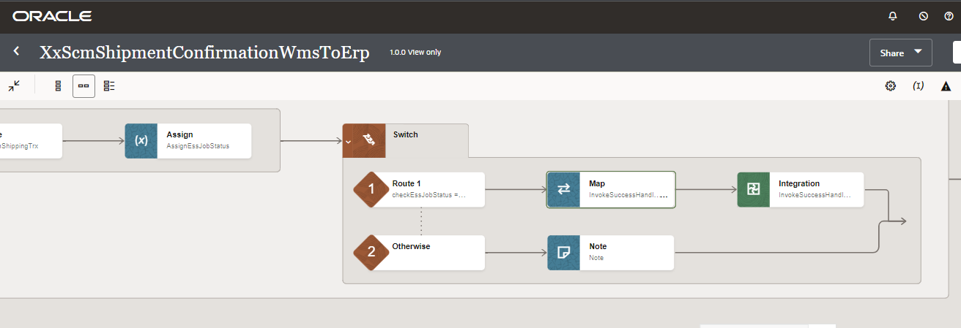
4f
4ee

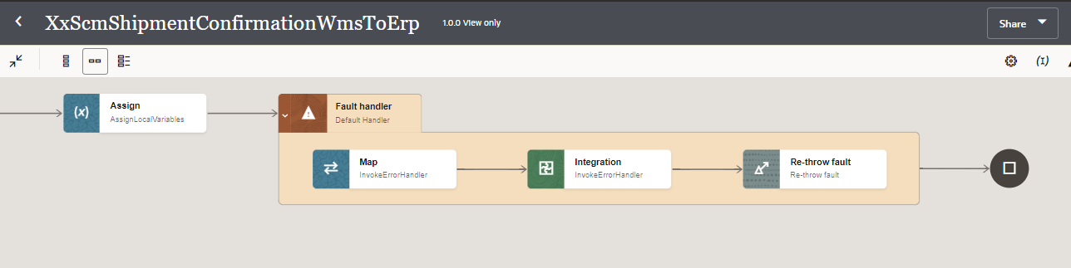
5

Figure: Main flow code snippet

- Integration -XxScmShipmentConfirmationWmsToErp

- Main: This is a trigger step to trigger the integration.

- GlobalVariabledef: The Global variable will be the Integration code which will be fetched from maintained lookup – “XXDominoCommonLookup” with the reference of this lookup all other local variables will fetched which are given below.

IntegrationCode | String | dvm:lookupValue('XXDominoCommonLookup', 'IntegrationCode', 'XXSCMSHIPMENTCONFIRMATIONWMSTOER', 'IntegrationCode', '')  IntegrationCode will be fetched from OIC lookup “XXDominoCommonLookup”, with reference to this lookup all other local variables will be fetched.  Value for IntegrationCode variable comes from Integration identifier.

- GetVariables: This step will invoke integration ‘XxGetLookupVariable(1.0)’.
Map Activity GetVariables: In this Map activity, ‘Integration Name’ received from Integration Metadata will be mapped to ‘Integration Code’ in Fetch Variable (request). Once ‘Integration Code’ gets passed to ‘XxGetLookupVariable(1.0)’ integration, values of variables can be retrieved.
- ShipmentServiceScope :
  - Invoke Shipment Service : This is oracle ERP cloud adapter connection which will call the Shipment request service to create and confirm the shipment in ERP.
- Business Object – ShipmentService
- Operation – createAndConfirm
- Map Shipment Service: In the map activity, WMS Lgf Data fields are mapped with the ERP Shipment Service Request payload to create and confirm the shipment.
Note: WMS-ERP payload mapping will be as per the mapping document provided in “Sample Data & Mapping Template” section.
- Invoke PerformShippingTrxESSJob : This step will run the “Perform Shipping Transactions” ESS Job to confirm the Shipment in ERP by passing parameter as “ShipmentName” while running the ESS job.
- While : This step will run the ESS Job, following below condition till the Job run is completed -
- checkEssJobStatus not equal to SUCCEEDED
- checkEssJobStatus not equal to WARNING
- checkEssJobStatus not equal to ERROR
- Wait : ESS Job will wait for 10 sec to complete the run and once completed will proceed to next step.
- Invoke PerformShippingTrx : This step will invoke the ERP Integration Service to get the ESS Job Status based on ESS Job Result.
- Switch : This step will check the ESS Job Run Status result, if the ESS Job run completes with Status “Succeeded” it will create and confirm the Shipment in ERP and if fails with Status as “Warning or Error”, it will not create any Shipment.
- InvokeSuccessHandlerNotification : Once the shipment is created and confirmed in Fusion and all the operations in Integration are completed normal then success email notification will be sent to respective team through “XxCommonNotificationHandler”.
With map activity, process will map the below values to common error handler Integration.
Request Parameters | Values
IntegrationCode | $IntegrationCode
IntegrationID | $IntegationID
InstanceID | $self/nsmpr1:metadata/nsmpr1:runtime/nsmpr1:instanceId
ErrorCode | NULL
ErrMsg | NULL
EmailFrom | $EmailFrom
SuccessNotifyEmail | $SuccessNotifyEmail
EmailSub | concat("FYI",":","SUCCESS",":",$self/nsmpr4:metadata/nsmpr4:integration/nsmpr4:name,"(",$self/nsmpr4:metadata/nsmpr4:integration/nsmpr4:version,")",":",$self/nsmpr4:metadata/nsmpr4:runtime/nsmpr4:instanceId )
Logging | Y
- The global fault handler is responsible for the whole execution scope and process the exceptions occurred in the individual stages.
- AssignGlobalVar :
Variable name | Data type | Value
IntegrationCode | String | dvm:lookupValue('XXDominoCommonLookup', 'IntegrationCode', 'XXSCMSHIPMENTCONFIRMATIONWMSTOER', 'IntegrationCode', '')  IntegrationCode will be fetched from OIC lookup “XXDominoCommonLookup”, with reference to this lookup all other local variables will be fetched.  Value for IntegrationCode variable comes from Integration identifier.

- AssignErrorVariables :
  - Using assign activity, variables will be declared to map the values required for invoking common error handler integration.
Variable | Values
IntegrationID | dvm:lookupValue('XXDominoCommonLookup','IntegrationCode', $IntegrationCode, 'RiceID', '')  This value will be fetched from common lookup “XXDominoCommonLookup” maintained in OIC, with reference of integration code value from Global variable.
ErrNotifyEmail | dvm:lookupValue('XXDominoCommonLookup','IntegrationCode', $IntegrationCode, 'FailureNotify', '')  This value will be fetched from common lookup “XXDominoCommonLookup” maintained in OIC, with reference of integration code value from Global variable. It will be failure notify email id.
EmailFrom | dvm:lookupValue('XxDominoConstantLookup', 'ID', 'FromEmailId', 'Value', '')  This value will be fetched from constant lookup “XxDominoConstantLookup” maintained in OIC.

- InvokeCommonErrorHandler:
  - The global fault handler will invoke the local integration “XxCommonNotificationHandler” which captures the error occurred at any step in overall integration flow and notify it over the email.
  - Using the map activity “Map to InvokeCommonErrorHandler”, process would map the below values required for XxCommonNotificationHandler.

Request Parameters | Values
IntegrationCode | $IntegrationCode
IntegrationID | $IntegationID
InstanceId | $self/nsmpr1:metadata/nsmpr1:runtime/nsmpr1:instanceId
ErrorCode | $GlobalFaultObject/nsmpr0:fault/nsmpr0:errorCode
ErrMsg | $GlobalFaultObject/nsmpr0:fault/nsmpr0:reason
EmailFrom | $EmailFrom
ErrNotifyEmail | $ErrNotifyEmail
EmailSub | concat("FYI",":","ERROR",":",$self/nsmpr1:metadata/nsmpr1:integration/nsmpr1:name,"(",$self/nsmpr1:metadata/nsmpr1:integration/nsmpr1:version,")",":",$self/nsmpr1:metadata/nsmpr1:runtime/nsmpr1:instanceId )
Logging | Y

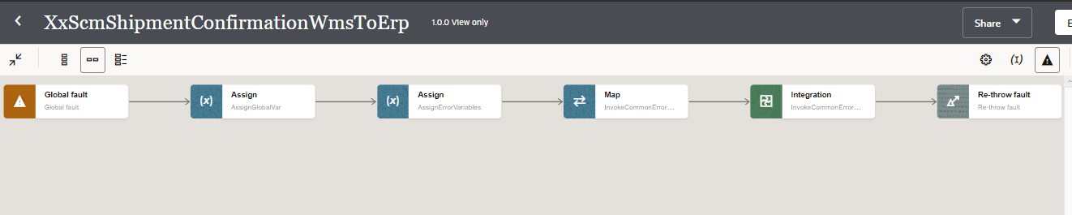
4
3
2
1
Figure: Global Fault Code Snippet

Migration Steps
2

- Import “XXSCMSHIPMENTCONFIRMATIONWMSTOER_01.00.0000.iar” in OIC environment.
- Update the OIC Connections with Password, details as per the Environment.
- Validate the "XxCommonNotificationHandler", which is deployed in OIC.
- Configure the Connection with Dev Instance URL, Instance Name (whenever updated) which is present in “Domino Constant lookup maintained in OIC.
- Complete the OIC integration configuration and activate OIC service.

Unit Testing
2
4
3

Open and Closed Issues
This section is used to summarise any open and closed questions relating to Error Handler

ID | Topic | Description | Status | Owner
1
2.


Copyright © 2015, Oracle and/or its affiliates. All rights reserved. This document is provided for information purposes only and the contents hereof are subject to change without notice. This document is not warranted to be error-free, nor subject to any other warranties or conditions, whether expressed orally or implied in law, including implied warranties and conditions of merchantability or fitness for a particular purpose. We specifically disclaim any liability with respect to this document and no contractual obligations are formed either directly or indirectly by this document. This document may not be reproduced or transmitted in any form or by any means, electronic or mechanical, for any purpose, without our prior written permission.
Oracle and Java are registered trademarks of Oracle and/or its affiliates. Other names may be trademarks of their respective owners.
AMD, Opteron, the AMD logo, and the AMD Opteron logo are trademarks or registered trademarks of Advanced Micro Devices. Intel and Intel Xeon are trademarks or registered trademarks of Intel Corporation. All SPARC trademarks are used under license and are trademarks or registered trademarks of SPARC International, Inc. UNIX is a registered trademark licensed through X/Open Company, Ltd. 1212

Connect with us
blogs.oracle.com
facebook.com/oracle
twitter.com/oracle
oracle.com

