TASK 1.

Order of files to open-

1.“datav2.py”:

* Contains the data loader class.

2. “modelv2.py”:

* contains the CNN architecture

3. “trainv2.py” :

* where the model was trained using the the actual labels as target and mel-spectrograms as input.
* This model was saved as ‘feedforwardnet.pth’

4. “inference.py”

* Model was evaluated and inference was taken.

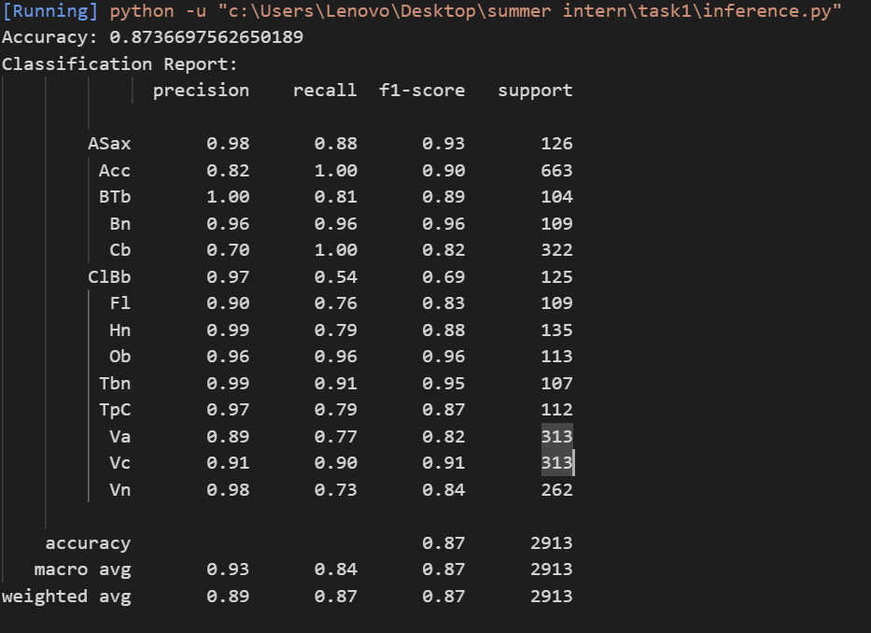

* Expected and predicted values were mapped in a file “inference.py”
* Using the inferences, an updated annotations file was made containing the pseudo labels. ‘updated_metadata.csv’

5.”train_pseudo.py”

* Same model was trained using the pseudo labels instead of ground truth
* Trained model was saved at “pseudo_model.pth”

6. “inference_pseudo.py”

* This new model was then evaluated and inference was taken.
* The inferences were then compared to both actual labels and pseudo labels and accuracy was noted.
* Against true labels ---

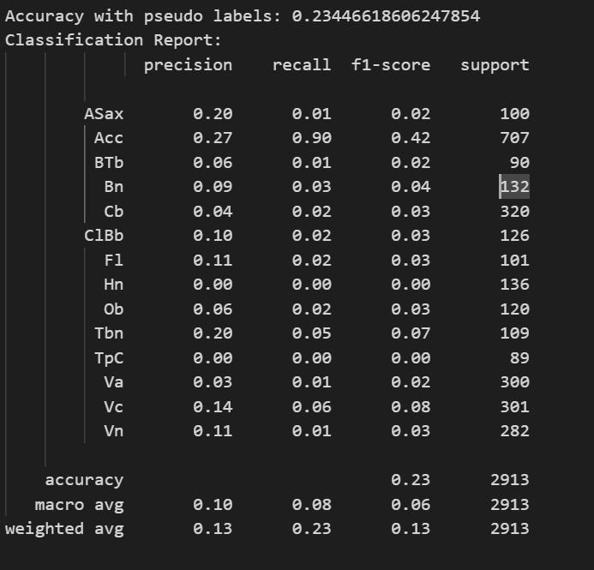

* Against pseudo label

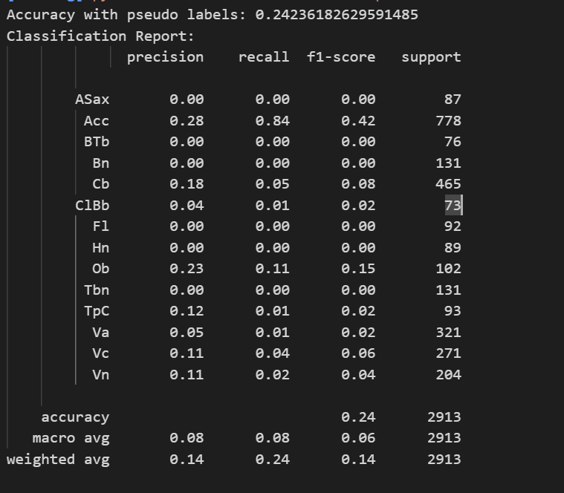

Observation---

[Accuracy against pseudo labels(pseudo trained model) ] by[ accuracy againt True labels (pseudo trained model] = accuracy against true labels(model trained with true label)