MUNICIPAL WATER TREATMENT

* The main objective of Municipal Water Treatment is to remove all water contaminants through physical,chemical and biological process

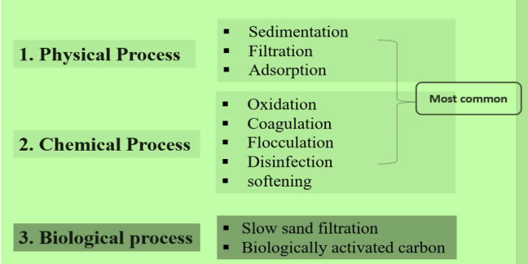

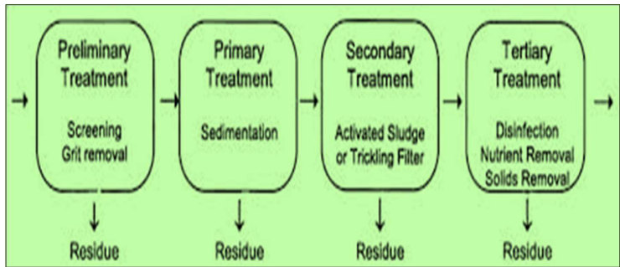

Screening:  
The raw water is passed through screens which contains large number of holes where floating matter is retained.

Sedimentation:

* Sedimentation with coagulation is a process of removing fine particles by addition of chemicals (coagulants) before sedimentation.
* Commonly used coagulants are Alum (K2SO4 Al2(SO4)3.24H2O), Sodium aluminate (NaAlO2) etc. Al2 (SO4)3 + H2O→2Al (OH)3 ↓+ 3 H2SO4
* Al(OH)3 acts as flocculent (due to its enormous surface area) and removes the impurities either by neutralizing the charge or by adsorption and mechanical entrainment.
* Coagulant are added to increase the efficiency of the process
* Substantial reduction of bacteria also takes place during this process. (O2 released by some coagulants destroys bacteria, breaks up some organic compounds, partial removal of color & taste producing organisms.)

Filtration

It is the process of clarification of water by passing the water through a porous material, which is capable of retaining coarse impurities on its surface & in the pores.

Common materials used are:  
1)Quartz sand

2. Crushed anthracite

3. Porous clay

Slow sand filtration is generally employed in municipal water treatment

Process: ⦁ A typical sand filter consists of a tank with a bed containing fine sand (top layer), coarse sand, coarse gravel (bottom layer).

⦁

It is provided with inlet for sedimented water and under drain channel at the bottom for exit of filtered water

⦁ Sedimented water is distributed uniformly over the bed and flows slowly through various layers.

⦁ Rate of filtration slowly decreases due to retention of impurities in the pores. ⦁ Top layer is scrapped and replaced with clean sand to increase the efficiency of process.

Removal Of Microorganisms -Disinfection

Removal of pathogen (Disease causing microorganism) is known asdisinfection.

* Boiling water kills all the harmful bacteria and virus but this method cannot
* By adding bleaching powder CaOCl2+H2O → Ca (OH)2 + Cl2↑ Cl2 +H2O →HCl + HOCl (Hypo chlorous acid kills germs)
* When bleaching powder is added to water first Cl2 is liberated along with Ca(OH)2 Cl2 reacts with water & forms HCl & HOCl (Hypochlorous acid). HOCl is a germicide which kills bacteria or germs present in water.

Limitations: It is unstable, difficult to store. It introduces calcium in water which increases hardness of water when used in excess.

Addition of chlorine – (Chlorination) Disinfection is done by addition of liquid chlorine or gaseous chlorine. Chlorine produces hypochlorous acid [HOCl] which killsmicroorganisms. Cl2+H2O → HCl + HOCl HOCl → H+ + OClHOCl → Kills Germs

Initially it was found that nascent oxygen [O] from HOCl [Hypochlorous acid] kills the microorganisms, but later it was found that HOCl also causes death of microorganisms. Chlorine is s good disinfectant at a pH of 6.5.

Chlorination depends upon ➢ Time of contact : Number of Micro-organisms destroyed by chlorine per unit time is proportional to number of microorganisms remaining alive. So death rate is maximum at starting.

34Temperature of water : Higher the temperature, the rate of reaction is faster & killing of microorganisms increase.

➢ pH value of water: Lower the pH value ,the reaction is faster & a small contact period is required.

Advantages:

Effective & economical

It requires very little space.

Disadvantages:

Excess of chlorine produces unpleasant odour & taste.

Free chlorine should not exceed 0.1-0.2ppm

It is more effective below 6.5 & less effective at higher pH values.

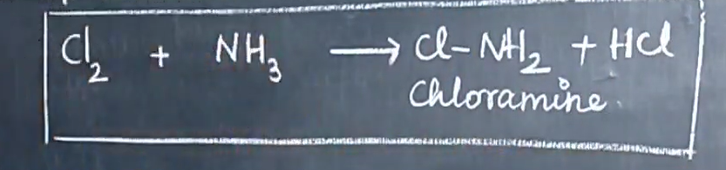

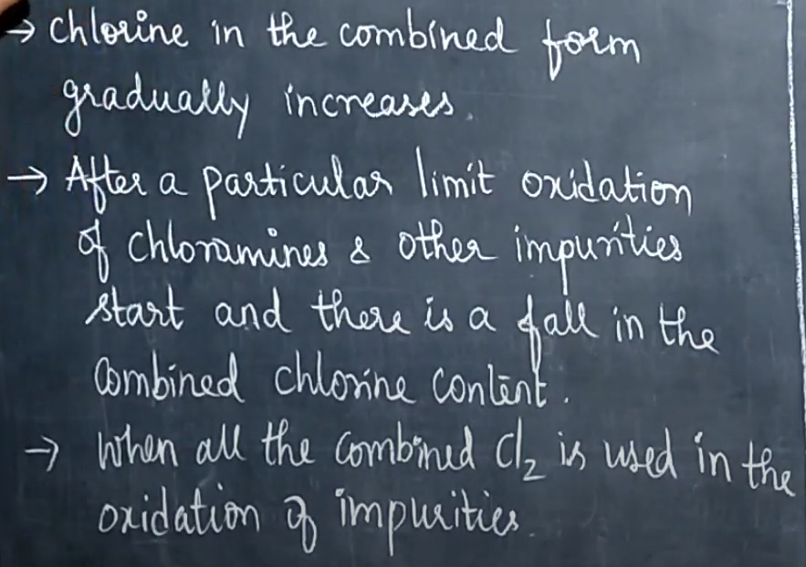

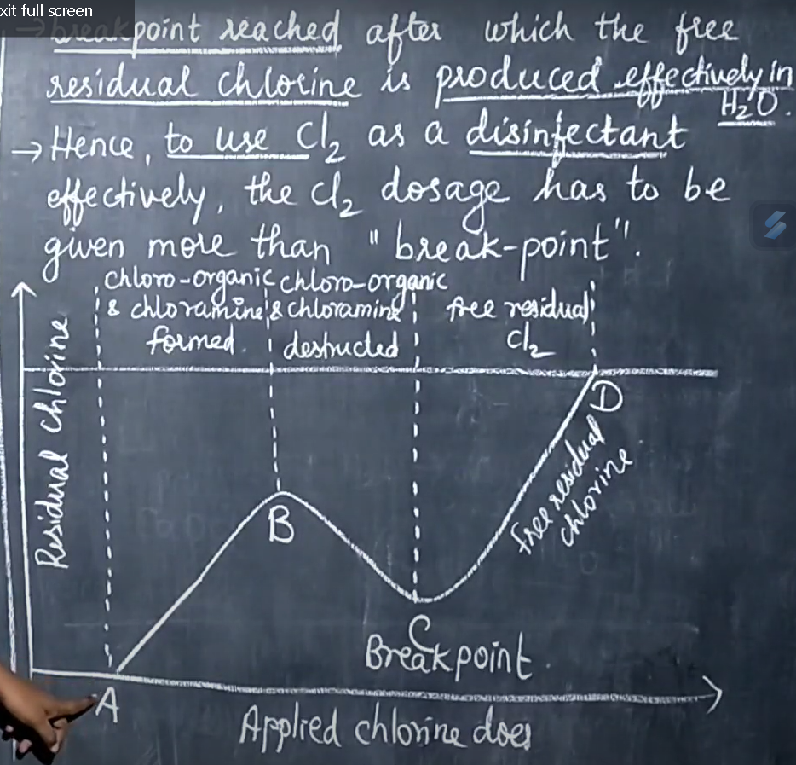

Combined Chlorine = Total Chlorine - Free Available Chlorine Usually all tastes and odors disappear at break point.

Advantages: Break point chlorination gives an idea about the amount of chlorine that is required to add for chlorination. It 1) Oxidizes completely organic matter, NH3 and reducing agents. 2) Removes colours in water. 3) Destroys completely all the disease producing bacteria. 4) Removes odour from water. 5) Prevents growth of weeds in water.

Disadvantages: 1) If excess chlorine is added it releases residual or free chlorine which imparts bad taste and odour. 2) Dechlorination must be done in order to remove free chlorine. Dechlorination is done by passing SO2 & sodium sulphite.

By using chloramines When chloramines are added into water they produce HOCl which act as germicide. Chloramines can be prepared by passing chlorine gas into ammonia chamber. Now a day’s municipalities are using this process. Cl2+NH3 →NH2Cl+HCl NH2Cl+H2O →HOCl + NH3

UV Treatment: UV Disinfection System is an extremely effective way to combat microbial

contamination in water. However, microbes have to be exposed to UV light in the proper amount in order to effectively disinfect the water.

UV Disinfection Systems are used in different applications ranging from the purification of drinking water in individual homes to disinfecting the water in industrial wastewater treatment. UV treatment for water is recognized as a safer and more cost-effective way to disinfect water for industrial applications

Ultraviolet light of wavelength 253.7 nanometers is used for the disinfection of

bacteria, viruses, molds, algae, and other microorganisms, which multiply and grow. UV disinfection technology destroys the DNA of microorganisms which leaves them dead and unable to grow further. The technology can be used for wastewater disinfection, and surface disinfection.

Benefits of UV treatment • Natural •

Environmentally Friendly

• • •

Effective Economical Safe and Chemical-Free

Disinfection by ozone (OZONATION).

By sending raw water through ozonizer, where the nacent oxygen liberated from ozone act as a germicide and kills the microorganisms. Ozone is unstable so easily decomposes to

O3 →[O]+O2

Advantages: It removes chlorine odour (smell) taste etc. if ozone is in excess, it is not harmful. Disadvantages : Equipment is Expensive