**Rasa**

**Upside**

-it is opensource

-highly customizable with different domains

-it can also work offline

-full control

-high privacy

-high scalability and flexibility

**Use Case**

-predefined domain

-for higher security

**Downside**

-has complex setup method

-needs some experience in this field

-needs the data to train if needs more accuracy

**Pricing**

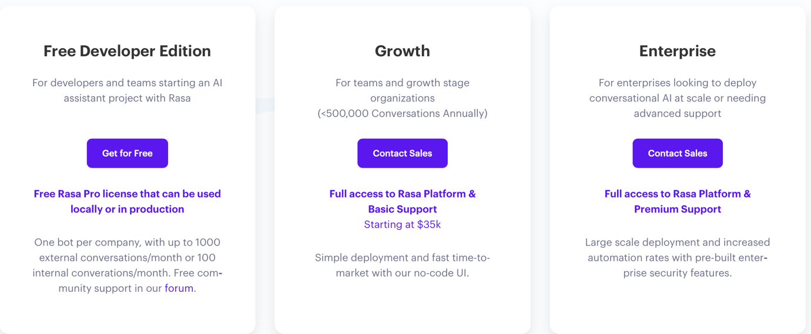

**Dialogflow CX (Google)**

**Upside**

-easy setup

-simple ui

-multi language support

-good support from support team

**Use Case**

-for large and multi domain

-for quick and easy establishment

**Downside**

-costly for large projects

-less flexibility

**Pricing**

-with gen ai it is $1000 worth of free credit for 1 year then charged on demand

-without gen ai is $600 worth of free credit for 1 year then charged on demand

**Wit.ai (Meta)**

**Upside**

-most compatible with facebook messanger but also works with other threw api and more

-quick and easy to setup

**Use Case**

-facebook bots

-bot for testing

**Downside**

-limited training

-slow in training and learning

-not much loved by the users

-don’t have many use cases

**Pricing**

Free

**Hugging face BERT**

**Upside**

-high accuracy

-open model for use

-supports complex work

-works well with custom intent

**Use Case**

-complex tasks

-

**Downside**

-needs gpu power

-slow training

-needs high dataset for processing

**Pricing**

-open model for free use