Qestion1:

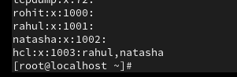

Question2:

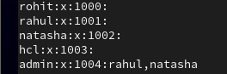







Question3:

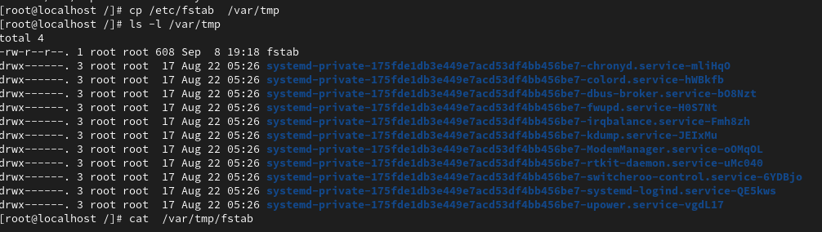

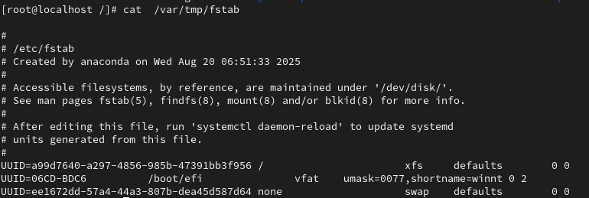

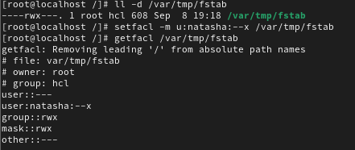



Question5:

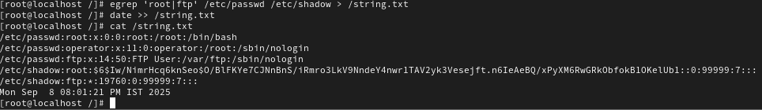

Question6:



Question7:



Question8:



Question9:

Question10: