QS1: 1. Create the following users, groups, and group memberships

- A group named webasha

- A user rahul who belongs to webasha as a secondary group

- A user natasha who also belongs to webasha as a secondary group

- A user mohit who does not have access to an interactive shell on the system, and who is not a member of webasha

- Rahul, natasha, and Mohit should all have the password of password with Algorithm DES







QS2: 2- Create a collaborative directory /network/cloud with the following characteristics

- Group ownership of /network/cloud is webasha

- The directory should be readable, writable, and accessible to members of webasha, but not to

any other user. (It is understood that root has access to all ﬁles and directories on the system.)

- Files created in /network/cloud automatically have group ownership set to the webasha group





QS3: 3- Copy the ﬁle /etc/fstab to /var/tmp. Conﬁgure the permissions of /var/tmp/fstab so that:

the ﬁle /var/tmp/fstab is owned by the root user.

the ﬁle /var/tmp/fstab belongs to the group webAsha.

the ﬁle /var/tmp/fstab should not be writable by anyone.

the user rahul is able to read and write /var/tmp/fstab.

the user natasha can neither write nor read /var/tmp/fstab.

all other users (current or future) have the ability to read /var/tmp/fstab

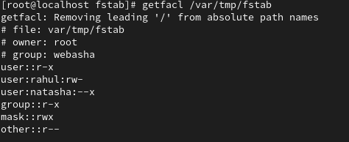

Ques4: Find the 'mic' string in /usr/share/dict/words file and copy that string in /string.txt

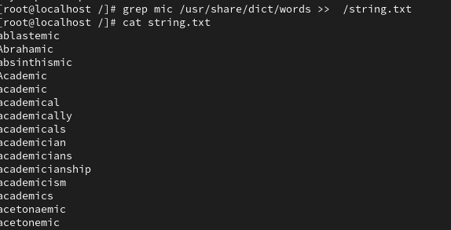

Ques5: Create a tar archive named /root/archive.tgz which contains the content of /etc.

The tar archive must be compress using gzip technique.

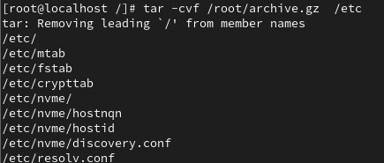

6- copy all the file that end with .conf from /etc and save into /exam

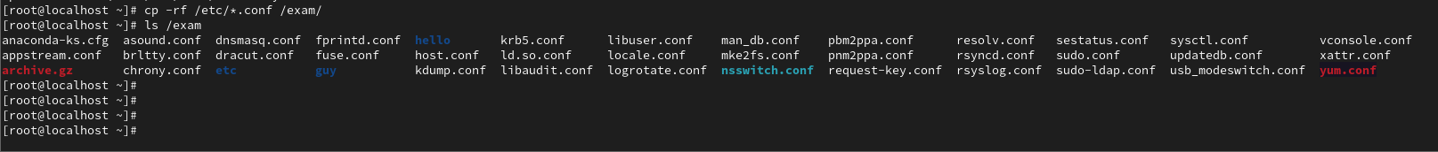

8- user Soniya can only execute fdisk and useradd command.

--vim /etc/sudoers

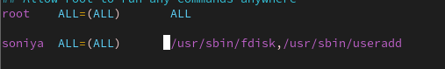

9- Find all file that created on location '/tmp' on behalf of root user and copy all file into directory /root/mytmp .



10- Add user shubham but his home directory should be /buildings and

Set the last day of password change as need to be asked on login for user shubham.



