
Infrastructure Management Support
We support to support your infrastructure!

Document Control Sheet

Current Version | 0.2
Project Code | Magento
Client Name | Eros
Document Type | Proposal Document
Author | Rohit
Sales Person
Reviewed by | Mayur
Frequency of Document Review | First Standard Document
Document Creation Date | Wednesday, Sept 8, 2021
Document Last Updated | Tuesday, Apr 8, 2022

Revision History
Version | Date | Name | Comment / Revision
1.0 | 9/8/21 | Rohit | Infrastructure Management Support
2.0 | 9/14/21 | Rohit | Estimation for 1000-2000 concurrent users

Scope of Services
Greenfield implementation of cloud architecture for magento application.

Assumptions
Assuming infrastructure as a high availability and fault tolerance with security best practices.
Assume parameters
- Region: Bahrain
- Average user load: 2000 per day

Supported Technologies
- Cloud: Amazon cloud services
- OS: Linux
- DB: RDS

Reference Architecture

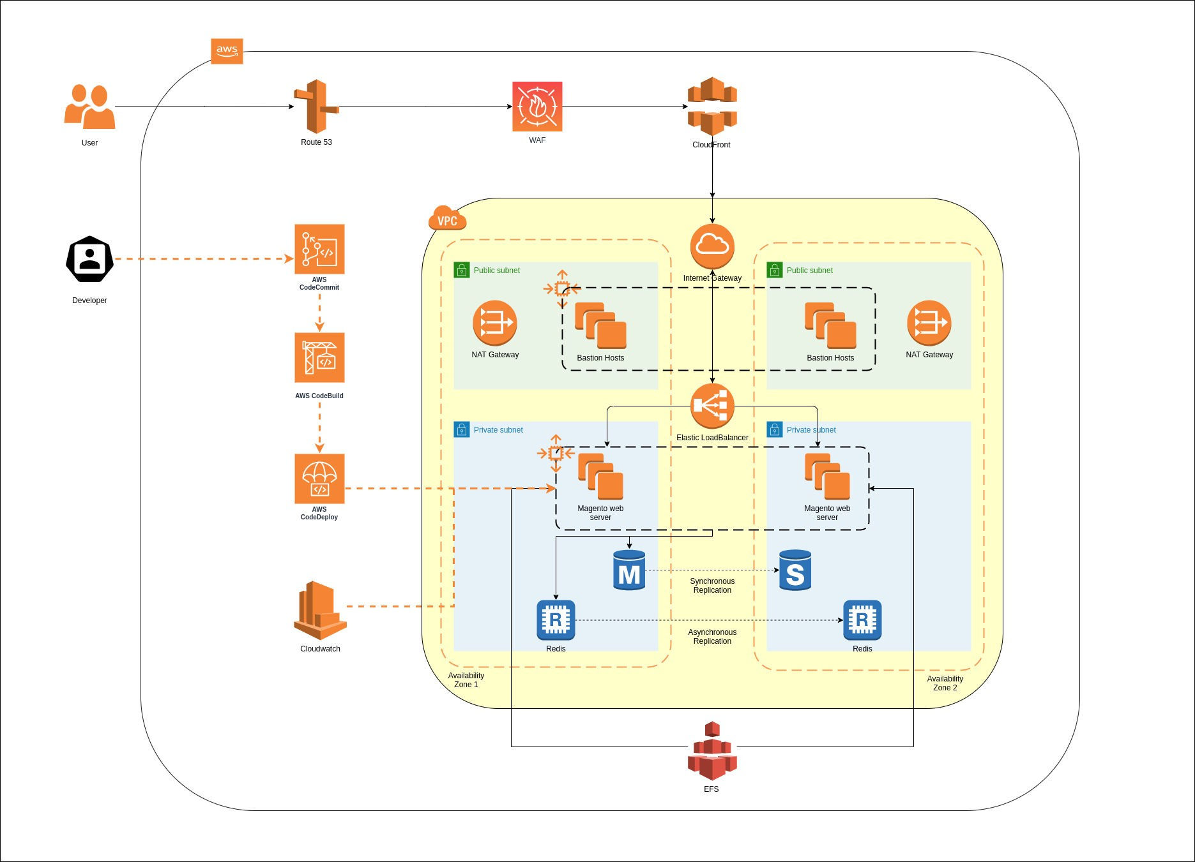

AWS components
  - CloudFront CDN is setup that is connected with WAF to block all the unwanted traffic coming from a source.
  - Route 53 is used for DNS mapping that is connected to the internet
  - A VPC that spans two Availability Zones. Each Availability Zone is configured with a private and a public subnet.
  - In a public subnet, a bastion host to provide Secure Shell (SSH) access to the Magento web servers. The bastion host is maintained by an Auto Scaling group that spans multiple Availability Zones, and is configured to ensure there is always one bastion host available.
  - AWS-managed network address translation (NAT) gateways deployed into the public subnets and configured with an Elastic IP address for outbound internet connectivity. The NAT gateways are used for internet access for all EC2 instances launched within the private network.
  - Either an Amazon RDS for MySQL or an Amazon Aurora database engine deployed via Amazon RDS in the first private subnet. If you choose Multi-AZ deployment, a synchronously replicated secondary database is deployed in the second private subnet. This provides high availability and built-in automated failover from the primary database.
  - An Amazon ElastiCache cluster with the Redis cache engine launched in the private subnets.
  - EC2 web server instances launched in the private subnets. Elastic Load Balancing deployed to automatically distribute traffic across the multiple web server instances.
  - Elastic Load Balancing deployed to automatically distribute traffic across the multiple web server instances.
  - Amazon EFS created and automatically mounted on web server instances to store shared media files.
  - Auto Scaling enabled to automatically increase capacity if there is a demand spike, and to reduce capacity during low traffic times. The
default installation sets up low and high CPU-based thresholds for scaling the instance capacity up or down. You can modify these hresholds during launch and after deployment.
  - An IAM instance role with fine-grained permissions for access to AWS services necessary for the deployment process.
  - Appropriate security groups for each instance or function to restrict access to only necessary protocols and ports. For example, access to HTTP server ports on Amazon EC2 web servers is limited to Elastic Load Balancing. The security groups also restrict access to Amazon RDS DB instances by web server instances.

Core Budget

Description | Price | Hours included
AWS Cost Estimation | 742.52 | Per month

Why Us
A Wide Range of Services

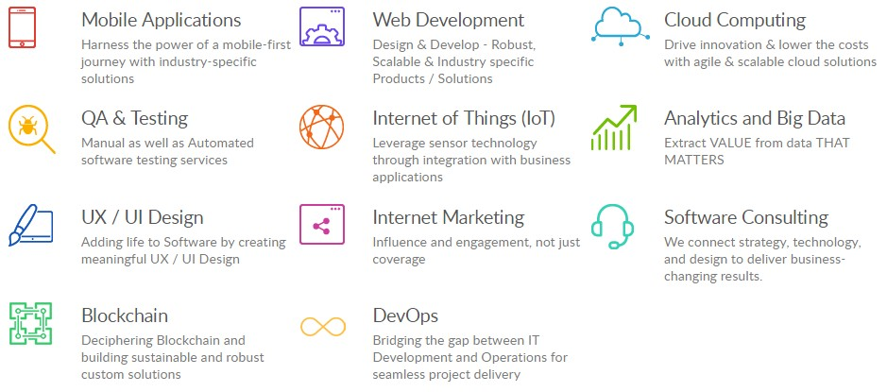

Numbers tells the clear picture

5500+
Websites

750+
Mobile Apps

1500+
Employees

1500+
Customers

Industries served



Banking and Finance Ecommerce & Retail Education & E-learning


Government Health care Insurance


IT & Consulting Manufacturing


Media & Entertainment


News & Publication


Startup
Telecom

What we do
Mobile Applications Web Development UX / UI Design  Blockchain | Cloud Computing QA & Testing Internet Marketing  DevOps | Internet of Things (IoT) Analytics and Big Data Software Consulting  Domain & Hosting

Certifications

