1. Send POST request

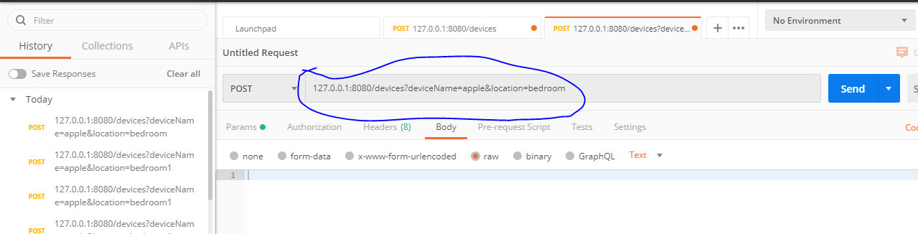

Method as POST and url is 127.0.0.1:8080/devices?deviceName=apple&location=bedroom

1. Get All

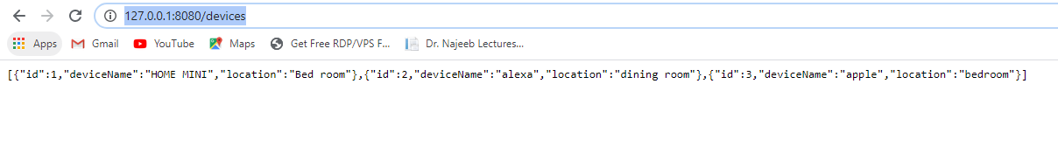

1. GetOne

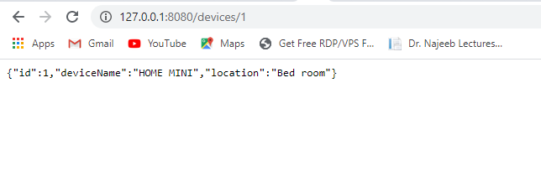

1. Modify:

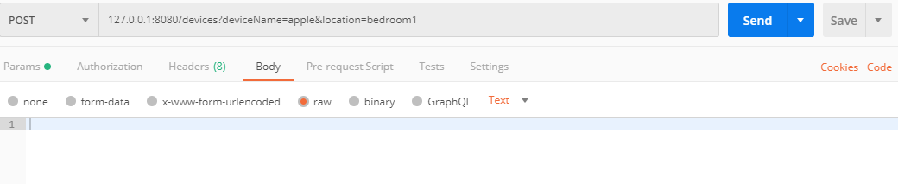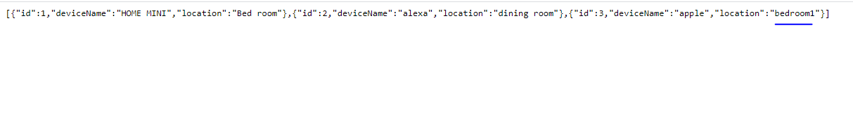

1. Delete

