PROJECT REPORT
AI and the Future of Employment:
Analyzing the Impact of Artificial Intelligence on the Job Market

Submitted for

IBM SkillsBuild Data Analytics with AI Internship 2026

Student Name | Rohit Bandaru
Project Type | Data Analytics / Exploratory Data Analysis
Primary Dataset | ai_job_market_insights.csv
Analysis Tool | Python

Internship Project Report

Declaration and Project Information

I hereby present this project report as documentation of the data analytics work completed on the topic “AI and the Future of Employment: Analyzing the Impact of Artificial Intelligence on the Job Market.” The analysis was performed using Python-based data processing and visualization techniques on the provided job-market dataset.

The report describes the analytical process, visual findings, learning outcomes, challenges encountered, and the limitations of the dataset. The analysis is observational: the patterns reported in the project represent associations in the data and should not be interpreted as proof that AI adoption directly causes a particular employment, salary, or growth outcome.

Project Information

Project Title | AI and the Future of Employment: Analyzing the Impact of Artificial Intelligence on the Job Market
Internship | IBM SkillsBuild Data Analytics with AI Internship 2026
Dataset | ai_job_market_insights.csv
Main Code | ai_job_market_analysis.py
Visualization Libraries | Matplotlib and Seaborn
Core Analysis | AI adoption, automation risk, salary, skills, remote work and job growth
Output | Analytical charts, insights and an interactive-ready project structure

Abstract

Artificial Intelligence is changing the way organizations design jobs, allocate tasks, and identify required skills. This project investigates job-market patterns related to AI adoption by examining industry distribution, salary levels, automation risk, required skills, remote-work characteristics, and projected job growth.

The project follows a structured analytical flow: AI Adoption → Automation Risk → Salary & Job Characteristics → Required Skills → Future Job Growth. Python and pandas were used for data loading, validation, cleaning, grouping, cross-tabulation, and statistical summaries. Matplotlib and Seaborn were used to create visualizations that make the patterns easier to interpret.

The analysis includes ten visualizations covering industry-level job counts and salaries, AI adoption, automation risk, job-growth projections, skill frequency, and remote versus non-remote salary distributions. The resulting observations are intended to support understanding of the dataset rather than to make causal predictions about the future of employment.

Keywords

- Artificial Intelligence (AI)
- Data Analytics
- Exploratory Data Analysis (EDA)
- Automation Risk
- Job Growth
- Salary Analysis
- Required Skills
- Remote Work
- Data Visualization

1. Introduction

The relationship between Artificial Intelligence and employment is multidimensional. Some jobs may experience higher levels of automation exposure, while other roles may increasingly require technical, analytical, communication, or management skills. Salary and growth patterns can also vary by industry and job characteristics.

This project uses an observational job-market dataset to examine these dimensions together. Instead of treating a single variable as the complete explanation of employment outcomes, the analysis compares multiple categorical and numerical attributes to identify patterns.

Project Objectives

- Analyze the distribution of jobs across industries.
- Compare average salary levels across industries and AI adoption categories.
- Measure the distribution of low, medium, and high AI adoption.
- Examine the distribution and industry composition of automation risk.
- Study how job-growth projections vary across AI adoption levels.
- Identify the most frequently required skills in the dataset.
- Compare salary distributions for remote-friendly and non-remote jobs.
- Present findings through clear, professional visualizations.
- Document the limitations of observational data and avoid causal over-interpretation.

Scope

The scope is limited to the variables available in the supplied dataset. It does not attempt to forecast actual employment numbers, build a predictive machine-learning model, or establish causal relationships between AI adoption and employment outcomes.

2. Dataset Description

The project uses the dataset named ai_job_market_insights.csv. The analysis script verifies that the expected fields are present before proceeding. The required columns are shown below.

Field | Purpose in Analysis
Job_Title | Identifies the job role.
Industry | Groups records by industry sector.
Company_Size | Describes organization size category.
Location | Represents the job location.
AI_Adoption_Level | Categorical indicator of AI adoption.
Automation_Risk | Categorical indicator of automation exposure.
Required_Skills | Primary skill associated with the role.
Salary_USD | Numeric salary measure used for comparisons.
Remote_Friendly | Indicates whether a role is remote-friendly.
Job_Growth_Projection | Categorical projection: Decline, Stable or Growth.

Data Quality and Cleaning

- The script checks whether the CSV can be loaded and whether it is empty.
- Expected columns are validated before analysis.
- Leading and trailing whitespace is removed from text columns.
- Salary_USD is converted to numeric values; invalid entries are treated as missing.
- Rows with missing critical values are removed.
- Non-positive salary values are removed.
- Duplicate records are removed and the index is reset.

3. Methodology and Analytical Process

Stage | Description
1. Data Loading | Read the CSV file into a pandas DataFrame and validate its structure.
2. Data Understanding | Inspect dimensions, column names, data types, missing values, duplicates and categorical values.
3. Data Cleaning | Standardize text, convert salary to numeric form, remove invalid/missing records and duplicates.
4. Exploratory Data Analysis | Calculate frequency distributions, group-wise averages and cross-tabulations.
5. AI Impact Analysis | Compare AI adoption with salary, automation risk and job-growth projections.
6. Skills Analysis | Count required skills and examine salary patterns by skill.
7. Visualization | Generate ten charts to communicate the main patterns.
8. Interpretation | Summarize findings while distinguishing association from causation.

Tools and Technologies

- Python – primary programming and analysis language.
- pandas – data loading, cleaning, grouping and cross-tabulation.
- Matplotlib – chart generation and figure export.
- Seaborn – statistical visualization styling and boxplots.
- CSV – lightweight tabular data source.
- Microsoft Word / DOCX – project documentation.
- Streamlit and Plotly – suitable technologies for presenting the analysis as an interactive dashboard.

4. Exploratory Data Analysis – Industry

Industry analysis establishes the baseline structure of the dataset. The first visualization counts the number of job records in each industry, while the second compares average salary across industries.

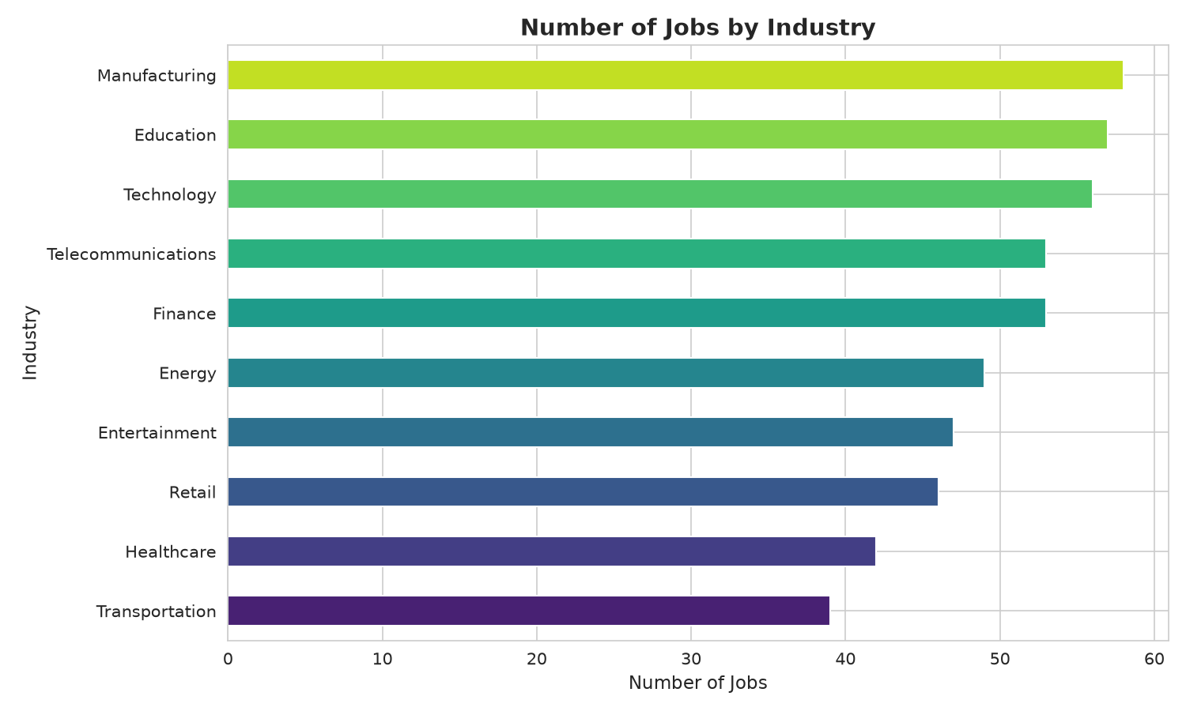
Figure 1. Number of jobs by industry.

Chart Definition: This chart presents the number of job records available for each industry in the dataset. It provides a basic view of how the dataset is distributed across sectors and helps identify industries with relatively larger or smaller representation.

Summary: The chart shows that the dataset contains job records across a broad range of industries rather than being limited to one sector. This distribution provides a useful foundation for comparing salary, AI adoption, automation risk and job-growth patterns across industries.

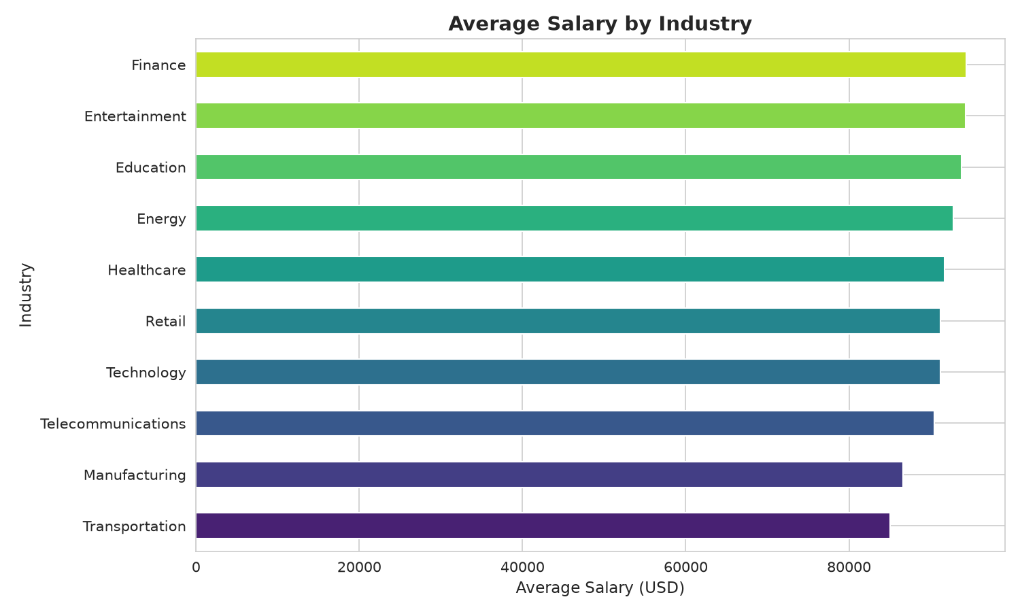
Figure 2. Average salary by industry.

Chart Definition: This chart compares the mean Salary_USD value for each industry. Average salary is calculated by grouping job records according to Industry and then computing the arithmetic mean of the recorded salaries.

Summary: The chart indicates visible differences in average salary between industries. These differences highlight the importance of considering industry context when studying compensation and should be interpreted as characteristics of the supplied dataset rather than universal salary levels.

Interpretation: The dataset contains substantial representation across multiple industries rather than being concentrated in a single sector. Average salary also varies between industries, showing that sector context is an important characteristic when examining job-market patterns.

5. AI Adoption and Salary Patterns

AI adoption is one of the central variables in the project. The analysis groups job records into Low, Medium and High AI adoption categories and then compares the average salary associated with each category.

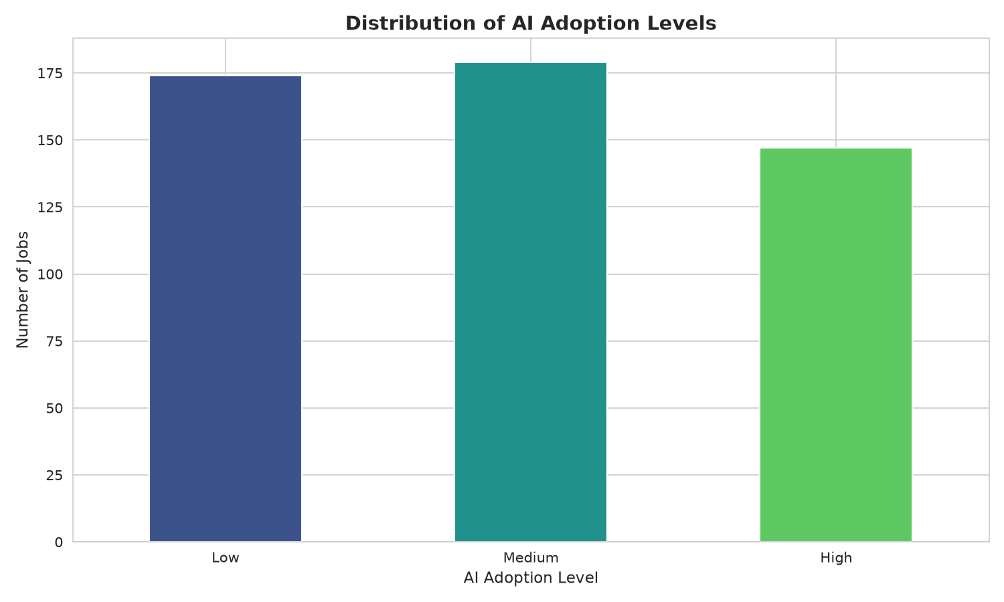
Figure 3. Distribution of AI adoption levels.

Chart Definition: This chart shows how the recorded jobs are distributed among three AI adoption categories: Low, Medium and High. It helps establish the overall level of AI adoption represented in the dataset before examining its relationship with other variables.

Summary: All three adoption categories are represented, but their frequencies are not identical. The distribution provides a starting point for examining whether salary, automation risk and job-growth projections differ across AI adoption groups.

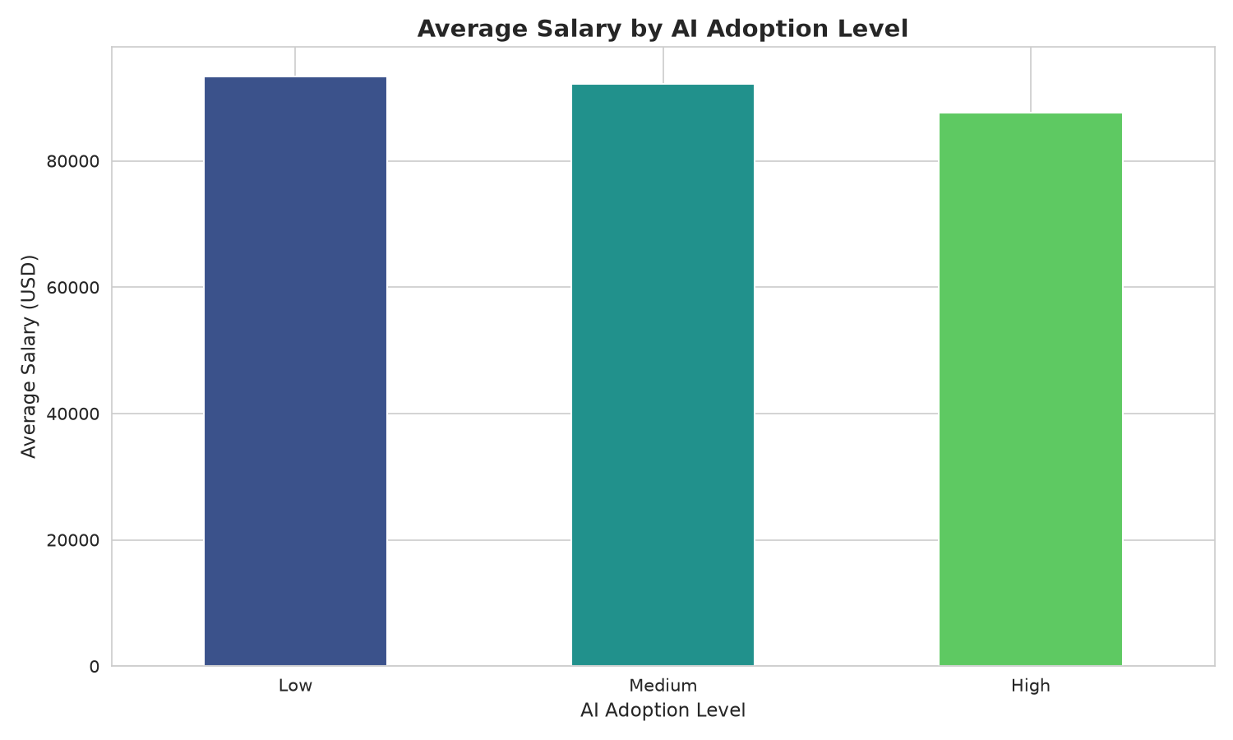
Figure 4. Average salary by AI adoption level.

Chart Definition: This chart compares the average recorded salary for jobs classified as having Low, Medium or High AI adoption. The calculation groups salary observations by AI_Adoption_Level and provides a simple comparison of compensation patterns across the categories.

Summary: Average salary varies across the three AI adoption categories in the dataset. The result indicates an association between the two variables, but it does not establish that a particular level of AI adoption directly causes higher or lower salary.

Interpretation: The adoption distribution is not identical across the three categories, and salary levels also differ between adoption groups. These differences describe patterns within the dataset; they do not establish that AI adoption itself causes salary changes.

6. Automation Risk Analysis

Automation risk provides a second dimension for understanding how AI may relate to job characteristics. The project examines both the overall distribution of automation-risk categories and the composition of those categories within industries.

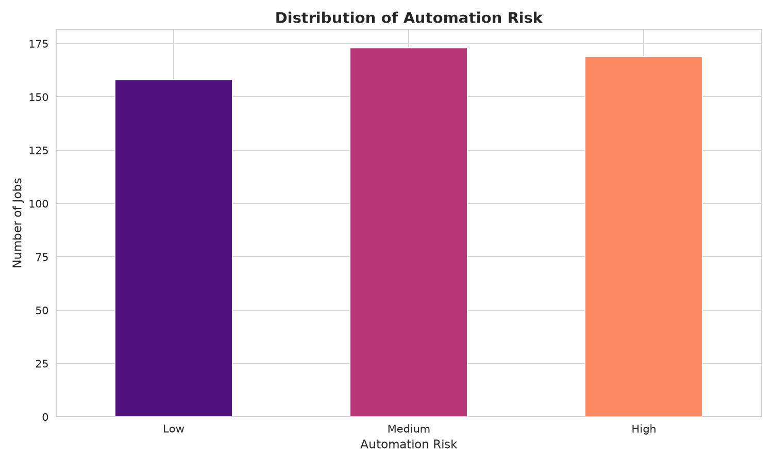
Figure 5. Overall distribution of automation risk.

Chart Definition: This chart presents the number of job records classified as Low, Medium or High automation risk. Automation_Risk is treated as a categorical variable and its frequency is used to understand the overall distribution of automation exposure.

Summary: The dataset contains a substantial number of records in each automation-risk category. This representation makes it possible to examine how automation risk differs by industry, AI adoption level, salary and projected job growth.

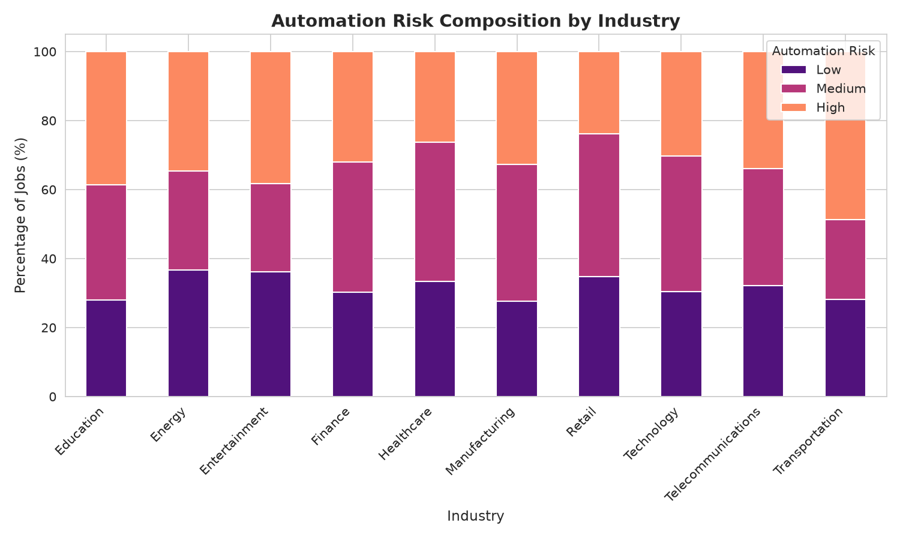
Figure 6. Automation-risk composition by industry.

Chart Definition: This stacked bar chart shows the percentage composition of Low, Medium and High automation-risk jobs within each industry. Converting the counts into percentages makes industries with different numbers of records easier to compare on a common 100% scale.

Summary: The proportions of automation risk are not identical across industries. The visualization therefore demonstrates that automation exposure varies by sector within the dataset and supports more detailed industry-level interpretation.

Interpretation: Automation risk is distributed across Low, Medium and High categories. The industry composition chart shows that the proportions are not identical from one industry to another. This supports the need to examine job-market effects at both overall and industry levels.

7. Job Growth and AI Adoption

Future job growth is represented by three categories: Decline, Stable and Growth. The project first examines the overall distribution and then compares growth composition across AI adoption levels.

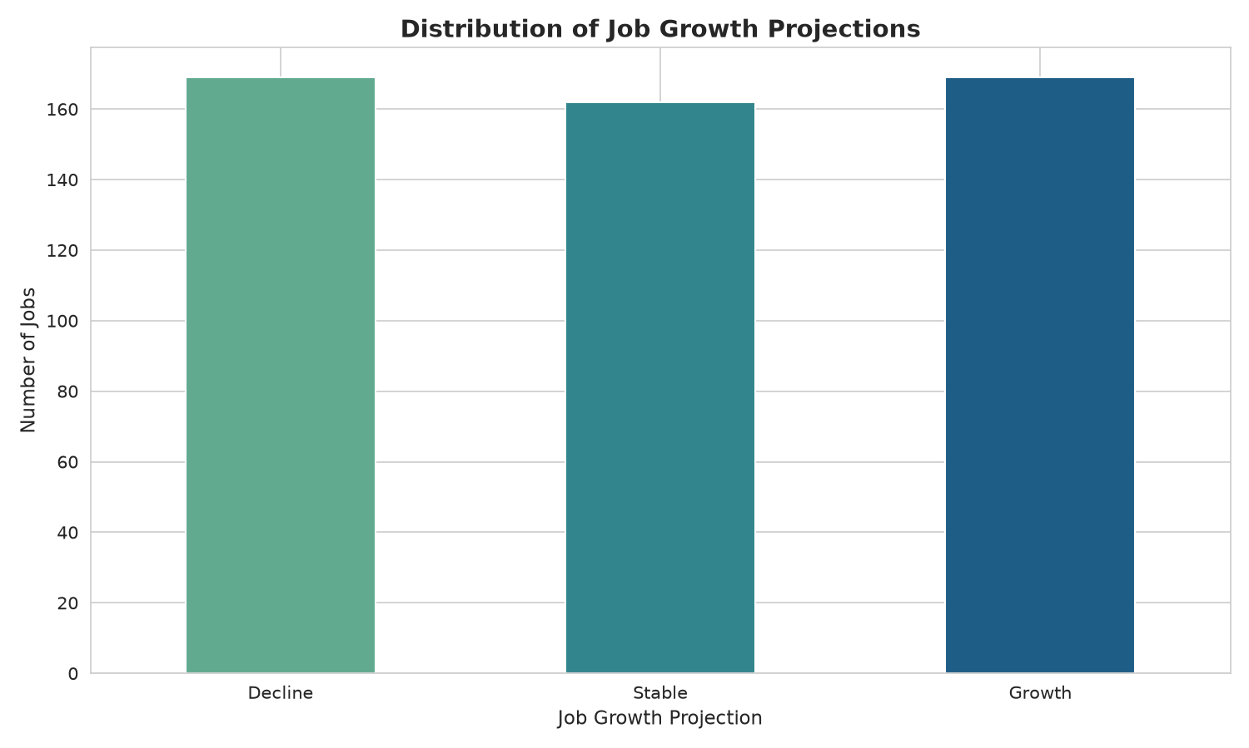
Figure 7. Distribution of job-growth projections.

Chart Definition: This chart displays the frequency of the three Job_Growth_Projection categories: Decline, Stable and Growth. It provides an overall view of how the dataset classifies the future direction of the recorded job roles.

Summary: Decline, Stable and Growth projections are all present in the dataset. The distribution gives a high-level picture of projected employment direction and serves as a reference point for the later comparison with AI adoption.

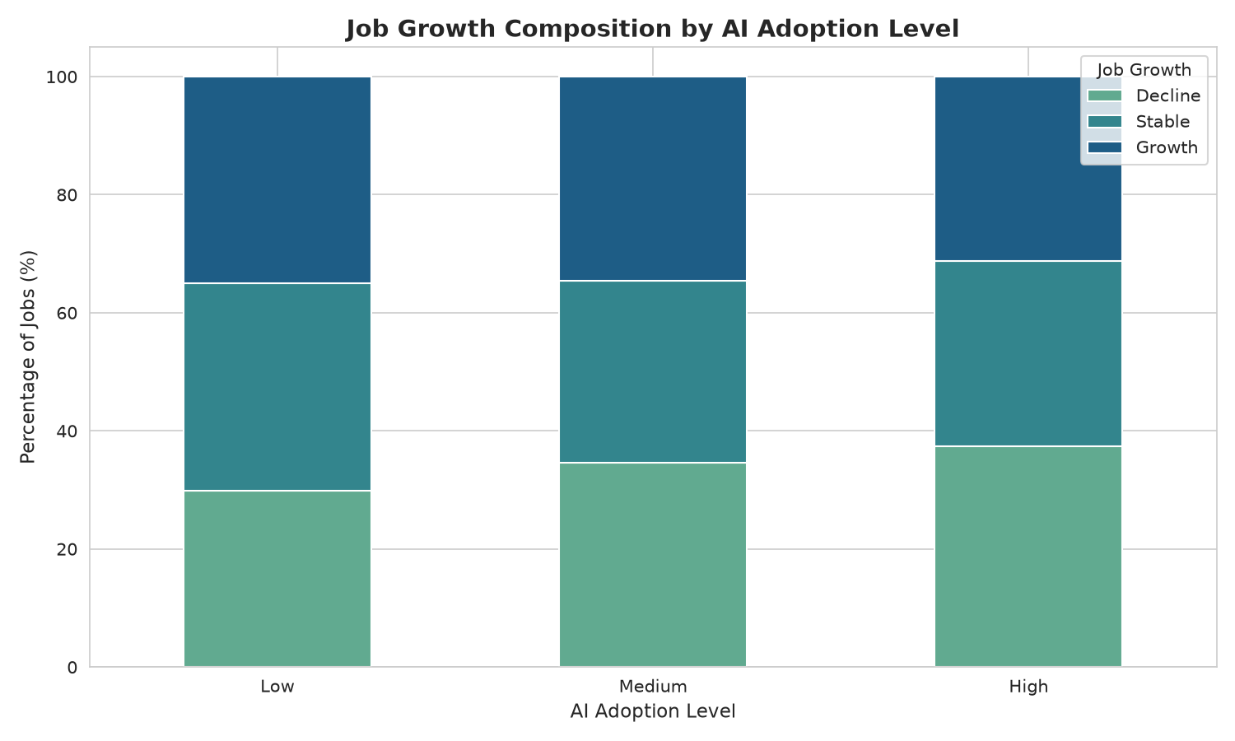
Figure 8. Job-growth composition by AI adoption level.

Chart Definition: This stacked bar chart compares the percentage of Decline, Stable and Growth projections within each AI adoption category. The percentage-based composition allows the three adoption groups to be compared even when their total record counts differ.

Summary: The composition of projected job growth changes across AI adoption levels. This suggests that AI adoption and job-growth projection are associated in the recorded data, while the observational nature of the dataset means the chart should not be interpreted as evidence of a causal relationship.

Interpretation: Growth projections are distributed across all three categories. The composition changes across AI adoption groups, indicating that AI adoption and projected growth vary together in the dataset. The relationship should be interpreted as an observed association, not as a forecast or causal effect.

8. Required Skills Analysis

Skills analysis is important because AI-related changes in employment can alter the types of capabilities requested by organizations. The project counts the frequency of each value in Required_Skills and identifies the ten most frequently recorded skills.

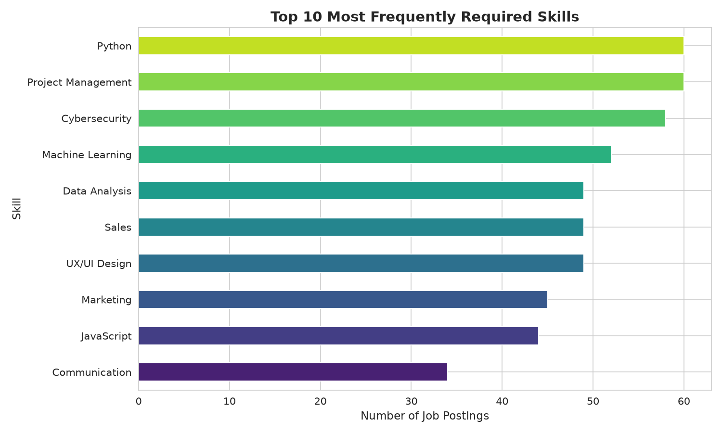
Figure 9. Top 10 most frequently required skills.

Chart Definition: This chart ranks the ten skills that occur most frequently in the Required_Skills field. The analysis counts each recorded skill and selects the ten highest frequencies to provide a concise view of the skills most represented in the dataset.

Summary: Python appears prominently among the recorded requirements, followed by a mixture of technical, analytical, business and communication-oriented skills. The chart illustrates the diversity of skills associated with the dataset and can help identify areas for further learning or analysis.

Skill-Level Observations

- The dataset contains a range of technical and non-technical skills.
- Python appears prominently among the frequently recorded skills in the visualization.
- Project management, cybersecurity, machine learning and data analysis also appear among the leading recorded requirements.
- JavaScript, communication, marketing, UX/UI design and sales are represented as well.
- The project also calculates average salary by required skill, allowing skill frequency and salary patterns to be studied separately.

The skill chart should be treated as a description of this dataset rather than a universal ranking of skills in the global labor market.

9. Remote Work and Salary Distribution

Remote-friendly work is another job characteristic included in the dataset. A boxplot is used instead of a simple average because it shows the median, spread, and potential outliers of salary distributions for remote-friendly and non-remote roles.

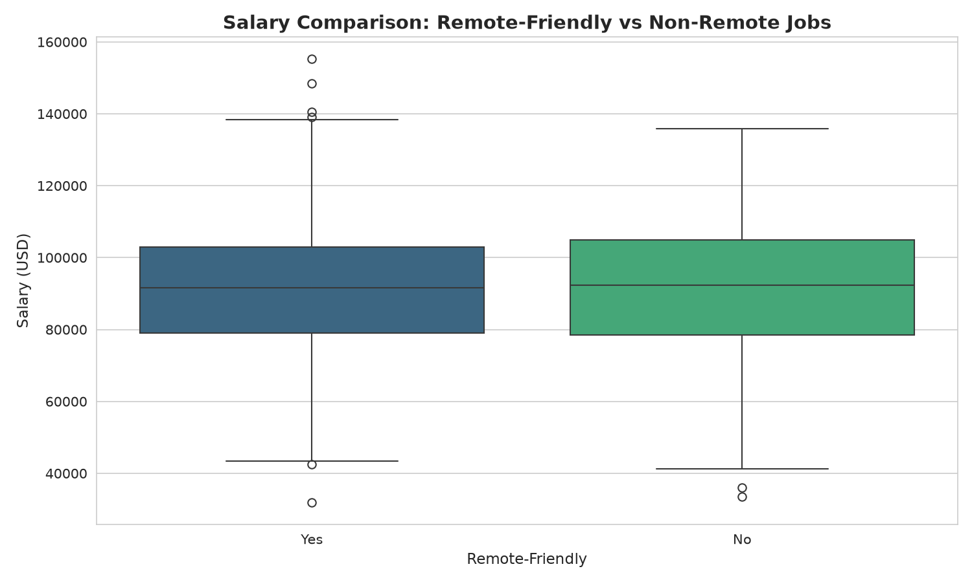
Figure 10. Salary comparison between remote-friendly and non-remote jobs.

Chart Definition: This boxplot compares Salary_USD distributions for remote-friendly and non-remote jobs. Unlike a simple average, a boxplot displays the median, central spread, overall range and potential outliers, making it useful for understanding differences in salary distributions.

Summary: The two groups show overlapping but distinct salary distributions, with visible variation and outliers. This indicates that remote status is associated with differences in the recorded salary distribution, but the chart alone cannot establish that remote work causes salary differences.

Interpretation: The two groups show overlapping but different salary distributions. The presence of outliers also demonstrates why distributional analysis is useful when comparing salaries. The observed difference should not be interpreted as proof that remote work causes higher or lower salary.

Additional Analysis Performed
- Average salary by automation-risk category.
- Remote-friendly job percentage.
- Remote-friendly jobs by industry.
- Job growth versus automation risk.
- AI adoption versus automation risk.
- Average salary by job title and required skill.
- Job titles with the highest observed share of High automation risk.
- Job titles with the highest observed share of Growth projection.

10. Key Findings

The combined analysis produces the following major findings from the supplied dataset:
- Job records are distributed across several industries, allowing cross-industry comparisons.
- Average salary differs across industries, indicating meaningful sector-level variation in the recorded data.
- AI adoption is represented by Low, Medium and High categories, with different frequencies.
- Salary varies across AI adoption categories, but the dataset does not demonstrate causation.
- Automation risk is distributed across three categories and its composition varies by industry.
- Job-growth projections include Decline, Stable and Growth categories, with different compositions across AI adoption levels.
- The required-skills analysis identifies Python as a prominent recorded skill and shows a mixture of technical and business-oriented skills.
- Remote-friendly and non-remote roles have different salary distributions, including visible salary outliers.
- The relationships among AI adoption, automation risk, salary, skills and job growth are multidimensional rather than reducible to one variable.

Overall Analytical Flow

AI Adoption → Automation Risk → Salary & Job Characteristics → Required Skills → Future Job Growth
This flow provides a logical structure for interpreting the project: first understand how AI adoption is distributed, then examine associated automation exposure, compare salary and work characteristics, identify skill demand, and finally examine projected job growth.

11. Learning Outcomes

- Learned how to load and validate a real-world-style CSV dataset using pandas.
- Improved understanding of data cleaning, missing-value handling, duplicate removal and numeric conversion.
- Learned to use groupby(), value_counts(), crosstab() and descriptive statistics for exploratory analysis.
- Learned how to choose charts based on the analytical question: bar charts for category comparisons, stacked bars for composition, and boxplots for distributions.
- Learned how to interpret association without claiming causation.
- Improved ability to convert raw analysis into an understandable project narrative.
- Learned how to structure a reusable Python analysis script with sections for loading, cleaning, EDA, visualization and conclusions.
- Developed a clearer understanding of how AI adoption, automation risk, salary, skills and job growth can be analyzed together.

12. Challenges Faced and Solutions

Challenge | How It Was Addressed
Keeping the dataset reliable | Added validation, numeric conversion, missing-value handling and duplicate removal.
Choosing meaningful visualizations | Used separate charts for distribution, comparison, composition and salary distribution.
Interpreting AI impact carefully | Explicitly treated the dataset as observational and avoided causal claims.
Handling categorical variables | Used value_counts(), groupby() and crosstab() to summarize categories.
Presenting many findings clearly | Organized the project into a fixed analytical flow and saved ten named PNG outputs.
Balancing technical detail with readability | Used simple chart titles, axis labels and concise interpretations.

13. Conclusion

This project demonstrates a complete exploratory data analytics workflow for studying AI-related job-market patterns. Starting from data validation and cleaning, the analysis progresses through industry comparisons, AI adoption, automation risk, salary, skills, remote work and job-growth projections. Ten visualizations make the main patterns accessible and provide evidence for the observations discussed in this report.
The most important methodological conclusion is that the dataset should be interpreted as observational evidence. Differences between AI adoption groups, industries, salaries, automation-risk categories or growth projections are patterns in the supplied records. They should not be presented as proof that one variable directly causes another.

14. Future Scope

- Add a larger and more current dataset containing multiple years of job postings.
- Include additional variables such as experience level, education, company revenue and job-posting date.
- Perform statistical significance testing and correlation/association analysis where appropriate.
- Build an interactive Streamlit dashboard with filters for industry, AI adoption, automation risk and job growth.
- Add time-series analysis if historical job-posting dates become available.
- Use machine-learning models only where the dataset supports a clearly defined prediction task.
- Compare multiple geographic markets to understand regional differences.
- Track changes in required skills over time to identify emerging skill demand.

15. References and Project Artifacts

- Primary dataset: ai_job_market_insights.csv.
- Primary analysis script: ai_job_market_analysis.py.
- Python pandas documentation and standard data-analysis practices used as implementation references.
- Matplotlib and Seaborn used for data visualization.
- IBM SkillsBuild Data Analytics with AI Internship 2026 project context.

