SDN LEARNING SWITCH CONTROLLER
C Rohit Reddy PES2UG24CS125

ABSTRACT:
This project presents the implementation of a Software Defined Networking (SDN) based Learning Switch using the Ryu controller and Mininet emulator. The objective is to replicate the behavior of a traditional Ethernet learning switch while leveraging the centralized control paradigm of SDN.
In this system, the OpenFlow-enabled switch initially lacks knowledge of host locations and forwards incoming packets to the controller using a table-miss rule. The controller processes packet-in events, extracts source and destination MAC addresses, and dynamically builds a MAC-to-port mapping table. Based on this learned information, the controller decides whether to flood the packet (in case of unknown destination) or forward it to a specific port (if the destination is known). Additionally, the controller installs flow rules in the switch to handle future packets directly, thereby reducing controller involvement and improving network efficiency.
The functionality of the system is validated using tools such as ping and iperf to demonstrate connectivity and performance, along with Wireshark to analyze packet-level behavior. Observations show that initial communication involves ARP broadcasting and flooding, while subsequent transmissions are handled efficiently through installed flow rules.
This project highlights key SDN concepts including controller–switch interaction, dynamic flow rule installation, and centralized network control, demonstrating improved scalability and flexibility compared to traditional networking approaches.

GITHUB LINK: https://github.com/rohit1234-spec/SDN

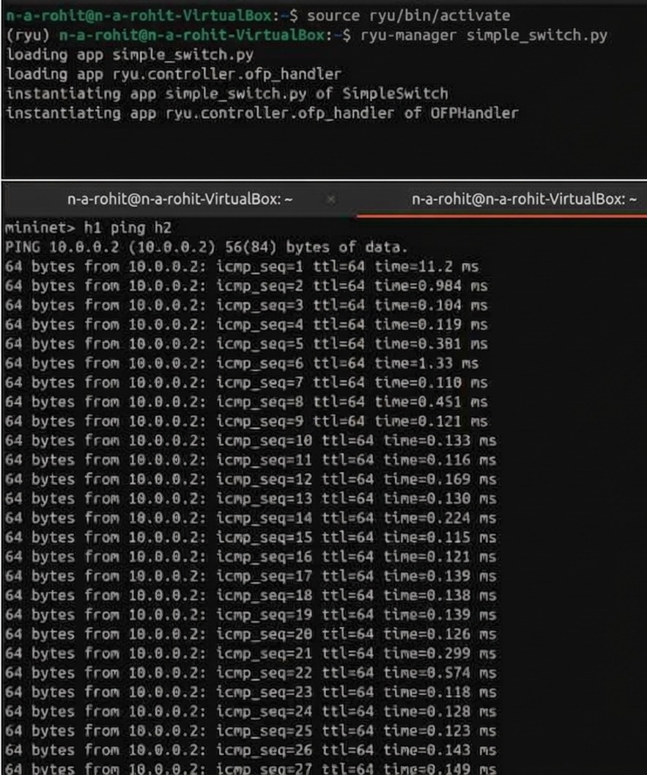
SCREENSHOTS:
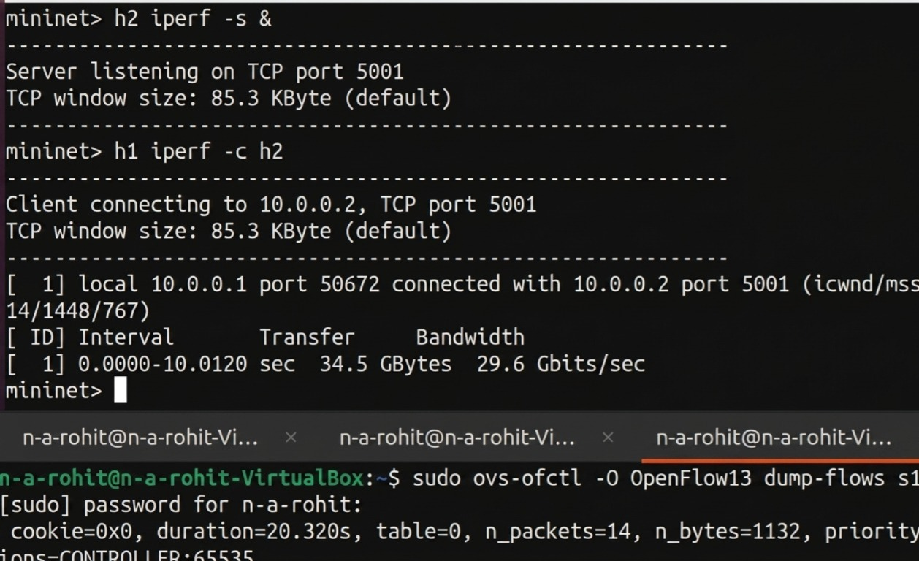
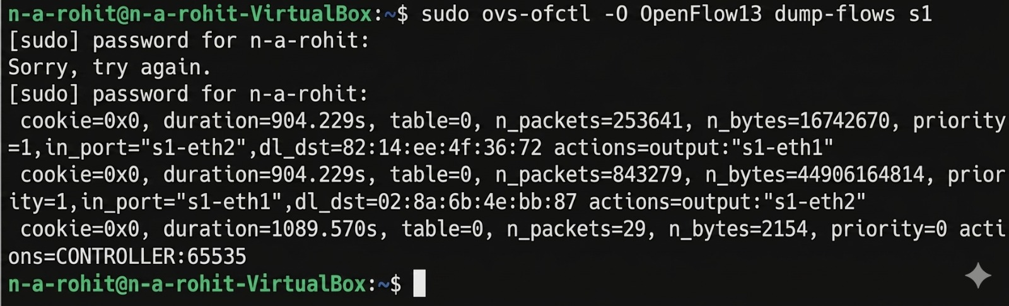
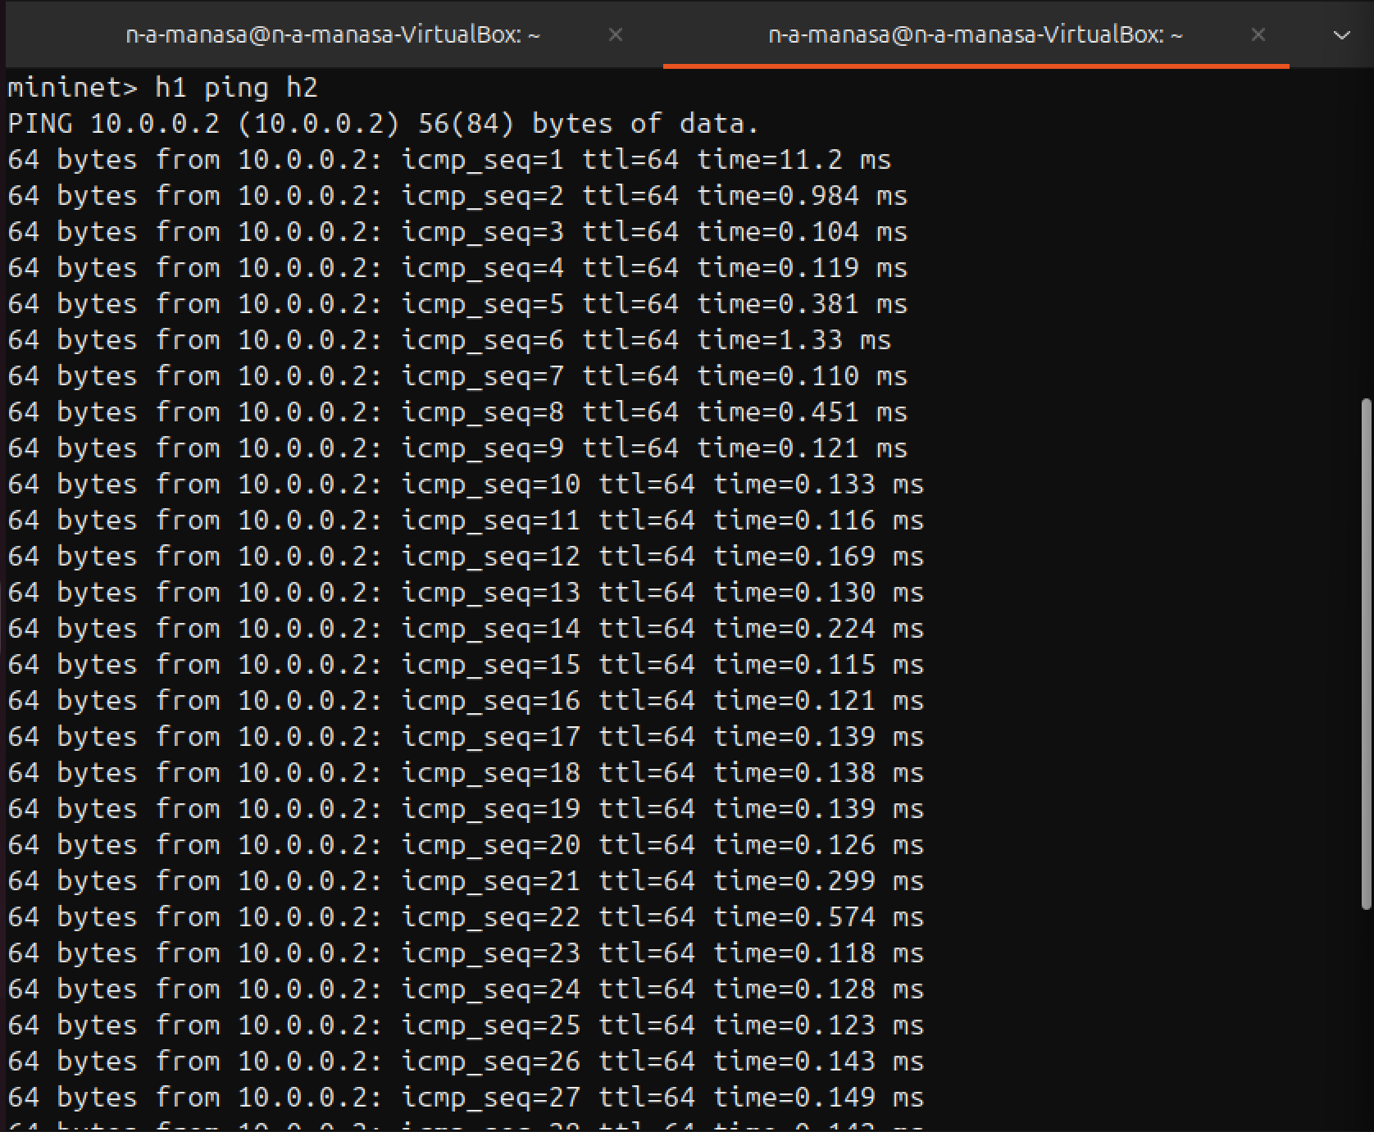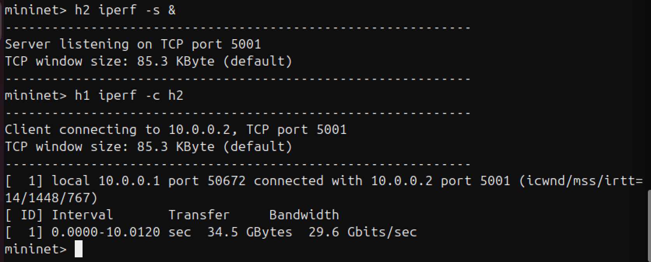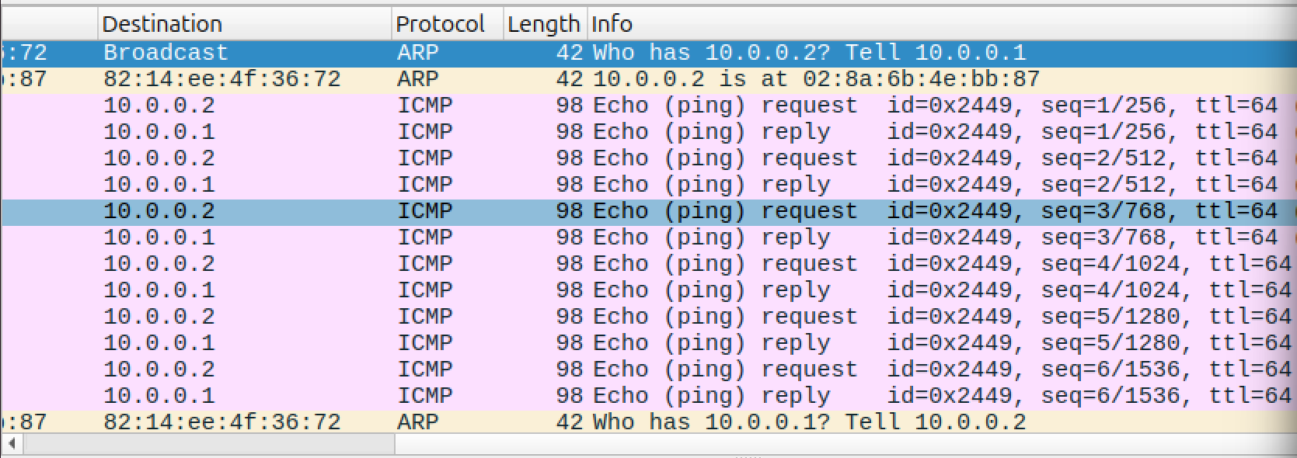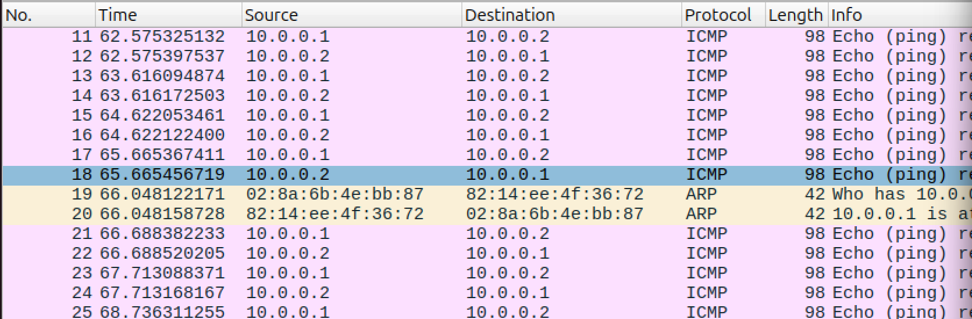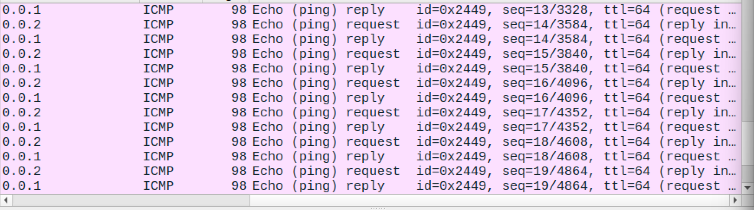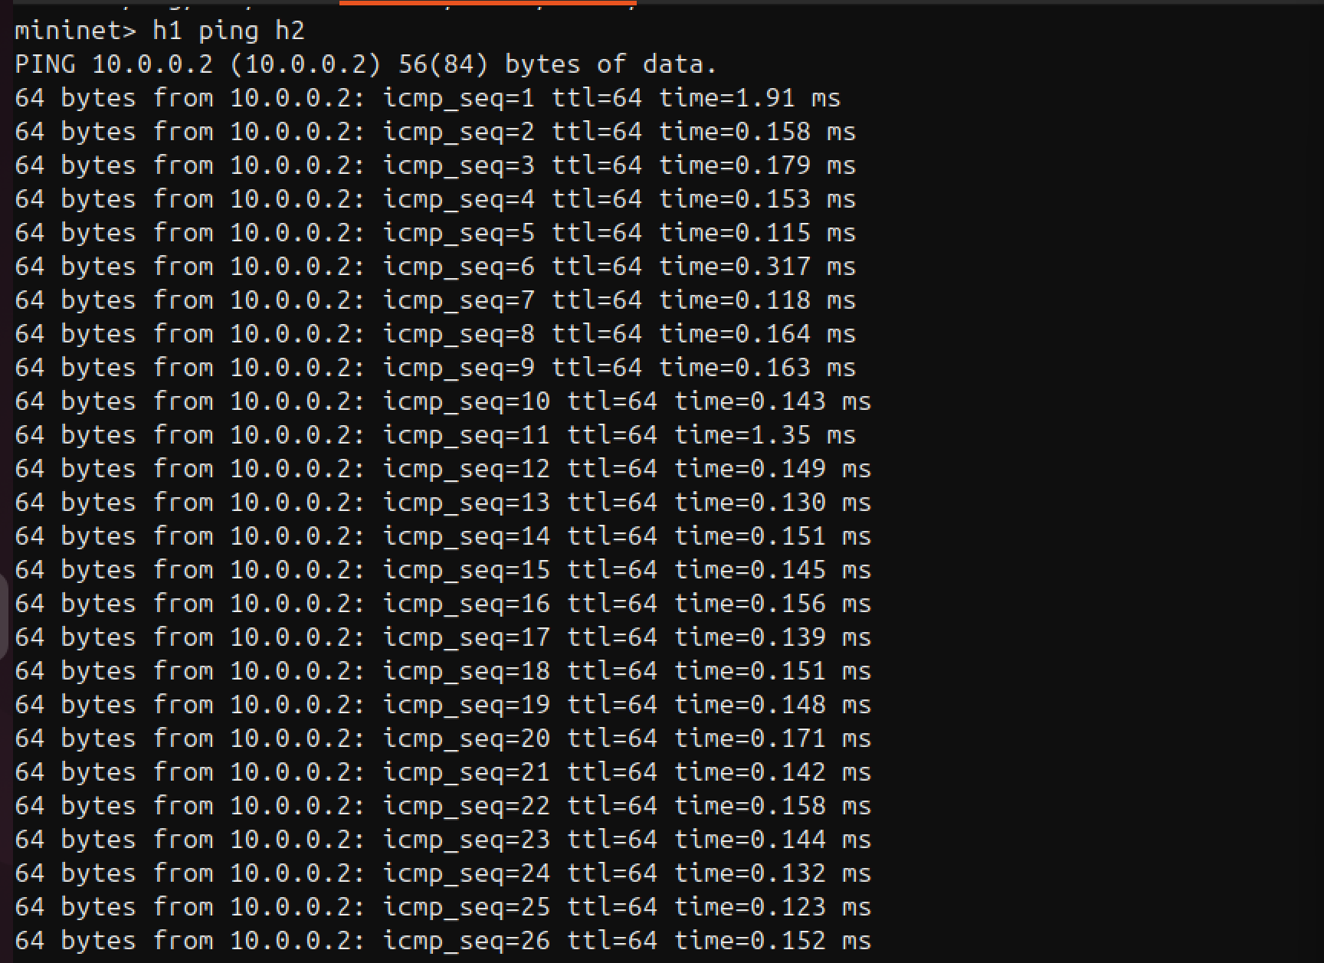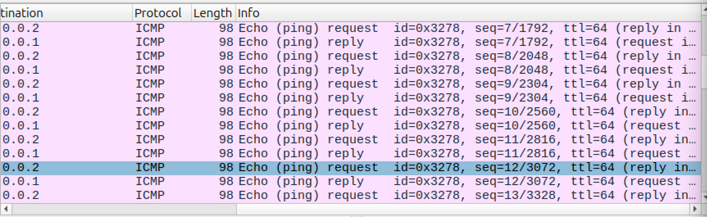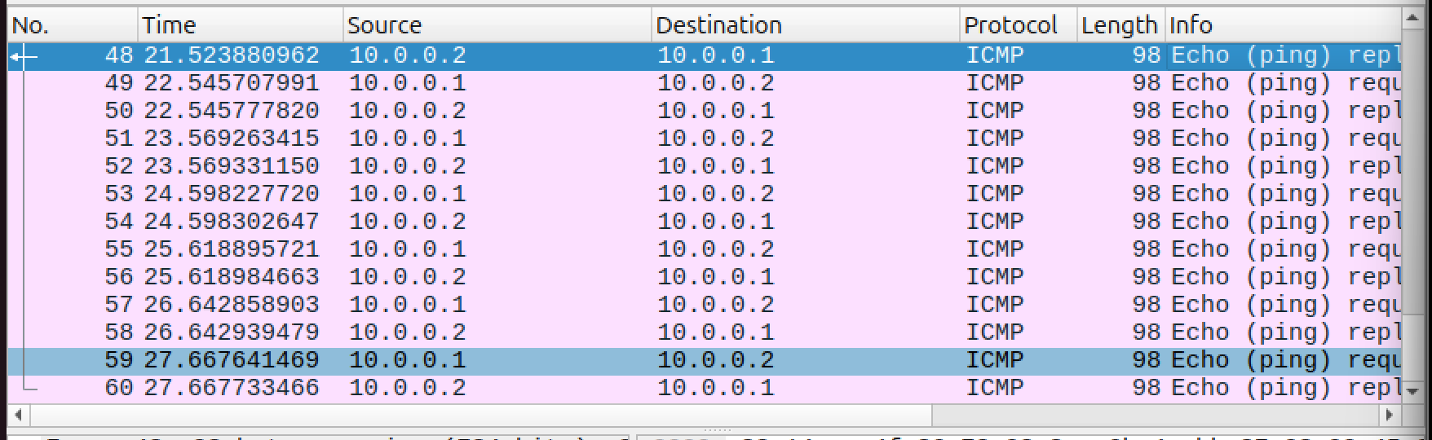

README:
# SDN_LearningSwitch

## SDN learning switch controller

To implement a controller that mimics a learning switch by dynamically learning MAC addresses and installing forwarding rules.
Demonstrates MAC address learning logic, Dynamic flow rule installation, Packet forwarding validation, Flow table inspection

Implementation:

Hosts (2 hosts in this case) are connected to the Switch. Initially, the switch does not know the destination mac address when a host sends a packet, so the switch forwards the packet to the Ryu controller. The controller processes the packet, learns the source MAC address, and instructs the switch to either flood the packet or install a flow rule for future packets. During the first communication between hosts, ARP broadcast and flooding are seen, indicating that the switch is learning the network and MAC addresses. After the controller installs the appropriate flow rules, subsequent communications are handled directly by the switch, resulting in efficient forwarding with reduced overhead.

Steps to Run the Project:

### 1. System Preparation

On terminal run, (to upgrade)

```bash
sudo apt update
sudo apt upgrade -y
```

---

### 2. Install Required Tools

Install Mininet

```bash
sudo apt install mininet -y
```

Install Open vSwitch

```bash
sudo apt install openvswitch-switch -y
```

Install Python dependencies

```bash
sudo apt install python3-pip -y
pip3 install ryu
pip3 install eventlet==0.30.2
```

---

### 3. Clean Previous Mininet State

Clear old configurations

```bash
sudo mn -c
```

---

### 4. Start the Ryu Controller

Run the learning switch controller

```bash
source ryu/bin/activate
ryu-manager simple_switch.py
```

---

### 5. Start Mininet Topology

Open a new terminal and run

```bash
sudo mn --topo=single,2 \
--controller=remote,ip=127.0.0.1,port=6653 \
--switch ovsk,protocols=OpenFlow13
```

This creates:

* 1 switch (s1)
* 2 hosts (h1, h2)

---

### 6. Verify Connectivity

Inside the Mininet CLI

```bash
pingall
```

---

### 7. Observe Learning Behavior

Run the ping command twice

```bash
h1 ping h2
```
Observations:
* First run: ARP broadcast and flooding
* Second run: Direct forwarding using installed flow rules

---

### 8. View Flow Table

In a new terminal while Mininet is running

```bash
sudo ovs-ofctl -O OpenFlow13 dump-flows s1
```

---

### 9. Measure Performance

Inside Mininet

```bash
h2 iperf -s &
h1 iperf -c h2
```

---
On wireshark we see:

* ARP packets during first communication
* ICMP packets after flow rules are installed

---

### 10. Exit Mininet

```bash
exit
```
Results:

## Network Topology

The network consists of a single OpenFlow switch (s1) connected to two hosts (h1 and h2). The switch is controlled by a remote Ryu controller.

h1 ----\
s1 ---- Controller (Ryu)
h2 ----/

Initially, the switch has no knowledge of MAC addresses. All packets are sent to the controller, which learns MAC addresses dynamically and installs flow rules.

### 1. Running the simple_switch.py code and ryu controller

![](images/ss1.png)

### 2. Case 1: First ping (Before the switch learns the MAC addresses)

Running the ping command for the first time:

![Ping 1](images/ss2.png)

When we run iperf, we get the following results:

![iperf results](images/ss3.png)

Flow table observed when we ping the hosts for the first time, before the switch learns the MAC addresses:

![Flow table](images/ss4.png)

Results observed on Wireshark: (ARP Broadcast and flooding can be observed)

![](images/ss5.1.png)
![](images/ss5.2.png)
![](images/ss5.3.png)

### 3. Case 2: Second ping (After the switch learns the MAC addresses)

Running ping command the second time:

![](images/ss6.png)

Running iperf command the second time:

![iperf results](images/ss7.png)

Flow table observed on second ping:

![Flow table](images/ss8.png)

Wireshark results (ICMP Packets observed):

![](images/ss9.1.png)
![](images/ss9.2.png)
![](images/ss9.3.png)

