AirCast
Smart Air Quality Prediction & Travel Planning Tool
Submitted by: Rohit Murari
Class: ND | Roll No: 22515500078
Academic Year: 2026 – 2027

1. The Real-World Problem
Air pollution is one of India’s most serious public health challenges, especially in cities like Delhi-NCR. Every day, schools, hospitals, parents, and travellers must decide whether outdoor activities or trips are safe. Currently, people only check today’s AQI and have no reliable way of knowing what the air quality will be over the next few days. This makes travel planning difficult — a 4 or 5-day trip to a city like Delhi or Nainital can turn unhealthy if pollution suddenly rises.
The gap is clear: there is no simple, intelligent tool that combines live air quality data with machine learning to predict AQI for upcoming days and then suggests the best travel plan based on those predictions.

2. What AirCast Will Do
AirCast is an intelligent web application that goes beyond simple AQI prediction. It creates a complete data-to-decision pipeline:
- Live Data Fetching: Automatically pulls real-time AQI and weather data (temperature, humidity, wind speed, pressure, etc.) from public live APIs such as OpenAQ, CPCB, and weather services.
- ML Prediction Pipeline: Uses machine learning models trained on historical + live data to forecast AQI for the next 1 to 5 (or more) days for any selected city.
- Smart Trip Planning: When a user selects a destination (for example Delhi, Nainital, or any other city) and the duration of the journey (e.g., 4 days or 5 days), AirCast predicts the air quality for each day of the trip and generates a personalised travel plan.
- Actionable Recommendations: Based on the predicted AQI, the system suggests the best days to visit outdoor places, when to stay indoors, recommended precautions (masks, air purifiers), and overall whether the trip is advisable or should be rescheduled.
- User-Friendly Interface: A clean Streamlit web app where anyone can select a city, choose travel dates, and instantly receive predictions + a ready-made day-wise plan.

3. Technologies & Tools
- Live API Integration: REST APIs (OpenAQ, CPCB, weather APIs) for continuous real-time data.
- Machine Learning: Python (scikit-learn, XGBoost / Random Forest / time-series models), feature engineering, and evaluation with confidence intervals.
- Data Pipeline: Automated pipeline that fetches live data → cleans & engineers features → runs prediction → generates travel plan.
- Frontend & Visualization: Streamlit web app + Power BI dashboards for trends and model performance.
- Statistics: Correlation analysis, chi-square tests, and confidence intervals to justify predictions.
- Software Engineering: Full SDLC – SRS, system design, testing, modular code, and cloud-ready deployment.

4. Scalability – India & Worldwide
AirCast is built to scale:
- India-wide: The same architecture works for any Indian city. Users can select Delhi, Nainital, Mumbai, Bangalore, or any other location supported by the live APIs.
- Global potential: Because air quality and weather APIs exist worldwide, the core pipeline can be extended to international destinations with minimal changes.
- Phased rollout: Start with major Indian cities → expand nationwide → then enable global destinations.

5. How AirCast Helps in the Real World
- Travellers: Get a day-by-day AQI forecast and a smart itinerary suggestion so they can plan the healthiest possible trip.
- Schools & Sports Academies: Decide in advance whether outdoor activities should be cancelled or moved indoors.
- Hospitals & Families: Prepare for higher respiratory cases and advise vulnerable people proactively.
- Tourism & Awareness: Helps promote healthier travel decisions and raises awareness about air quality.

6. Academic & Career Value
AirCast demonstrates four key subjects in one project:
- Machine Learning – real multi-day prediction model on live data
- Data Visualization – Streamlit + Power BI
- Statistics & Probability – correlation, hypothesis testing, confidence intervals
- Software Engineering – full SDLC, live API pipeline, scalable design, and end-to-end product
For portfolio and interviews this becomes a powerful story: “I built AirCast – a tool that fetches live air quality data, predicts AQI for multi-day trips, and generates personalised travel plans so people can visit cities like Delhi or Nainital more safely.” This is far stronger than a generic classification project and showcases full-stack ML skills that employers value.
In short: AirCast takes a real daily problem, solves it end-to-end with live APIs, machine learning, and intelligent trip planning, and is designed to scale from Delhi-NCR to all of India and beyond — helping people make healthier travel and outdoor decisions.

7. End-User Objectives & Requirements
AirCast is designed around what the end user actually wants to know and decide, rather than only displaying an AQI prediction. These objectives convert the prediction into practical, user-facing decisions.
• 1. Know the Air Quality: See current and predicted AQI for the selected destination over the upcoming days.
• 2. Know When to Travel: Identify the best and safest day to travel based on predicted air-quality conditions.
• 3. Know What Activities Are Safe: Know whether outdoor activities such as sightseeing, walking, hiking, or sports are advisable each day.
• 4. Know What Precautions to Take: Receive clear precautions such as reducing outdoor exposure, using a mask, staying indoors, or considering rescheduling when pollution is high.
End-user decision flow: Where should I go? → When should I go? → What can I do? → What precautions should I take?
8. What the End User Will See
Feature | User Sees | User Need / Decision
Destination Selection | Selected city/destination | Where should I go?
AQI Forecast | Current + 1–5 day predicted AQI | How will the air quality be?
Trip Planner | Travel dates and day-wise AQI | When should I travel?
Destination Comparison | AQI comparison between destinations | Which destination is healthier?
Activity Advisor | Safe / caution / avoid guidance | What can I do outdoors?
Travel Safety Score | Simple overall trip status | Is the trip advisable?
Precaution Advisor | Personalized precautions | What should I do to stay safer?
AQI Map | AQI across selected cities | Which destination is better?
Pollution Alert | Warning when AQI is expected to rise | Should I change my plan?
Day-wise Itinerary | Recommended activities for each day | How should I plan my trip?
Example of the information the end user should receive
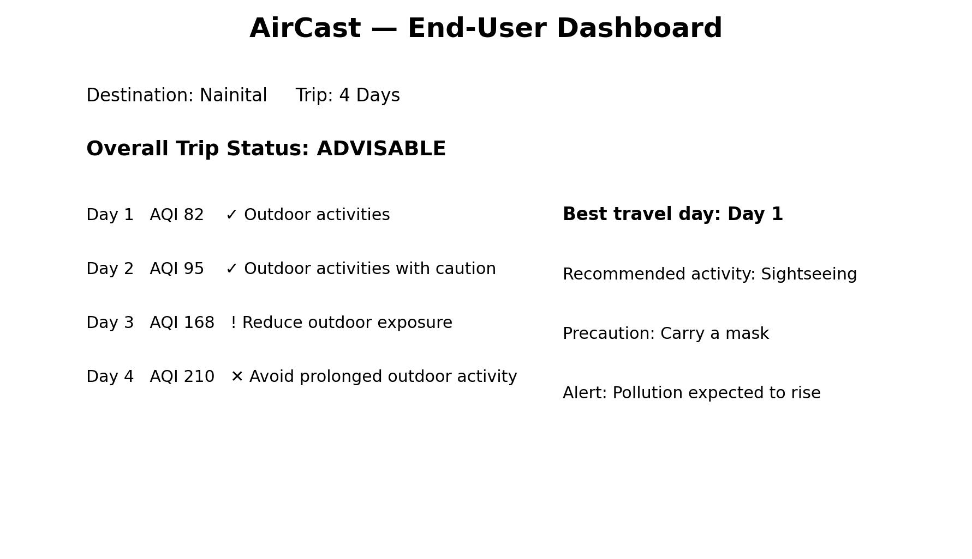
9. End-User Value
The main purpose of AirCast is to transform complex air-quality and machine-learning outputs into simple actions. Instead of asking the user to interpret AQI values alone, the system should answer practical questions: where to go, when to go, what activities are suitable, and what precautions are recommended.

