GLA UNIVERSITY, GREATER NOIDA
Greater Noida – 201310, Uttar Pradesh, India

AIRCAST
Smart Air Quality Prediction & Travel Planning Tool
SOFTWARE REQUIREMENT SPECIFICATION
BACHELOR OF TECHNOLOGY
in
COMPUTER SCIENCE & ENGINEERING – AIML
Submitted By
ROHIT MURARI
Roll No.: 22515500078 | Section: ND
Under the Supervision of  Palash Singh Raghuwanshi  GLA University, Greater Noida | Reviewed By  Gautam Mukherjee  GLA University, Greater Noida

SCHOOL / DEPARTMENT OF COMPUTER SCIENCE & ENGINEERING / APPLICATIONS
GLA UNIVERSITY, GREATER NOIDA – 201310

Revision History
Version | Date | Change | Reason
1.0 | 14/09/2025 | Initial version | First submission

1. Introduction

1.1 Purpose
This document specifies the software requirements for AirCast v1.0, an intelligent web application that forecasts city-level Air Quality Index (AQI) and outdoor-activity suitability for short-term trips (up to 15 days) using live data, and provides trend-based guidance for longer planning horizons using historical patterns.

1.2 Scope
The system accepts a destination city, drawn from a supported-city list, and a trip duration of 1 to 5 days, and returns a predicted AQI for each day of the trip together with a day-wise recommendation covering outdoor-activity suitability, precautions, and an overall Travel Safety Score. The system also allows AQI comparison across up to three destination cities at once.
The system does not book flights, trains, hotels, or any other travel arrangement. The system does not provide medical diagnosis or health-condition-personalized advice; its precautions are general CPCB (Central Pollution Control Board)-band guidance, not tailored to an individual user's medical history. The system does not generate a forecast for a city outside the set of cities covered by its historical dataset and live data sources — such a request is rejected rather than approximated.
Trip duration (how many days the trip lasts, 1–5) is a separate concept from planning horizon (how far in advance of today the trip starts). Planning horizon determines the data source: a start date within the next 15 days uses live API data (short-horizon forecast); a start date more than 15 days out uses historical seasonal trends and outlier detection instead (long-horizon guidance), and is explicitly labelled advisory rather than a precision forecast.

1.3 Definitions
Term | Definition
AQI | Air Quality Index, computed from pollutant concentrations on the CPCB 0–500 scale.
Threshold crossing | The event that tomorrow's AQI moves into a worse CPCB category (e.g., Moderate → Poor) than today's.
Precision@5 | The proportion of the 5 highest-confidence next-day threshold-crossing predictions that are correct; the classifier's primary evaluation metric (Section 3.1).
Travel Safety Score | A single 0–100 number summarizing a multi-day forecast into one trip-level recommendation (FR-3.3).
Supported city | A city present in both the historical training dataset and the live AQI/weather API used at prediction time.
Short-horizon forecast | Next 1–15 days, produced from live APIs plus the trained model.
Long-horizon guidance | 1–2+ months out, produced from historical trends, seasonal patterns, and outlier detection instead of the live model.
Streamlit | Streamlit is an open-source Python framework that allows you to transform data scripts into interactive, shareable web applications in minutes without requiring HTML, CSS, or JavaScript expertise.

2. Overall Description

2.1 User Classes
User class | Who they are | What they may do
End User (Traveler) | Any visitor to the AirCast web app; no account or login in v1.0. | Select one to three destination cities, choose trip dates (1–5 days), view the AQI forecast, activity advisory, precautions, and Travel Safety Score.

2.2 Assumptions and Dependencies
- The system depends on public live AQI/weather APIs (e.g., OpenAQ, CPCB, and a weather provider); when a provider is unreachable or rate-limited, the forecast falls back to the most recently cached reading (FR-2.4) rather than failing outright.
- The system depends on a free-tier hosting plan for the Streamlit app, which may sleep after a period of inactivity; first-request latency after such idle periods is outside the system's control.
- The system assumes the historical dataset (Kaggle "Air Quality Data in India (2015–2020)", city_day.csv) remains representative of current pollutant behaviour for the cities it covers; a structural change in a city's pollution sources over time is not modelled in v1.0.
- Live APIs are the primary source for the next 10–15 days.
- The 2015–2020 historical dataset (plus any cached recent fetches) is the primary source for longer-term trend analysis and "best time to visit" recommendations.

2.3 Constraints
C1: The set of cities the system can forecast for is limited to those with a monitoring station in the historical dataset and matching coverage in the live API; a city with only one of the two cannot be added without collecting new data.
C2: The fixed project timeline (Development Sprint I to Final Presentation, September–December 2026, Section 7.2) bounds the amount of feature-engineering and model iteration possible before the MVP deadline.

3. Data Source, Baseline, and Technology Stack

3.1 Historical Dataset and Baseline Metrics
Item | Value | Required now?
Dataset name | Air Quality Data in India (2015–2020) | Yes
Source and URL | Kaggle — https://www.kaggle.com/datasets/rohanrao/air-quality-data-in-india | Yes
License / Terms of use | CC0: Public Domain | Yes
Number of rows and columns | city_day.csv: 29,531 rows × 16 columns — City, Date, PM2.5, PM10, NO, NO2, NOx, NH3, CO, SO2, O3, Benzene, Toluene, Xylene, AQI, AQI_Bucket, covering 26 cities from 2015 to mid-2020. | Yes
Prediction target | Whether AQI is expected to move into a worse CPCB category within the requested horizon (short-term binary threshold-crossing for 1–15 days; trend/outlier signals for longer horizons). | Yes
Task type | Binary classification (primary short-horizon model) + trend/outlier analysis (long horizon). | Yes
Class balance (estimated) | Threshold-crossing is expected to be the minority class. AQI shows strong day-to-day persistence within a CPCB band, so the positive ("crosses into a worse category tomorrow") case is estimated at roughly 20–30% of city-days, with the exact figure confirmed once city_day.csv is grouped by city and the day-over-day category change is computed in Sprint I. | Yes
Primary evaluation metric | Precision@5 | Yes
Why that metric | AirCast never shows the user a full ranked classification report — it surfaces a short list of the 5 highest-confidence "pollution is about to worsen" alerts (FR-3.4). Precision@5 measures exactly what that feature needs: of the alerts the user actually sees, how many are correct. A model can have mediocre overall accuracy and still be useful here, as long as its top-5 most-confident calls are trustworthy; conversely, high accuracy driven by the (easy) majority "no crossing" days would not show up in this metric at all, which is why it is preferred over plain accuracy for this specific feature. | Yes
Level 0 baseline and its score | Always predicting the majority class ("no crossing") gives no confidence ranking to draw a top-5 alert list from. For comparability, the Level 0 score is Precision@5 under a random ranking of test days, which converges to the crossing base rate above — approximately 0.20–0.30. This is the number any confidence-based ranking has to beat to add real value. | Yes
Known data quality problems | Xylene and NH3 have majority-missing readings across cities and years and are dropped from the feature set; PM2.5 and PM10 are the most complete pollutant columns and anchor it instead. AQI_Bucket is null wherever too many of the pollutant sub-indices needed for the CPCB formula are missing for that day. Monitoring coverage is denser for large metros (Delhi, Mumbai, Bengaluru, Hyderabad) than for smaller cities (Aizawl, Shillong, Jorapokhar), so per-city sample sizes vary widely. A small number of duplicate station-days and physically implausible readings (e.g., negative concentrations) are also present and are dropped during cleaning. | Yes
Short-horizon data source | Live weather + AQI APIs (Open-Meteo, CPCB real-time, OpenAQ) for the next 10–15 days. | Yes
Long-horizon data source | Historical trends + outlier detection from the 2015–2020 (and cached recent) dataset for 1–2+ months ahead. | Yes
Level 1 baseline and its score (planned) | Logistic regression over lag features — previous day's AQI, category, and a 3-day rolling trend — plus city and calendar (month, is-winter) features. To be trained and scored in Sprint II against the same test split as the Level 0 baseline above. | Later
Target for this release (planned) | Precision@5 ≥ 0.70 on the held-out test split — roughly double the Level 0 baseline — considered realistic because the top-5 confidence alerts skew toward the Oct–Jan pollution-rise season, where day-to-day signal is strongest and the model should be most confident. | Later

3.2 CPCB AQI Category Bands
FR-3.1 and FR-2.2 classify every predicted day using the CPCB National AQI categories below (CPCB, 2014). AirCast further collapses these six categories into the three-band Safe / Caution / Avoid advisory shown to the user.
CPCB Category | AQI Range | Health Effect | AirCast Band (FR-3.1)
Good | 0–50 | Minimal impact | Safe
Satisfactory | 51–100 | Minor breathing discomfort to sensitive people | Safe
Moderate | 101–200 | Breathing discomfort to people with lung disease, asthma, or heart disease | Caution
Poor | 201–300 | Breathing discomfort to most people on prolonged exposure | Caution
Very Poor | 301–400 | Respiratory illness on prolonged exposure | Avoid
Severe | 401–500 | Affects healthy people; seriously impacts those with existing disease | Avoid
Safe = Good + Satisfactory; Caution = Moderate + Poor; Avoid = Very Poor + Severe. This mapping drives FR-3.1's classification and the per-day itinerary in FR-3.2.

3.3 Technology Stack
Layer | Technology | Purpose in AirCast
Language | Python 3.11 | Single language across data prep, modelling, and the web app.
Data handling | Pandas, NumPy | Loading and feature-engineering city_day.csv; merging live API responses.
Modelling | scikit-learn | Level 0 majority-class baseline and the Level 1 logistic-regression threshold-crossing classifier (Section 3.1).
Model persistence | joblib | Saving the trained model so the Prediction Service loads it without retraining per request.
Web application | Streamlit | User-facing city/date input and forecast, plan, and alert display (D2, Section 9).
Live data sources | CPCB real-time feed, OpenAQ, Open-Meteo | Current AQI and weather readings for the Live Data Fetcher (FR-4.1).
Historical data | Kaggle "Air Quality Data in India (2015–2020)" | Trains the classifier and drives long-horizon trend/outlier guidance (Section 3.1).
Analyst dashboard | Power BI | Separate trend and model-performance reporting over the Prediction Log (D3, Section 9).
Hosting | Streamlit Community Cloud (free tier) | Public deployment for the live demo URL (Section 2.2, AC-1 through AC-4).
Version control | Git / GitHub | Source history and the single-developer workflow across the three sprints (Section 7.2).

4. System Architecture
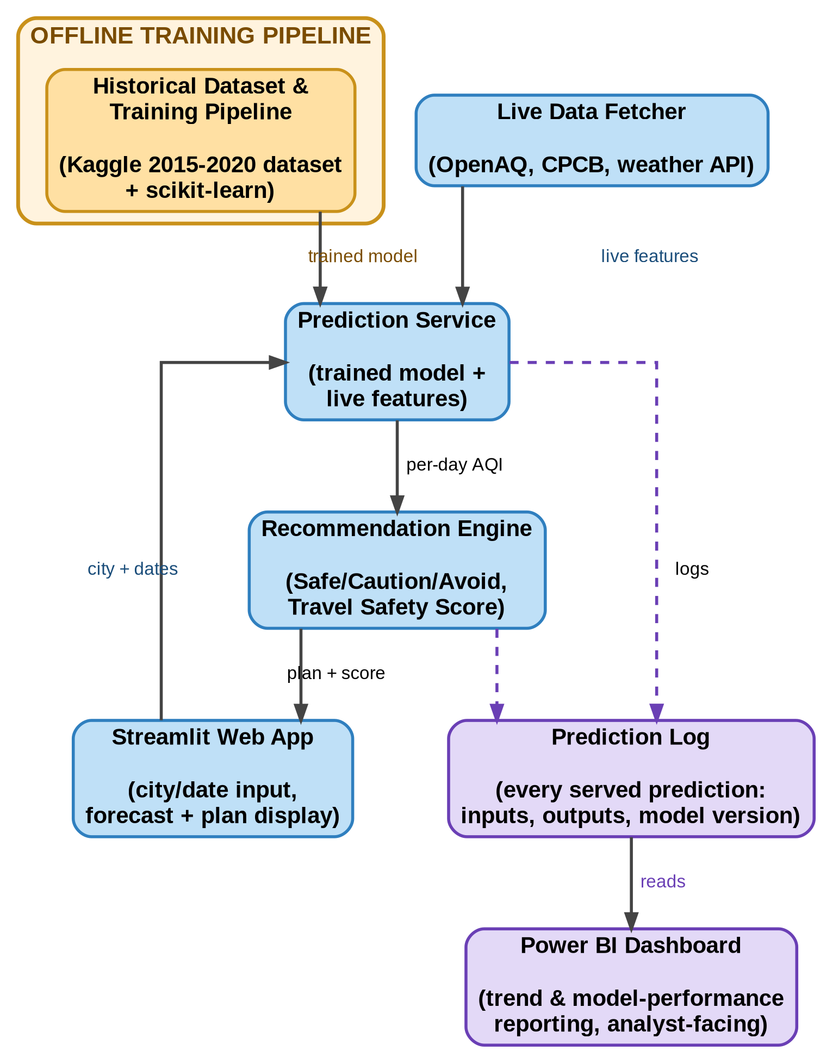
Figure 1: AirCast system architecture — the offline training pipeline (amber, top left) fits the classifier once from the historical dataset; the online per-request path (blue) combines that trained model with live features on every request; every served prediction is logged (purple) for the separate Power BI dashboard.
Component | Responsibility
Live Data Fetcher | Pulls current AQI and weather readings for supported cities from public APIs (OpenAQ, CPCB, Open-Meteo — Section 3.3) on a fixed schedule and normalises them into the model's feature format.
Historical Dataset & Training Pipeline | Engineers features from the 2015–2020 station-level history and fits the next-day threshold-crossing classifier offline, using scikit-learn (Section 3.3).
Prediction Service | Given a city and a date range, combines the trained model with the latest live features and returns a per-day AQI forecast.
Recommendation Engine | Converts each day's forecast into a Safe/Caution/Avoid band (Section 3.2), a precaution list, and the trip's overall Travel Safety Score.
Streamlit Web App | Collects the user's destination city/cities and trip dates, and renders the forecast, plan, and alerts (D2, Section 9).
Prediction Log | Stores every served prediction with its inputs, outputs, and model version, for later evaluation (NFR-3).
Power BI Dashboard | Reads the Prediction Log to show trend and model-performance reporting, separate from the live user-facing app (D3, Section 9).

5. Functional Requirements

5.1 Destination and Trip Input
FR-1.1 The system shall allow the user to select a destination city from the list of supported cities (Section 2.3, C1).
FR-1.2 The system shall allow the user to select a trip duration of 1 to 5 days (inclusive) for the selected destination city.
FR-1.3 The system shall reject a start date earlier than the current date, displaying an error stating the date must be today or later.
FR-1.4 The system shall allow the user to select between 2 and 3 destination cities at once for AQI comparison.

5.2 Model-backed Prediction
FR-2.1 The system shall accept a valid (city, date-range) request and reject a city outside the supported list, naming that city in the error.
FR-2.2 The system shall return a predicted AQI value and CPCB category (Good / Satisfactory / Moderate / Poor / Very Poor / Severe — Section 3.2) for each day of the requested trip.
FR-2.3 The system shall present each day's predicted AQI together with a confidence indicator derived from the model's prediction interval.
FR-2.4 The system shall, when the live API or the prediction service is unavailable, display the most recent cached AQI value labelled "last known" instead of showing an empty result.
FR-2.5 The system shall allow the end user to mark a day's plan as manually overridden (e.g., "going anyway") without altering the underlying prediction.

5.3 Output and Recommendation
FR-3.1 The system shall classify each predicted day into Safe, Caution, or Avoid for outdoor activity, using the CPCB category bands and Safe/Caution/Avoid mapping defined in Section 3.2.
FR-3.2 The system shall generate a day-wise itinerary recommending outdoor versus indoor activities for each day of the trip, based on its Safe/Caution/Avoid band.
FR-3.3 The system shall display a single overall Travel Safety Score, an integer from 0 to 100, computed from the trip's day-wise predictions.
FR-3.4 The system shall alert the user when the predicted AQI is expected to rise by more than one CPCB category between two consecutive days of the trip.
FR-3.5 The system shall reject a comparison request for fewer than 2 or more than 3 cities, stating the valid range in the error.

5.4 Live and Historical Data Handling
FR-4.1 The system shall automatically refresh live AQI and weather readings for every supported city at a fixed interval of 60 minutes.
FR-4.2 The system shall flag a live reading that falls outside physically plausible bounds (e.g., a negative AQI) and fall back to the last valid cached reading for that city instead of using it.
FR-4.3 The system shall route a forecast request to the live-data model when the requested start date is within 15 days of the current date, and to the historical trend/outlier-based estimator, labelled "long-range advisory," when the requested start date is more than 15 days ahead.

6. Non-Functional Requirements
NFR-1 A forecast request for a trip of up to 5 days across up to 3 cities shall be returned within 3 seconds at the 95th percentile.
NFR-2 The system shall store every external API key server-side as an environment variable, never in client-side Streamlit code, logs, or the Prediction Log.
NFR-3 The system shall log every served prediction with a timestamp, city, requested dates, predicted values, and model version identifier, to enable later comparison against the Section 3.1 baselines.
NFR-4 The Streamlit UI shall render the forecast and plan within 1 second of the Prediction Service responding, so rendering itself adds no more than 1 second of perceived delay.

7. Build Plan

7.1 Minimum Viable Product
FR/NFR ID | Requirement (short) | Why this one is in the MVP
FR-1.1 | Select destination city | Every later feature depends on knowing which city was requested; nothing else can run first.
FR-1.2 | Select trip duration (1–5 days) | Defines how many days the forecast loop must produce; core to the MVP's single-city flow.
FR-2.1 | Accept/reject (city, dates) | Without this, the prediction service and every downstream feature could silently receive an unsupported city.
FR-2.4 | Fallback to last cached reading | Keeps the MVP demonstrable even when a free-tier live API (Section 2.2) is down or rate-limited during a demo.
FR-3.1 | Safe/Caution/Avoid classification | Turns a bare AQI number into the actionable decision the project exists to support; without it the MVP is only a number, not an advisor.
NFR-1 | 3-second response bound | Confirms the Streamlit UI stays visibly responsive rather than appearing frozen during a live demo.
NFR-3 | Prediction logging | Needed from day one so the Level 1 baseline (Section 3.1) can later be compared against what was actually served, not reconstructed afterwards.
Deliberately not in the MVP: FR-2.5 (manual override of the plan). It felt important for user trust, but it needs the base Safe/Caution/Avoid flow (5.3) working first, and would benefit from seeing how real users react to that labelling before designing an override control.

7.2 Build Order
Fixed project stages, with the work window that ends at each deliverable date:
Stage | Deliverable | Start | End
Development Sprint I | Prototype / initial working model | 18 Aug 2026 | 22 Sep 2026
Development Sprint II | 50% functional application | 23 Sep 2026 | 17 Oct 2026
Development Sprint III | 75–80% functional application | 18 Oct 2026 | 7 Nov 2026
Testing & Validation | Test report and bug log | 8 Nov 2026 | 17 Nov 2026
Deployment & Documentation | Deployed application, user manual, technical documentation | 18 Nov 2026 | 30 Nov 2026
Final Presentation | Final report, presentation and viva | 5 Dec 2026 | 10 Dec 2026

8. Data Requirements

8.1 Entities
Entity: Trip Forecast Request
Field | Type | Constraint / Notes
id | UUID | Primary key.
city | string | Not null; must be one of the supported cities (Section 2.3, C1; FR-2.1).
start_date | date | Not null; must not be earlier than the current date (FR-1.3).
duration_days | integer | Not null; 1–5 inclusive (FR-1.2).
requested_at | timestamp | Not null; set by the server on receipt.
forecast_mode is not a stored input — it is derived at request time from (start_date − requested_at), per FR-4.3: "live" if ≤15 days, "advisory" otherwise. Storing the derived value alongside the request is optional and left for a later version.
Other entities: AQI Reading (station-level historical and live pollutant readings), City Master (supported city → monitoring station mapping), Prediction Log (one row per served forecast, per NFR-3). Their key fields and relationships are shown in the entity-relationship diagram below (Section 8.2); full field tables for these come in a later version.

8.2 Entity Relationship Diagram
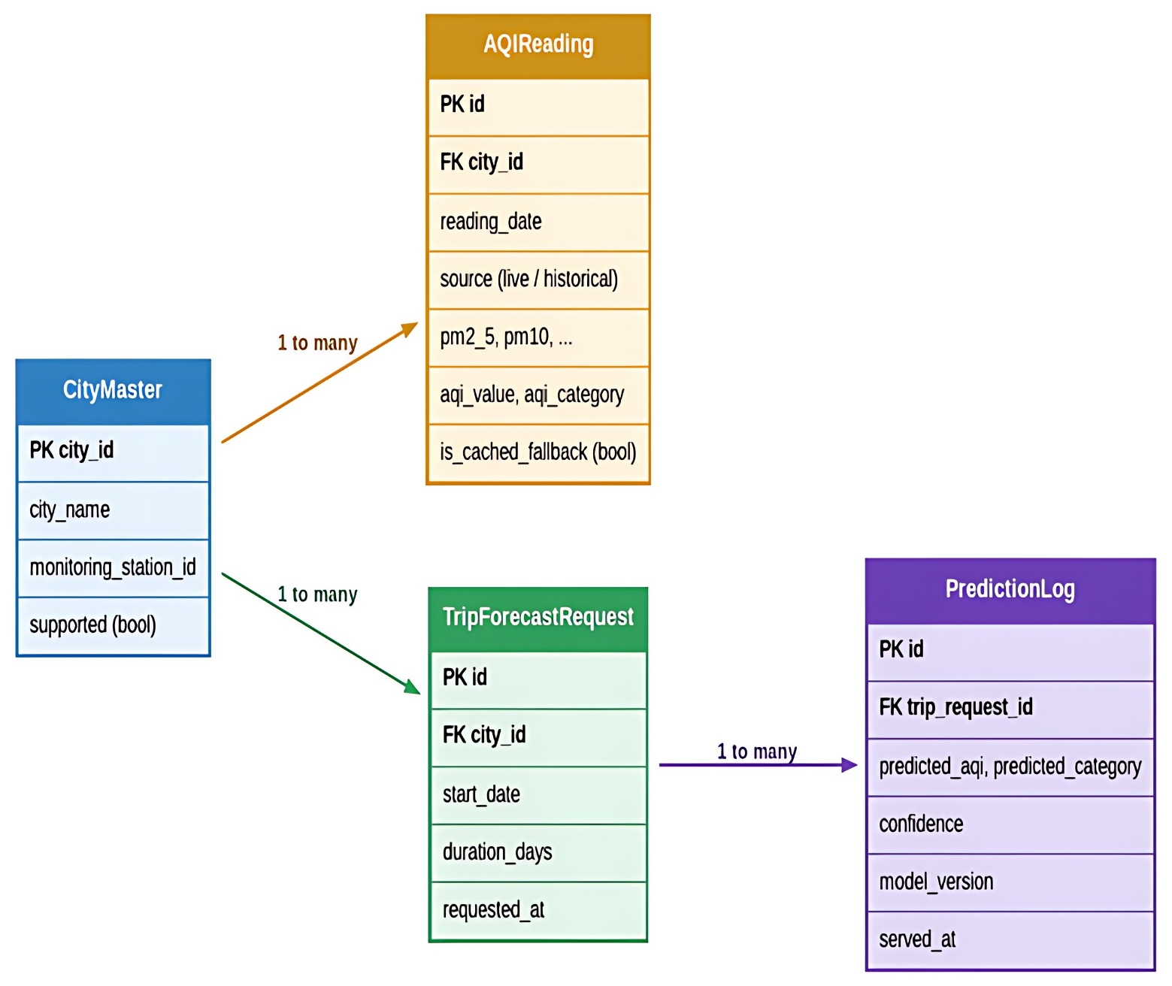

Figure 2: AirCast entity-relationship diagram. A City Master row (Section 2.3, C1) owns many AQIReading rows (one per station-day, live or historical) and many Trip Forecast Request rows (one per user request, Section 8.1); each Trip Forecast Request produces many Prediction Log rows — one per forecast day served, per NFR-3.
All four relationships are one-to-many: a city is referenced by many readings and many requests, and a single request (a multi-day trip) is logged as one Prediction Log row per day. AQI Reading, City Master, and Prediction Log show only the fields needed to support the relationships above; their complete field tables — with the same Type / Constraint columns as Trip Forecast Request in Section 8.1 — remain for a later version, once the schema is implemented against a real database rather than sketched from requirements.

9. Design Decisions and Alternatives Considered
# | Decision | Alternative rejected | Reason
D1 | Predict next-day AQI threshold crossing (binary) rather than the raw AQI value. | Regression on the numeric AQI value. | A regression model minimises overall numeric error, which does not guarantee small error exactly at the CPCB band boundary — the one point that actually flips the Safe/Caution/Avoid label (Section 3.2). Framing the problem as boundary-crossing classification optimises directly for the decision the app needs, rather than for numeric closeness that can be accurate mid-band and still wrong at the boundary that matters.
D2 | Streamlit for the user-facing app. | A hand-built Flask/React frontend. | As a solo project across three fixed sprints ending 7 Nov 2026 (Section 7.2), Streamlit's built-in city/date widgets and one-command deployment remove the frontend build-and-hosting effort a hand-built app would need, so the limited sprint time goes into the prediction pipeline (Sections 3–6), which is the project's actual contribution.
D3 | Power BI as a separate analyst-facing dashboard. | Plotly/Matplotlib charts embedded directly in the Streamlit app. | Keeping Power BI separate keeps the Data Visualization coursework deliverable distinct from the production Streamlit tool, and lets the Prediction Log (NFR-3) be explored and iterated on without redeploying or touching the live user-facing app.

10. Acceptance Criteria
AC-1 Selecting Delhi with a 4-day trip starting tomorrow returns a per-day AQI forecast and a Safe/Caution/Avoid label for all 4 days, within the NFR-1 time bound.
AC-2 Selecting a city outside the supported list returns an error naming that city, and no forecast is generated or logged.
AC-3 (Failure path) With the live API temporarily unreachable, requesting a forecast for a supported city displays the last cached AQI labelled "last known" instead of an empty or broken screen.
AC-4 Selecting a start date before today is rejected with an error stating the date must be today or later, and no request reaches the Prediction Service.

11. Out of Scope for This Release
Flight, hotel, or train booking integration. AirCast recommends when to travel; it does not connect to any booking platform to make or hold a reservation.
International destinations. v1.0's supported-city list (Section 2.3, C1) is limited to Indian cities with historical station coverage; extending abroad needs new training data (Section 4) and is future scope, not this release.
Medical/health-condition-personalized precautions. Precautions in Section 5.3 are general CPCB-band guidance, not adjusted for a user's asthma, age, or other condition, because the system collects no health data in v1.0.

Appendix A: State Model
Not required for v1.0 — to be completed in a later version, once a component of the system (e.g., a forecast request or a live-data refresh job) has a named lifecycle worth modelling as states.

Appendix B: Traceability
Not required for v1.0 — to be completed once the task board and test cases exist. Start with the MVP requirements from Section 7.1: each will need a task card ID and, later, a test case ID.

