**Robotic Process Automation**

**Introduction to RPA**

Robotic process automation (RPA) is the application of technology that allows employees in a company to configure computer software or a “robot” to capture and interpret existing applications for processing a transaction, manipulating data, triggering responses and communicating with other digital systems.

Any company that uses labor on a large scale for general knowledge process work, where people are performing high-volume, highly transactional process functions, will boost their capabilities and save money and time with robotic process automation software.

Just as industrial robots are remaking the manufacturing industry by creating higher production rates and improved quality, RPA “robots” are revolutionizing the way we think about and administer business processes, IT support processes, workflow processes, remote infrastructure and back-office work. RPA provides dramatic improvements in accuracy and cycle time and increased productivity in transaction processing while it elevates the nature of work by removing people from dull, repetitive tasks.

The technology of RPA can be applied specifically to a wide range of industries.

**Process automation**

Technologies like presentation-layer automation software – a technology that mimics the steps of a rules-based, non-subjective process without compromising the existing IT architecture – are able to consistently carry out prescribed functions and easily scale up or down to meet demand. Process automation can expedite back-office tasks in finance, procurement, supply chain management, accounting, customer service and human resources, including data entry, purchase order issuing, creation of online access credentials, or business processes that require “swivel-chair” access to multiple existing systems.

**IT support and management**

Automated processes in the remote management of IT infrastructures can consistently investigate and solve problems for faster process throughput. RPA can improve service desk operations and the monitoring of network devices. Separating scalability from human resources allows a company to handle short-term demand without extra recruiting or training.

**Automated assistant**

As in voice recognition software or automated online assistants, developments in how machines process language, retrieve information and structure basic content mean that RPA can provide answers to employees or customers in natural language rather than in software code. This technology can help to conserve resources for large call centers and for customer interaction centers.

As RPA brings more technologically-advanced solutions to businesses around the world, operating models that adopt automation, whether in-house or offshored, will cut costs, drive efficiency and improve quality.

**Benefits of RPA**

**Wide-range automation**

Spanning across an ever increasing number of industries, RPA speeds up and executes with perfect accuracy processes in the fields of banking & finance, insurance, healthcare, manufacturing, telecom and many more. A virtually boundless spectrum of increasingly complex functions can be automated, by improving in more than one way every transactional, high-volume process.

##### Rapid ROI

Typically, one software robot can replace and outperform 3 workers. In less than 12 months, most enterprises already have a positive return on investment. Moreover, potential further accumulative cost reductions can reach 20% in time.

##### Enterprise scalability

RPA introduces a highly flexible and scalable virtual workforce with reduced induction time. Additional robots can be deployed quickly with minimal costs, according to work flux and seasonality. Have them perform a massive number of operations in parallel, from desktop to cloud environments. All of this, while allowing multiple users to monitor and control software robots from multiple business units around the globe, from a single secure device.

##### Powerful analytics

Gathering data becomes agile and exhaustive. This enables better management and provides insights for ongoing business enhancement. Every robot’s activity can be logged and interpreted through customized reporting tools. Improved governance and compliance can be easily achieved as requirements are set in the automation rules.

**RPA Lifecycle**

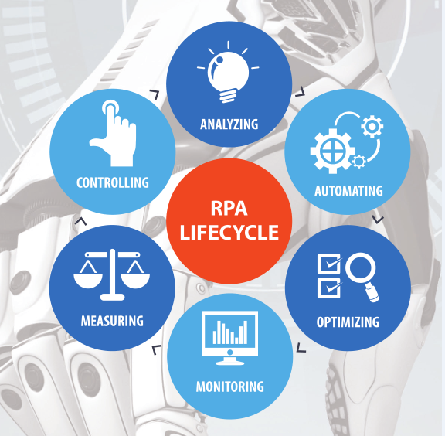

**Limitation of RPA**

1. The work speed of the bot is limited to the speed of the application.
2. Tasks that require judgements & creativity cannot be automated.
3. Even minor changes to the applications will need the robots to be reconfigured.