

Charter-Automation
UI PATH
Version 1.0

© Xavient Information Systems
This document contains the confidential and proprietary information of Xavient Information Systems, the disclosure of which would provide a competitive advantage to others. As a result, no part of this document should be disclosed, used, duplicated, reproduced, stored, copied, or transmitted, in whole or in part, in any form or means, electronic, mechanical, photocopying or otherwise without the express consent of Xavient Information Systems. This document shall remain the property of Xavient Information Systems.
This restriction does not limit the rights of the recipient to use information contained within the document if it is rightfully obtained from the source without restriction. The data subject to this restriction are contained in the entire document

Xavient Information Systems
2125 C Madera Road; Simi Valley, C.A 93065.
Main Line: 1.805.955.4111, Fax Line: 1.805.955.4144 Visit us: www.xavient.com
Version Summary

Version No. | Prepared By | Reviewed By | Approved  By | Release Date
1.0 | ChandanPanigrahi/ Chirag Singh  /  PaPanigrahi

Modification Details
Version No. | Release Date | Description Of Change (if any)

Contents
Contents 3
1. Introduction 4
1.1 Purpose 4
1.1. Scope 4
2. Introduction to Ui Path 4
2.1. Overview 4
2.2. Hardware Requirements 5
2.3. Software Requirements 5
3. Installing and Licensing UiPath Studio 5
3.1. Download 5
3.2. Installing Ui Path - Windows Installer (.msi) 6
3.3 Licensing 8
3.4 Activating Studio License 10
3.5 Online Activation 11
3.6 Offline Activation 12
4. User Interface of UiPath 15
4.1. The Ribbon 16
4.2. The Universal Search Bar 17
4.3. The Designer Panel 17
4.4. The Activities Panel 18
4.5. The Library Panel 20
4.6. The Project Panel 20
4.6. The Properties Panel 21
4.7. The Outline Panel 22
4.7. The Output Panel 23
5. Scripting in UiPath 24
5.1. UiPath Scripts for Hallwaze login 24
6. Conclusion: 29
7. Future Plans 29

1. Introduction

Purpose
The purpose of the document is to provide an insight details function of Ui Path RPA tool for Web application. The document mainly focuses on the approach, benefits of using RPA (Robotic Process Automation).

Scope
This is introductory document and therefore the scope of this document is limited to give an overview of Ui Path tool.

Introduction to Ui Path

Overview
UiPath Studio is a complete solution for application integration, and automating third-party applications, administrative IT tasks and business IT processes. One of the most important notions in Studio is the automation project.
A project is a graphical representation of a business process. It enables you to automate rule-based processes, by giving you full control of the execution order and the relationship between a custom set of steps, also known as activities in UiPath Studio. Each activity consists of a small action, such as clicking a button, reading a file or writing to a log panel.
The main types of supported projects are:
- Sequences - suitable to linear processes, enabling you to smoothly go from one activity to another, without cluttering your project.
- Flowcharts - suitable to more complex business logic, enabling you to integrate decisions and connect activities in a more diverse manner, through multiple branching logic operators.
- State Machines – suitable for very large projects; they use a finite number of states in their execution which are triggered by a condition (transition) or activity.
(Reference link - https://studio.uipath.com/docs/introduction)

2.2. Hardware Requirements

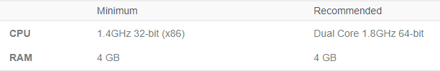
Reference Link – (https://studio.uipath.com/docs/hardware-requirements)

2.3. Software Requirements

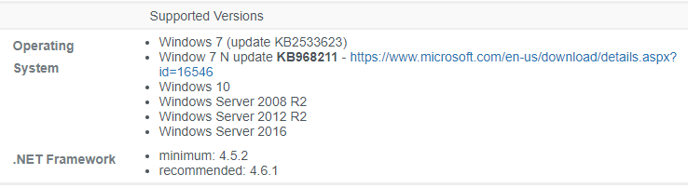
Reference Link – (https://studio.uipath.com/docs/software-requirements)

3. Installing and Licensing UiPath Studio
Load Complete is a smart bear product that can run on Windows, with minimum system requirement mentioned below.

3.1. Download

Find UiPath installer from following link with 60 day trail version:
(https://www.uipath.com/download-free-automation-software-trial)

Note - Provide all the mandatory details and click on Request Trail for downloading setup file.

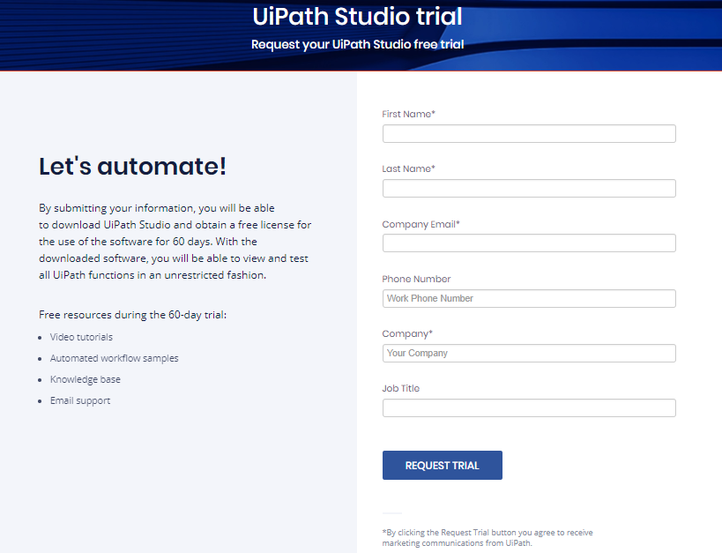

Installing Ui Path - Windows Installer (.msi)
- The UiPath Platform installer (UiPathPlatform.msi) enables you to install the entire UiPath suite. However, please note that the UiPath Orchestrator component is not displayed if you do not launch the installer as an administrator from the command line and if IIS 7+ is not installed on the machine.
- After reading and accepting the terms of the License Agreement, the following Advanced options are available:
- UiPath Studio - Instals Studio. This option is enabled by default.
- UiPath Robot - Instals the Robot on the local hard drive. This option is enabled by default and cannot be disabled.
  - Register as Windows Service - Installing the Robot as a Windows Service or in a user mode. By default, the Robot is installed as a Windows Service.
  - Install local activities feed - Instals the activities feed locally, in the %localappdata%\UiPath\Activities folder. This option is enabled by default. Having the activities packages locally is useful if you do not intend to connect your Robot to Orchestrator, or you want to have a better control of the activities used in an automation project.
  - Automatically start client - Running the Robot at Windows startup. This option is disabled by default.
  - Java Bridge - Install the UiPath Java Bridge for a better integration and automation in regards to Java applications. This option is disabled by default. Please note that installing the Java Bridge may cause the installation to last longer than usual.
- To change the default installer settings, click the button next to each feature and select one of the following options:
- Will be installed on the local hard drive - helps you install the corresponding feature on the local hard drive.
- Entire feature will be installed on the local hard drive - installs the corresponding feature on the local hard drive, along with all its sub-features.
- Entire feature will be unavailable - does not install the corresponding feature.
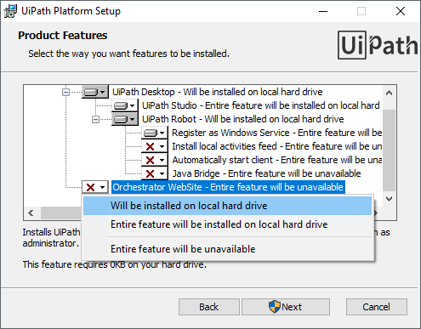

Licensing

After installing and running Studio for the first time, the user is prompted with a license activation wizard, where he is presented with several choices.
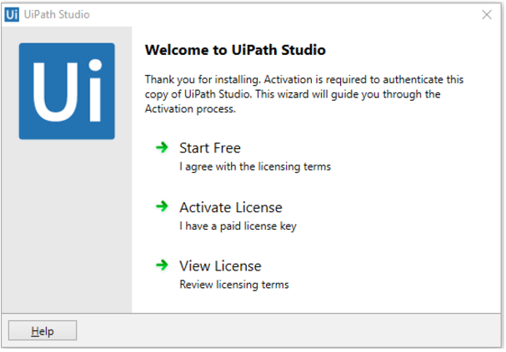

- Start Free - A free Community license can be requested, lasting for a limited period of time, which is renewable. This option can only be activated online. The Robot that comes with the Community Edition Studio can only be connected to the UiPath Orchestrator Comunity Edition, under your own tenant.
- Activate License - If the user has an enterprise license code, Studio can be activated by selecting this option. This type of license activates the Enterprise Edition of Studio. For computers running in a closed network or with no internet access, Studio can be licensed offline, as explained here.
- View License - The licensing terms can be reviewed at all times by selecting this option.
Activating Your License While Installing
- The UiPath suite can be activated while running the UiPath Platform installer, using the Command Prompt. To perform this action you must run it with the CODE command, followed by the license code. For example:
C:\UiPathPlatform.msi CODE=1234567890
- Also, for an unattended installation, there are some silent parameters that you can use:
- /quiet - Quiet mode, no user interaction
- /passive- Unattended mode - progress bar only
- /q[n|b|r] - Sets user interface level
  - n - No UI
  - b - Basic UI
  - r - Reduced UI
- For example:
C:\UiPathPlatform.msi CODE=1234567890 /passive installs all the default features and activates your license, showing a progress bar.
Activating You License after Installation
- After performing a normal installation, you can automatically license your product from the Command Prompt. You can use the following command C:\Program Files (x86)\UiPath Platform\UiPath\regutil.exe activate /email=documentation@uipath.com /code=1234567890, where /email is your valid email address, and /code is the license code you wish to utilize.

Activating Studio License

Note -
The Windows 10 16.07 Anniversary Update changes the device ID of the machine it is installed on. This leads to Studio and Robot licenses becoming corrupted. Similarly, other buggy major future updates or refreshing your Windows installation might cause the same issue. To fix this, your license needs to be reactivated.

Online Activation
After installing and running Studio for the first time, the user is prompted with a license activation wizard. To activate a paid license, select the Activate License button.
Note:
An Activation Error might be displayed during the licensing process if an antivirus is installed on the machine. To avoid the error message, Studio has to be whitelisted in both the antivirus and the Firewall.

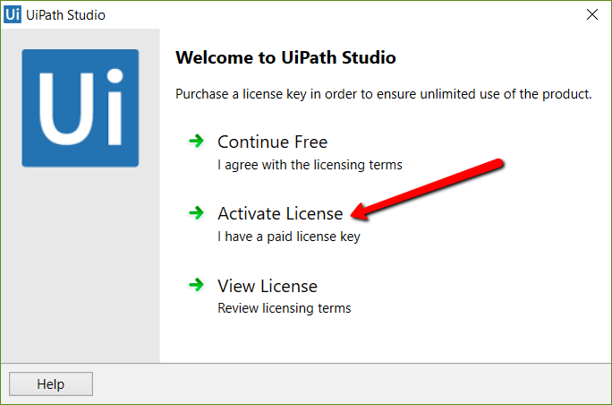
Enter your e-mail address and your license key in the UiPath Registration step and finish the activation by pressing the Activate button.
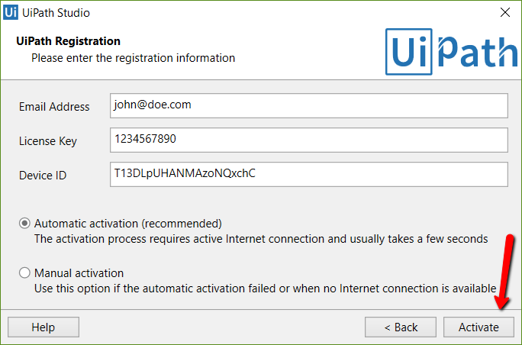

Offline Activation
When UiPath Studio is installed on a machine that is not connected to the internet or when your network security software/firewall prevents access to our license validation server, you can manually activate it by following the steps below:
Note:
You have to keep the Activation Window open until the process is complete.
- The Activation Certificate must be sent to a machine that has an internet connection, or is not blocked by a security software/firewall. There are 2 ways to do that:
- Press the Email activation button. If on the current machine there is an email program set as default (Outlook, Thunderbird, etc.), a new email containing the activation information will be created automatically. Otherwise, a warning message will be displayed. Press the Next button afterwards.
- Press the Copy to clipboard button. This will copy the activation information to the clipboard. Paste it into a file (or an email) and send it to a machine that has an internet connection, or is not blocked by a security software/firewall. Press the Next button afterwards.
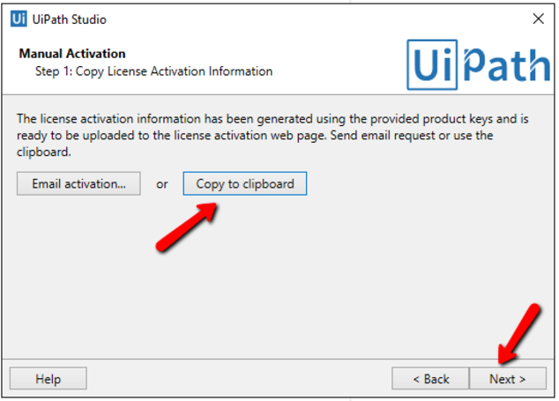
On the machine with internet connection:
a. Access the Activation portal.
b. Paste the Activation Certificate (that was sent in the previous step) into the empty field in the page.
c. Click Activate. The Server Response is generated. Copy and save the generated response from server to a .txt file and copy/send it via email or USB flash drive back to the machine where UiPath Studio is installed.
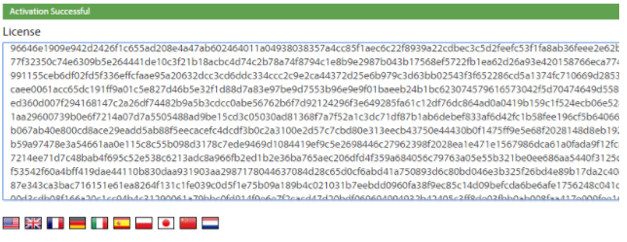
In Studio, click next. Step 3 of the Manual Activation is displayed.
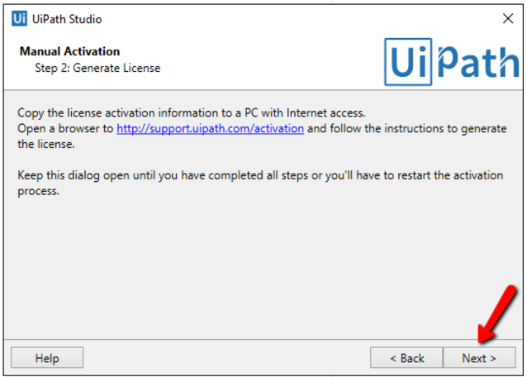

Paste the license data (The server response) obtained in the previous steps in the activation window. There are two ways to do this:
Press the Load from file button and insert the .txt with the server response.
Copy the server response and press the Paste from clipboard button.
Click Activate. The license is activated for the given machine.
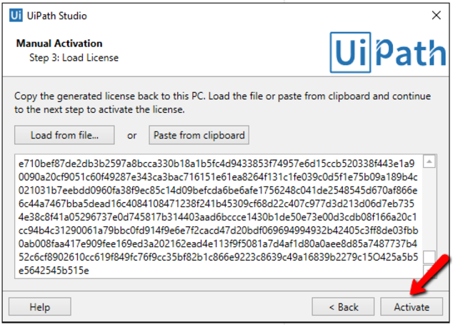

User Interface of UiPath
UiPath Studio contains multiple panels for an easier access to specific functionalities. They can be docked, act as floating windows, or the Auto-hide option can be enabled.

4.1. The Ribbon

- Start - create a project or open a previously created one, switch to a Beta or Stable version, go to the online documentation or submit a request. By default, projects are created in C:\Users\Username\Documents\UiPath.
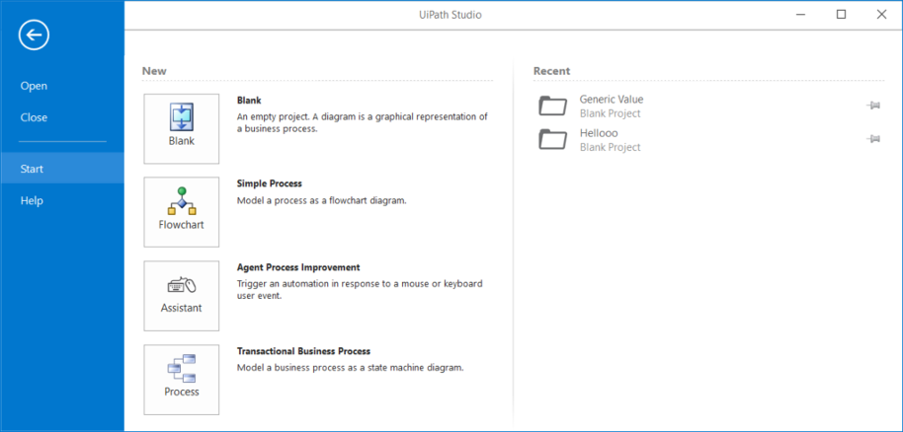

- Design - create or launch sequences, flowcharts or state machine diagrams, access wizards, manage variables, and inspect user interface elements from third-party apps.
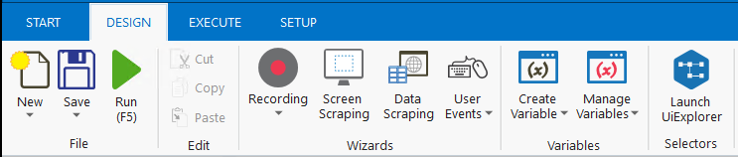

- Execute - run or stop projects, start the debug process, slow down steps and open logs.
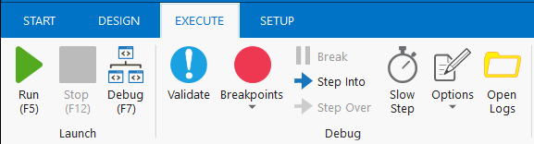
- Setup - publish a project or create a shortcut for it, schedule tasks, and install extensions with just one click.
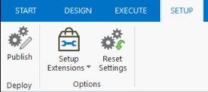

4.2. The Universal Search Bar

The Universal Search bar enables the user to find anything contained in the Activities, Libraries, Project and Designer panels of Studio.
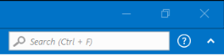

4.3. The Designer Panel
The Designer panel displays your current automation project, enables you to make changes to it, and provides quick access to variables, arguments and imports .
It is possible to navigate within a diagram by double-clicking the activity you want to view. The path is displayed as breadcrumbs in the header of the Designer panel.

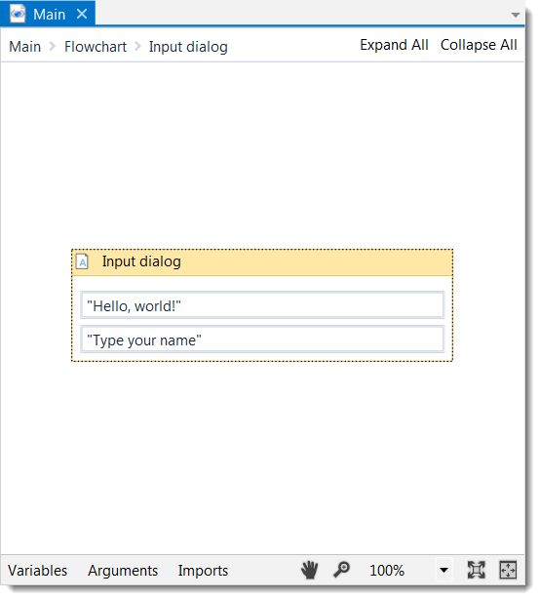

4.4. The Activities Panel
The Activities panel provides quick access to all available activities that can be dragged to the current project.
It features a search box, and the Show Activities list enables you to hide or show the Favorites, Recent and Available folders of activities.
The Manage Packages functionality enables you to install additional activity packages.
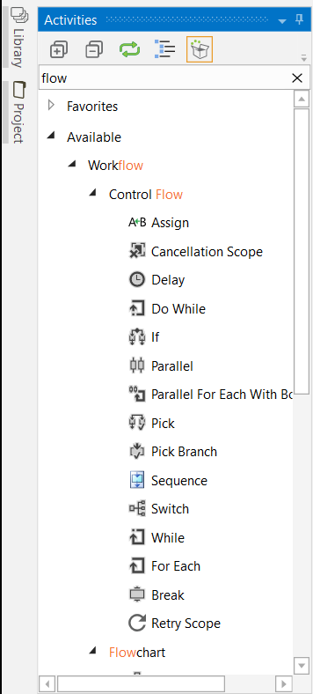

4.5. The Library Panel
The Library panel enables you to easily reuse automations. A search box is included to facilitate finding items faster.
It includes, by default, multiple samples and snippets, and you can add your own by clicking the Add Folder button and selecting a directory from your hard drive.
To remove a folder, right-click it and select Remove.
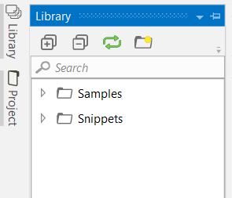

4.6. The Project Panel
The Project panel enables you to view the contents of the current project and open the file location in a Windows Explorer window.
You can connect to a type of source control, either TFS or SVN, and create a new project directly from this panel.

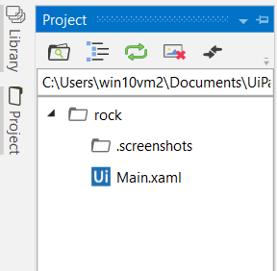

4.6. The Properties Panel
The Properties panel is contextual and enables you to view and change the properties of a selected activity.
The properties can be sorted alphabetically, while the search box enables you to look for a specific one.
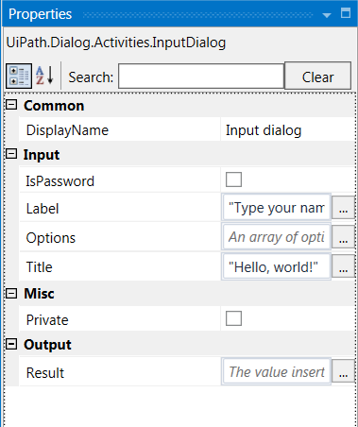

4.7. The Outline Panel
The Outline panel displays the project hierarchy, all available variables and nodes, and includes a search box. This enables you to easily navigate through large automations.
You can highlight activities in this panel by selecting them in the Designer panel, or you can go to a specific activity by selecting it in the Outline panel.
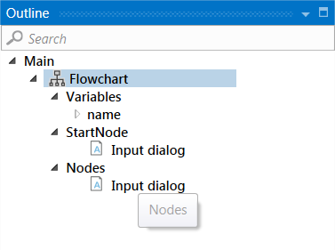

4.7. The Output Panel
The Output panel enables you to display the output of the Log Message or Write Line activities, as well as the logs when the debug mode is activated.
When debugging, the logs are more or less detailed, depending on the option you selected in the Execute tab, under Options > Logging Level.
You can hide or show timestamps, errors, warnings, information or trace data, by clicking the buttons in the panel’s header. Additionally, the Clear All button erases all info displayed in the Output panel.
Double-clicking a message displays further details about it.
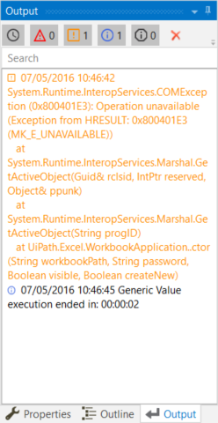

Scripting in UiPath

5.1. UiPath Scripts for Hallwaze login

Create a project in uipath
- Click on start
- Click on Blank
- Give the Project Name and Click on Create
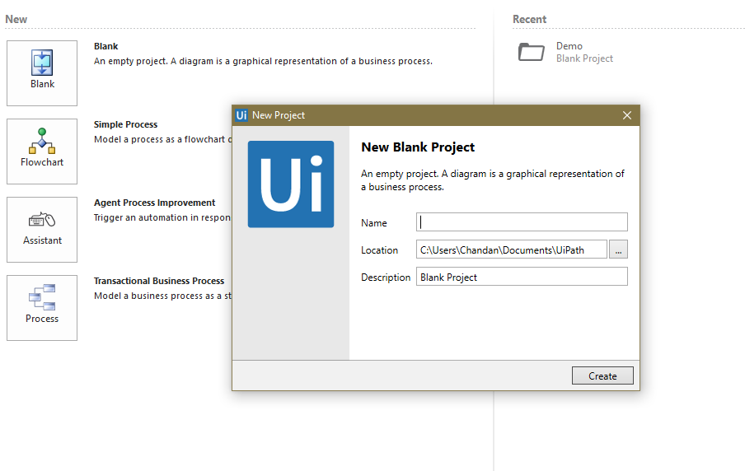
Create a Sequence Project-
- Click On New
- Click On Sequence
- Give the sequence name and click on Create
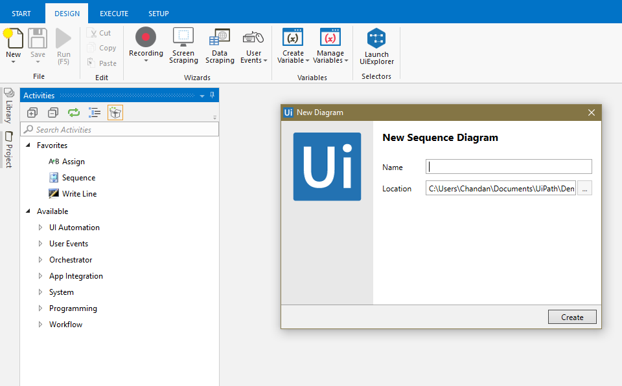

- Now in Search activities bar search open browser (It is used for launch the browser)
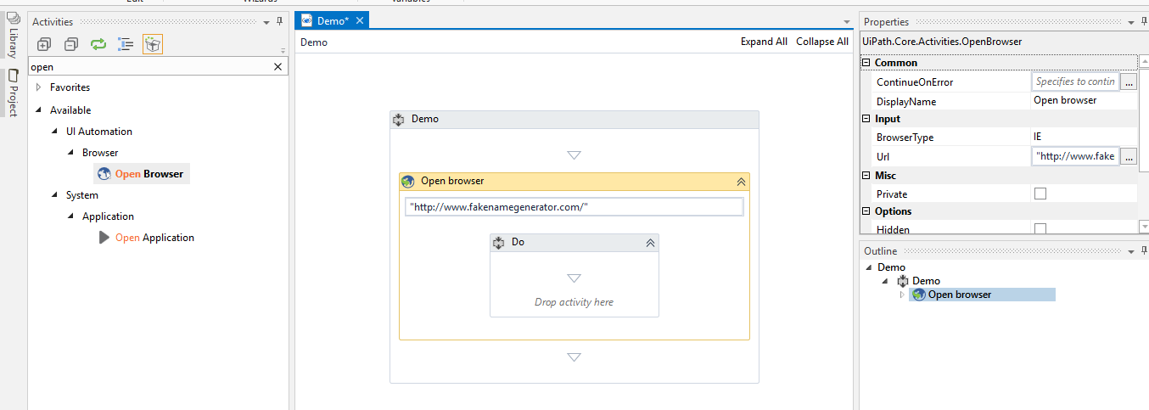
- Search for click in activities bar (It is used for click on any web element)
- Click on indicate element inside browser to indicate any element
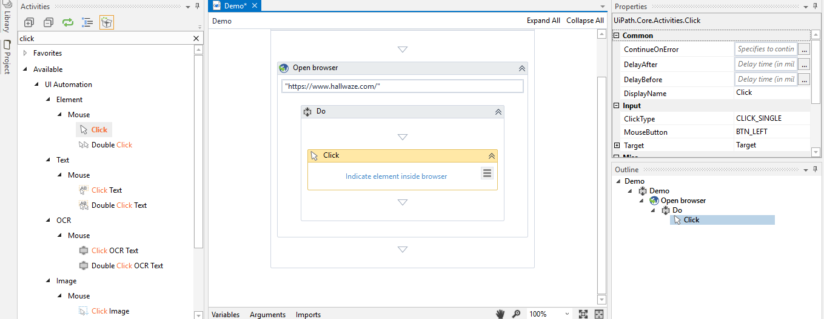

- Search for type into in activities bar (It is used for send values)
- Click on indicate element inside browser to indicate any element
- Send the value inside the text bar

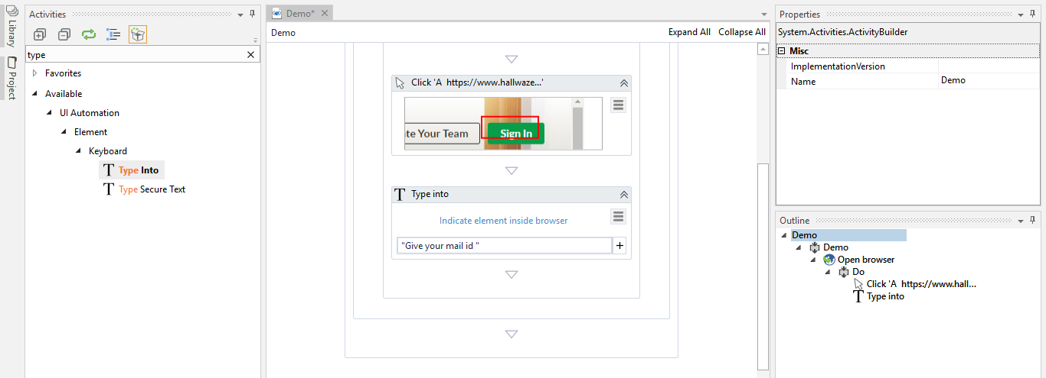
- Perform the click operation to click on next Button
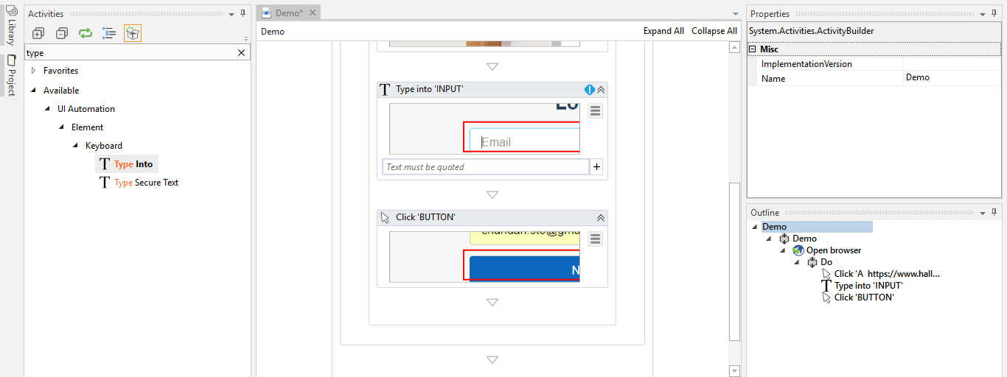

- Perform the type into for sending value inside the password field
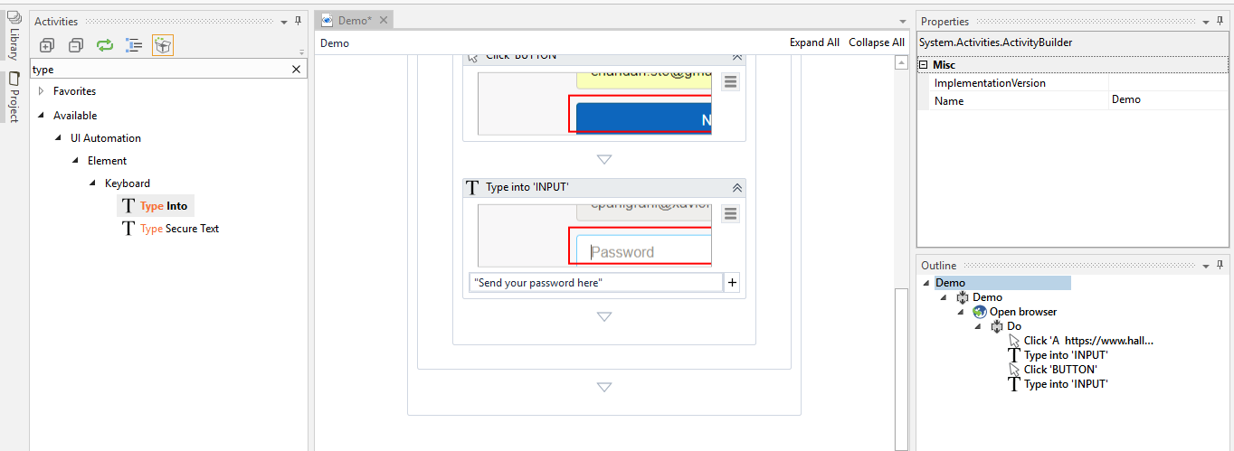
- Perform the click operation to click on Sign In button
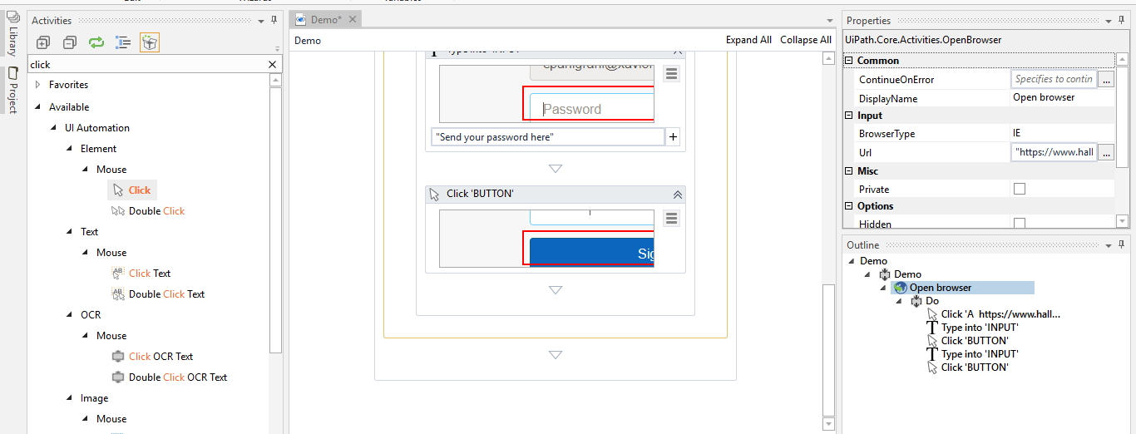

- Save the script by clicking on save button.

- Now click on run button to execute the script.

- See Pass and Fail logs generate on the console.

Conclusion:
Why UI Path is different from other automation tools?
- No need of program knowledge.
- Robot can work 24X7 and they don’t take line off.
- Robot can be trained to do more than one process at different schedules.
- Robot can work across the multiple platforms like windows, web, java and main frame application.
- Robot improves efficiency and accuracy on human tasks.

Future Plans
Will do R&D in below points:
- Different kinds of bots which are available in UI Path
- Reporting and logs.
- Data base connection.
- Continuous Integration.
- Mail configuration.

