Power Query Topics Covered:

Sales-data File:
- Load data to power query
- Change data type of column
- Remove columns, remove blank rows, view column quality
- Merge columns (new column replace previous column)
- Add new column: add custom column, add column from examples
- Split Column
- Replace null values
- Close & Load vs Close & Load To
Messy_csv_data file:
- If data is too big (10lkh+ rows), excel is unable to load that data. But we can open that csv file in power query.
- Data From Text/CSV select csv file Transform data
- total num of rows: select column Transform Statistics count values
- We can't load data in excel file, but we can create pivot table on csv file using power query. close & load to Pivot Table Report

- Changing Date column data type:
- Right-click column Choose Change Type Using Locale
- then data type: Date and Locale: English (United States)

- Reuse the applied Power Query transformation steps:
- Power Query Editor locate Source step in the Applied Steps pane browse new file

Image data from Pdf-Img and Website:
- Get Data from file from pdf select multiple items Transform Data in power query home append queries as a new; then home use First Row as Headers

- To append tables, number of columns should be same and name of columns must be similar. So, for column names to be similar, remove column name step from applied step pane and after appending different tables convert first row into header.

- You typically don’t need to load the intermediary tables as sheets in Excel. After close & load, to Remove Unwanted Loaded Tables, right-click each intermediate query click Load To... only create connection after this delete unwanted sheets.

- Copy URL from you want to extract table; then get data from web and paste URL close and load to create connection only (if you don't want to convert every table into excel sheet).

- Later if you want to convert connection to table then write click on that query load to... table.
“Get Data from Picture” feature is only available in Microsoft 365 (subscription-based Office)

Append multiple workbooks (Get Data from Folder):
- Rule: same number of columns in all files and column heading must be similar.
- If we have different months sales data in a folder then we can use Get data from folder Transform data
- All files in the folder should have the same structure.
- If your folder contains unwanted files move them elsewhere before combining.
Merge in power query:
- It combines data from two tables based on matching values in one or more columns (like a lookup).

Duplicate vs Reference

- Duplicate creates a copy of the query as it is right now. All the applied steps till now will be added. Duplicate query is independent of the original query. If you change the duplicate, it does not affect the original and vice versa - changing the original won't change the duplicate.

- For example, if you delete a column in original query after creating a duplicate, it will not delete that column in duplicate query.

- Reference creates a new query that depends on the original. It's like creating a view of the original query. If you change the original query, the reference query updates too. But if you change the reference query, the original does not change.

- For example, if you delete a column in original query after creating a reference, it will also delete the column from reference query. But deleting column in reference query will not affect original query.

Merge Vs Append Queries

- Merge combines columns from two tables based on matching key, for example, customer_id.
- This will add extra information from another table for matching rows.
- You can only merge two queries at a time using the Merge Queries operation. But you can repeat the merge operation to join additional queries. See the join types in image.

- Append Stacks tables on top of each other - adding rows. End result will be a single table with all the rows from both tables.
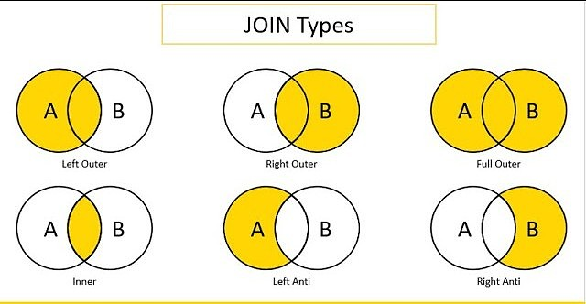

M language

- M Language is the formula language used in Power Query to describe data transformation steps.
- It’s the underlying language that drives Power Query.
- We can see M language in the Advance Editor and in Formula Bar inside Power Query.

