A Microservices-Based Home Energy Tracker for Event-Driven Monitoring, Deduplicated Alerting, and ML-Based Anomaly Detection

Rohit Shrivastava¹, Harsh Gupta², Anshika Rai³, Syamasudha Veeragandham⁴
^{1,2,3,4}School of Computer Science and Engineering, Vellore Institute of Technology, Vellore,
Tamil Nadu, India – 632014
Email: ¹rohit.lalbahadur2023@vitstudent.ac.in, ²harsh.gupta2023@vitstudent.ac.in,
³anshika.rai2023@vitstudent.ac.in , ⁴ syamasudha.v@vit.ac.in
⁴Corresponding author

Abstract- Residential energy platforms require a traceable path from telemetry admission to storage, analysis and regulated notification. In this work, we introduce a local Home Energy Tracker with gateway-mediated access control, device-token ingestion, Apache Kafka, InfluxDB, MySQL, deterministic insights, alert deduplication, and baseline Random Forest inference service, built as an event-driven microservices composition. The legacy classifier was tested historically on a repository given 5,000 record labelled CSV and exactly duplicated offline. Its held out F1 is reported as historical dataset specific proof, not a REFIT or field result. A separate live endpoint smoke check simply checks baseline load and response generation. To improve data provenance we checksum-verified five official REFIT cleaned files and normalised H1/H2/H4 into 468,847 maintained interval-energy records (386.398411389 kWh estimated by an actual-delta sample-hold rule). H3/H11 are separated as a solar affected sensitivity data. Isolated provisioning and safe deployment are not complete, thus end-to-end REFIT ingestion, alert-deduplication validation and REFIT anomaly-accuracy evaluation are waiting. The contribution is therefore a reproducibility and implementation study with clear proof boundaries, not a claim of calibrated metering, general anomaly correctness, or production readiness.

Keywords - Home energy management, microservices, Apache Kafka, anomaly detection, REFIT, reproducibility, IoT telemetry, alert deduplication.

I. INTRODUCTION:
Residential energy monitoring is more than a dashboard: it involves a controlled data path from a device-like source, to persisting measurements, user-visible analytics, and bounded warnings. Instead of claiming utility-grade measurement accuracy, our initiative sidesteps that integration difficulty by providing a local, event-driven Home Energy Tracker. The implementation separates out concerns of admission, ingestion, aggregation, inference, alerting, identity, and observation so that each may be inspected and verified in isolation.
The active runtime gets Wokwi-compatible telemetry with deviceId, energy used and timestamp. User-facing requests are mediated by role and ownership checks and JWTs backed by Keycloak. Simulated-device ingestion employs a device-bound token. Kafka decouples acceptance from downstream consumption, InfluxDB keeps time-series usage and MySQL saves household, device and alert status. The system also provides deterministic bill, ranking, standby, forecast and saving-tip capabilities. This design makes claims regarding software component implementation and data flow, not physical sensor calibration.
II. RELATED WORK AND RESEARCH GAPS
A. Connection to Previous Work
There is recent work that frames domestic energy management as a challenge of data engineering and design. Nunez et al describe a flexible microservices architecture for household energy-efficiency monitoring [1], whereas Motta et al propose a conceptual cloud architecture grouped around intake, operating and analytical contexts [2]. Veloso et al. integrate microservices and hybrid communication for a smart-grid environment[3]. These studies support the usefulness of modular, event-capable designs but their deployment settings and evaluation aims are different from our local prototype and their results are not used as a numerical benchmark for this work.
Studies of anomalies on smart meters are also indicative of the importance of data provenance and evaluation methodology. In [4] Hernandez et al. assess activity related anomalies using a commercial meter in a real household. Conversely, the current Random Forest was historically assessed on an internally supplied labelled CSV with an undocumented source, license, label-generation procedure, and causal provenance of the Avg_Past_Consumption. Thus, its measurements can only support a replicable legacy-baseline assertion. The REFIT study offers a better documented recorded residential source, with aggregate electrical power sampled at a nominal 8 s cadence [5]-[7].
B. Research Gap and Research Contributions
The identified gap is not a new anomaly detection algorithm. It is the necessity for a traceable prototype that connects the notion of residential telemetry admission to event-mediated persistence, deterministic insights, baseline inference and duplicate-aware alarm delivery while clearly differentiating implemented proof from pending testing. The present contribution is threefold: (i) an implemented microservices architecture with an event-driven processing path, (ii) an exact offline reproduction of the repository's historical supervised baseline, and (iii) a checksum-traceable REFIT preprocessing that creates a scientifically usable primary cohort and interval-energy representation. This study does not claim completion of REFIT replay, REFIT-based anomaly accuracy, or production resilience.
III. IMPLEMENTED SYSTEMS AND METHODS
A. Architecture Event-Driven
On the API border the gateway allows user requests via JWT, role and ownership controls and allows telemetry compatible with simulators via a device bound token. The Ingestion Service checks the agreed telemetry contract and emits energy usage events to Kafka. The Usage Service consumes these events and persists the time series and aggregations of specified windows. The baseline FastAPI inference service independently consumes events of the same class and publishes anomaly results. The Alert Service processes threshold and anomaly pathways, maintaining notification status and applying a 15 min defined deduplication window. Prometheus and Grafana are supported for service observation. The architecture is depicted in Fig. 1.

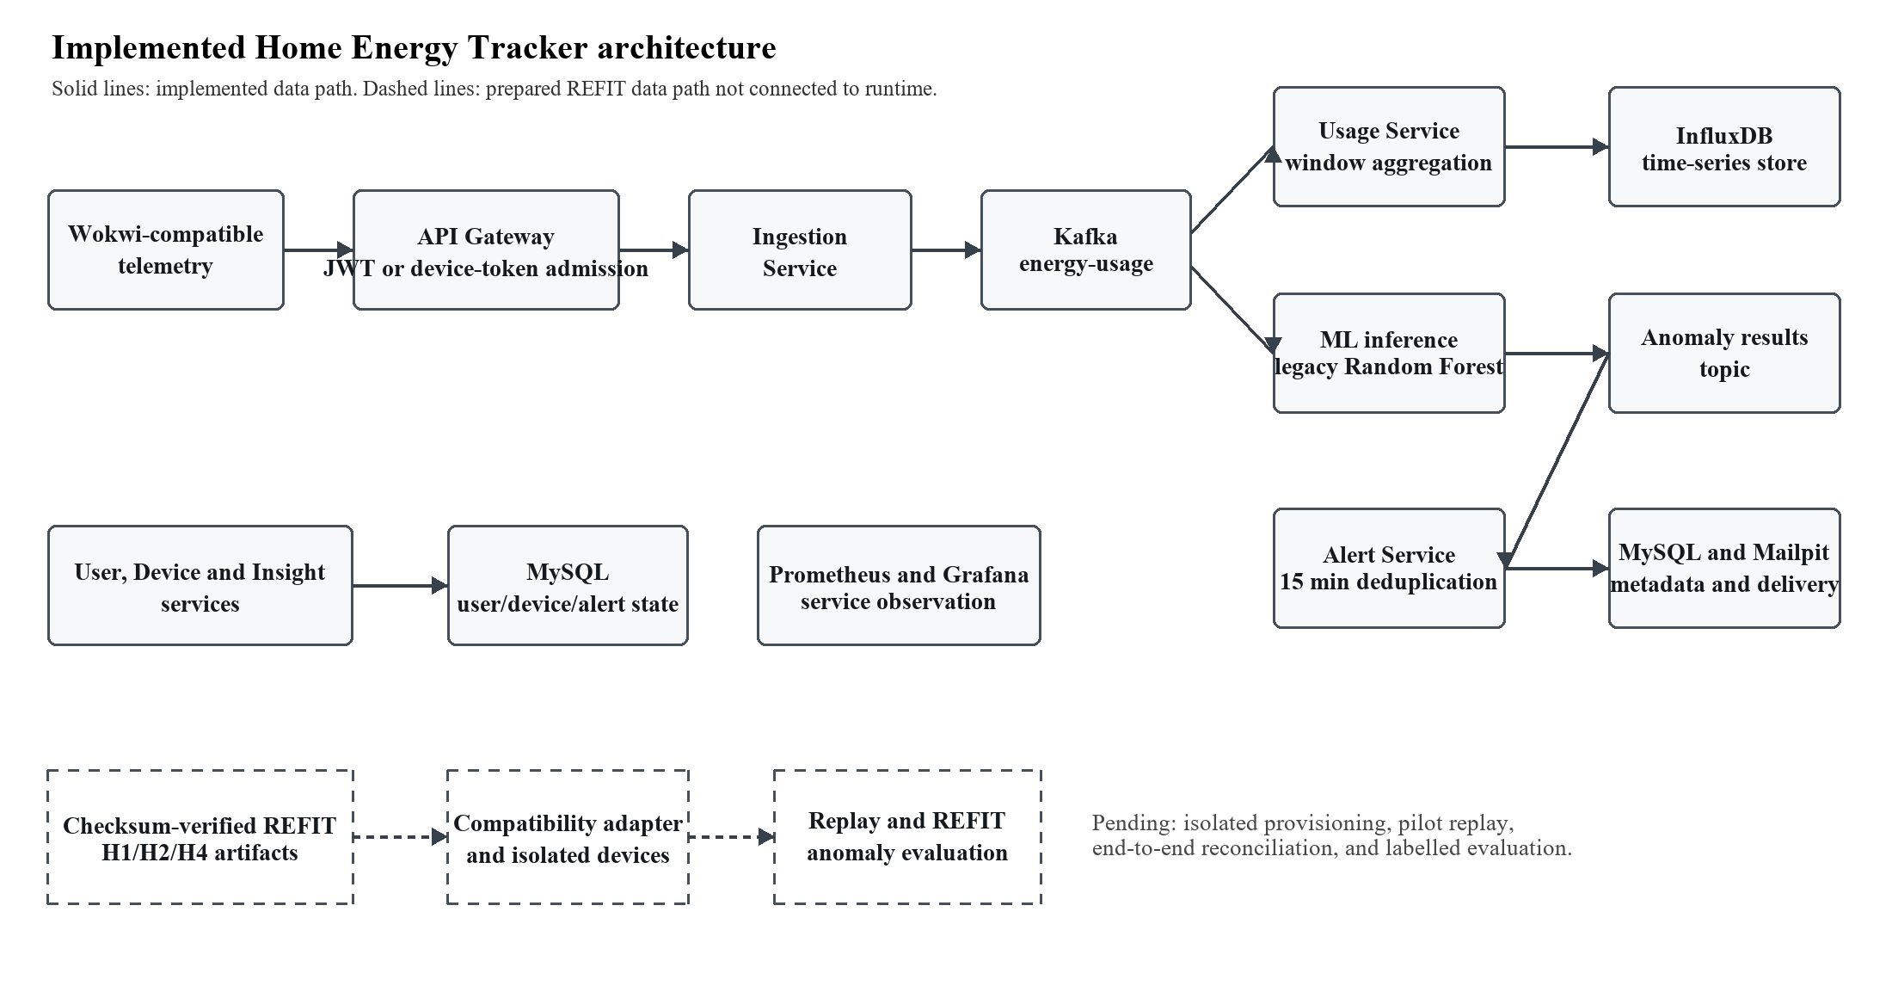
Fig. 1. Developed architecture for Home Energy Tracker. The REFIT branch is deliberately shown as ready but not connected to the runtime.
TABLE I. System components deployed and evidence limits
Ingredient | Behaviour Implemented | evidence boundaries
Admission Admission | Keycloak-backed user routes. Device-token telemetry admission at the gateway. | Functional architecture, some authorisation controls. No security evaluation for production.
Broking and ingestion | Ingest validates telemetry and publishes Kafka energy usage events. | Historical and dated local event-path evidence No REFIT replay has been run.
Storage and usage | use aggregation Writes time-stamped use to InfluxDB. Household, device, alert state Use MySQL. | Component and historical integration evidence; no utility bill verification.
Inference on baseline. | A FastAPI service loads the fixed Random Forest and outputs the anomalous results. | REFIT accuracy is not the same as evaluation on historical datasets and a live working smoke test.
Alerting and monitoring | Threshold/anomaly paths to Alert Service with 15 min deduplication configured Prometheus/Grafana observing services | There are historical local tests and fault and replay tests after isolation are pending.
REFIT datapath | Separate preparation of checksum-verified, normalised H1/H2/H4 artefacts. | Device provisioning, ingestion, alert or tagged anomaly assessment not finished.

B. ML Boundary (Baseline)
The baseline model installed is the persistent Random Forest artefact random_forest-csv-20261003T205417Z. It is dependent on 8 features: Electricity_Consumed, Temperature, Humidity, Wind_Speed, Avg_Past_Consumption, Hour, DayOfWeek, ConsumptionDeviation. The historical protocol used the provided data in a stable order, a chronological 3,500/750/750 train/validation/test split, and selected the decision threshold using validation F1. The saved model has 300 trees, min_samples_leaf = 2, class_weight = balanced_subsample, random_state = 42, and threshold 0.31.
A runtime payload compatible with Wokwi is missing four contextual fields. The model is trained on the data using median imputation on Temperature, Humidity, Wind_Speed and Avg_Past_Consumption and derived temporal features from the timestamp. So its live three-field prediction is a smoke test of the inference interface, not a validation of the statistical accuracy of the historical model. The reported Wokwi values also lie outside the 0–1 Electricity_Consumed range of the training CSV for five out of six evaluated simulator borders, suggesting interface-scale mismatch necessitating future range or out-of-distribution controls.
C. REFIT Preprocessing Approach
Prior to examination, five local REFIT cleaned files (H1, H2, H3, H4 and H11) were checked against the official Zenodo MD5 manifest. Whole-house active power (aggregate) was chosen in watts. Chronology was selected as Unix and Time was left as is. H1/H2/H4 is the main cohort. The primary summary exclude H3 and H11 since the REFIT descriptor captures solar generation interference and they are instead a separately marked sensitivity cohort, without solar or net-export correction.
For each subsequent record the interval energy estimate is : E_kWh = P_start,W * delta_t,s / 3,600,000 Time intervals are integrated only for $0 < \delta_t \leq 16$ s. No longer cross gap periods are excluded without interpolation, filling, capping or synthesis. Negative power is not included in the affected integration but is kept in the source audit, IQR flags are diagnostic not clipping rules, and REFIT Issues values are context not anomaly labels. This keeps the separation between active power samples and the anticipated interval energy.

TABLE II. Historical legacy-baseline appraisal, exact reproduction, and smoke-test border
Evidence item | Protocol 1 | Observed result | Explanation:
Historical Random Forest | Timeline split 70/15/15; 750 test records held out; threshold tuned on validation. | Precision 0.880952, Recall 0.925000, F1 0.902439, ROC-AUC 0.997430, PR-AUC 0.948532. | Historical CSV particular evaluation Not REFIT or fresh replicated field result
Logistic regression in history | Same hold-out split; threshold = 0.28. | Precision 0.053333 Recall 1.000000 F1 0.101266 ROC-AUC 0.422852 PR-AUC 0.059710 | Legacy baseline comparator only.
Off-line reproduction | Current deterministic trainer and input with 5,000 copied records. | All reported metric differences = 0. Reproduced Random Forest artefact SHA-256 matched legacy artefact. | It confirms the reproducibility of the old legacy experiment, not its external validity.
Live inference smoketest | deviceId 1, energyConsumed 0.55, timestamp 2026-10-11T00:00:00Z. (Wokwi-compatible) | anomaly = false ; probability = 0.0 ; threshold = 0.31 ; 4 context features reported as imputed . | It just confirms endpoint execution and declared imputation, not accuracy, latency or end to end alert outcome.

TABLE III. Normalisation results for the REFIT primary cohort
Home | Time window (UTC) | Chosen rows | Time left intervals | Rows Excluded | Energy (kWh) estimated | Quality Output
H1 | 2014-10-01 - 2014-10-15 | 153,762 | 153,578 | 184 | 104.820956111 | PASS; 95.97% native cadence
H2 | 10/01/2014 through 10/15/2014 | 155,097 | 154,985 | 112 | 170.354373889 | PASS 95.64% native cadence
H4 | 22 Apr 2015 - 6 May 2015 | 160,324 | 160,284 | 40 | 111.223081389 | PASS; 99.30% native cadence
Total primary | Three 14 day periods | 469,183 | 468,847 | 336 | 386.398411389 | All record reconciliations passed
Note: Aggregate is active power in W for the whole house. Energy is a true delta, left-rectangle/sample hold estimate. Table III purposefully omits H3/H11 sensitivity data because of the known caveat of solar interference.

IV. EVALUATION AND REPLICABILITY
A. Classification of Evidence
Rather of a single aggregate score, the evaluation is structured by type of evidence. Historical supervised metrics are named as such and retain their original provenance. The precise offline reproduction tests if present code and copied input reproduce past outputs. The live inference check checks a given service contract and model load. REFIT preprocessing checks the integrity of the source, the choice of the cohort, the treatment of the timestamps and the transformation of the units. These sorts of evidence address various questions and are not interchangeable.
B. REFIT repeatability
The preprocessing pipeline was ran twice with the same five validated source files, selection criteria and setup. The two sets of created artefacts passed validation and were byte-identical, containing cleaned primary and solar-sensitivity cohorts, the manifest, excluded-record log, quality report, preprocessing summary, and timestamp-interval report. The main output SHA-256 is dfdba435f35a1548661309fd67b267548f419edd489cacf25c7566098f189163 This allows deterministic preparation of the local data artefacts, not their delivery over the deployed ingestion API.
We do not consider the official appliance-level annotations of REFIT as the ground truth of anomalies in aggregate. The annotation coverage in the publication overlaps the local primary cohort only at H1 and the schema, counts, timestamp semantics and alignment to aggregate readings of the annotation file have not been confirmed. The reported REFIT accuracy value was obtained without any synthetic anomaly production. Figure 2, separating completed evidence from the future isolated replay and evaluation path.

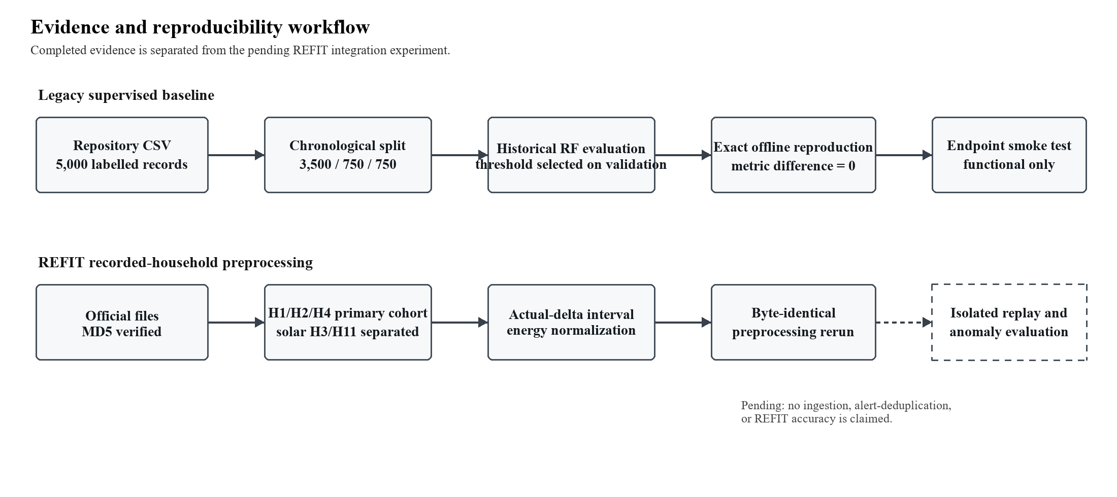
Fig. 2. Workflow: Evidence and reproducibility REFIT phase is pending. Isolated devices, credentials, pilot reconciliation and verified evaluation process.
TABLE IV. Publication border and current result status
Region | Proven outcome | Not configured
System implementation | So, in the local composition, we are doing microservices, gateway, event processing, storage, deterministic insights, alert path, and observability. | Production scale capacity, full recovery behaviour, and independent penetration security testing.
Baseline legacy. | A dated endpoint smoke test passed, and offline reproduction of Historical Random Forest metrics was precise with the provided copied csv. | External data provenance, actual household generalisation, REFIT accuracy, and a comprehensive post-restart ML-to-alert outcome.
REFIT data . | Five local official files were MD5 validated, principal H1/H2/H4 interval artefacts were normalised and replicated byte-for-byte. | End-to-end ingestion, device/token provisioning, pilot replay/full replay, alert deduplication, aggregate anomaly label evaluation.
Viability of deployment | The design of the isolated experiment and the safety assessments indicate the provisioning and storage boundaries that are needed. | Safe isolated deployment on the 8 GB laptop. The measured memory constraint does not allow the main and the isolated stacks to execute simultaneously.

V. DISCUSSION AND RESULTS
A. The Legacy Baseline Reading
On the recorded historical protocol, the Random Forest significantly outperforms the logistic-regression comparator in held-out F1, ROC-AUC, and PR-AUC (Table II). The fresh offline run provided those same numbers, exactly, and matched the artefact hash deployed. This provides strong proof that the legacy experiment of the repository is replicable with its available inputs and configuration. It is not evidence that the same measures apply to REFIT, to Wokwi data, or to a physical house. The lacking source, licensing, label-generation procedure, household identity and causal design of Avg_Past_Consumption exclude that stronger conclusion.
B. Preparation for REFIT Interpretation
The REFIT contribution improves the data provenance of the study and prepares an actual recorded-household experiment without claiming system performance too early. The main cohort has 468,847 interval data over three precise 14-day intervals. All primary selection records match, no duplicate or out-of-order Unix timestamps were found in the selected windows, and each home passed the predefined cadence, coverage, missing-slot and maximum-gap gates. H3/H11 are kept separate to avoid their recorded solar-generation interference contaminating normal consumption-only summary.
The energy totals are calculated integrations of aggregate active-power samples, not a re-labelling of REFIT as direct kWh records. Actual consecutive intervals are used to prevent treating gaps as typical 8 s readings. Cross-gap records removed are traceable in the output log. These controls make the dataset eligible for a future reconciliation experiment, but do not prove that energyConsumed has been accepted by the present ingestion service, or that alerts act correctly under REFIT replay.
C. System Implications
The practical usefulness of the system is the clear separation of event admission, persistence, analytics, inference and alert delivery. This split allows a future experiment to reconcile acceptable telemetry against use records, ML results and deduplicated notifications. It also provides segregated storage design, so replayed household data does not pollute current development records. These safety features are still part of design goals with supporting groundwork. They should be considered as part of planned until isolated provisioning, replay and failure mode tests provide supporting logs.
VI. LIMITATIONS AND FUTURE WORK
The study has four fundamental limitations. First, Wokwi telemetry is synthetic and not calibrated. Second, the legacy supervised CSV contains open provenance and feature building questions, and hence its historical metrics cannot be generalised. Third, REFIT provides a documented aggregate power source but not yet a proven aggregate anomaly-label protocol for H1/H2/H4 cohort. Fourth, the local 8 GB Windows laptop has a Docker memory limit of 3.696 GiB whereas the observed main stack requires ca. 2.89 GiB; an isolated REFIT provisioning stack must not operate concurrently with the main stack. This resource restriction means we cannot rely on deployment status as a proxy for scientific validation.
Future work should supply an entire isolated Keycloak realm, database volumes, Kafka broker, 3 household profiles, and 3 device-bound credentials. Then test the derived_interval_energy_kwh to energyConsumed mapping against the actual ingestion contract. Run a modest pilot replay with request/event reconciliation and only after pilot acceptance, move on to H1/H2/H4. Independently validated label alignment, household-held-out or temporal evaluation, input-range controls, repeated latency/throughput measurements, alert-deduplication evidence, and fault/recovery testing are also needed for a credible anomaly research. None of these future actions are shown as finished here.
VII. CONCLUSIONS
This work describes an evidence-aware Home Energy Tracker whose implemented architecture incorporates gateway-mediated admission, Kafka event processing, time-series and relational storage, deterministic insights, a baseline Random Forest service, duplicate-aware alerting and monitoring. The legacy classifier was replicated exactly offline with historical results while a separate live validation merely checks baseline endpoint execution. The REFIT study adds checksum-verified official data, a scientifically separated H1/H2/H4 primary cohort, actual-delta interval-energy normalisation, quality controls and deterministic artefact reproduction. The results collectively endorse a faculty assessment of a transparent implementation and repeatability study. They do not support a journal claim of real-world anomaly accuracy, completed REFIT end-to-end operation, production readiness, or generalisable performance until the outstanding isolated deployment and evaluation gates are met.
Funding Statement
The author declares that no funding, grants, or external support were received during the development of this work.
Declaration of competing interests
The authors declare that they have no known competing financial interests or personal relationships that could have appeared to influence the work reported in this paper.
BIBLIOGRAPHY
[1] I. Nuñez, C. Rovetto, E. Cruz, A. Smolarz, D. Concepcion, and E. E. Cano, “Design of a microservices-based architecture for residential energy efficiency monitoring,” International Journal of Electronics and Telecommunications, vol. 70, no. 4, pp. 1089–1098, 2024, doi: 10.24425/ijet.2024.152511.
[2] L. L. Motta, W. S. Alvarez, H. R. Carvajal, F. B. Neto, E. R. de Lima, and L. G. P. Meloni, “A cloud architecture for home energy management systems: a conceptual model,” Energy Informatics, vol. 8, Art. no. 142, 2025, doi: 10.1186/s42162-025-00599-1.
[3] A. F. S. Veloso, J. V. Reis, Jr., and R. A. L. Rabelo, “A Microservices-Based Solution with Hybrid Communication for Energy Management in Smart Grid Environments,” Sensors, vol. 26, no. 5, Art. no. 1714, 2026, doi: 10.3390/s26051714.
[4] Á. Hernández, R. Nieto, L. de Diego-Otón, M. C. Pérez-Rubio, J. M. Villadangos-Carrizo, D. Pizarro, and J. Ureña, “Detection of Anomalies in Daily Activities Using Data from Smart Meters,” Sensors, vol. 24, no. 2, Art. no. 515, 2024, doi: 10.3390/s24020515.
[5] D. Murray, L. Stankovic, and V. Stankovic, “An electrical load measurements dataset of United Kingdom households from a two-year longitudinal study,” Scientific Data, vol. 4, Art. no. 160122, 2017, doi: 10.1038/sdata.2016.122.
[6] D. Murray, L. Stankovic, and V. Stankovic, “REFIT: Electrical Load Measurements (Cleaned),” dataset, University of Strathclyde, Jun. 2016, doi: 10.15129/9ab14b0e-19ac-4279-938f-27f643078cec.
[7] D. Murray and L. Stankovic, “REFIT: Electrical Load Measurements (Cleaned),” Zenodo, dataset, Jun. 2016, doi: 10.5281/zenodo.5063428.
[8] K. Kulkarni, “Anomaly Detection in Smart Electric Meters for Detecting Faults and Misuse of Electric Energy Consumption,” INTERANTIONAL JOURNAL OF SCIENTIFIC RESEARCH IN ENGINEERING AND MANAGEMENT, vol. doi: 10.55041/ijsrem34689
[9] M. H. Abu-Arqoub, A. A. Titinchi, and R. R. Marie, “A Scalable IoT-AI Framework for Real-Time Energy Anomaly Detection in Smart Grid Networks,” in 2026 2nd International Conference on Computational Intelligence Approaches and Applications (ICCIAA), 2026, pp. 1–6, doi: 10.1109/ICCIAA68481.2026.11543846.
[10] S. Maitra, S. Kundu, and A. Shankar, “A Real-time Anomaly Detection Using Convolutional Autoencoder with Dynamic Threshold,” arXiv preprint arXiv:2404.04311, 2024, doi: 10.48550/arXiv.2404.04311.
[11] Dr. Karthika K, Thrupthi Chandana G, Taahani Sheikh, Sankeerthana, and Umme, “Smart Energy Monitoring System,” International Journal of Innovative Research in Information Security, vol. 11, no. 9, Oct. 2025, doi: 10.26562/ijiris.2025.v1109.15.
[12] J.-H. Liu and Y.-T. Hsiao, “Smart plug-based home energy management with IoT and anomaly detection,” Journal of the Chinese Institute of Engineers, vol. 49, no. 3, pp. 655–670, 2026, doi: 10.1080/02533839.2025.2557233.
[13] K. M. W. Hidayat and M. G. Al-Faris, “IoT-Based Electrical Power Consumption Monitoring System in Households Using ESP32 and PZEM-004T,” Brilliance: Research of Artificial Intelligence, vol. 5, no. 2, pp. 1077–1081, 2025, doi: 10.47709/brilliance.v5i2.6368.
[14] S. Sirisumrannukul, T. Intaraumnauy, and N. Piamvilai, “Optimal control of cooling management system for energy conservation in smart home with ANNs-PSO data analytics microservice platform,” Heliyon, vol. 10, no. 6, Art. no. e26937, 2024, doi: 10.1016/j.heliyon.2024.e26937.
[15] M. S. Hossain and M. M. Hassan, “Smart Energy Meter with Real Time Monitoring System,” in 2024 13th International Conference on Electrical and Computer Engineering (ICECE), 2024, pp. 761–766, doi: 10.1109/ICECE64886.2024.11024970.
[16] D. G. S, T. Gangakhedkar, A. P, A. Ashwija and C. B. T. Rambapuri, “IOT Enabled Electrical Consumption Tracking for Intelligent Energy Saving,” International Journal of Scientific Research in Engineering and Management, 2025. doi: 10.55041/ijsrem54847.
[17] Y. Zhu and M. Yue, “Design of an IoT-Based Smart City Energy Management System,” in 2025 4th International Conference on Green Energy and Power Systems (ICGEPS), 2025, pp. 489–492, doi: 10.1109/ICGEPS65133.2025.11034388.
[18] S. Susikala, R. K, J. K, S. K, Y. M, “IoT Based Smart Electricity Monitoring System with Real Time Alerts & Remote Control,” International Journal of Engineering & Extended Technologies Research, 2026. doi: 10.15662/ijeetr.2026.0802420 .

