A Microservices-Based Home Energy Tracker for Event-Driven Monitoring, Deduplicated Alerting, and ML-Based Anomaly Detection
Rohit Shrivastava¹ , Anshika Rai² , Harsh Gupta³ , Syamasudha Veeragandham⁴
^{1,2,3,4}School of Computer Science and Engineering, Vellore Institute of Technology, Vellore,
Tamil Nadu, India – 632014
Email: ¹rohit.lalbahadur2023@vitstudent.ac.in, ²anshika.rai2023@vitstudent.ac.in,
³harsh.gupta2023@vitstudent.ac.in, ⁴ syamasudha.v@vit.ac.in
⁴Corresponding author

Abstract - Residential energy platforms require a traceable route from meter-like telemetry to controlled feedback. This study implements a local 17-service Docker composition combining Wokwi-compatible ESP32 telemetry, API-gateway admission control, Apache Kafka, InfluxDB, MySQL, deterministic insights, and duplicate-aware alert delivery. User-facing routes apply Keycloak JWT, role, and ownership checks, while simulated-device ingestion uses a device token. A Random Forest anomaly model is selected by validation F1 from the supplied CSV and deployed as a fixed FastAPI artifact; its held-out precision, recall, F1, ROC-AUC, and PR-AUC are 0.880952, 0.925000, 0.902439, 0.997430, and 0.948532, respectively. Controlled local checks recorded a 1.50 kWh analytics case, a 1.00 kWh threshold-alert case, eight expected security statuses, duplicate suppression within 15 min, eight active Prometheus targets, and 450/450 accepted k6 ingestion requests. The results demonstrate implementation-level integration and bounded local evidence, not physical-meter accuracy, field-model generalisation, production security, or production-scale resilience.
Keywords - Home Energy Tracker, Internet of Things, microservices, Apache Kafka, anomaly detection, Keycloak, alert deduplication, Wokwi simulation.
I. INTRODUCTION
Residential electricity bills provide limited visibility into when energy is consumed, which registered device contributes most, or when a configured threshold is exceeded. A practical Home Energy Management System therefore needs an auditable path from telemetry to stored records, interpretable outputs, and controlled notification. Recent IoT systems demonstrate affordable sensing and remote visualisation, whereas other studies focus on energy analytics or anomaly detection [3]-[6], [13], [16], [18]-[21], [23].
This work addresses the integration of a local, event-driven energy platform rather than the accuracy of a physical meter. The deployed composition separates user and device metadata, ingestion, usage, insight, alert, API gateway, and ML inference functions, and includes Kafka, InfluxDB, MySQL, Mailpit, Keycloak, Prometheus, Grafana, and a frontend. Wokwi supplies timestamped synthetic JSON payloads to the same HTTP ingestion contract intended for a future meter; Kafka decouples request acceptance from downstream persistence and analysis.
The study makes three bounded contributions: it implements a 17-service local Docker path from simulated telemetry to time-series storage and access-controlled APIs; it trains and deploys a fixed anomaly-inference artifact while retaining deterministic bill, ranking, standby, and threshold functions; and it records controlled local evidence for end-to-end behavior, gateway security, alert deduplication, observability, ingress load, and selected outage conditions. The scope excludes calibrated sensing, utility-bill validation, physical-field generalisation, production penetration testing, and production-scale resilience claims.
II. RELATED WORK AND RESEARCH GAP
A. Existing Approaches
The literature represented in the source paper spans three complementary directions. Low-cost IoT systems use ESP32-class controllers and energy sensors to expose consumption or power-quality information [3]-[6], [13], [16], [18]-[21], [23]. Their measurement evidence cannot be transferred to the Wokwi-generated values used here. A second direction uses machine-learning or statistical methods for appliance classification, anomaly detection, and behavioural analysis [1], [7]-[11], [15], [22]. The present system evaluates a binary classifier only on its supplied labelled CSV and does not equate those results with real-household anomaly performance.
A third direction considers microservices, cloud organisation, or distributed control for energy-management systems [2], [12], [14], [17], [24]. These works motivate service separation, event processing, and maintainability, while leaving a practical need for a traceable prototype that links a telemetry contract, access-controlled API boundary, event broker, time-series persistence, deterministic insights, anomaly inference, and duplicate-aware notification. The present work adopts this integration focus without claiming equivalence to the scale or fault tolerance targeted by prior architectural research.
B. Research Gap and Contribution
The research gap is limited implementation-level linkage between residential telemetry, event-driven services, controlled access, historical storage, transparent analytics, anomaly inference, and alert delivery with explicit verification boundaries. The proposed system addresses that gap through Wokwi-compatible telemetry, gateway admission control, Spring Boot microservices, Kafka, InfluxDB, MySQL, a deployed Random Forest artifact, deterministic insight functions, and Mailpit-backed alerting with a configured deduplication window. Remaining gaps include calibrated sensing, documented dataset provenance, per-household contextual labels, field validation, production-grade security assessment, and distributed resilience evaluation.
III. PROPOSED SYSTEM AND METHODOLOGY
A. Architecture and Telemetry Path
The runtime input contains deviceId, energyConsumed, and timestamp. Wokwi firmware emits this JSON payload at an approximately 8 s interval; Eco, Heavy, and Alert Test modes generate controlled values for integration demonstration and are not calibrated physical measurements. User-facing requests enter through the API Gateway with Keycloak JWT, realm-role, and ownership checks, while Wokwi-compatible ingestion uses an X-Device-Token. The Ingestion Service validates accepted payloads and publishes energy-usage events to Kafka.
The Usage Service consumes energy-usage events, writes time-stamped energy_usage points to InfluxDB, and derives selected-window aggregates. User and Device Services maintain household, appliance, and alert-setting metadata in MySQL. In parallel, an ML worker calls a FastAPI service that loads a fixed Random Forest artifact and publishes anomaly-results. Threshold and anomaly paths reach the Alert Service, which persists notifications and uses a configured 15-min deduplication window. Prometheus and Grafana provide service-level target and metric observation.

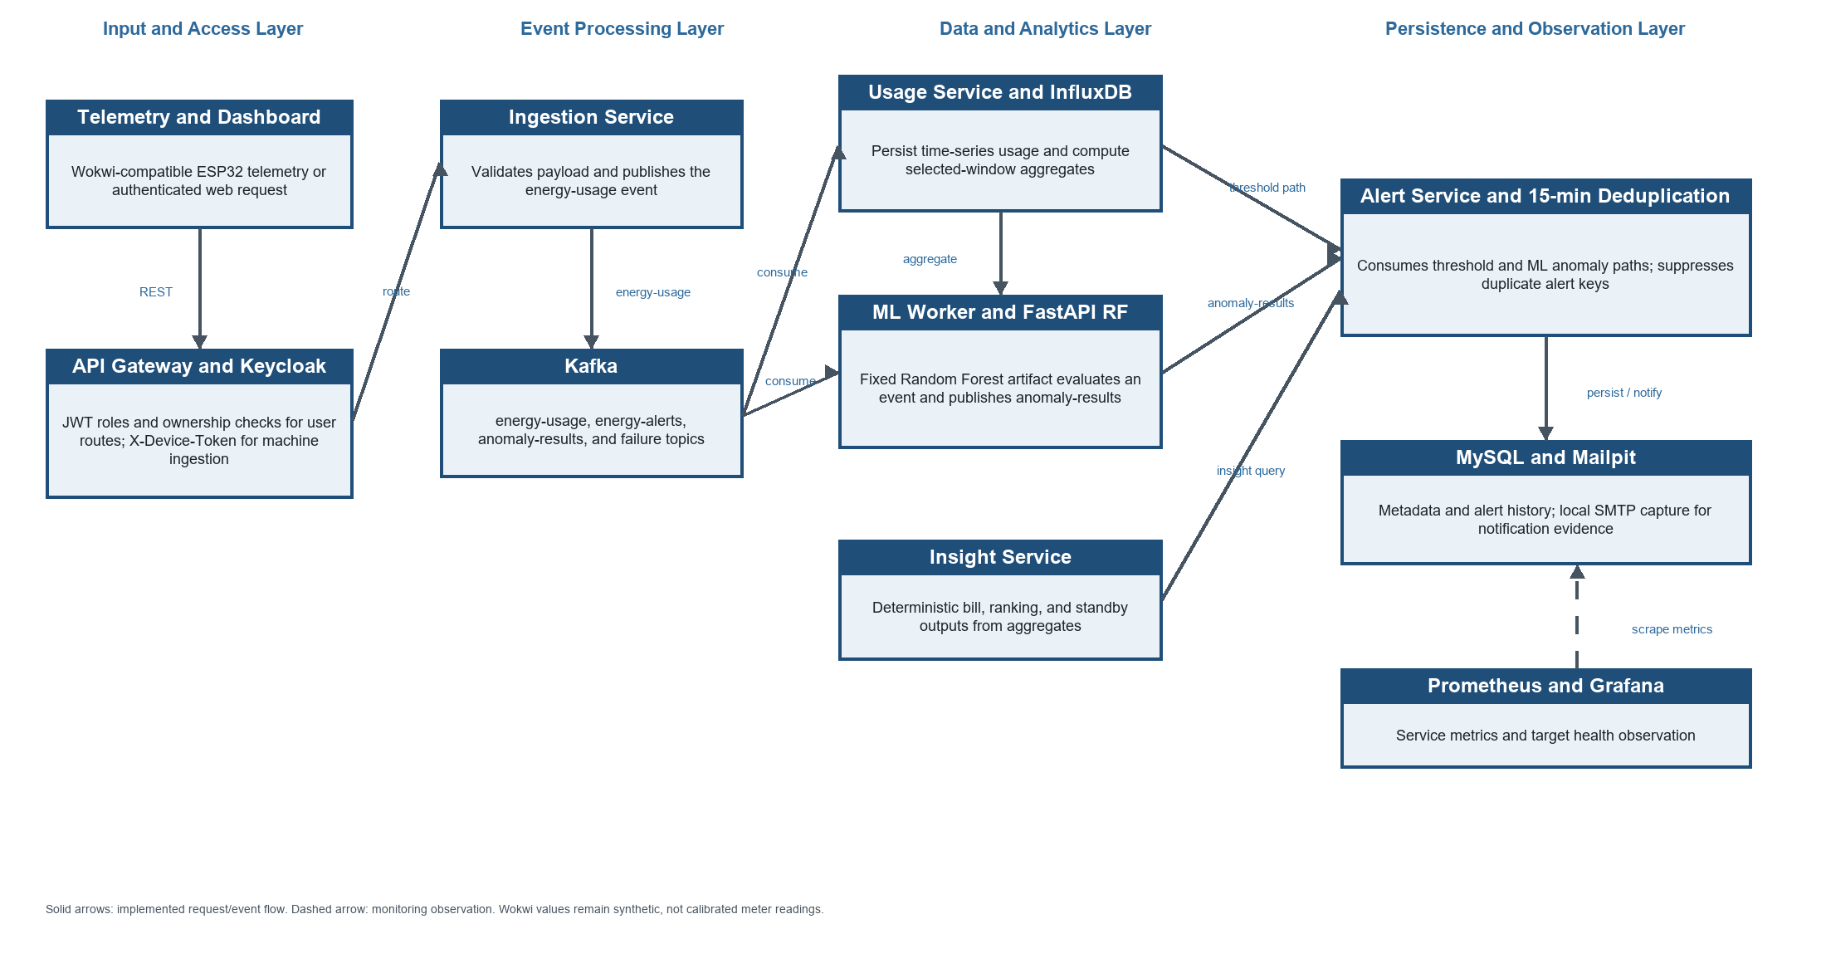
Fig. 1. Verified service architecture and data paths of the Home Energy Tracker.

B. Deterministic Insight and Alert Methods
The Insight Service derives deterministic outputs from aggregated usage. It computes a daily rate and a 30-day energy projection from total energy E over D selected days. The configured local tariff uses a fixed 10.00 charge and slab rates of 0.12 per kWh for 0-100 kWh, 0.18 per kWh for 100-300 kWh, and 0.25 per kWh above 300 kWh. Device ranking uses each device total divided by the household total, and the standby estimate remains 20% of average load. These are demonstration rules, not a utility tariff or an appliance-level standby measurement.
$$E_{day} = \frac{E_{tot}}{D}; E_{30} = 30 x E_{day}$$
The anomaly branch uses the supplied smart_meter_data.csv with 5,000 records and seven columns, including Electricity_Consumed, weather/context fields, Avg_Past_Consumption, and Anomaly_Label (4,750 Normal and 250 Abnormal). Records are stably ordered by timestamp; Hour, DayOfWeek, and ConsumptionDeviation = Electricity_Consumed - Avg_Past_Consumption are derived. A chronological 3,500/750/750 train/validation/test split compares a balanced logistic-regression pipeline with a 300-tree balanced-subsample Random Forest. The Random Forest threshold 0.31 is selected by validation F1 and its saved artifact is loaded at FastAPI startup; missing optional context is median-imputed. The dataset source, licence, and label-generation provenance are not documented.
$$P_{avg} = (\frac{E_{tot}}{24D}) x 1000 W; P_{base} = 0.20 x P_{avg}$$
For threshold alerting, a scheduler evaluates the preceding one-hour household sum every 10 s. When alerting is enabled and the sum exceeds the user-defined threshold, an energy-alerts event is published. The Alert Service consumes threshold and ML anomaly paths, persists alerts in MySQL, and attempts SMTP delivery with Mailpit as the local demonstration inbox. Its deduplication key is userId:deviceId-or-HOUSEHOLD:alertType; matching keys are suppressed during the configured 15-min window. The ML worker includes a bounded default of three attempts and an anomaly-processing-failures topic as implemented handling, not as a separately evaluated recovery guarantee.

TABLE I
Verified System Components and Traceable Data Flow
Stage | Implemented component and technique | Output
Access and telemetry | Keycloak JWT, roles, and ownership protect user routes; Wokwi-compatible ingestion uses X-Device-Token. | Authorised request or machine admission.
Ingestion and event transfer | Ingestion validates payloads and publishes Kafka energy-usage events. | Asynchronous energy event.
Storage and aggregation | Usage writes InfluxDB energy_usage points; User/Device metadata and alert records use MySQL. | Selected-window device and household totals.
Model and insight | ML worker calls the fixed FastAPI Random Forest artifact and publishes anomaly-results; Insight computes bill, ranking, and standby. | Anomaly probability and deterministic outputs.
Alerting and observation | Threshold and ML paths reach Alert Service, which applies 15-min deduplication and uses Mailpit; Prometheus/Grafana observe services. | Alert/email evidence and service metrics.

C. Operational Workflow
Fig. 2 summarises the verified offline and runtime paths. The upper lane prepares the supplied CSV, selects the model and threshold on validation data, and produces a fixed inference artifact. The runtime lane keeps authorised telemetry admission, ingestion, Kafka publication, usage persistence, ML inference, deterministic insight generation, alert deduplication, and output delivery distinct. Controlled E2E, security, deduplication, target-health, ingress-load, and selected outage checks are evaluation branches rather than evidence of a single production benchmark.

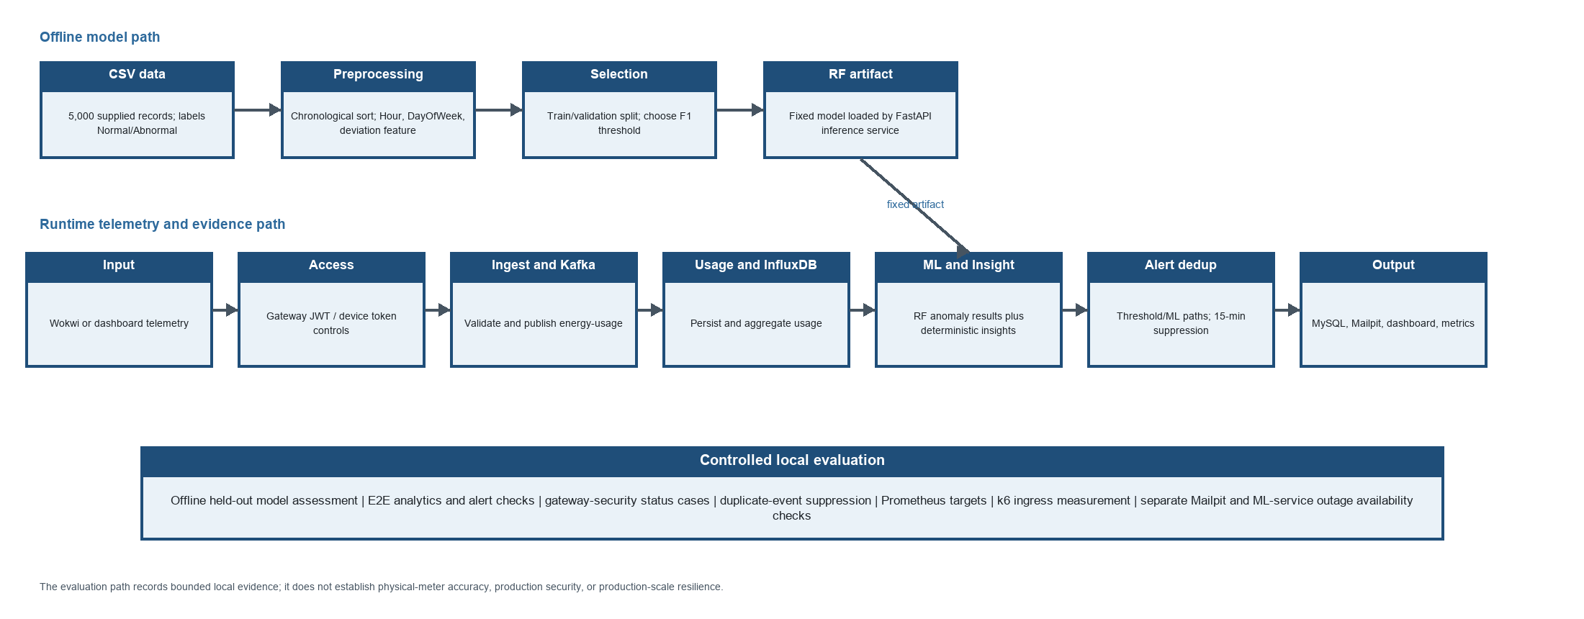
Fig. 2. Verified telemetry-to-alert workflow and evaluation path.

IV. IMPLEMENTATION AND FUNCTIONAL VERIFICATION
A. Implementation Environment
The system was exercised as a local, single-host Docker deployment on Windows 11 Home Single Language (10.0.26300) with eight logical processors and 7.74 GiB RAM. The compose configuration defines 17 services covering relational, event, time-series, e-mail, identity, application, frontend, and observability functions. The environment supports controlled implementation and verification; it is not a replicated cloud or production deployment.

TABLE II
Local Experimental Environment and Evidence Conditions
Element | Documented configuration
Runtime and deployment | Windows 11 Home Single Language 10.0.26300; local single-host Docker with eight logical processors and 7.74 GiB RAM. The compose file defines 17 services across data, application, identity, monitoring, and frontend functions.
Application and data stack | Java 17 Spring Boot services and API Gateway; React/Vite frontend; Apache Kafka, MySQL, InfluxDB, Mailpit, Keycloak, Prometheus, and Grafana. The source configuration defines this local service composition.
IoT simulation | Wokwi ESP32 DevKit with potentiometer, pushbuttons, and SSD1306 OLED. It posts Wokwi-compatible synthetic telemetry and is not a calibrated physical meter.
CSV data and model | smart_meter_data.csv: 5,000 records, seven columns, and Normal/Abnormal labels of 4,750/250. A chronological 3,500/750/750 split selects the Random Forest by validation F1. Source, licence, and label provenance are undocumented.
Controlled local E2E | 0.25, 0.50, and 0.75 kWh analytics inputs for user 15/device 314; a 1.00 kWh threshold input for user 16/device 315. These are synthetic REST observations.
Evaluation protocols | Gateway-security status cases; duplicate-event check; Prometheus target snapshot; k6 POST arrival-rate stages of 2/5/10 requests/s; separate Mailpit and ML-service outage availability checks with manual restart.

B. Verification Procedure
1. The latest successful controlled local E2E case submitted 0.25, 0.50, and 0.75 kWh analytics inputs for user 15/device 314 and a separate 1.00 kWh threshold input for user 16/device 315, whose configured threshold was 0.10 kWh.
2. The offline procedure stably sorted the supplied CSV, produced chronological train/validation/test partitions of 3,500/750/750 records, selected the threshold by validation F1, and evaluated the chosen and logistic-regression baseline models once on the held-out partition.
3. Gateway-security checks covered owned access, missing, invalid, and expired JWTs, cross-user access, administrator access, and device-token ingestion. Separate controlled checks examined duplicate-event suppression and the Prometheus target snapshot.
4. Local ingress was measured with k6 at 2, 5, and 10 requests/s for 30 s stages plus ramp-down; separate Mailpit and ML-service outage checks recorded ingress availability and manual container recovery. Historic Java tests (28 completed, three skipped), three Python in-process tests, and a later four-test gateway regression are reported without being merged into one fresh suite total.
V. RESULTS AND DISCUSSION
A. Functional Results
Table III separates model, functional, security, monitoring, load, and fault evidence because these measurements were collected by different controlled procedures. The latest successful E2E run confirms request-to-output traceability, while the supplied CSV assessment quantifies only data-specific model performance. The historical Java summary records 28 completed tests with no failures or errors and three skips; three Python tests passed, and the post-fix gateway regression passed 4/4. These records should not be interpreted as one unified production-readiness score.

TABLE III
Verified Local Evaluation Results
Verification item | Condition | Observed result
Random Forest held-out test | 750 records; selected threshold = 0.31. | TN 705, FP 5, FN 3, TP 37; precision 0.880952; recall 0.925000; F1 0.902439; ROC-AUC 0.997430; PR-AUC 0.948532.
Logistic-regression baseline | Same held-out partition; threshold = 0.28. | Precision 0.053333; recall 1.000000; F1 0.101266; ROC-AUC 0.422852; PR-AUC 0.059710.
Controlled E2E analytics | Three inputs total 1.50 kWh. | 3/3 HTTP 201; cost $0.18; daily 0.50 kWh; projected 15.00 kWh/$11.80; rank 100%; standby 4.17 W/LOW; observed within polling-bounded 3.79 s.
Threshold alert and Mailpit | 1.00 kWh input exceeds 0.10 kWh threshold. | HTTP 201; persisted sent THRESHOLD alert and matching Mailpit email; observed within polling-bounded 13.64 s.
Gateway security | Eight configured access-control cases. | 8/8 expected statuses: owned 200; missing/invalid/expired JWT 401; cross-user 403; administrator 200; device-token ingestion 201.
Alert deduplication | Two identical 1.00-kWh events at the same timestamp. | One ML_ANOMALY alert was stored and a duplicate was explicitly suppressed within 15 min.
Observability | Prometheus target snapshot. | 8/8 active targets up. No runtime inference latency is reported because the observed counter had zero samples.
Local ingress and fault checks | k6 2/5/10 requests/s; Mailpit and ML separately stopped. | 450/450 accepted; mean 39.442 ms; p95 109.773 ms; 0% HTTP failure. During each outage, ingestion returned 201 and manual restart recovered the container.

B. Interpretation and Evidence Boundaries
On the supplied held-out CSV, the Random Forest achieved substantially stronger precision, F1, ROC-AUC, and PR-AUC than the logistic-regression baseline. This supports the selection of the saved Random Forest artifact for this dataset and split, but it does not validate field anomaly detection. The E2E analytics and alert observations demonstrate a traceable local integration path from synthetic REST input to stored usage, deterministic outputs, and a captured notification; they do not establish physical-meter accuracy or utility-bill agreement.
The eight expected gateway statuses provide functional evidence for the tested authentication, authorization, ownership, administrator, device-token, and expiry scenarios. The duplicate-event experiment demonstrates one controlled suppression within the 15-min window. The Prometheus snapshot shows eight active targets up, and the k6 result measures only local gateway ingestion under the stated workload. The two outage checks show that ingress returned HTTP 201 while Mailpit or ML inference was stopped and that manual restart recovered the container; they do not demonstrate automatic recovery, replay, notification delivery, or general fault tolerance.
The data and runtime boundaries remain material. The CSV has no documented source, licence, label provenance, household/device identifier, or provenance for Avg_Past_Consumption. Its Electricity_Consumed values are in an undocumented 0-1 range, whereas Wokwi modes send direct values in approximately the 1-40 range; optional Wokwi context is median-imputed and no range-validation or calibration experiment is reported. No runtime ML latency is reported because the observed inference-latency counter had zero samples.
VI. LIMITATIONS AND FUTURE WORK
The principal limitations are synthetic, non-calibrated Wokwi telemetry; the anonymous dataset and missing provenance; the training-to-Wokwi unit/range mismatch; and the absence of physical-meter, utility-bill, and external-field validation. The evaluation uses one local Docker host with a bounded ingress test, no distributed tracing or Kafka-lag study, and only selected manually recovered service-outage checks. Keycloak and gateway controls were functionally checked in eight HTTP cases, but no TLS/cloud deployment or penetration assessment was performed. The deterministic standby estimate remains a 20% average-load heuristic.
Future work should collect consented, documented, calibrated interval-meter data with per-device and household context; establish label and feature provenance; and add range or out-of-distribution checks before model deployment. It should repeat end-to-end and load measurements over longer workloads, add tracing and Kafka-lag instrumentation, and perform automated fault, retry, failure-topic, replay, and recovery experiments. Production hardening should address TLS, secret rotation, device provisioning, and an independent security assessment before any real-world deployment claim.
VII. CONCLUSION
This paper presents a microservices-based Home Energy Tracker updated from an integration baseline to a locally evaluated event-driven system with gateway access controls, Kafka-mediated processing, InfluxDB and MySQL persistence, deterministic insights, a deployed Random Forest inference artifact, alert deduplication, and Prometheus/Grafana observation. Controlled evidence includes the supplied CSV model assessment, synthetic E2E analytics and alert checks, eight gateway-security cases, duplicate suppression, an eight-target snapshot, local k6 ingress measurement, and two limited outage-availability observations. The work demonstrates implementation-level integration and bounded local verification; it does not establish meter accuracy, externally generalisable anomaly detection, production-scale performance, comprehensive resilience, or production security.
REFERENCES
[1] A. Shuaibu, S. U. Haq, B. Almadani, F. Aliyu, and E. Al-Nahari, "Smart Metering Meets AI: Real-Time Appliance Monitoring and Anomaly Detection Over DDS Middleware," IEEE Transactions on Industry Applications, 2026. doi: 10.1109/tia.2025.3608687.
[2] I. Núñez, C. A. Rovetto, E. Cruz, A. Smolarz, D. H. Concepción, and E. Cano, "Design of a microservices-based architecture for residential energy efficiency monitoring," International Journal of Electronics and Telecommunications, 2024. doi: 10.24425/ijet.2024.152511.
[3] W. Agustiarmi et al., "Real-Time IoT-based Energy Power Consumption Monitoring System for Smart Homes," International Journal on Advanced Science, Engineering and Information Technology, 2025. doi: 10.18517/ijaseit.15.5.20918.
[4] M. Islam, N. Jobaida, M. S. Hossain, M. R. Uddin, and M. Hasan, "IoT-Based Smart Energy Monitoring and Energy Demand Response System," 2024 IEEE 3rd International Conference on Electrical Power and Energy Systems (ICEPES), 2024. doi: 10.1109/icepes60647.2024.10653605.
[5] S. S. Shashank, Yogesh, M. Krishnamoorthy, N. Karuppiah, P. Mounica, and R. Abinaya, "Smart Energy Monitoring for Real-Time Power Consumption Tracking and Optimization Using an IoT-Based Cost-Effective System," 2025 11th International Conference on Electrical Energy Systems (ICEES), 2025. doi: 10.1109/icees67011.2025.11212888.
[6] T. B. D. Sousa and R. Rabelo, "Smart Metering Enabled by the Internet of Things for Monitoring Residential Energy Consumption and Power Quality," IEEE Access, 2025. doi: 10.1109/access.2025.3627191.
[7] B. Jyothi et al., "Empowering energy management: anomaly detection in smart meter data for proactive consumption control," Bulletin of Electrical Engineering and Informatics, 2026. doi: 10.11591/eei.v15i3.10957.
[8] K. Kulkarni, "Anomaly Detection in Smart Electric Meters for Detecting Faults and Misuse of Electric Energy Consumption," INTERANTIONAL JOURNAL OF SCIENTIFIC RESEARCH IN ENGINEERING AND MANAGEMENT, 2024. doi: 10.55041/ijsrem34689.
[9] M. AbuArqoub, A. A. Titinchi, and R. Marie, "A Scalable IoT-AI Framework for Real-Time Energy Anomaly Detection in Smart Grid Networks," 2026 2nd International Conference on Computational Intelligence Approaches and Applications (ICCIAA), 2026. doi: 10.1109/icciaa68481.2026.11543846.
[10] Á. Hernández et al., "Detection of Anomalies in Daily Activities Using Data from Smart Meters," Sensors (Basel, Switzerland), 2024. doi: 10.3390/s24020515.
[11] S. Maitra, S. Kundu, and A. Shankar, "A Real-time Anomaly Detection Using Convolutional Autoencoder with Dynamic Threshold," ArXiv, 2024. doi: 10.48550/arxiv.2404.04311.
[12] A. F. S. Veloso, J. Reis, and R. Rabelo, "A Microservices-Based Solution with Hybrid Communication for Energy Management in Smart Grid Environments," Sensors (Basel, Switzerland), 2026. doi: 10.3390/s26051714.
[13] D. K, "Smart Energy Monitoring System," International Journal of Innovative Research in Information Security, 2025. doi: 10.26562/ijiris.2025.v1109.15.
[14] L. L. Motta, W. S. Alvarez, H. R. Carvajal, F. B. Neto, E. D. Lima, and L. F. P. Meloni, "A cloud architecture for home energy management systems: a conceptual model," Energy Informatics, 2025. doi: 10.1186/s42162-025-00599-1.
[15] J. Liu and Y. Hsiao, "Smart plug-based home energy management with IoT and anomaly detection," Journal of the Chinese Institute of Engineers, 2025. doi: 10.1080/02533839.2025.2557233.
[16] K. M. W. Hidayat and M. G. Al-Faris, "IoT-Based Electrical Power Consumption Monitoring System in Households Using ESP32 and PZEM-004T," Brilliance: Research of Artificial Intelligence, 2025. doi: 10.47709/brilliance.v5i2.6368.
[17] S. Sirisumrannukul, T. Intaraumnauy, and N. Piamvilai, "Optimal control of cooling management system for energy conservation in smart home with ANNs-PSO data analytics microservice platform," Heliyon, 2024. doi: 10.1016/j.heliyon.2024.e26937.
[18] M. S. Hossain and M. Hassan, "Smart Energy Meter with Real Time Monitoring System," 2024 13th International Conference on Electrical and Computer Engineering (ICECE), 2024. doi: 10.1109/icece64886.2024.11024970.
[19] D. G. S, T. Gangakhedkar, A. P, A. Ashwija, and C. B. T. Rambapuri, "IOT-Enabled Electrical Consumption Tracking for Intelligent Energy Saving," International Journal of Scientific Research in Engineering and Management, 2025. doi: 10.55041/ijsrem54847.
[20] Y. Zhu and M. Yue, "Design of an IoT-Based Smart City Energy Management System," 2025 4th International Conference on Green Energy and Power Systems (ICGEPS), 2025. doi: 10.1109/icgeps65133.2025.11034388.
[21] S. Susikala, R. K, J. K, S. K, and Y. M, "IoT-Based Smart Electricity Monitoring System with Real-Time Alerts and Remote Control," International Journal of Engineering & Extended Technologies Research, 2026. doi: 10.15662/ijeetr.2026.0802420.
[22] C. S. Sinha, "Smart Meter-Based Power Consumption Detection System: An Integrated Approach Using LSTM Networks and Real-Time Web Interface," International Journal For Multidisciplinary Research, 2025. doi: 10.36948/ijfmr.2025.v07i01.37948.
[23] F. Dinmohammadi, A. M. Farook, and M. Shafiee, "Improving Energy Efficiency in Buildings with an IoT-Based Smart Monitoring System," Energies, 2025. doi: 10.3390/en18051269.
[24] S. Son, S. Ko, H. Lee, S. Lee, and B. Lee, "SIMA: Scalable IoT Microservice Architecture With Users and Things Joint Load Balancing," IEEE Internet of Things Journal, 2024. doi: 10.1109/jiot.2023.3317430.

