**Jenkins**: is an open source automation tool written in Java with plugins built for Continuous Integration purpose. Jenkins triggers a build for every change made in the source code repository for example Git repository. Once the code is built it deploys it on the test server for testing. Concerned teams are constantly notified about build and test results. Finally, Jenkins deploys the build application on the production server. Alternates for Jenkins:

Standalone:

1. TeamCity
2. Atlassian Bamboo

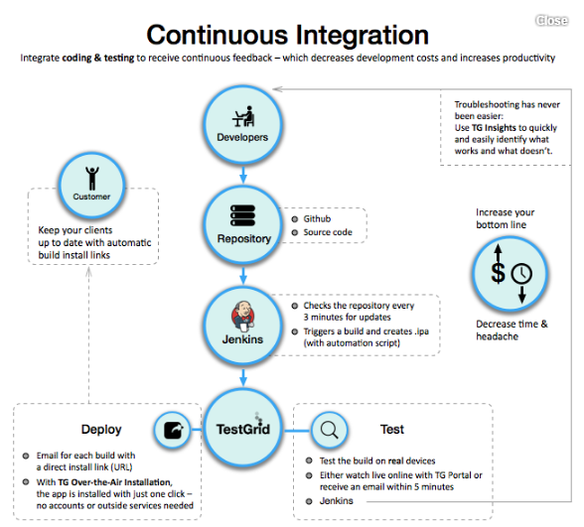

Jenkins can do anything

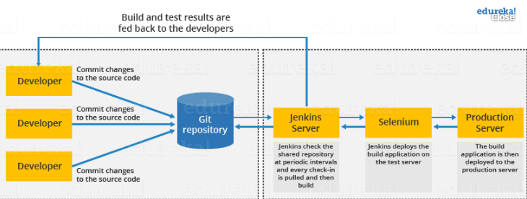

Supports for all languages not only for java it also supports .net

It is a web based tool

Built in min web server

Highly extensible: due to plugins, allow u to integrate with all source control systems, configuration management systems, u can write ur own plugins