**RPM: RPM** Package Manager (also known simply as **RPM**), originally called the **Red-hat Package Manager**, is a program for installing, uninstalling, and managing software packages in **Linux**. **RPM** was developed on the basis of the **Linux** Standard Base (LSB).

**EPEL: Extra packages for enterprise linux**

**File System Structure:**

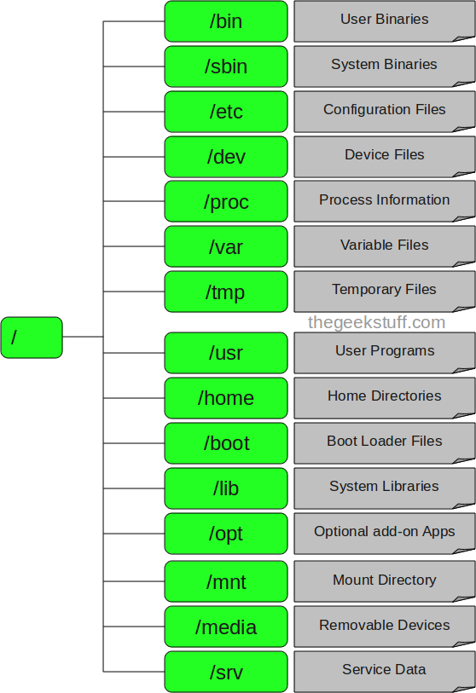

**1. / – Root**

Every single file and directory starts from the root directory.

Only root user has write privilege under this directory.

Please note that /root is root user’s home directory, which is not same as /.

**2. /bin – User Binaries**

Contains binary executables.

Common linux commands you need to use in single-user modes are located under this directory.

Commands used by all the users of the system are located here.

For example: ps, ls, ping, grep, cp.

**3. /sbin – System Binaries**

Just like /bin, /sbin also contains binary executables.

But, the linux commands located under this directory are used typically by system aministrator, for system maintenance purpose.

For example: iptables, reboot, fdisk, ifconfig, swapon

**4. /etc – Configuration Files**

Contains configuration files required by all programs.

This also contains startup and shutdown shell scripts used to start/stop individual programs.

For example: /etc/resolv.conf, /etc/logrotate.conf

**5. /dev – Device Files**

Contains device files.

These include terminal devices, usb, or any device attached to the system.

For example: /dev/tty1, /dev/usbmon0

**6. /proc – Process Information**

Contains information about system process.

This is a pseudo filesystem contains information about running process. For example: /proc/{pid} directory contains information about the process with that particular pid.

This is a virtual filesystem with text information about system resources. For example: /proc/uptime

**7. /var – Variable Files**

var stands for variable files.

Content of the files that are expected to grow can be found under this directory.

This includes — system log files (/var/log); packages and database files (/var/lib); emails (/var/mail); print queues (/var/spool); lock files (/var/lock); temp files needed across reboots (/var/tmp);

**8. /tmp – Temporary Files**

Directory that contains temporary files created by system and users.

Files under this directory are deleted when system is rebooted.

**9. /usr – User Programs**

Contains binaries, libraries, documentation, and source-code for second level programs.

/usr/bin contains binary files for user programs. If you can’t find a user binary under /bin, look under /usr/bin. For example: at, awk, cc, less, scp

/usr/sbin contains binary files for system administrators. If you can’t find a system binary under /sbin, look under /usr/sbin. For example: atd, cron, sshd, useradd, userdel

/usr/lib contains libraries for /usr/bin and /usr/sbin

/usr/local contains users programs that you install from source. For example, when you install apache from source, it goes under /usr/local/apache2

**10. /home – Home Directories**

Home directories for all users to store their personal files.

For example: /home/john, /home/nikita

**11. /boot – Boot Loader Files**

Contains boot loader related files.

Kernel initrd, vmlinux, grub files are located under /boot

For example: initrd.img-2.6.32-24-generic, vmlinuz-2.6.32-24-generic

**12. /lib – System Libraries**

Contains library files that supports the binaries located under /bin and /sbin

Library filenames are either ld* or lib*.so.*

For example: ld-2.11.1.so, libncurses.so.5.7

**13. /opt – Optional add-on Applications**

opt stands for optional.

Contains add-on applications from individual vendors.

add-on applications should be installed under either /opt/ or /opt/ sub-directory.

**14. /mnt – Mount Directory**

Temporary mount directory where sysadmins can mount filesystems.

**15. /media – Removable Media Devices**

Temporary mount directory for removable devices.

For examples, /media/cdrom for CD-ROM; /media/floppy for floppy drives; /media/cdrecorder for CD writer

**16. /srv – Service Data**

srv stands for service.

Contains server specific services related data.

For example, /srv/cvs contains CVS related data.

**Permission:**

1. **CHMOD**

**U= User**

**G= Group**

**+= Add permission**

**- = Remove permission**

**a= Any**

**R= Recursively**

**1. Add single permission to a file/directory**

Changing permission to a single set. + symbol means adding permission. For example, do the following to give execute permission for the user irrespective of anything else:

**$ chmod u+x filename**

**2. Add multiple permission to a file/directory**

Use comma to separate the multiple permission sets as shown below.

**$ chmod u+r,g+x filename**

**3. Remove permission from a file/directory**

Following example removes read and write permission for the user.

**$ chmod u-rx filename**

4. Change permission for all roles on a file/directory

Following example assigns execute privilege to user, group and others (basically anybody can execute this file).

**$ chmod a+x filename**

**5. Make permission for a file same as another file (using reference)**

If you want to change a file permission same as another file, use the reference option as shown below. In this example, file2’s permission will be set exactly same as file1’s permission.

**$ chmod --reference=file1 file2**

**6. Apply the permission to all the files under a directory recursively**

Use option -R to change the permission recursively as shown below.

**$ chmod -R 755 directory-name/**

**7. Change execute permission only on the directories (files are not affected)**

On a particular directory if you have multiple sub-directories and files, the following command will assign execute permission only to all the sub-directories in the current directory (not the files in the current directory).

**$ chmod u+X \***

Note: If the files has execute permission already for either the group or others, the above command will assign the execute permission to the user

1. **CHMOD File Permissions**
2. Read = 4
3. Write = 2
4. Execute =1

Permissions pattern = User - Group - Others (--- --- ---)