CSE476: Agentic AI and Automation
Practical Question Paper: Multi-Agent System
Time Allowed | Maximum Marks | Mode
1 Hour | 20 | Practical (Python + any LLM)

Instructions: Attempt all parts. Use the given data only. Submit the code file, the message log file and the results table.

Question
Build a multi-agent system in which three Department Agents, each knowing only its own courses and preferences, negotiate a weekly timetable through a Mediator Agent. A Room Manager Agent controls the rooms, and a Python validator tool checks every draft. The final timetable must have zero clash, satisfy as many preferences as possible, and recover when a room goes offline.

Architecture to implement
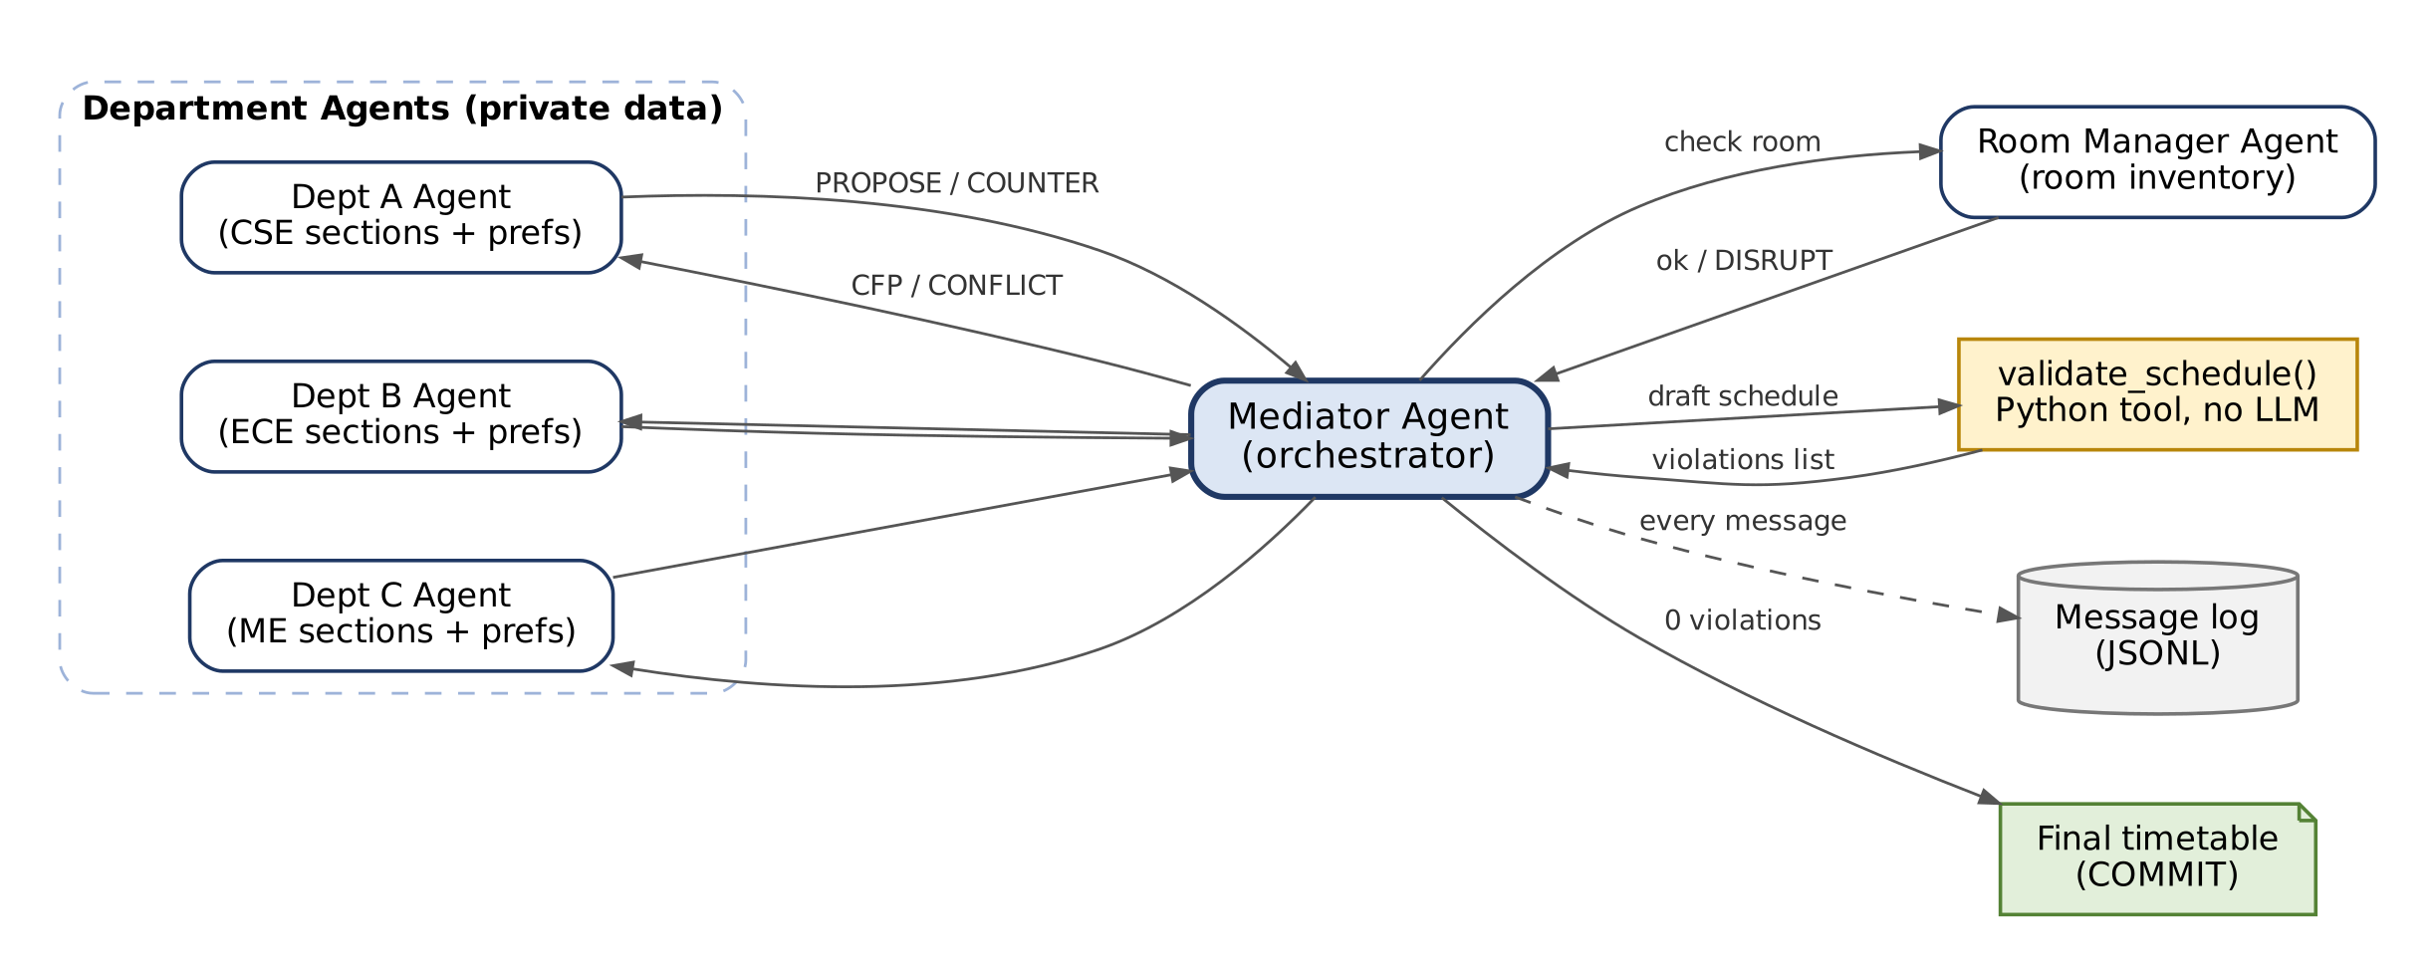
Figure 1. Departments talk only to the Mediator; the validator is plain Python; every message is logged.

Given data
- Slots: Monday and Tuesday, 5 slots each (M1 to M5, T1 to T5).
- Rooms: R1 (60 seats), R2 (60), R3 (40), LAB1 (30, labs only).
Department | Sections (strength, faculty) | Preferences (private)
A (CSE) | A1 (55, F1), A2 (35, F2), A3 lab (30, F1), A4 (40, F3) | F1 avoids Monday; no class in M5
B (ECE) | B1 (60, F4), B2 (38, F5), B3 lab (28, F4), B4 (50, F6) | F4 prefers slots 1 to 2; B1 in R1
C (ME) | C1 (45, F7), C2 (30, F8), C3 (58, F7), C4 (25, F9) | F7 at most 2 classes a day; avoid T5

- Rules (must never break): one section per room per slot; one section per faculty per slot; strength not above room capacity; labs only in LAB1 for 2 consecutive slots.
- Disruption: at round 3, room R2 becomes unavailable on Tuesday.

Tasks
Part | Task | Marks
(a) | Write validate_schedule() in plain Python (no LLM) that returns every rule violation. | 3
(b) | Single-agent baseline: one LLM sees all data and produces a timetable. Validate it and record the result. | 3
(c) | Create the Mediator, three Department Agents and the Room Manager with separate prompts. Each Department Agent must see only its own data. | 5
(d) | Agents exchange JSON messages (CFP, PROPOSE, COUNTER, ACCEPT, CONFLICT, COMMIT). Run negotiation until zero violations or 8 rounds. Save all messages to a log file. | 4
(e) | Apply the disruption at round 3 and repair only the affected sections. | 3
(f) | Fill the results table below and state in 2 lines which approach performed better. | 2

Results table (to be filled)
Measure | Single LLM | Multi-agent
Rule violations in final timetable
Preferences satisfied (out of 6)
Rounds taken | NA
Messages exchanged | NA
Sections moved after disruption | NA

