***Car Pooling Website***

***Happy Ride***

**Home Page**

This is the first page of our project which is a Car pooling website named ‘Happy Ride’.

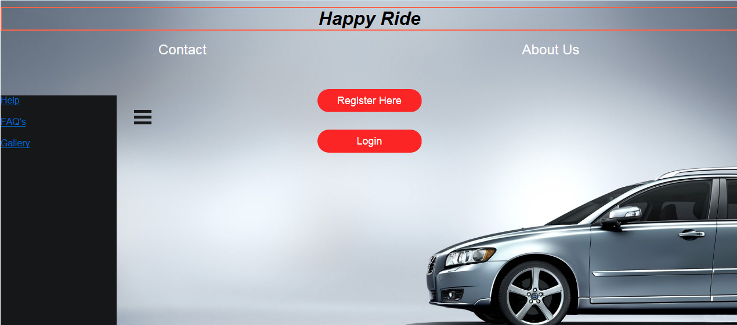

The Home Page has following Links.

1. Contact Page
2. About Us Page
3. Help Page
4. FAQ’s Page
5. Gallery
6. Register Page
7. Login Page

**Contact Page**

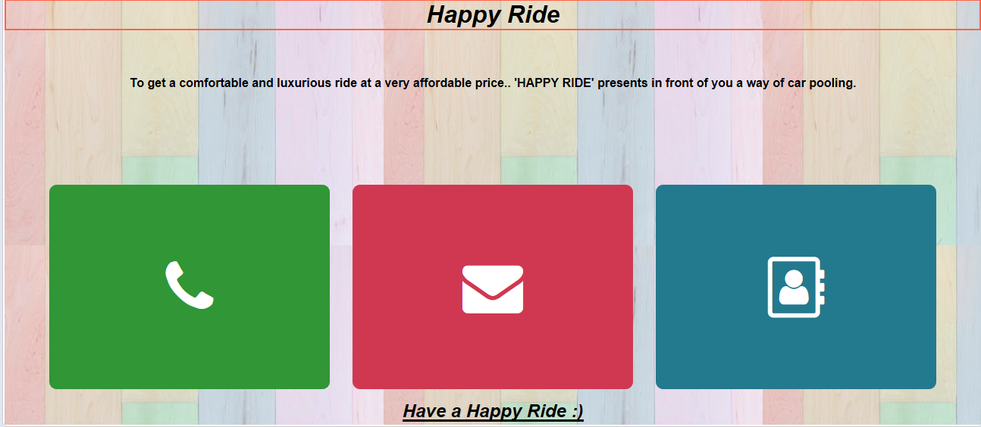

**About Us Page**

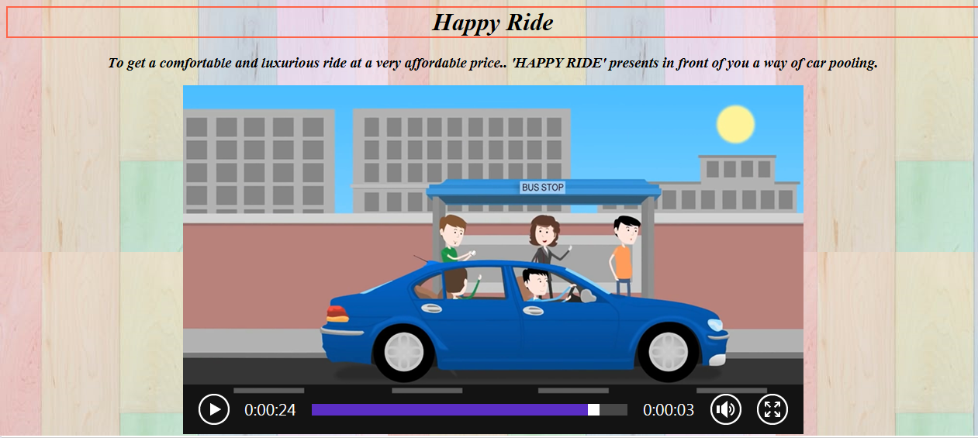

**Help Page**

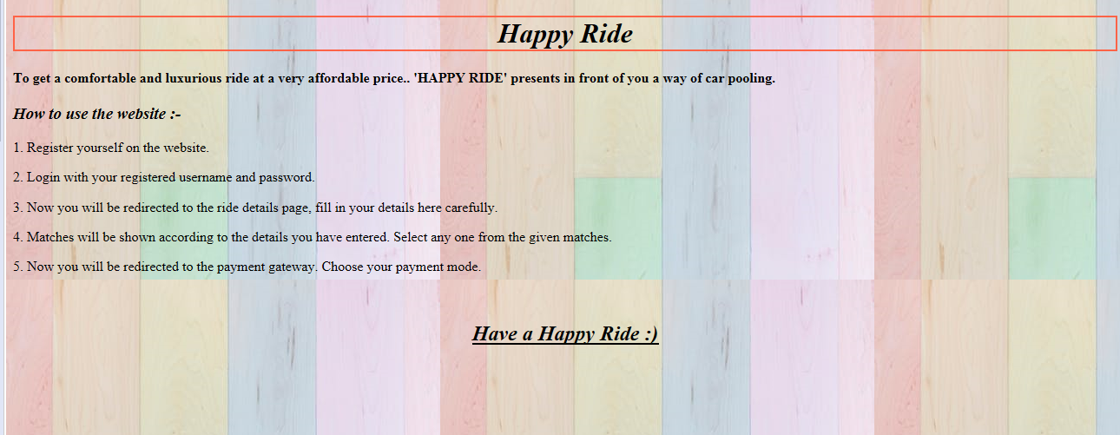

**FAQ’s**

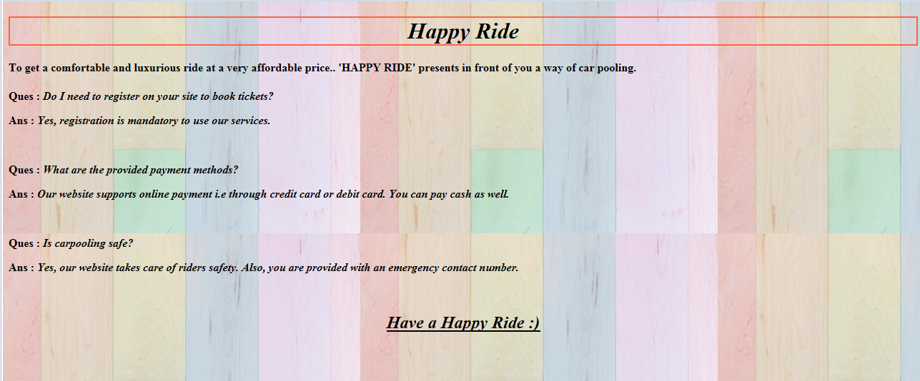

**Gallery Page**

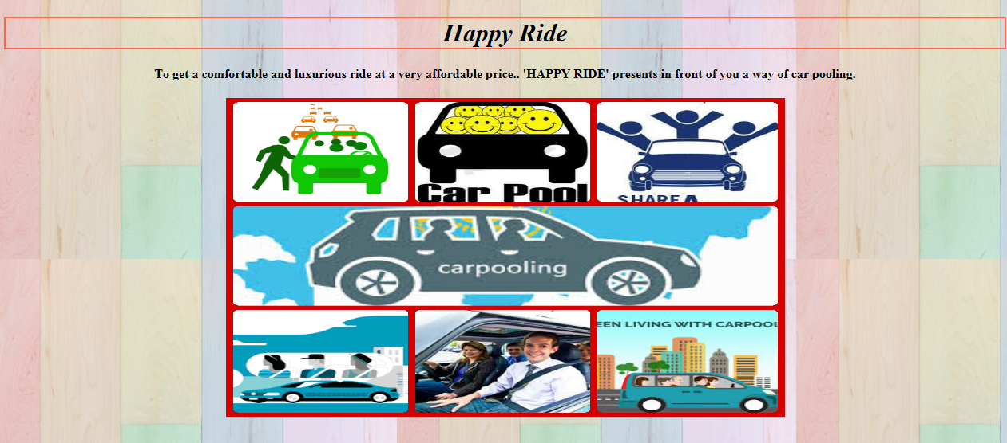

**Register Page**

The users will have to enter their details here to register themselves in the Car Pooling Website.

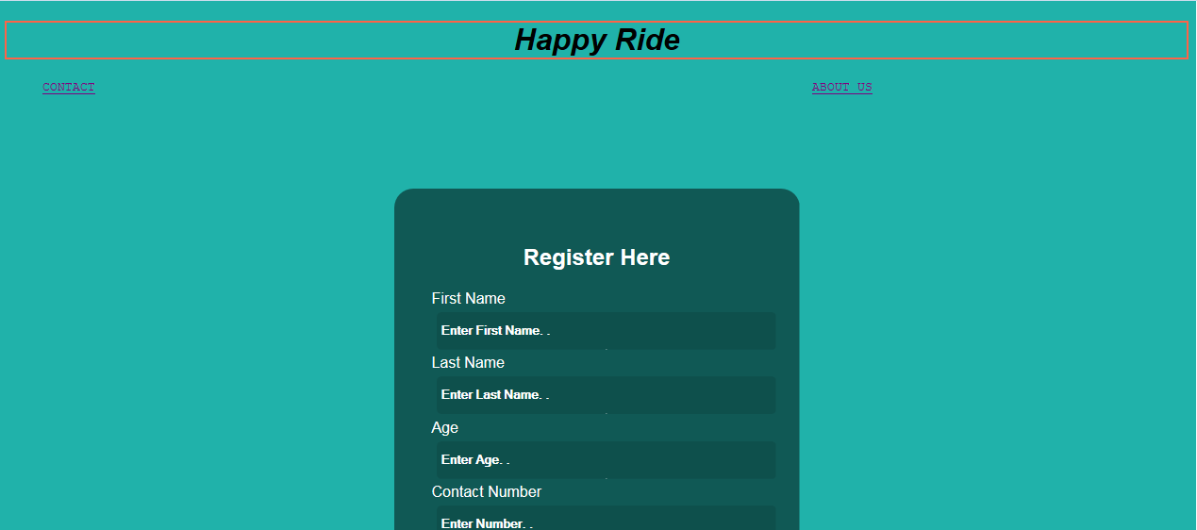



**Login Page**

The user is supposed to login to the website by entering the same user id and password which he/she created during registration. This will redirect them to the ride page.

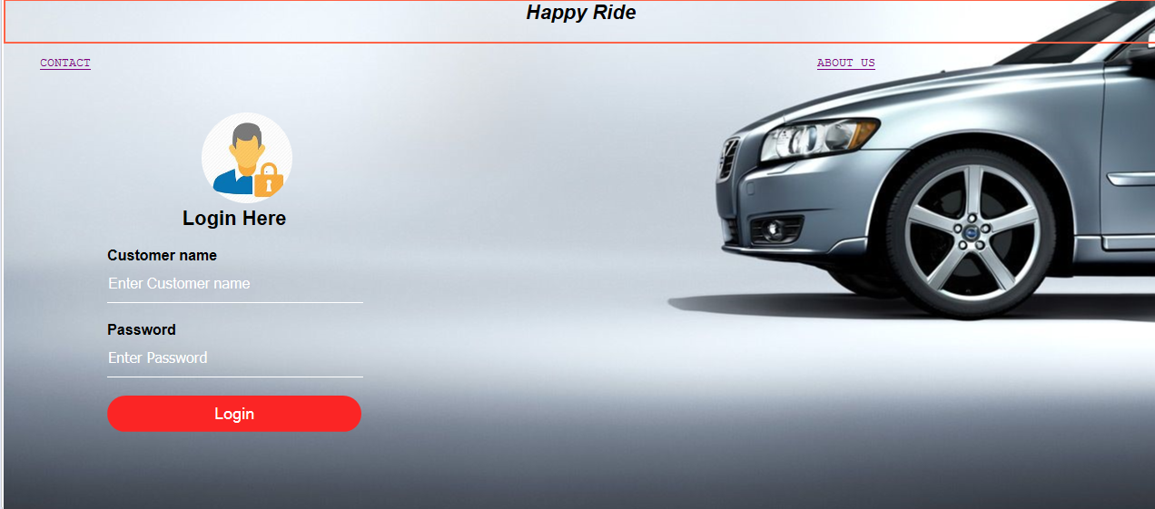

**Ride Page**

The ride page has two options: Give Ride and Take Ride.

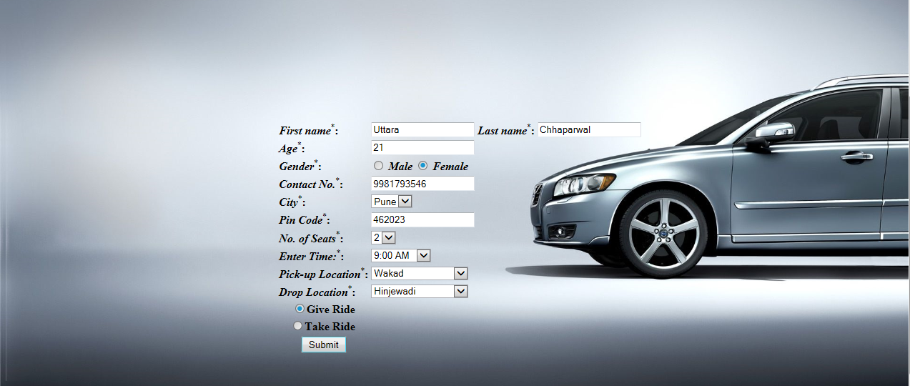

1. Give ride will redirect to the following page.

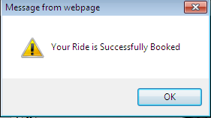



1. Take Ride will redirect to the following page.

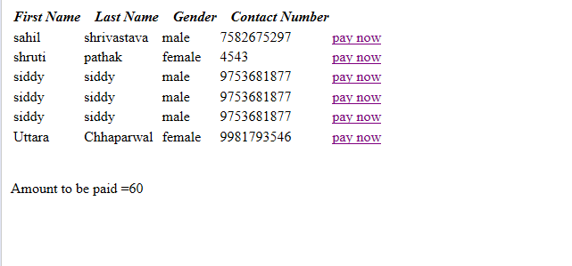

Now to select the ride user have to click on anyone of the Pay now options which will redirect him to the Payment page.

**Payment Page**

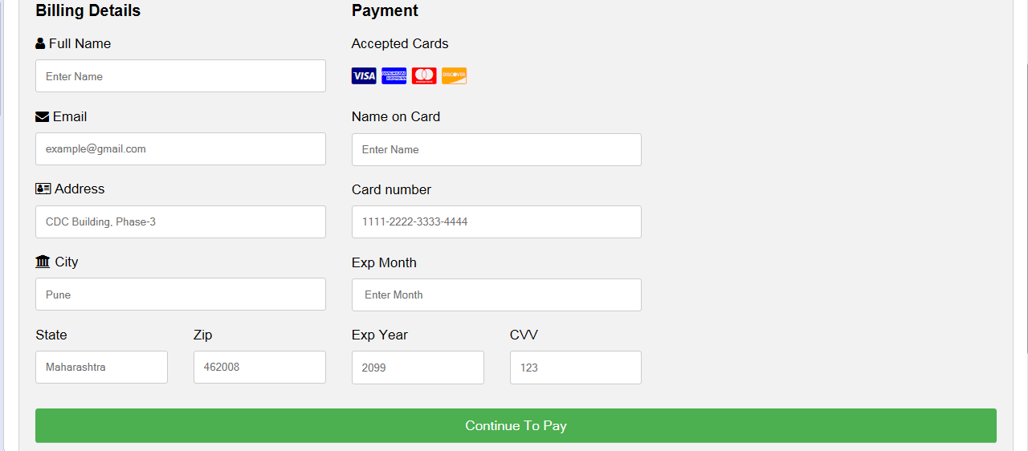

**Thank You Page**

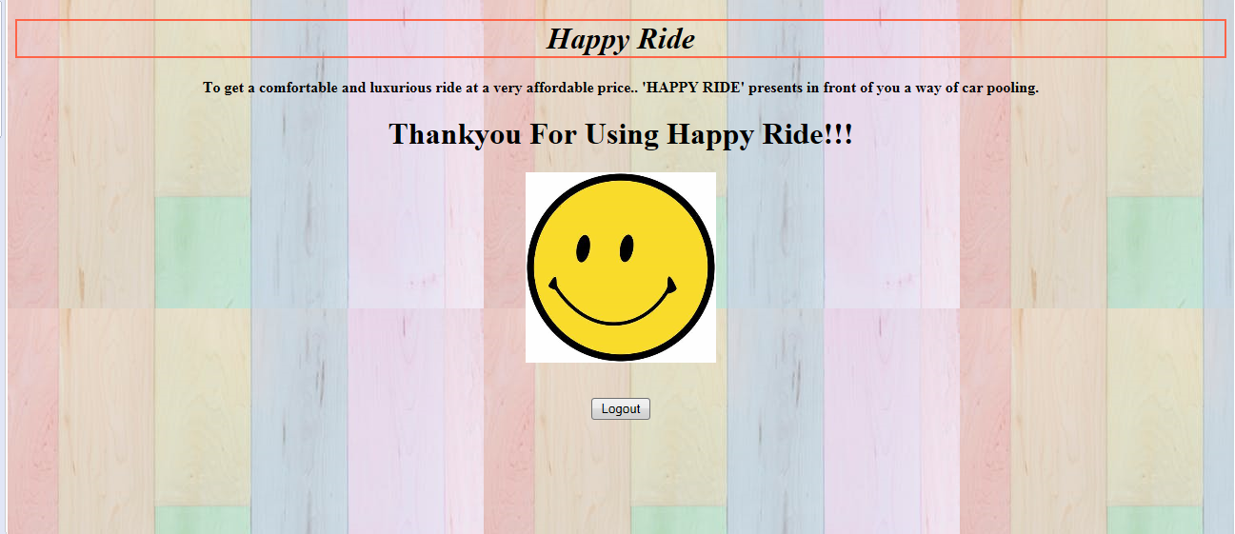

Log out button will redirect the user to the Home Page of the Website.