10MinRescue
Emergency Ambulance Dispatch Platform

Product Overview Document

"Get an Ambulance to Any Emergency in Under 10 Minutes"

Document Type | Product & Stakeholder Brief
Version | v1.0 — May 2026
Audience | Non-Technical Stakeholders, Investors, Partners
Status | Final — For Distribution

01. Executive Summary

10MinRescue is a technology-powered emergency ambulance service that connects people facing medical emergencies to the nearest available ambulance driver and hospital — all within 10 minutes. Whether you call, send a WhatsApp message, or tap a button on our website, our system immediately gets to work: locating the closest driver, alerting the right hospital, and giving you a live tracking link so you always know where help is.
This document explains what 10MinRescue is, why it was built, how it works, and what success looks like — written entirely for someone who does not need to know how the technology works, only what it does and why it matters.
KEY STATEMENT: 10MinRescue is live and operational. It is built on a real-time digital backbone that handles everything automatically — from finding the driver to guiding them to the hospital — so that in a crisis, no one has to figure anything out alone.

02. Problem Statement

Every year, thousands of people die not because medicine could not save them, but because help arrived too late. In India, the emergency response system faces deep, structural challenges that delay ambulances at the worst possible moment.
The Reality on the Ground
• No centralised dispatch system. When someone has a heart attack, their family starts calling hospitals one by one. There is no single number or system that intelligently finds the nearest available ambulance.
• Long waits and wrong directions. Drivers do not have navigation tools or patient location data. Families must guide them over phone calls while managing a medical emergency.
• Hospitals are blind to incoming patients. A hospital learns an ambulance is coming only when it arrives at the gate. No bed is pre-arranged, no team is ready.
• No live tracking. Families have no way to know where the ambulance is or when it will arrive. This helplessness adds enormous psychological stress.
• WhatsApp and calls go uncoordinated. Many families try reaching help through WhatsApp or direct calls, but there is no structured system to capture, process, and route these messages to an actual driver.

The Cost of This Problem
Situation | Without 10MinRescue | With 10MinRescue
Cardiac arrest at home | Family calls 5+ numbers, waits 30–60 min | Driver notified in seconds, arrives in <10 min
Hospital bed availability | Unknown until arrival | System checks live beds before dispatch
Driver navigation | Guided by panicked family on call | Automatic route guidance to patient location
Family during emergency | Helpless, no visibility | Live tracking link on phone
Hospital preparation | No advance notice | Hospital pre-alerted with patient details

03. Purpose

The purpose of 10MinRescue is simple and non-negotiable:
OUR PURPOSE: Ensure that no one dies waiting for an ambulance because the system failed to connect them to help in time.

We built 10MinRescue to fill the gap between the moment an emergency happens and the moment professional help arrives. Every feature in the app — from the SOS button to the live map to the hospital dashboard — exists to make that gap as small as possible.
This is not a ride-hailing app adapted for ambulances. It is an emergency coordination system built specifically for life-or-death situations, where every second matters.
04. Objectives

What 10MinRescue sets out to achieve:
• Reduce ambulance response time to under 10 minutes in urban and semi-urban areas.
• Give families real-time visibility — a live tracking link from the moment help is dispatched.
• Pre-alert hospitals automatically so beds and teams are ready before the ambulance arrives.
• Create a verified driver network of trained ambulance operators matched to the right type of emergency.
• Make emergency access multi-channel — web, WhatsApp, or phone call — so no one is left without a way to reach us.
• Provide hospitals with a simple dashboard to manage incoming ambulances and their bed availability in real time.
• Build an admin control layer so operators can monitor every active emergency and intervene when needed.
05. What Is 10MinRescue & Why Does It Exist?

What Is It?
10MinRescue is an emergency ambulance coordination platform made up of three connected tools that work together as one system:
The Public Website (10minrescue.com)
Anyone in an emergency can open this on any phone or computer, press "Emergency SOS", describe what happened, share their location, and within seconds the system begins finding the nearest driver. No app download needed.
The Driver Mobile App (Android)
Ambulance drivers carry this app on their phones. When a nearby emergency is reported, their phone rings with an alert. They see exactly where the patient is, what type of ambulance is needed, and which hospital has been pre-selected. They tap Accept and start navigating immediately.
The Hospital Web Dashboard
Hospitals log into a secure dashboard on any computer or tablet. They see every ambulance coming their way in real time — the patient's condition, the ambulance type, and the estimated arrival time. They can manage their bed availability with simple + / − buttons so the system always knows what's available.
Why Was It Built?
India has over 1.4 billion people and a deeply underfunded emergency response infrastructure. Government ambulance services are overstretched. Private ambulances are uncoordinated. Hospitals have no advance warning system. Families in a crisis are left to navigate all of this alone, under the worst possible psychological pressure.
10MinRescue was built because the founders believed that technology — used simply and correctly — could save lives that are currently being lost not to illness, but to broken systems.
06. How 10MinRescue Solves the Problem

The Complete Emergency Journey — Step by Step
Here is exactly what happens from the moment someone calls for help to the moment the patient is safe in a hospital:
STEP 1  1 | Someone Calls for Help  The patient's family opens 10minrescue.com on their phone. They tap "Emergency SOS" and fill in three quick things: what happened (e.g. "father collapsed, chest pain"), how serious it is (Critical / Serious / Stable), and the system automatically selects the right ambulance type. They tap "Share My Location" and hit Send SOS. This entire process takes less than 60 seconds.
STEP 2  2 | System Finds the Nearest Driver  The moment the SOS is sent, our system searches for all available ambulance drivers within 1 kilometre of the patient. If no one is found in 30 seconds, it expands to 2 km, then 5 km, then 10 km. The closest available driver with the right type of ambulance gets an instant alert on their phone.
STEP 3  3 | Driver Accepts and Navigates  The driver's phone shows the patient's exact location, the emergency description, and the pre-selected hospital. They tap Accept and open navigation. The family receives a live tracking link immediately — they can watch the ambulance moving on a map in real time.
STEP 4  4 | Hospital Is Pre-Alerted  As soon as a hospital is selected (either by the patient or the driver), the hospital's dashboard shows the incoming ambulance — patient's name, condition, ambulance type, and estimated arrival time. The hospital can prepare the right bed, the right team, and the right equipment before the ambulance even arrives.
STEP 5  5 | Patient Arrives, Hospital Is Ready  The driver marks the patient as picked up. The hospital sees the status update live. When the ambulance arrives, no time is wasted — the team is at the gate, the bed is ready, and the patient moves directly into care.
STEP 6  6 | Trip Completed  Once the patient is received by the hospital, the driver marks the trip as complete. The hospital logs the intake. The entire journey — from SOS to hospital — is recorded, timestamped, and stored for reporting.

Three Ways to Reach 10MinRescue
Channel | How It Works | Best For
Emergency SOS (Website) | Open site → tap SOS → fill form → share location | Anyone with internet access
WhatsApp Message | Message our number → describe emergency → share location | Users comfortable with WhatsApp
Phone Call | Call +91 78660 67136 → speak to operator | Situations where typing is impossible

07. Application Screens — Visual Walkthrough

Below are screenshots of every screen in the 10MinRescue platform, with plain-language explanations of what each screen does and who uses it.
7.1 The Public Website — What Patients & Families See
Home / Landing Page
This is the first page anyone sees when they visit 10minrescue.com. It is designed to be simple and fast: the two big red buttons — Emergency SOS and Request Callback — are the only things that matter in a crisis. The page also explains how the service works and builds trust with information about the verified driver and hospital network.
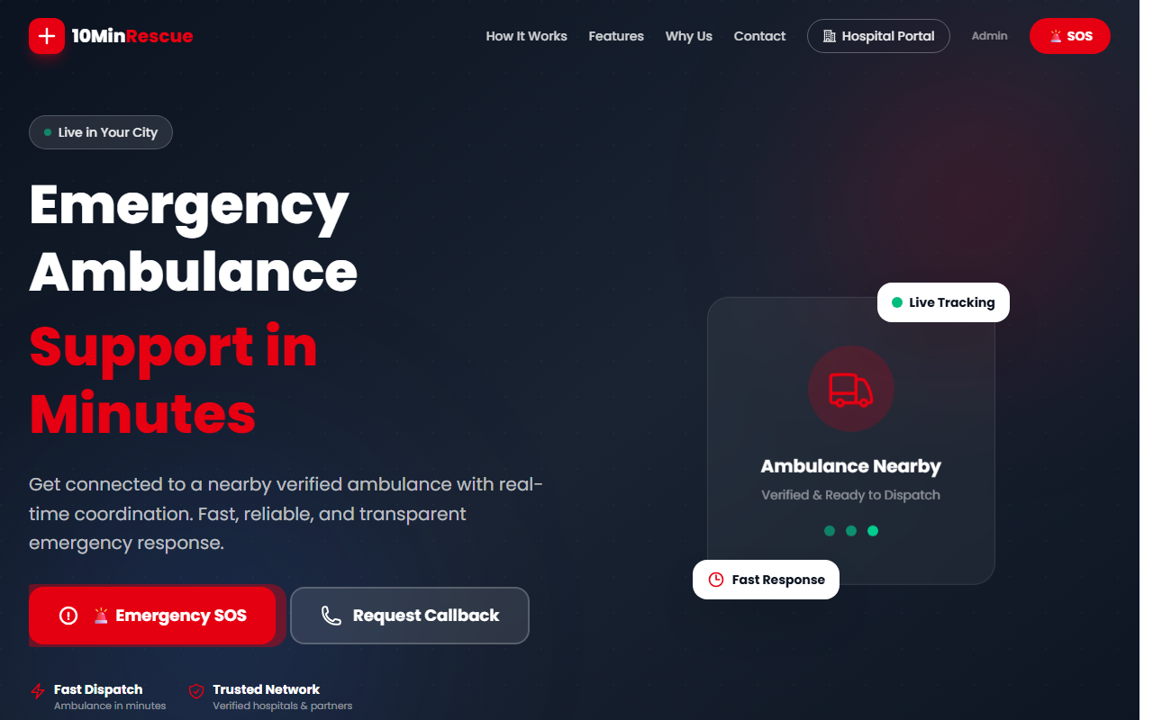
Figure 1: 10MinRescue Home Page — "Emergency SOS" and "Request Callback" buttons are immediately visible
How It Works Section
Scrolling down the home page reveals the three channels: SOS button, Callback request, and WhatsApp. This section reassures a first-time visitor that they can reach help in whatever way is easiest for them.
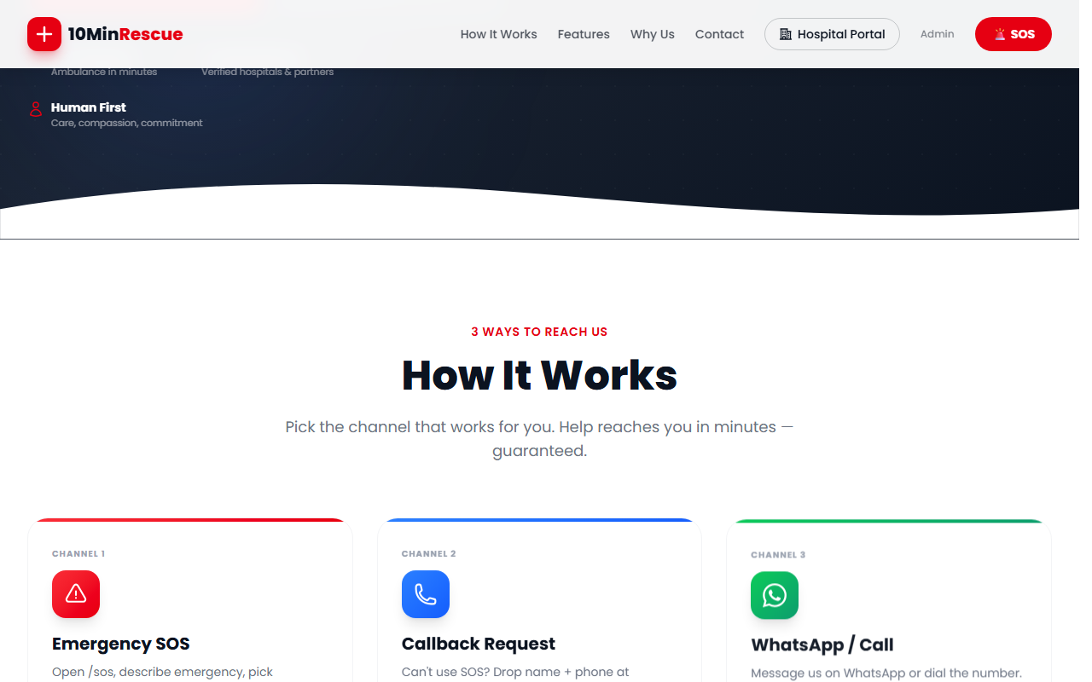
Figure 2: Three channels — Emergency SOS, Callback, and WhatsApp/Call
End-to-End Flow Banner
This section on the website shows the patient the full journey: Patient → Driver → Hospital → Live Track. It builds confidence that the system handles everything automatically.
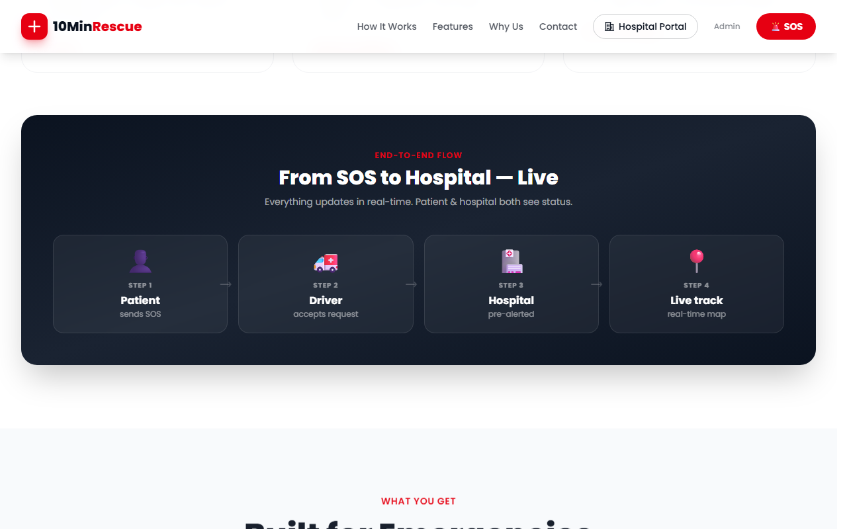
Figure 3: "From SOS to Hospital — Live" — real-time coordination flow
7.2 The SOS Wizard — Step-by-Step Emergency Request
When someone taps Emergency SOS, they enter a guided 4-step process. It is designed to collect the minimum necessary information as quickly as possible. There is a progress bar at the top so the user always knows where they are.
Step 1 — Describe the Emergency
The user types a brief description of what happened and selects the urgency level: Critical (cardiac arrest, unconscious), Serious (severe injury, bleeding), or Stable (minor injury, transport needed). The colour coding — red, amber, green — makes the choice instant and intuitive.
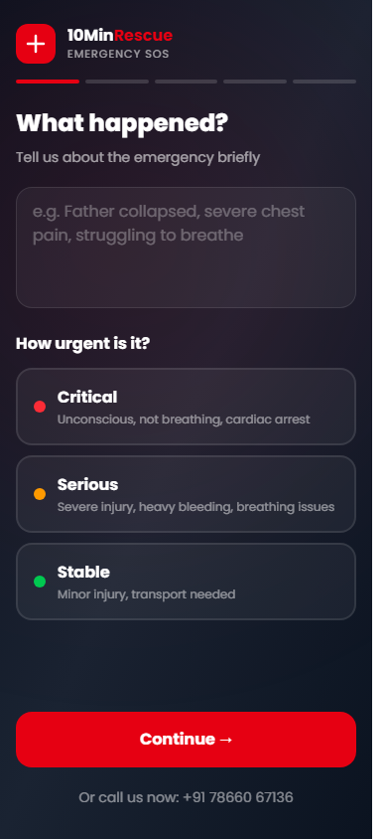
Figure 4: SOS Step 1 — Emergency description and urgency selection
Step 2 — Ambulance Type (Auto-Selected)
Based on the urgency chosen, the system automatically selects the right ambulance type: Type A (ICU, for Critical), Type B (Advanced, for Serious), or Type C (Normal, for Stable). The user can override this if needed. This removes the burden of medical decision-making from a panicked family member.
Step 3 — Choose Hospital (or Let System Decide)
The system shows nearby hospitals with available beds of the required type, sorted by rating and distance. The user can choose a specific hospital or select "Let System Decide" — in which case the driver will choose the best hospital after pickup. Distance and bed availability are shown for each option.
Step 4 — Review and Send
A final confirmation screen shows all details: the emergency description, urgency, ambulance type, hospital, and GPS coordinates. The large red "SEND SOS NOW" button sends everything to the system in one tap. There is no way to accidentally send — this is the final, deliberate confirmation.
7.3 Callback Request Page
For users who cannot fill the SOS form (elderly users, low internet, or highly distressed situations), the Callback option lets them simply drop their name and phone number. An operator calls them back immediately.
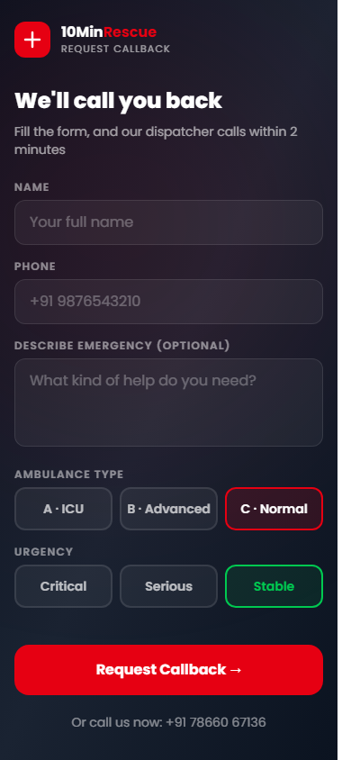
Figure 5: Callback Request — drop name and number, we call you
7.4 Hospital Portal — What Hospitals See
Every partner hospital gets a secure login to the Hospital Portal. This is a web-based dashboard that works on any computer or tablet — no app download required. It gives hospital staff real-time visibility into every incoming ambulance assigned to them.
Hospital Login Screen
Hospitals log in with a secure email and password provided by the 10MinRescue admin team. Access is restricted — only authorised hospital accounts can log in.
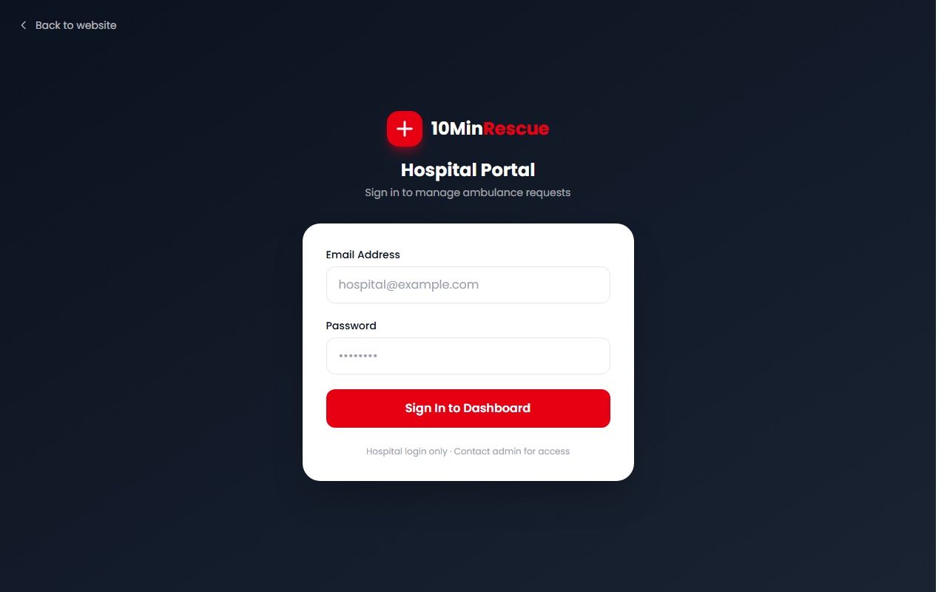
Figure 6: Hospital Portal Login — secure, role-specific access
Hospital Dashboard — Live Ambulance Tracking
Once logged in, hospital staff see three tabs:
• Incoming: Ambulances that have been assigned to this hospital and are on their way
• In Transit: Ambulances currently en route with the patient on board
• History: All completed and cancelled trips for record-keeping
At the top of the dashboard, hospitals can manage their bed count in real time. They use simple + and − buttons to adjust ICU, Advanced, and Normal bed availability. This ensures the system always knows which hospital can accept which type of patient.
HOW IT WORKS: The hospital dashboard is entirely automatic — hospitals do not need to accept or decline ambulances. They are notified, see the incoming patient details, and prepare. The system handles the matching.

7.5 Admin Panel — Operations Control Centre
The Admin Panel is accessible only to 10MinRescue's own operations team. From here, administrators can see every active emergency request across the entire platform, verify driver documents before they go live, and manage both the driver and hospital networks.
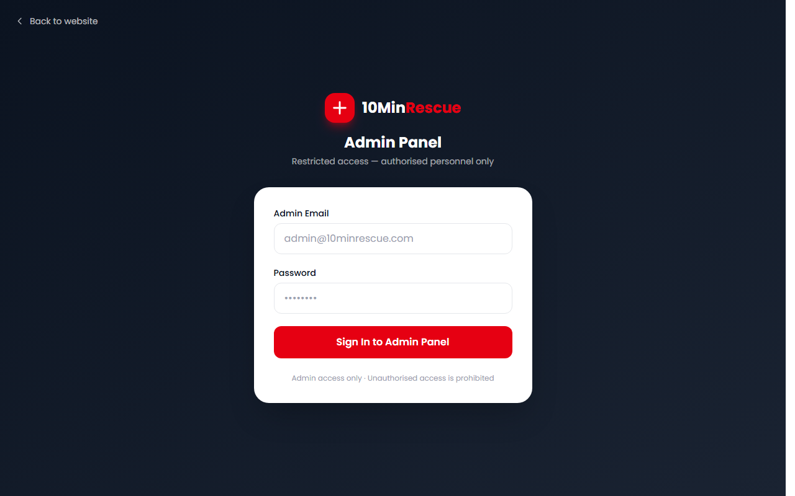
Figure 7: Admin Panel Login — restricted to authorised personnel only
Key admin functions include:
• Review and approve driver registration and documents
• Monitor all active rescue requests across the city
• See which drivers are online and where they are
• Manage hospital accounts and their bed configurations
• View the full history of completed trips
7.6 Driver Mobile App — What Ambulance Drivers See
Ambulance drivers use the 10MinRescue Android app. It is designed for use in a moving vehicle — large buttons, minimal reading, clear navigation. Below is a description of the key screens drivers interact with during every shift.
Driver Home Screen (Online/Offline Toggle)
When a driver opens the app and goes Online, the app begins sharing their GPS location to the system every few seconds. The home screen shows their current status (online or offline), their ambulance type (ICU, Advanced, or Normal), and any pending SOS alerts nearby.
Incoming Request Alert
When a nearby emergency matches their ambulance type, the driver receives a loud push notification. The screen shows: the patient's location on a map, the distance from the driver, the emergency description, the urgency level (colour-coded), and the pre-selected hospital. The driver taps Accept or Dismiss.
Navigation to Patient
After accepting, the driver's app shows turn-by-turn navigation to the patient's exact GPS location. When they arrive, they tap "Mark Patient Picked Up" and the hospital is automatically notified.
Navigation to Hospital
After picking up the patient, the app shows navigation to the hospital. The driver can also view the hospital's address and call them if needed. On arrival, they tap "Confirm Arrival" and the trip is marked complete.
Driver Registration & Document Upload
New drivers register through the app by uploading their licence, vehicle documents, and a photo. These are reviewed by the admin team before the driver is approved and goes live.
NOTE: Driver app screenshots shown here are representative screen descriptions. Actual device screenshots from a running Android device can be inserted in their place for the final version of this document.

7.7 Live Tracking Page — What the Family Sees After SOS
After the SOS is sent, the patient or family immediately receives a tracking link. Opening it shows a live map with the ambulance's position updating in real time. No app download is needed — it works in any mobile browser. The page also shows the emergency status, the assigned hospital, and an emergency call button.
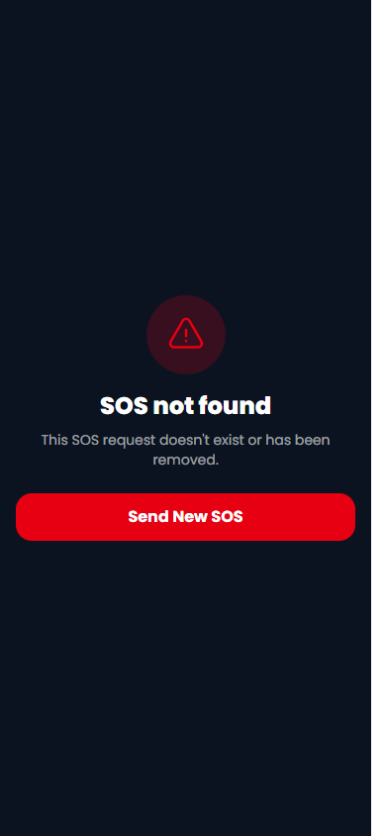
Figure 8: Live Tracking page — family can watch the ambulance in real time
08. Edge Cases — What Happens When Things Go Wrong?

A life-saving platform must be prepared for every possible failure scenario. Here is how 10MinRescue handles the situations that could otherwise leave someone without help:
! | No driver available nearby: The system automatically expands the search radius every 30 seconds: 1 km → 2 km → 5 km → 10 km. If still no driver, the admin team is alerted and can manually coordinate. The patient is never silently abandoned.

! | Driver does not accept the request: If a driver does not respond within 30 seconds, the request is automatically sent to the next nearest available driver. This continues until someone accepts.

! | Patient's location cannot be detected: The SOS form shows a clear message: "Tap Allow when your browser asks for location." If location is still unavailable, the patient can use the Callback option or WhatsApp to describe their address verbally.

! | Hospital bed count is zero: If a hospital has no available beds of the required type, it does not appear as an option. The system only shows hospitals with confirmed availability. "Let System Decide" lets the driver choose on the ground.

! | Driver loses internet mid-journey: The last known location is cached. Navigation continues offline. The app re-syncs automatically when connection is restored.

! | Patient closes the browser after sending SOS: The SOS request is already submitted — it cannot be lost. The patient's last SOS ID is saved locally so they can return to the tracking page even if they close the browser accidentally.

! | Multiple SOS requests from same location: The system detects duplicate requests from the same GPS coordinates within a short window and prevents multiple drivers being sent to the same emergency.

! | Hospital does not update bed count: The system flags hospitals with stale bed counts. Admins receive alerts and can contact the hospital. Bed counts that have not been updated in over 24 hours are marked as "unverified" to prevent over-dispatch.

! | Driver app crashes or phone dies: The patient's family receives an automatic notification if the driver goes offline mid-journey. The admin team is alerted to manually reassign the request if the driver does not reconnect within 2 minutes.

! | WhatsApp message is incomplete: The WhatsApp bot asks follow-up questions to collect the minimum required information (location, urgency) before routing to a driver.

09. Scope — What 10MinRescue Covers

The following capabilities are fully built and operational in the current version of 10MinRescue:
• Emergency SOS request via web browser (mobile and desktop)
• Automatic nearby driver search using GPS-based geolocation
• Smart radius expansion (1 km → 10 km) when no driver is immediately available
• Three ambulance types matched to three urgency levels (Critical, Serious, Stable)
• Real-time hospital bed availability display during SOS flow
• Live ambulance tracking page for patients and families
• Driver Android app: online/offline toggle, incoming request alert, GPS navigation
• Hospital web dashboard: incoming ambulance view, bed management, trip history
• Admin web panel: driver verification, request monitoring, hospital management
• WhatsApp emergency intake via Cloud API webhook
• Callback request form for voice-based emergency coordination
• Firebase Cloud Functions for all automated matching and notification logic
• Push notification system for drivers (FCM — Firebase Cloud Messaging)
• Firestore real-time database for all live data (requests, driver locations, bed counts)
• Role-based access control (patient, driver, hospital, admin)
• Full trip history and status lifecycle tracking
10. Out of Scope

The following are explicitly NOT part of the current version of 10MinRescue. These may be considered for future phases but are not promised or implied:
✗ Payment processing: No billing, invoicing, or payment gateway is integrated. All pricing and payment coordination happens offline.
✗ iOS Driver App: The driver app currently supports Android only. An iOS version is not part of this release.
✗ In-app chat between driver and patient: Communication happens via phone call. There is no in-app messaging or chat feature.
✗ Government ambulance integration: 10MinRescue operates its own verified private network. Integration with 108 or government fleets is not included.
✗ Automatic fare estimation: The platform does not calculate or display trip costs. This is handled separately between the driver and the patient.
✗ Medical record storage: Patient medical history, prescriptions, or health records are not stored in 10MinRescue.
✗ Dispatch to fire brigade or police: The platform is ambulance-specific. It does not route to fire or law enforcement services.
✗ AI-based triage or medical advice: The system collects urgency information from the user but does not provide medical diagnoses or treatment recommendations.
✗ Multi-city or multi-country rollout (v1): The current version is deployed for a single city. Multi-city expansion is a future roadmap item.
11. Success Matrix — How We Know It Is Working

Success for 10MinRescue is measured across three dimensions: speed, reliability, and reach. These are the metrics we track to know the platform is delivering on its promise.
Primary Success Metrics
Metric | What It Measures | Target (Phase 1)
Average Response Time | Time from SOS sent to driver accepting the request | < 3 minutes
Ambulance On-Scene Time | Time from SOS sent to ambulance arriving at patient | < 10 minutes
Driver Accept Rate | % of requests accepted by the first notified driver | > 80%
Hospital Pre-Alert Rate | % of trips where hospital was notified before ambulance arrival | 100%
SOS Completion Rate | % of SOS requests that result in a completed trip | > 90%
System Uptime | Availability of the platform (website + app + backend) | > 99.5%
Driver App Crash Rate | % of driver sessions with a crash or freeze | < 1%

User Experience Metrics
Metric | What It Measures | Target
SOS Form Completion Time | Time to fill and submit the SOS form | < 60 seconds
Family Satisfaction Score | Post-trip feedback from patient's family | > 4.2 / 5.0
Hospital Dashboard Adoption | % of partner hospitals actively using dashboard | > 85%
Driver App Daily Active Use | % of registered drivers going online each day | > 70%
Callback Response Time | Time from callback request to first call back | < 5 minutes

Network Growth Metrics
Metric | What It Measures | Target (6 months)
Active Drivers | Verified drivers going online at least once a week | 50+ drivers
Partner Hospitals | Hospitals with active dashboard logins | 20+ hospitals
Total SOS Requests Served | Cumulative emergencies handled by the platform | 500+ cases
Geographic Coverage | Area covered by active driver network | Full city coverage
Average Driver Rating | Patient-rated score for driver performance | > 4.0 / 5.0

What Does NOT Count as Success
IMPORTANT: A fast response time with poor patient outcomes is not success. High driver acceptance rates with no verified hospital beds is not success. Platform uptime with zero active drivers is not success. Every metric must be seen together — the system only works when all parts work.

12. Final Note

10MinRescue is built on a straightforward belief: in a medical emergency, every minute that passes without help arriving is a minute too long. The platform exists to make those minutes disappear.
This document has described what the platform is, why it was built, how it works, who uses it, and how we measure whether it is working. The screenshots show the actual, live product — not a design mockup.
We welcome questions, feedback, and partnership conversations. The contact for this document is:
CONTACT: Email: mcteam.myewards@gmail.com | Phone: +91 78660 67136 | Website: 10minrescue.com

10MinRescue — Stakeholder Brief v1.0 — May 2026 — Confidential

