10MinRescue
Emergency Ambulance Dispatch Platform

Complete Product Overview — For Non-Technical Readers

"Get an Ambulance to Any Emergency in Under 10 Minutes"

Document Type | Product & Stakeholder Brief
Version | v2.0 — May 2026
Audience | Non-Technical Stakeholders, Investors, Partners
Status | Final — For Distribution

01. Executive Summary

10MinRescue is a technology-powered emergency ambulance coordination platform that connects people facing medical emergencies to the nearest available ambulance driver and hospital — in under 10 minutes. It works across three connected tools: a public website anyone can open on any phone, an Android app for ambulance drivers, and a web dashboard for hospitals.
This document explains everything about the platform — what it is, why it was built, how every screen works, how the live map tracks the ambulance, how hospitals see and manage their bed availability, how the driver app guides a driver from alert to hospital — written for anyone, with no technical knowledge assumed.
KEY STATEMENT: 10MinRescue is live and operational. Every screen shown in this document is from the actual, running product.

02. Problem Statement

Every year, thousands of people die not because medicine could not save them, but because an ambulance arrived too late. In India, the emergency response system faces deep, structural problems:
The Five Core Problems
• No single dispatch system. Families call 5–10 hospitals one by one during a crisis. There is no central system that finds the nearest ambulance automatically.
• Drivers have no navigation. Ambulance drivers depend on a panicked family member directing them over the phone, causing delays and wrong turns.
• Hospitals have no advance notice. A hospital only knows an ambulance is coming when it arrives at the gate. No team is ready, no bed is prepared.
• Zero visibility for families. Once help is called, the family has no way to track where the ambulance is or how long it will take.
• WhatsApp and calls are uncoordinated. Many people try to reach help via WhatsApp or phone, but there is no structured system to capture and route these requests to a real driver.

Before vs. After 10MinRescue
Situation | Without 10MinRescue | With 10MinRescue
Cardiac arrest at home | Family calls 5+ numbers, waits 30–60 min | Driver notified in seconds, arrives <10 min
Hospital bed availability | Unknown until ambulance arrives at gate | Checked live before dispatch
Driver navigation | Guided by panicked family on phone | Automatic GPS route to patient
Family during crisis | Helpless, no visibility | Live tracking link on phone
Hospital preparation | No advance notice, team not ready | Pre-alerted with patient details

03. Purpose

OUR PURPOSE: Ensure that no one dies waiting for an ambulance because the system failed to connect them to help in time.

10MinRescue fills the gap between the moment an emergency happens and the moment professional help arrives. Every feature in the app — from the SOS button to the live map to the hospital bed panel — exists to make that gap as small as possible.
04. Objectives

• Reduce ambulance response time to under 10 minutes in urban areas.
• Give families real-time tracking from the moment help is dispatched.
• Pre-alert hospitals automatically so beds and teams are ready before arrival.
• Create a verified driver network matched to the right ambulance type for each emergency.
• Make emergency access multi-channel — web, WhatsApp, or phone call.
• Give hospitals a live bed management dashboard updated in real time.
• Build an admin control layer to monitor every active emergency and intervene if needed.
05. What Is 10MinRescue?

10MinRescue is three connected tools that work as one system:
The Public Website (10minrescue.com)
Open on any phone or computer — no app download needed. Anyone can press "Emergency SOS", describe what happened, share their location, and within seconds the system finds the nearest driver. Also accessible via WhatsApp or a phone callback request.
The Driver Android App
Ambulance drivers carry this on their phones. When a nearby emergency matches their ambulance type, they receive an immediate alert with a 30-second countdown. They see the patient location, emergency details, and pre-selected hospital, then navigate directly to the patient.
The Hospital Web Dashboard
Hospitals log in on any computer or tablet. They see every ambulance assigned to them in real time, manage their bed availability with + / − buttons, and view the full history of completed trips.
06. Ambulance Types — Equipment & Seating Layout

10MinRescue matches each emergency to the right type of ambulance. There are three ambulance types, each designed for a different level of medical need. When a patient selects their urgency level (Critical, Serious, or Stable), the system automatically recommends the correct ambulance type — though the patient can override this if needed.
TYPE A — ICU AMBULANCE (For: CRITICAL emergencies)

Used for: Cardiac arrest, unconscious patient, no pulse or breathing, life-threatening trauma.
Equipment on board:
• Cardiac monitor and defibrillator (restarts stopped heart)
• Ventilator (breathes for the patient if they cannot breathe)
• Pulse oximeter (monitors blood oxygen levels)
• IV drip lines and emergency medications
• Oxygen cylinder with mask and flow meter
• Suction machine (clears airways)
• Spinal board and neck collar (for trauma cases)
• AED — Automated External Defibrillator
Seating & space layout:
The ICU ambulance has the most equipment-dense interior:
• 1 stretcher (patient lies flat, fully monitored)
• 1 paramedic seat alongside the stretcher (for constant monitoring)
• 1 attendant fold-down seat at the patient's feet
• All equipment mounted on walls and ceiling rails for quick access
• No standing room — every inch is used for life-support equipment
WHY IT MATTERS: In a cardiac arrest, the paramedic in a Type A ambulance can administer defibrillation shocks and run an IV drip while the ambulance is moving — this is life-saving care that cannot wait until hospital arrival.

TYPE B — ADVANCED AMBULANCE (For: SERIOUS emergencies)

Used for: Severe injuries, heavy bleeding, breathing difficulties, high-risk pregnancies, major road accidents.
Equipment on board:
• Oxygen cylinder and mask
• Defibrillator (for heart rhythm correction)
• Advanced monitoring — blood pressure, ECG, oxygen saturation
• IV drip lines and fluids
• First aid and wound management supplies
• Immobilisation equipment — splints, collars, backboard
• Emergency medications — pain relief, anti-seizure drugs
Seating & space layout:
The Advanced ambulance has more flexibility than the ICU type:
• 1 stretcher (patient lies flat or is semi-reclined)
• 1 EMT (Emergency Medical Technician) seat alongside the patient
• 1–2 attendant seats for a family member or second responder
• Storage compartments for medication and equipment along both walls
• More accessible interior — EMT can move around the patient

TYPE C — NORMAL AMBULANCE (For: STABLE / transport cases)

Used for: Minor injuries requiring hospital transport, post-discharge transfers, stable patients who need monitoring en route.
Equipment on board:
• Basic oxygen supply
• First aid kit (bandages, wound care)
• Stretcher or wheelchair depending on patient mobility
• Basic vitals monitoring (blood pressure, pulse)
Seating & space layout:
• 1 stretcher or reclining seat for the patient
• 2 attendant seats — typically for a family member and a first-aider
• Spacious interior — designed for comfort over intensive care
• Fold-down step at the rear for easy boarding by mobile patients

How the System Selects the Ambulance Type Automatically
Urgency | Ambulance Type | Typical Condition | Who Rides Along
CRITICAL (Red) | Type A — ICU | Cardiac arrest, no pulse, unconscious | Paramedic with life support skills
SERIOUS (Amber) | Type B — Advanced | Severe injury, heavy bleeding, breathing issues | EMT with advanced first aid training
STABLE (Green) | Type C — Normal | Minor injury, transport needed | First-aider or driver only

NOTE: The patient or their family can override the auto-selected type on the SOS wizard (Step 2). If they are unsure, "Let System Decide" is always the safest choice.

07. How 10MinRescue Solves the Problem

The Complete Emergency Journey — Step by Step
Here is exactly what happens from the moment someone calls for help to the moment the patient is safe in hospital:
STEP 1  1 | Someone Sends an SOS  The patient's family opens 10minrescue.com on any phone. They tap "Emergency SOS" and fill in three things: what happened (e.g. "father collapsed, chest pain"), how serious it is (Critical/Serious/Stable), and the system auto-selects the ambulance type. They share their GPS location and hit "SEND SOS NOW". The whole process takes under 60 seconds.

STEP 2  2 | System Finds the Nearest Driver  Instantly, the system searches for available drivers within 1 km of the patient. Only drivers with the matching ambulance type are notified. If no driver responds in 30 seconds, the search expands to 2 km, then 5 km, then 10 km — automatically, with no human intervention needed.

STEP 3  3 | Driver Gets an Alert on Their Phone  The driver's Android app shows a full-screen emergency alert with a 30-second countdown timer. They see the patient's name, phone number, emergency description, the urgency level (colour-coded), the ambulance type required, and the pre-selected hospital. They tap ACCEPT to respond.

STEP 4  4 | Driver Navigates to the Patient  After accepting, the driver app shows the patient's exact GPS location on a map. The family immediately receives a live tracking link — they can watch the ambulance icon moving toward them in real time.

STEP 5  5 | Hospital Is Pre-Alerted  The moment a hospital is confirmed (either by the patient during SOS or by the driver after pickup), the hospital's dashboard shows the incoming ambulance. Hospital staff see the patient's condition, ambulance type, and estimated arrival time. They prepare the right bed and the right team.

STEP 6  6 | Patient Is Picked Up & Transported  The driver marks "Patient Picked Up" in the app. The hospital sees this status update immediately. The ambulance navigates to the hospital while the patient receives care en route. The family can still track the vehicle.

STEP 7  7 | Patient Arrives, Hospital Is Ready  The driver marks "Arrived at Hospital". The hospital logs the patient intake. The bed is ready, the team is at the door. The trip is marked complete and the entire journey is stored in the system.

08. Application Screens — Complete Visual Walkthrough

Every screen in the 10MinRescue platform is shown below with a plain-language explanation of what it does and who uses it.
8.1 The Public Website — What Patients & Families See
Home Page / Landing Page
The first page anyone sees at 10minrescue.com. Two large buttons dominate the screen: "Emergency SOS" (red, for active emergencies) and "Request Callback" (for when someone needs us to call them). The page also explains how the service works and builds trust.
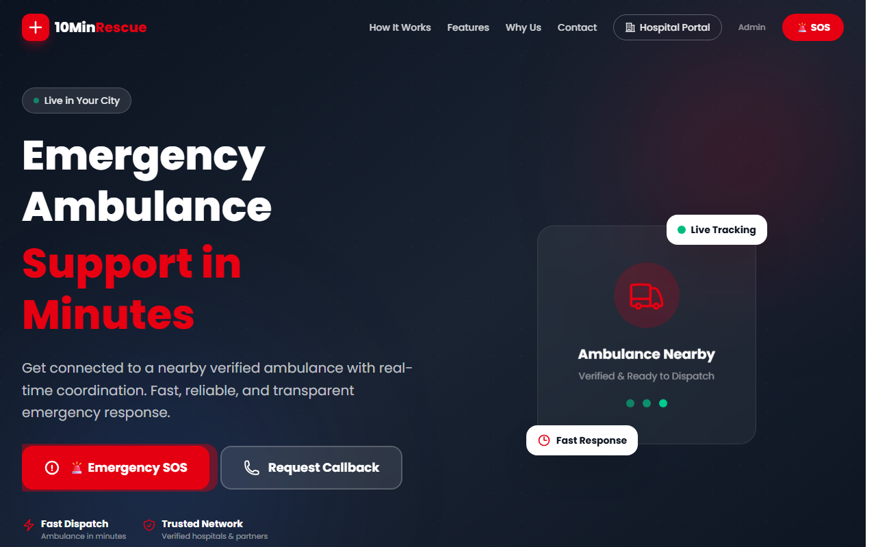
Figure 1: 10MinRescue Home Page — Emergency SOS and Request Callback are immediately visible
"How It Works" Section
Scrolling down the home page shows the three ways to reach 10MinRescue: the SOS button on the website, a callback request, or WhatsApp/phone call. Every channel connects to the same dispatch system.
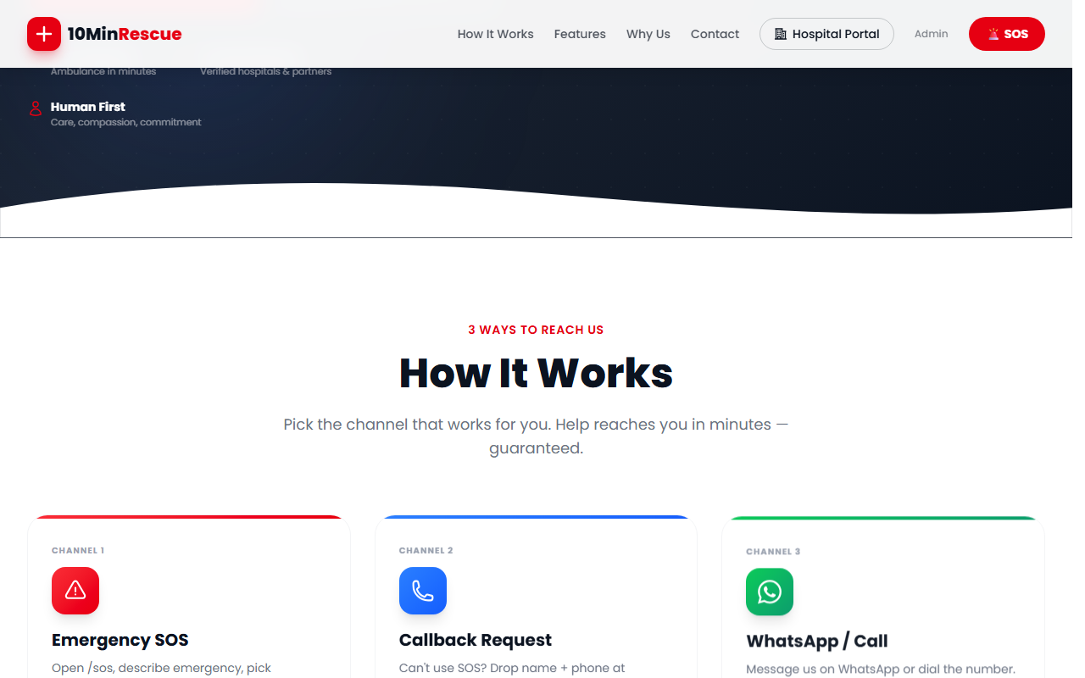
Figure 2: Three channels — Emergency SOS, Callback Request, and WhatsApp/Call
"From SOS to Hospital" Flow
This section on the website shows the patient the complete journey in four steps: Patient sends SOS → Driver accepts → Hospital is pre-alerted → Live tracking begins. This builds confidence that the system handles everything automatically.
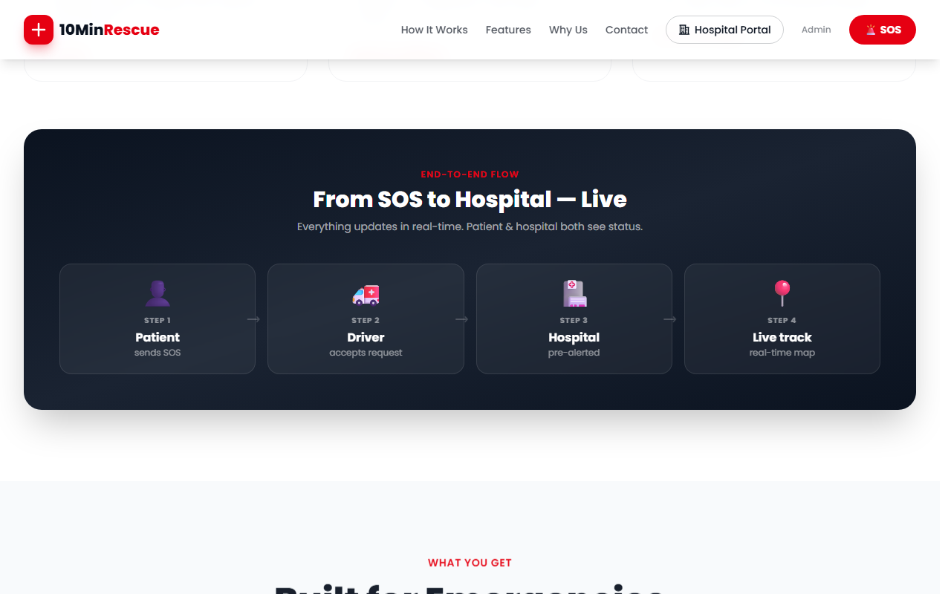
Figure 3: End-to-end real-time coordination — Patient → Driver → Hospital → Live Track
8.2 The SOS Wizard — Step-by-Step Emergency Request
When someone taps Emergency SOS, they enter a guided 4-step wizard. A progress bar at the top shows exactly where they are in the process. The design is intentionally simple — large buttons, minimal text, colour-coded choices — so it works even under extreme stress.
Step 1 — Describe the Emergency & Select Urgency
The user types a brief description of what happened (e.g. "Father collapsed, chest pain, not breathing"). They then select one of three urgency levels:
• CRITICAL (Red): cardiac arrest, unconscious, not breathing, life at immediate risk
• SERIOUS (Amber): severe injury, heavy bleeding, breathing difficulties, major trauma
• STABLE (Green): minor injury, patient is conscious, needs transport to hospital
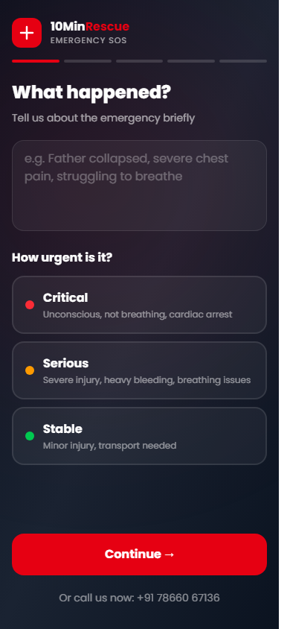
Figure 4: SOS Step 1 — Emergency description and three urgency levels (Critical/Serious/Stable)
Step 2 — Ambulance Type (Auto-Selected, Overridable)
Based on the urgency level, the system automatically highlights the right ambulance type: Type A (ICU) for Critical, Type B (Advanced) for Serious, Type C (Normal) for Stable. The user can change this if needed.
Step 3 — Choose a Hospital (or Let the System Decide)
The system shows nearby hospitals sorted by rating and distance, filtered to only those with available beds of the required type. Each hospital card shows the hospital name, distance, rating, and number of available beds. If the patient selects "Let System Decide", the driver will choose the best hospital after picking up the patient.
Step 4 — Review All Details and Send SOS
A final summary screen shows every detail: the emergency description, urgency level, ambulance type, hospital choice, and GPS coordinates. The large red "SEND SOS NOW" button submits everything in one tap. This is the final confirmation — nothing is sent by accident.
Callback Request Page
For users who cannot type (elderly, very distressed, or low internet), the callback page lets them enter just their name and phone number. An operator calls them back immediately to coordinate help.
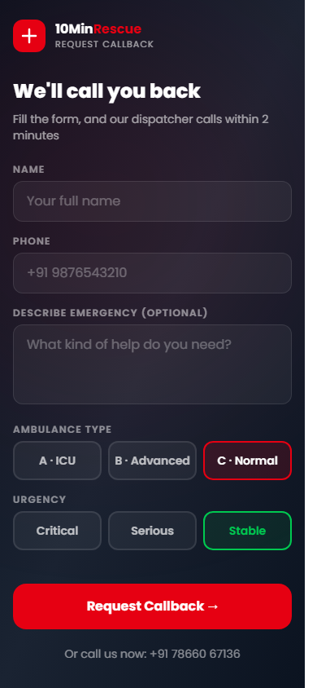
Figure 5: Callback Request — drop name and phone number, we call you back
09. Driver App — Every Screen Explained

The 10MinRescue Driver App runs on Android smartphones. It is designed for use in a moving vehicle — large buttons, colour-coded urgency, minimal reading required. Below is every screen a driver interacts with during a normal shift.
9.1 Driver Home Screen — Online/Offline Status & Live Alerts
This is the first screen a driver sees after logging in. It has three main areas:
• SOS Alert Card (top of screen, red background): When a nearby emergency matches the driver's ambulance type, a red alert card appears instantly at the top. It shows the emergency description, urgency level, distance to patient, ambulance type required, and pre-selected hospital. A large "ACCEPT REQUEST" button is prominently displayed.
• Status Hero (middle): Shows the driver's current status — Online & Available (green dot pulsing) or Offline. A toggle switch lets them go online or offline. When online, their GPS location is shared with the system every few seconds. The ambulance type they are assigned to (e.g. "Type A — ICU Ambulance") is shown as a chip below the status.
• Quick Stats Grid (bottom): Four stat cards show: Today's Trips completed, distance to nearest pending request, total trips completed all time, and the driver's average customer rating out of 5.
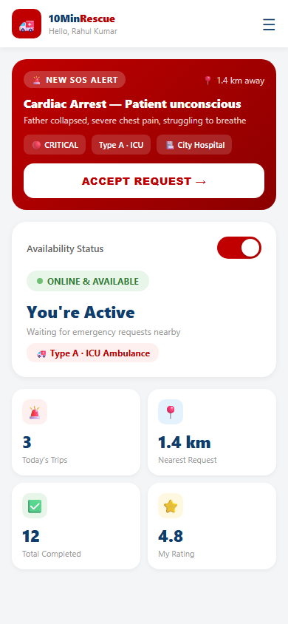
Figure 6: Driver Home Screen — Online status, live SOS alert, stats grid
SIDE MENU: The driver also has a side menu (hamburger icon) with: My Profile, Trip History, Document Upload, and Sign Out.

9.2 Incoming Request Alert — The 30-Second Decision Screen
When a new emergency comes in and the driver has been selected, the entire phone screen changes to a full-screen alert. This screen is designed to force immediate attention:
• Countdown Timer (top centre): A circular countdown shows how many seconds the driver has to respond. It starts at 30 seconds. If the driver does not respond, the request automatically goes to the next nearest driver.
• Urgency Gradient Background: The entire screen changes colour based on urgency — deep red gradient for Critical, amber for Serious, green for Stable. This is impossible to miss even in a moving vehicle.
• Pulsing Emergency Icon: A large ambulance/siren icon pulses and scales in and out to demand attention. The urgency label (CRITICAL / SERIOUS / STABLE) appears below it in a white badge, with the ambulance type below that.
• Patient Information Card: A frosted card shows: Patient name, phone number, emergency description (up to 2 lines), and the pre-selected hospital name.
• Two Buttons at the Bottom: "Decline" (outlined, white) and "ACCEPT REQUEST" (solid white with red/amber/green text). If the driver accepts, they immediately go to the navigation screen. If another driver has already accepted the same request, the app shows a snackbar: "Request already taken."
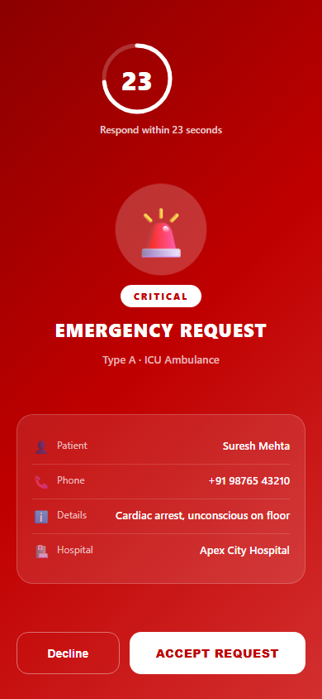
Figure 7: Incoming Request Alert — 30-second countdown, CRITICAL urgency, patient info, Accept/Decline
9.3 Navigation to Patient — Getting to the Emergency
After accepting, the driver immediately sees the navigation screen. It shows a live map (OpenStreetMap) with:
• A blue marker showing the driver's own position (updates in real time)
• A red pulsing marker showing the patient's exact GPS location
• A blue route line drawn along actual roads between the driver and patient
• Turn-by-turn navigation guidance
• Patient name, phone number, and emergency description shown below the map
• A "Call Patient" button for direct phone contact if needed
• A "Mark Patient Picked Up" button — tapped when the driver arrives and loads the patient
HOW THE MAP WORKS: The route line is calculated in real time using road data. As the driver moves, both the route and the ETA update automatically.

9.4 Navigation to Hospital
After marking "Patient Picked Up", the screen switches to hospital navigation:
• Live map now shows the route from current location to the pre-selected hospital
• Hospital name, address, and phone number shown below the map
• A "Call Hospital" button for advance coordination
• Patient's condition and ambulance type shown as a reminder
• "Confirm Arrival at Hospital" button — tapped when the ambulance reaches the hospital gate
When the driver confirms arrival, the hospital dashboard immediately shows the status as "Arrived". The trip is then marked complete.
9.5 Driver Registration & Document Upload
New drivers who want to join the 10MinRescue network register through the app. The registration screen collects:
• Full name and phone number
• Ambulance type (A, B, or C) they operate
• Vehicle registration number
• Driving licence number
• Document photo uploads: licence, vehicle permit, insurance certificate
• Selfie photo for identity verification
Once submitted, the admin team reviews the documents and either approves or rejects the driver. Until approved, the driver cannot go online or receive requests. If rejected, they see the reason and can resubmit.
10. Live Tracking Page — How the Map Works

After the SOS is sent, the patient or family immediately gets a live tracking link. Opening it shows a real-time map of the ambulance. No app download is needed — it works in any mobile browser.
What the Patient's Family Sees on the Tracking Page
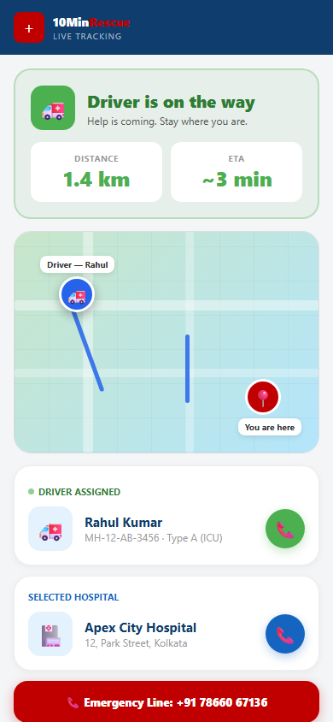
Figure 8: Live Tracking Page — ambulance position, ETA, driver info, hospital, emergency call button
Every Element on the Tracking Page — Explained
• Status Banner (top): Shows the current status in large text — "Finding nearest driver..." (amber) while searching, then "Driver is on the way" (green) once accepted. The colour and icon change automatically as the status changes.
• Distance and ETA boxes: Once a driver is assigned, two boxes appear showing the current distance from the driver to the patient (e.g. 1.4 km) and the estimated arrival time (e.g. ~3 min). Both update live as the driver moves.
• The Live Map: A real map (OpenStreetMap) showing two markers and a route line:
• 🚑 Blue ambulance marker = the driver's position, updating every few seconds
• 📍 Red pulsing marker = the patient's exact GPS location (where they sent SOS from)
• Blue route line = the actual road route between driver and patient
• Driver Information Card: Shows the driver's name, vehicle number, and ambulance type. A green phone button lets the family call the driver directly.
• Hospital Information Card: Shows the pre-selected hospital's name and address. A blue phone button lets the family call the hospital directly.
• Emergency Call Strip (bottom): A red button always visible at the bottom — "+91 78660 67136 — Emergency Line" — so the family can call us directly at any point.
How the Map Updates in Real Time
The live map is powered by a real-time database. Here is exactly what happens behind the scenes (explained without technical jargon):
1. Every few seconds, the driver's phone sends its GPS coordinates to our server.
2. The tracking page "listens" for any change — like a subscription to live news.
3. The moment new coordinates arrive, the ambulance icon on the map moves to the new position.
4. The route line is redrawn along actual roads using real road-routing data.
5. The distance and ETA numbers recalculate based on the new position.
6. This all happens automatically — the family does not need to refresh the page.
11. Hospital Dashboard — Every Section Explained

Every partner hospital gets a secure login to the Hospital Portal. It is a web-based dashboard that works on any computer or tablet. No app download required.
11.1 Hospital Login Screen
Hospitals log in with an email and password issued by the 10MinRescue admin team. The login page is separate from the patient website, accessible only at /hospital.
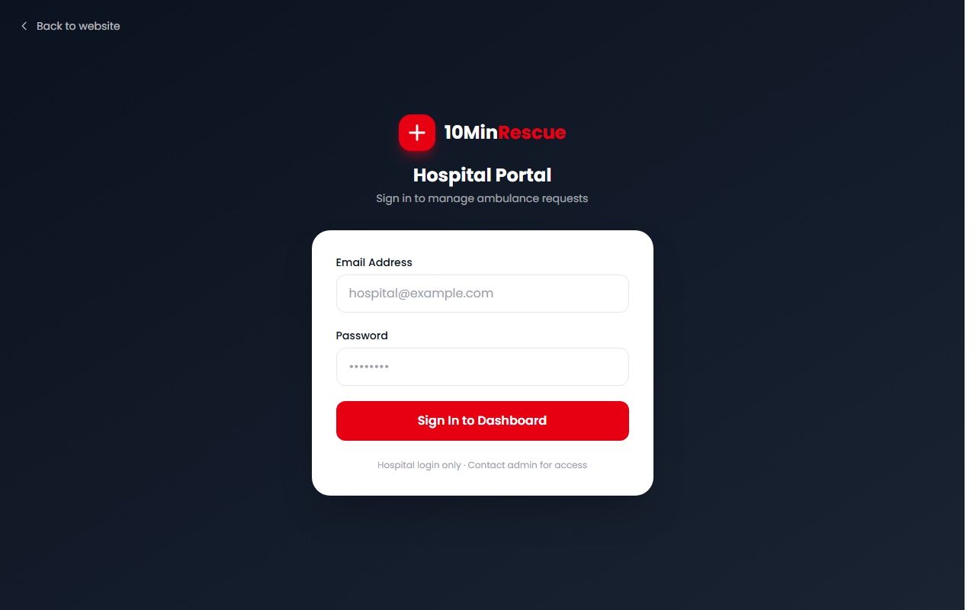
Figure 9: Hospital Portal Login — secure, role-specific access
11.2 The Full Hospital Dashboard — After Login
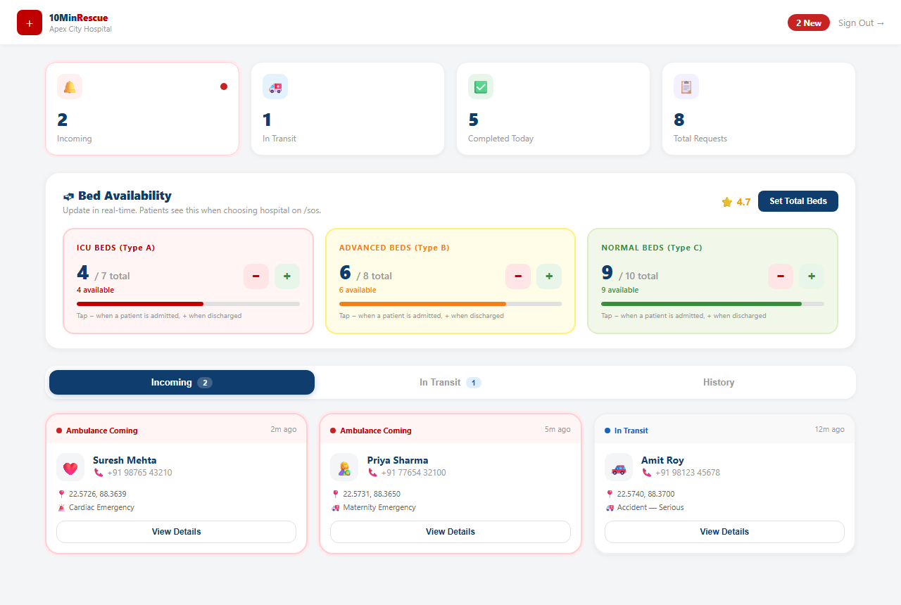
Figure 10: Hospital Dashboard — Stats, Bed Availability Panel, Tabs, and Request Cards
11.3 Statistics Bar (Top of Dashboard)
Four live counters at the top update automatically:
Counter | What It Shows | Colour Signal
Incoming | Number of ambulances currently assigned to this hospital and en route | Red background + pulsing dot when count > 0
In Transit | Ambulances currently carrying a patient to this hospital | Blue — steady
Completed Today | Trips successfully completed at this hospital today | Green — steady
Total Requests | All-time requests assigned to this hospital | Navy — steady

11.4 Bed Availability Panel — Real-Time Bed Management
This is the most important section of the hospital dashboard. It shows exactly how many beds of each type are available right now, and lets staff update the count with a single tap.
There are three bed type rows, each colour-coded:
ICU Beds (red)
• Purpose: For patients requiring intensive care and life-support equipment
• Linked to: Type A ambulances
• Used for: Critical emergencies — cardiac, respiratory failure
Advanced Beds (amber)
• Purpose: For patients requiring monitoring and advanced first aid
• Linked to: Type B ambulances
• Used for: Serious emergencies — trauma, accidents, high-risk maternity
Normal Beds (green)
• Purpose: For stable patients requiring basic hospital admission
• Linked to: Type C ambulances
• Used for: Minor injuries, post-procedure transfers
How to update bed count:
Each row shows the current available count and the total bed capacity (e.g. "4 / 7 total"). A progress bar shows the ratio visually. Staff use two buttons:
• − (Minus button — Red): Tap when a patient is admitted and occupies a bed. This reduces the available count by 1 and immediately updates what patients see when choosing a hospital during an SOS.
• + (Plus button — Green): Tap when a patient is discharged and the bed is available again. This increases the count by 1.
WHY THIS MATTERS: Patients see this bed count in real time when choosing a hospital during the SOS wizard. A hospital with zero beds of the required type will NOT appear as a choice — ensuring ambulances are only sent where beds exist.

Hospitals can also tap "Set Total Beds" to configure their total capacity (e.g. "We have 10 ICU beds total"). This only needs to be done once or when the hospital adds or removes beds.
11.5 The Three Tabs — Incoming, In Transit, History
Below the bed panel, three tabs organise all ambulance requests:
Tab | What It Shows | When to Check
Incoming | Ambulances confirmed for this hospital, currently en route | Constantly — these need immediate preparation
In Transit | Ambulances with the patient on board, travelling to hospital | When preparing for imminent arrivals
History | All completed and cancelled trips — searchable archive | For reporting, auditing, and performance review

11.6 Request Cards — What Each Card Shows
Each ambulance request appears as a card. An incoming request card (highlighted in red) shows:
• Emergency type icon (e.g. ❤️ for cardiac, 🚗 for accident, 🤱 for maternity)
• Patient name and phone number
• Patient's GPS location coordinates
• Emergency category (Cardiac, Accident, Maternity, General, etc.)
• Time since the request was created (e.g. "2m ago")
• "View Details" button — opens a full detail view with all request information
HOW IT WORKS: Hospitals do NOT need to accept or reject ambulances. They are automatically notified. Their job is to prepare the right team and bed before the ambulance arrives.

12. Admin Panel — Operations Control Centre

The Admin Panel is restricted to 10MinRescue's own operations team. It gives full visibility and control over the entire platform.
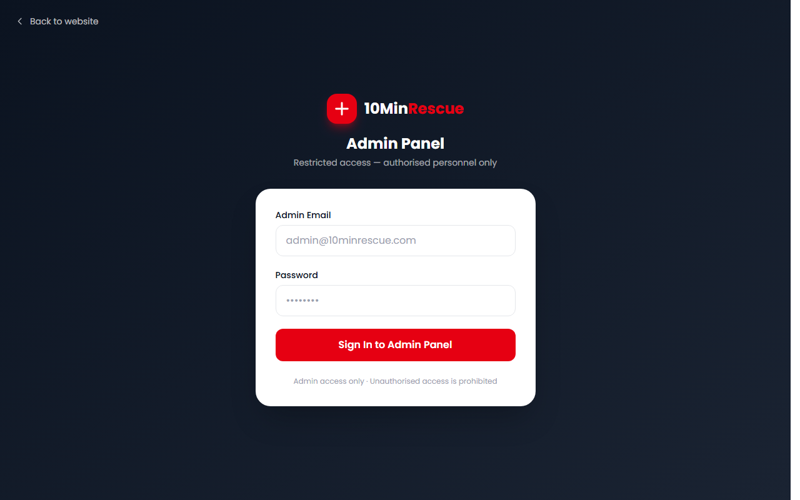
Figure 11: Admin Panel Login — authorised personnel only
Admin capabilities include:
• Review and approve/reject driver registrations and uploaded documents
• Monitor all active rescue requests across the city in real time
• See which drivers are currently online and where they are
• Manage hospital accounts and configure bed totals
• View full trip history and performance reports
13. Edge Cases — What Happens When Things Go Wrong?

A life-saving platform must handle every failure. Here is how 10MinRescue responds to each one:
! | No driver available nearby: Search automatically expands every 30 seconds: 1 km → 2 km → 5 km → 10 km. If still no driver, the admin team is alerted and can manually coordinate.

! | Driver does not accept within 30 seconds: Request automatically moves to the next nearest available driver. This repeats until someone accepts.

! | Patient's GPS location cannot be detected: The SOS form shows a "tap Allow for location" prompt. If still unavailable, the patient can use the Callback page or WhatsApp to describe their address verbally.

! | Hospital bed count reaches zero: That hospital disappears from the patient's hospital selection list. Only hospitals with confirmed available beds appear as options.

! | Driver loses internet mid-journey: The last known location is cached. Navigation continues offline. The app re-syncs as soon as the connection returns.

! | Patient closes browser after sending SOS: The SOS is already submitted and cannot be lost. The SOS ID is saved in the browser so the patient can return to the tracking page.

! | Multiple SOS requests from the same location: The system detects duplicates from the same GPS coordinates within a short time window and prevents multiple drivers being dispatched.

! | Hospital does not update bed count: Admins see hospitals with stale counts. Bed counts older than 24 hours are flagged as "unverified" to avoid incorrect dispatch.

! | Another driver accepts the same request first: The second driver's app shows: "Request already taken by another driver" and returns them to the home screen automatically.

! | WhatsApp message is incomplete: The WhatsApp system asks follow-up questions to collect location and urgency before routing to a driver.

14. Scope — What 10MinRescue Covers

• Emergency SOS via web browser (mobile and desktop)
• Automatic nearby driver search with GPS-based geolocation
• Smart radius expansion (1 km → 10 km) when no driver is immediately found
• Three ambulance types matched to three urgency levels
• Live hospital bed availability check during the SOS flow
• Live ambulance tracking for patients and families (real-time map)
• Driver Android app: online/offline toggle, incoming alerts, GPS navigation
• Hospital web dashboard: live request view, bed management, trip history
• Admin web panel: driver verification, platform monitoring, hospital management
• WhatsApp emergency intake via Cloud API
• Callback request form for voice-based coordination
• Push notification system for drivers (FCM)
• Real-time database — all request statuses, driver locations, bed counts
• Role-based access: patient, driver, hospital, admin
• Full trip history and status lifecycle recording
15. Out of Scope

✗ Payment processing: No billing or invoicing is integrated. Pricing is handled offline.
✗ iOS Driver App: The driver app supports Android only. iOS is not part of this release.
✗ In-app chat: Communication is by phone call. No in-app messaging feature.
✗ Government ambulance integration: The platform operates its own verified network.
✗ Automatic fare estimation: Trip costs are handled separately, not in-app.
✗ Medical records: Patient history and prescriptions are not stored.
✗ Fire or police dispatch: The platform is ambulance-specific only.
✗ AI medical advice: The system collects urgency info but never provides diagnoses.
✗ Multi-city rollout (v1): Current version is deployed for a single city.
16. Success Matrix

Success is measured across three areas: speed, reliability, and reach.
Response & Speed Metrics
Metric | What It Measures | Target
Average Response Time | Time from SOS sent to driver accepting | < 3 minutes
Ambulance On-Scene Time | Time from SOS sent to ambulance at patient | < 10 minutes
Driver Accept Rate | % of requests accepted by first notified driver | > 80%
Hospital Pre-Alert Rate | % of trips where hospital is notified before arrival | 100%
SOS Completion Rate | % of SOS requests resulting in a completed trip | > 90%

User Experience Metrics
Metric | Target
SOS form completion time (Steps 1–4) | < 60 seconds
Family satisfaction score (post-trip feedback) | > 4.2 / 5.0
Hospital dashboard active adoption | > 85% of partner hospitals
Driver daily active usage | > 70% of registered drivers go online daily
Callback response time | < 5 minutes

Network Growth (6-Month Targets)
Metric | Target
Active verified drivers | 50+ drivers online weekly
Partner hospitals with active dashboards | 20+ hospitals
Total SOS requests served | 500+ cases
City coverage | Full urban area covered
Average driver rating | > 4.0 / 5.0

17. Final Note

10MinRescue is built on one belief: in a medical emergency, every minute without help is a minute too long. The platform exists to make those minutes disappear.
This document has covered everything — what the platform is, why it was built, how every screen works, how the map tracks the ambulance in real time, how hospitals manage their bed availability live, and how the driver's phone guides them from alert to patient to hospital.
CONTACT: Email: mcteam.myewards@gmail.com | Phone: +91 78660 67136 | Website: 10minrescue.com

10MinRescue — Product Brief v2.0 — May 2026

