ELASTICSEARCH DOCUMENT

Contents
Elasticsearch Installation And Configuration 1
Kibana Installation And Configuration 2
Logstash Installation And Configuration 3
Elasticsearch RAM min/max 4
Elasticsearch Configuration 5
Kibana Installation And Configuring 6
Kibana RAM min/max 7
Logstash Installation 8
Logstash RAM min/max 9

Elasticsearch Installation And Configuration
Elasticsearch is an open-source, distributed search and analytics engine built on top of Apache Lucene. It is designed to be a highly scalable and efficient solution for storing, searching, and analyzing large volumes of data in near real-time. Elasticsearch is commonly used for various purposes, including full-text search, log analysis, data visualization, and business intelligence.

Below are the steps to install elasticsearch :
- Elasticsearch requires java to run . So first we have to install jdk .
sudo yum install java-1.8.0-openjdk
- Import Elastic’s GPG key :
sudo rpm --import https://artifacts.elastic.co/GPG-KEY-elasticsearch
- Add Elasticsearch repository :
sudo vi /etc/yum.repos.d/elasticsearch.repo
- Add the following content to the file:
[elasticsearch]
name=Elasticsearch repository for 7.x packages
baseurl=https://artifacts.elastic.co/packages/7.x/yum
gpgcheck=1
gpgkey=https://artifacts.elastic.co/GPG-KEY-elasticsearch
enabled=1
autorefresh=1
type=rpm-md
Below is the screenshot of a file :
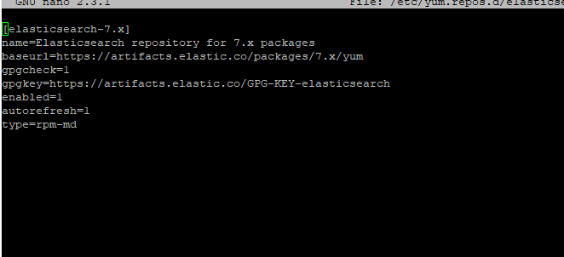
- Install Elasticsearch:
sudo yum install elasticsearch

- Start and enable Elasticsearch :
sudo systemctl start elasticsearch
sudo systemctl enable elasticsearch
- Verify Elasticsearch status:

sudo systemctl status elasticsearch
After starting elasticsearch when we execute the above command it gives below status :

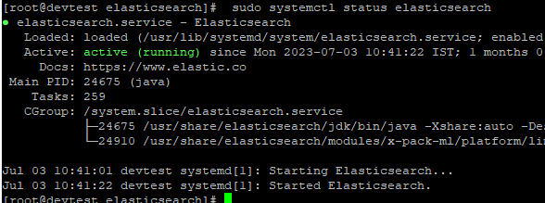

- Now after installing we can check that installation successfully done or not by below get api
curl -X GET "localhost:9200/"

Elasticsearch Configuration :

To configure elasticsearch go to the path where elasticsearch is installed and open the file name elasticsearch.yml for eg : I had installed on path : /etc/elasticsearch/
Now I will edit the file name elasticsearch.yml
- Set the cluster.name: my-application
- Set the path data where its stores the data eg path.data: /var/lib/elasticsearch
- Set the path of logs where it will stores the logs eg path.logs: /var/log/elasticsearch
- Set the network host eg network.host: 192.168.167.5
- Set the port eg http.port: 8080
- And set some properties given below :
ingest.geoip.downloader.enabled: false
xpack.security.enabled: false
xpack.security.transport.ssl.enabled: false
xpack.security.http.ssl.enabled: false

xpack.monitoring.enabled: true
xpack.monitoring.collection.enabled: true

# to compress the data size
index.codec: best_compression

Now save the file and restart the elasticsearch .

Below is the sample configuration file :
# ======================== Elasticsearch Configuration =========================
#
# NOTE: Elasticsearch comes with reasonable defaults for most settings.
# Before you set out to tweak and tune the configuration, make sure you
# understand what are you trying to accomplish and the consequences.
#
# The primary way of configuring a node is via this file. This template lists
# the most important settings you may want to configure for a production cluster.
#
# Please consult the documentation for further information on configuration options:
# https://www.elastic.co/guide/en/elasticsearch/reference/index.html
#
# ---------------------------------- Cluster -----------------------------------
#
# Use a descriptive name for your cluster:
#
cluster.name: my-application
#
# ------------------------------------ Node ------------------------------------
#
# Use a descriptive name for the node:
#
#node.name: node-1
#
# Add custom attributes to the node:
#
#node.attr.rack: r1
#
# ----------------------------------- Paths ------------------------------------
#
# Path to directory where to store the data (separate multiple locations by comma):
#
path.data: /var/lib/elasticsearch
#
# Path to log files:
#
path.logs: /var/log/elasticsearch
#
# ----------------------------------- Memory -----------------------------------
#
# Lock the memory on startup:
#
#bootstrap.memory_lock: true
#
# Make sure that the heap size is set to about half the memory available
# on the system and that the owner of the process is allowed to use this
# limit.
http.max_content_length: 1gb
# Elasticsearch performs poorly when the system is swapping the memory.
#
# ---------------------------------- Network -----------------------------------
#
# By default Elasticsearch is only accessible on localhost. Set a different
# address here to expose this node on the network:
#
network.host: 192.168.167.5
#
# By default Elasticsearch listens for HTTP traffic on the first free port it
# finds starting at 9200. Set a specific HTTP port here:
#
http.port: 8080
#
# For more information, consult the network module documentation.
#
# --------------------------------- Discovery ----------------------------------
#
# Pass an initial list of hosts to perform discovery when this node is started:
# The default list of hosts is ["127.0.0.1", "[::1]"]
#
#discovery.seed_hosts: ["host1", "host2"]
#
# Bootstrap the cluster using an initial set of master-eligible nodes:
#
#cluster.initial_master_nodes: ["node-1", "node-2"]
#
# For more information, consult the discovery and cluster formation module documentation.
discovery.type: single-node
#
# ---------------------------------- Various -----------------------------------
#
# Require explicit names when deleting indices:
#
#action.destructive_requires_name: true
#
# ---------------------------------- Security ----------------------------------
#
# *** WARNING ***
#
# Elasticsearch security features are not enabled by default.
# These features are free, but require configuration changes to enable them.
# This means that users donâ€™t have to provide credentials and can get full access
# to the cluster. Network connections are also not encrypted.
#
# To protect your data, we strongly encourage you to enable the Elasticsearch security features.
# Refer to the following documentation for instructions.
#
# https://www.elastic.co/guide/en/elasticsearch/reference/7.16/configuring-stack-security.html

##----------------------------------------------------------------------------------------------##
ingest.geoip.downloader.enabled: false
xpack.security.enabled: false
xpack.security.transport.ssl.enabled: false
xpack.security.http.ssl.enabled: false

xpack.monitoring.enabled: true
xpack.monitoring.collection.enabled: true

# to compress the data size
index.codec: best_compression

Kibana Installation And Configuration

Kibana is a tool using for monitoring of elasticsearch Storage , RAM ,Uptime , indices(table) , etc .
Below are the steps to install kibana :
- Import Elastic's GPG Key (if you haven't done it already during the Elasticsearch installation):
sudo rpm --import https://artifacts.elastic.co/GPG-KEY-elasticsearch
- Add Kibana repository:
sudo vi /etc/yum.repos.d/kibana.repo
- Add the following content to the file:
[kibana]
name=Kibana repository for 7.x packages
baseurl=https://artifacts.elastic.co/packages/7.x/yum
gpgcheck=1
gpgkey=https://artifacts.elastic.co/GPG-KEY-elasticsearch
enabled=1
autorefresh=1
type=rpm-md
- Install Kibana:
sudo yum install kibana
- Configure Kibana:
sudo vi /etc/kibana/kibana.yml
- Find the following settings and make sure they are set as follows:
server.host: "localhost"
elasticsearch.hosts: ["http://localhost:9200"]
- Verify Kibana status:
sudo systemctl status kibana
- Access Kibana :
You can access Kibana through a web browser by visiting http://localhost:5601. Kibana provides a user-friendly interface for visualizing and exploring data stored in Elasticsearch.
Below is the sample configuration file of kibana :
# Kibana is served by a back end server. This setting specifies the port to use.
server.port: 5601

# Specifies the address to which the Kibana server will bind. IP addresses and host names are both valid values.
# The default is 'localhost', which usually means remote machines will not be able to connect.
# To allow connections from remote users, set this parameter to a non-loopback address.
server.host: 192.168.167.5

# Enables you to specify a path to mount Kibana at if you are running behind a proxy.
# Use the `server.rewriteBasePath` setting to tell Kibana if it should remove the basePath
# from requests it receives, and to prevent a deprecation warning at startup.
# This setting cannot end in a slash.
#server.basePath: ""

# Specifies whether Kibana should rewrite requests that are prefixed with
# `server.basePath` or require that they are rewritten by your reverse proxy.
# This setting was effectively always `false` before Kibana 6.3 and will
# default to `true` starting in Kibana 7.0.
#server.rewriteBasePath: false

# Specifies the public URL at which Kibana is available for end users. If
# `server.basePath` is configured this URL should end with the same basePath.
#server.publicBaseUrl: ""

# The maximum payload size in bytes for incoming server requests.
#server.maxPayload: 1048576

# The Kibana server's name. This is used for display purposes.
#server.name: "your-hostname"

# The URLs of the Elasticsearch instances to use for all your queries.
elasticsearch.hosts: ["http://192.168.167.5:8080"]

# Kibana uses an index in Elasticsearch to store saved searches, visualizations and
# dashboards. Kibana creates a new index if the index doesn't already exist.
#kibana.index: ".kibana"

# The default application to load.
#kibana.defaultAppId: "home"

# If your Elasticsearch is protected with basic authentication, these settings provide
# the username and password that the Kibana server uses to perform maintenance on the Kibana
# index at startup. Your Kibana users still need to authenticate with Elasticsearch, which
# is proxied through the Kibana server.
#elasticsearch.username: "kibana_system"
#elasticsearch.password: "pass"

# Kibana can also authenticate to Elasticsearch via "service account tokens".
# If may use this token instead of a username/password.
# elasticsearch.serviceAccountToken: "my_token"

# Enables SSL and paths to the PEM-format SSL certificate and SSL key files, respectively.
# These settings enable SSL for outgoing requests from the Kibana server to the browser.
#server.ssl.enabled: false
#server.ssl.certificate: /path/to/your/server.crt
#server.ssl.key: /path/to/your/server.key

# Optional settings that provide the paths to the PEM-format SSL certificate and key files.
# These files are used to verify the identity of Kibana to Elasticsearch and are required when
# xpack.security.http.ssl.client_authentication in Elasticsearch is set to required.
#elasticsearch.ssl.certificate: /path/to/your/client.crt
#elasticsearch.ssl.key: /path/to/your/client.key

# Optional setting that enables you to specify a path to the PEM file for the certificate
# authority for your Elasticsearch instance.
#elasticsearch.ssl.certificateAuthorities: [ "/path/to/your/CA.pem" ]

# To disregard the validity of SSL certificates, change this setting's value to 'none'.
#elasticsearch.ssl.verificationMode: full

# Time in milliseconds to wait for Elasticsearch to respond to pings. Defaults to the value of
# the elasticsearch.requestTimeout setting.
#elasticsearch.pingTimeout: 1500

# Time in milliseconds to wait for responses from the back end or Elasticsearch. This value
# must be a positive integer.
#elasticsearch.requestTimeout: 30000

# List of Kibana client-side headers to send to Elasticsearch. To send *no* client-side
# headers, set this value to [] (an empty list).
#elasticsearch.requestHeadersWhitelist: [ authorization ]

# Header names and values that are sent to Elasticsearch. Any custom headers cannot be overwritten
# by client-side headers, regardless of the elasticsearch.requestHeadersWhitelist configuration.
#elasticsearch.customHeaders: {}

# Time in milliseconds for Elasticsearch to wait for responses from shards. Set to 0 to disable.
#elasticsearch.shardTimeout: 30000

# Logs queries sent to Elasticsearch. Requires logging.verbose set to true.
#elasticsearch.logQueries: false

# Specifies the path where Kibana creates the process ID file.
#pid.file: /run/kibana/kibana.pid

# Enables you to specify a file where Kibana stores log output.
#logging.dest: stdout

# Set the value of this setting to true to suppress all logging output.
#logging.silent: false

# Set the value of this setting to true to suppress all logging output other than error messages.
#logging.quiet: false

# Set the value of this setting to true to log all events, including system usage information
# and all requests.
#logging.verbose: false

# Set the interval in milliseconds to sample system and process performance
# metrics. Minimum is 100ms. Defaults to 5000.
#ops.interval: 5000

# Specifies locale to be used for all localizable strings, dates and number formats.
# Supported languages are the following: English - en , by default , Chinese - zh-CN .
#i18n.locale: "en"

Below are screenshot of kibana url and how to monitor the elasticsearch . now as in below screenshott click on stack monitoring .
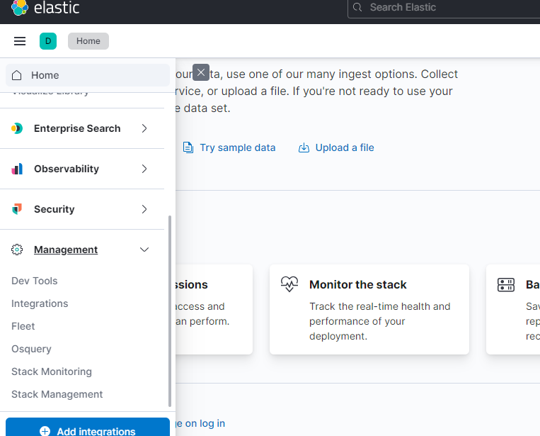
After that below monitoring page will open where we can monitor the RAM utilization and storage of elasticsearch and uptime of elasticsearch .
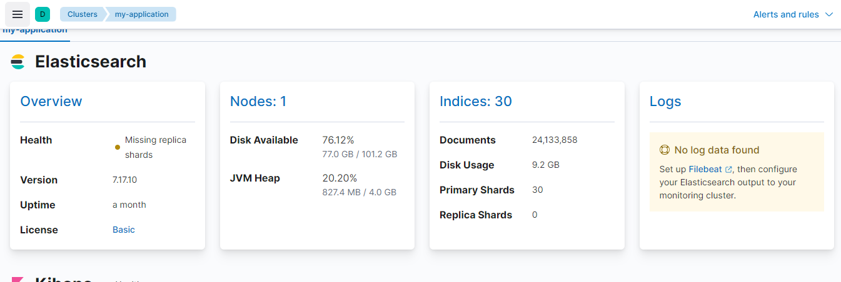

Logstash Installation And Configuration

Logstash is an open-source data processing pipeline that allows you to collect, process, and forward logs and other data from various sources. It's often used as part of the ELK (Elasticsearch, Logstash, Kibana) stack, which is used for real-time data analysis and visualization.
We had used logstash to sync data between mysql database and elasticsearch .
Below are the steps to install the logstash :
- Install Java :
sudo yum install java-1.8.0-openjdk

- Add Logstash Repository : Elasticsearch provides RPM packages for Logstash. You can add their repository to your CentOS system
sudo rpm --import https://artifacts.elastic.co/GPG-KEY-elasticsearch
sudo vi /etc/yum.repos.d/logstash.repo

Add the following content to the file:
[logstash]
name=Elastic repository for 7.x packages
baseurl=https://artifacts.elastic.co/packages/7.x/yum
gpgcheck=1
gpgkey=https://artifacts.elastic.co/GPG-KEY-elasticsearch
enabled=1
autorefresh=1
type=rpm-md
Below is the screenshot of file :

- Install Logstash : After adding the repository yopu can add logstash using yum

sudo yum install logstash

- Configure Logstash: The main configuration file for Logstash is located at /etc/logstash/logstash.yml. You can configure input, filter, and output settings here.
Additionally, Logstash pipeline configuration files are located in the /etc/logstash/conf.d/ directory. You can create .conf files in this directory to define your data processing pipeline.

For making connection with mysql you have to download mysql jar and give path of jar to config file to sync data of database table with elasticsearch as given below :

Example :

input {
jdbc {
jdbc_driver_library => "/usr/share/java/mysql-connector-j.jar"
jdbc_driver_class => "com.mysql.cj.jdbc.Driver"
jdbc_connection_string => "jdbc:mysql://192.168.167.61:3306/nsdlarchieve"
jdbc_user => "root"
jdbc_password => "PrQL:?0He9ZzK#3"
statement => "SELECT * FROM %{TABLE_NAME} WHERE id > :sql_last_value"
jdbc_paging_enabled => "true"
jdbc_page_size => "100000"
schedule => "* * * * *"
clean_run => true
use_column_value => true
tracking_column => "id"
tracking_column_type => "numeric"
record_last_run => true
last_run_metadata_path => "/etc/logstash/lastrun_%{TABLE_NAME}"
}
}
filter {
mutate {
remove_field => ["@version", "@timestamp"]
}
}
output {
elasticsearch {
hosts => ["http://192.168.167.5:8080"]
index => “ %{TABLE_NAME}”
document_id => "%{id}"
action => "update"
doc_as_upsert => true
}
}

- Then start and enable logstash by below commands :

sudo systemctl start logstash
sudo systemctl enable logstash

- Check logstash status by below command :

sudo systemctl status logstash

Elasticsearch RAM min/max

For defining min / max RAM to allocate the elasticsearch go to the path where elasticsearch is installed
For eg : I had installed on below path I go to that path configure min / max RAM .
Path : /etc/elasticsearch/
After that open file jvm.options.d and configure the min /max RAM as shown in below screenshot
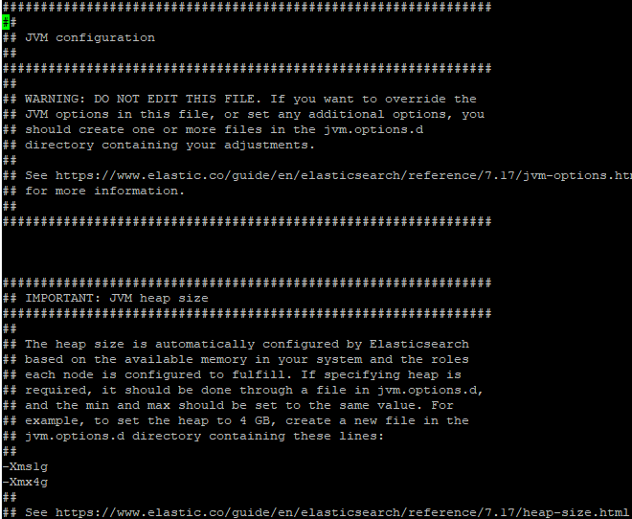
After configuring min /max RAM restart the elasticsearch by below command
Command : sudo systemctl restart elasticsearch

Kibana RAM min/max :

We can set the minimum and maximum RAM to allocate to kibana .
Below are the steps to configure the RAM allocation min/max
- Go to the path where kibana is installed for eg : in my case I had installed kibana at path : /etc/kibana . At that path there is a file name kibana.yml.
- Now open the file kibana.yml to edit and look for “node.options” setting in file and define the min and max RAM as required .

Logstash RAM min/max

You can define the min/max RAM top allocate the logstash config in /etc/logstash/jvm.options by using below commands
nano /etc/logstash/jvm.options
And configure the RAM as shown in below screenshot
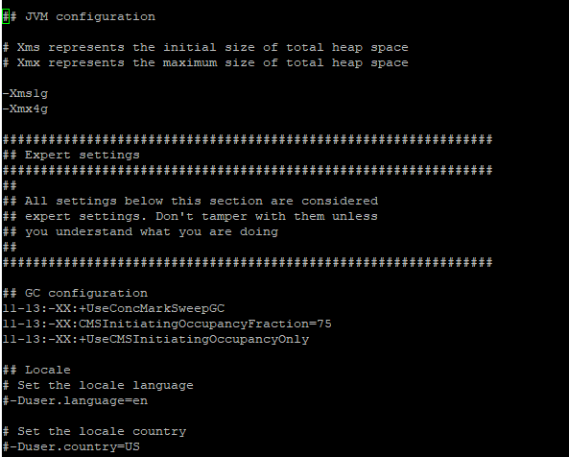
Below is the command to run the logstash config file which will sync the data of mysql table with elasticsearch .
nohup /usr/share/logstash/bin/logstash -f /etc/logstash/conf.d/ configname.conf --path.data /var/lib/logstash/ configname &

