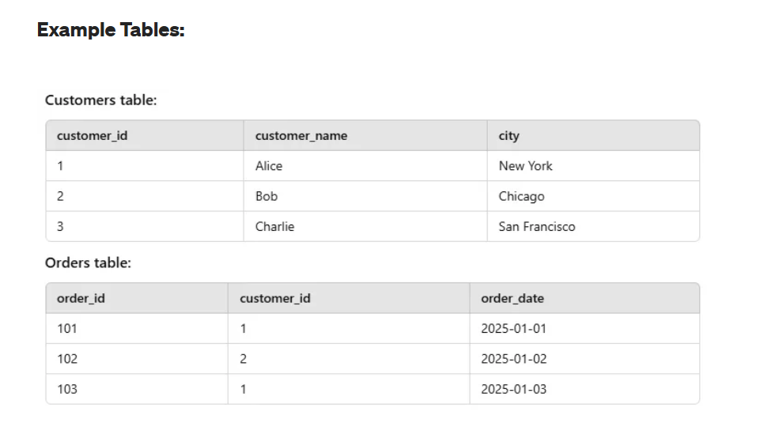
An INNER JOIN retrieves only the rows where there’s a match in both tables. Think of it as the "intersection" of datasets. If a record in one table doesn’t have a corresponding match in the other, it’s excluded from the results.
Syntax:
SELECT table1.column1, table2.column2
FROM table1
INNER JOIN table2
ON table1.common_column = table2.common_column;
Example:
Let’s combine Orders and Customers to show orders with valid customers.
SELECT Orders.order_id, Customers.customer_name
FROM Orders
INNER JOIN Customers
ON Orders.customer_id = Customers.customer_id;
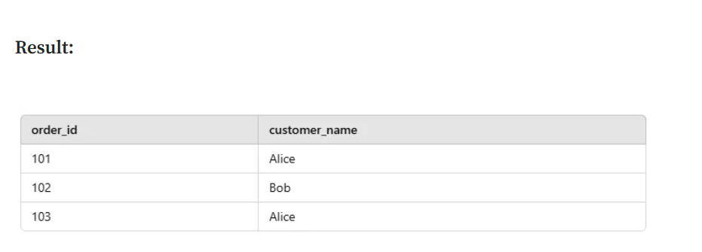
A LEFT JOIN returns all rows from the left table, along with the matching rows from the right table. If there’s no match, the result will include NULL values for the right table’s columns.
Syntax:
SELECT table1.column1, table2.column2
FROM table1
LEFT JOIN table2
ON table1.common_column = table2.common_column;
Use Case:
Find orders that aren’t linked to any valid customer.
Example:
SELECT Orders.order_id, Customers.customer_name
FROM Orders
LEFT JOIN Customers
ON Orders.customer_id = Customers.customer_id;
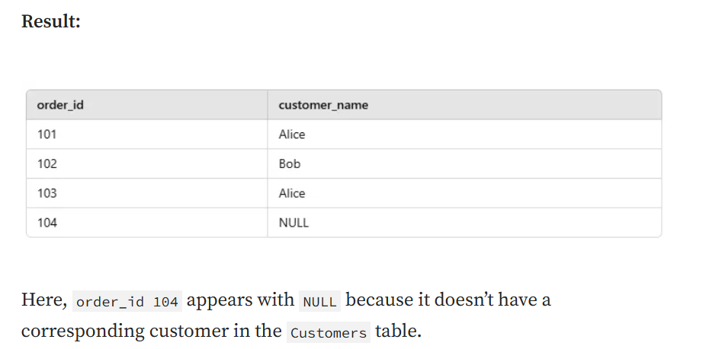
A RIGHT JOIN works like a LEFT JOIN, but the focus shifts to the right table. It returns all rows from the right table, and matching rows from the left table. Where no match exists, the left table’s columns will be filled with NULL.
Syntax:
SELECT table1.column1, table2.column2
FROM table1
RIGHT JOIN table2
ON table1.common_column = table2.common_column;
Use Case:
List all customers, including those without any orders.
Example:
SELECT Customers.customer_name, Orders.order_id
FROM Orders
RIGHT JOIN Customers
ON Orders.customer_id = Customers.customer_id;
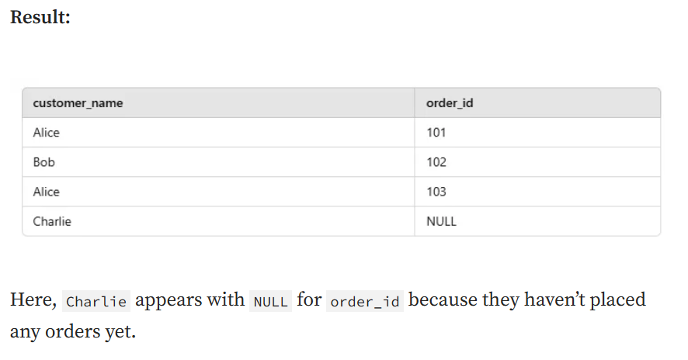A FULL OUTER JOIN combines the results of both LEFT JOIN and RIGHT JOIN. It includes all rows from both tables, with NULLs in places where no match exists.
Syntax:
SELECT table1.column1, table2.column2
FROM table1
FULL OUTER JOIN table2
ON table1.common_column = table2.common_column;
Use Case:
Identify all orders and customers, even if there’s no direct match between the tables.
Example:
SELECT Customers.customer_name, Orders.order_id
FROM Customers
FULL OUTER JOIN Orders
ON Customers.customer_id = Orders.customer_id;
Result:
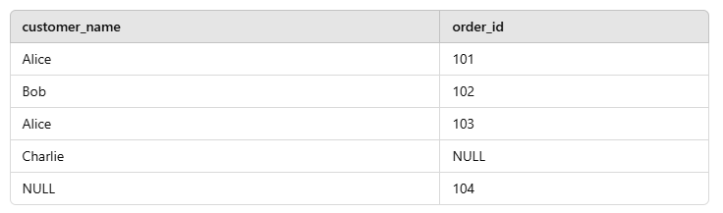
If your database (like MySQL) doesn’t support FULL OUTER JOIN, you can simulate it using a UNION:
SELECT Customers.customer_name, Orders.order_id
FROM Customers
LEFT JOIN Orders
ON Customers.customer_id = Orders.customer_id
UNION
SELECT Customers.customer_name, Orders.order_id
FROM Customers
RIGHT JOIN Orders
ON Customers.customer_id = Orders.customer_id;

