Low Level Design (add Employee module)

Project Code | Team3
Project Name | Employee Maintenance System

Prepared/Modified by | Role | Date of Preparation
Pratik Santoshiya  Gayitri Rathod  Shital Thakur  Ashutosh Jaiswal  Saikumar Reddy  Rohit Kumar Gupta | Software Associate | 6/04/2017
Reviewed by | Role | Date of Review
 |  | 5/04/2017
Approved by | Role | Date of Approval
 | Training Manager
Circulation List |  | Version Number of the template:1.0
Version Number | 1.3

Table of Contents

1. Description Of The Unit 3
2. References 4
3. Dependencies / Assumptions 5
4. Class Diagrams 6
5. Sequence Diagrams 7
6. Design Components 8
6.1 List Of UI Components 8
6.2 List Of Design Classes 8
7. Re-Usable Routines/Components 9
8. Messages 10
9. Configuration Files 11
10. Crud Matrix Table 12
11. Data Mapping Matrix 13
12. Action Flow Matrix 14
13. Stored Procedures 15
14. Program Specification / Pseudo Code 16
REVISION HISTORY OF THE WORK PRODUCT 17

Description Of The Unit

The add employee module allows the admin of the application to add new employees into the database. This module can be used only by the admin of the application.

On clicking on the add button in the admin home page, the admin is redirected to a add employee page. The admin enters all the details of the employee like employee id, employee first name, employee last name, employee designation, employee gender, employee marital status, employee basic salary
After entering all the employee details, the details are inserted into the database on clicking the add hotel button.

References

Reference | Description
Repository reference | https://IGTEBLRSVNTNG.igatecorp.com/svn/oct3_Team3
Class Diagram | /Project Documents/Design Documents/HLD/Class Diagrams
DB Design | /Project Documents/Design Documents/HLD/DB Design/EMS_GROUP_DBDESIGN.xls

Dependencies / Assumptions

Dependencies:
The admin should be logged in.

Assumptions:
The admin details are stored in the database.

Design Components

List Of UI Components

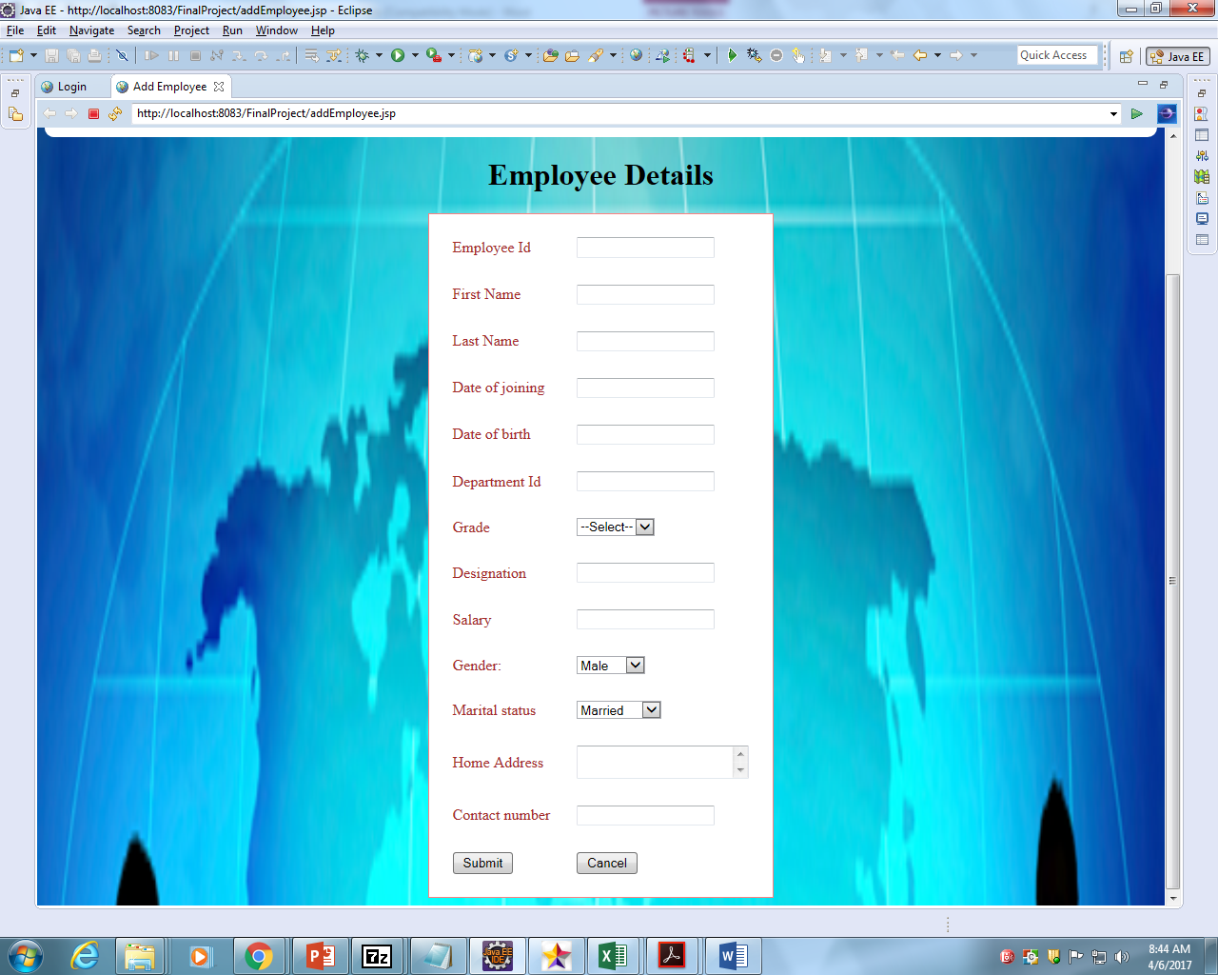

List Of Design Classes
Sr. No. | LLD Name | Class Name | Method Name | Method Description
1 | Add Employee Module | Employee | Appropriate getters and setters methods and toString methods. | Getters retrieve the property values and setters set the property values. toString method is used to get a String object representing the value of the number object.
2 | Add Employee Module | AdminController | @RequestMapping(value="addEmployee", method=RequestMethod.POST)  public ModelAndView employeeAdd(@ModelAttribute("data") Employee employee)  {  int id = employeeService. addEmployee (employee);  return new ModelAndView("success", "id", id);  } | The details of the addEmployee form is posted in the addEmployee method.And then it redirects to the success page showing the id of the new employee.
3 | Add Employee Module | EmployeeService | @Override  public int addEmployee(Employee employee)  {  return employeeDao. addEmployee (employee);  } | The Dao generates an id which gets returned to the service and it is given to the jsp page.
4 | Add Employee Module | IEmployeeDao | @Override  public int addEmployee (Employee employee)  {  entityManager.persist(employee);  entityManager.flush();  return employee.getemployeelId();  } | The hotel details gets added and the employee id which is generated is returned to the success page.

Re-Usable Routines/Components

Re-Usable Routines/Components

- Javascript files
- Database properties files

Configuration Files

File Name | Path | Description
oracle.properties | /Development/Source | To configure database connection.
Web.xml | /Development/Source | To configure the bean properties.
Dispatcher-servlet.xml | /Development/Source | To configure the request mapping and view resolver.

Crud Matrix Table

# | Table Name | Create | Read | Update | Delete
1. | Admin | Y | y | y | y
3. | Employee | N | Y | N | N

Action Flow Matrix

Sr. No. | Action | Description | Process
1 | On click of Add Button in Admin Homepage | Redirected to the Add Employee page | The admin clicks on the add button in the admin homepage and gets redirected to the add page.
2 | On click of Add Employee button in add page | The Employee details are inserted into the database. | Data is entered in the fields by the admin which gets inserted into the database when add button is pressed.

Stored Procedures

# | Stored Procedure Name  (with Description) | Input/Out Parameters | Type | Size
1. | NA | NA | NA | NA

Program Specification / Pseudo Code

<ACTION :ADD_CLICK >

Pseudo Code:
- Client Side Scripting:
None

- Server Side Scripting:
BEGIN
Call prepareAdd(Model model) in Controller class
Navigate to add page
END

14. 2 <ACTION: ADDEMPLOYEE_CLICK>

Pseudo Code:

- Client Side Scripting:

IF invalid EmployeeName
Print Error Message M1
IF EmployeeName isEmpty
Print Error Message M6
IF invalid Employee
Print Error Message M2
IF EmployeeDOB isEmpty
Print Error Message M6
IF EmployeeDOJ isEmpty
Print Error Message M3

IF invalid EmployeeDeptID
Print Error Message M4
IF EmployeeGrade isEmpty
Print Error Message M6
IF invalid EmployeeDesignation
Print Error Message M5
IF employeeBasic isEmpty
Print Error Message M6
IF EmployeeGender isEmpty
Print Error Message M6
IF EmployeeMarital_Status isEmpty
Print Error Message M7

IF EmployeeHome_Address isEmpty
Print Error Message M8

IF EmployeeConyact_no isEmpty
Print Error Message M9

14. 2 <ACTION: CANCEL_CLICK>

Pseudo Code:
1. Client Side Scripting:
None

2. Server Side Scripting:
BEGIN
Call prepareHomePage(Model model) in Controller class
Navigate to home page
END

REVISION HISTORY OF THE WORK PRODUCT

# | Date | Version # | Section Changed | Details of changes made | Approved By
1 | 05/04/2017 | 1.0 | LLD prepared | N/A
2 | 05/04/2017 | 1.1 | Reusable components,  Pseudo code | Reusable components added.  The pseudo code is modified as per the specified flow.
3 | 05/04/2017 | 1.2 | Reusable components,  References,  Data Mapping Matrix. | Reusable Components added.  File name with relative path is added in the references section.  The name of text boxes(screen label is changed).
4 | 05/04/2017 | 1.3 | Configuration files,UI Components | Paths of the configuration files is updated and UI components(Screen Shots) added.

