 | Title : Project Registration & Progress Review |  | FF No. 180
Department: Computer Engineering |  | Academic Year: 2026-27
Semester : SEM-I |  | Group No. : TY CS K09
Project: A Hybrid Fraud Detection and Retrieval Augmented Suspicious Activity Report Generation Framework with Blockchain-Based Audit Integrity
Project Area: Artificial Intelligence / Machine Learning, Fraud Detection & Anomaly Analysis, Natural Language Generation (LLM/RAG), Blockchain & Distributed Systems, Financial Technology (FinTech) / Regulatory Compliance
Group Members Details:

Sr. No. | Class & Div. | Roll No. | G.R.No. | Name of Student | Contact No. | Email ID
1 | CS-k | 09 | 12411641 | Jayant Shelke | 7666030930 | Jayant.shelke24@vit.edu
2 | CS-k | 28 | 12410477 | Rohit Shitole | 8329848038 | rohit.shitole24@vit.edu
3 | CS-k | 56 | 12412222 | Sujal Sune | 8999707759 | sujal.sune24@vit.edu
4 | CS-k | 59 | 12413202 | Aryan Surakar | 9579147697 | aryan.24@vit.edu

Name of Internal Guide:Prof. Priyanka Kadam Contact No. 8600838320 & Email ID: Priyanka.kadam@vit.edu

Project approved / Not approved

Guide Project Coordinator Head of Department

T
FF No 180

Project Synopsis

Financial institutions Anti-Money-Laundering (AML) compliance teams are mandated by law to review flagged transactions and report any suspicious activity as a Suspicious Activity Report (SAR) if a pattern raises concern about money laundering or fraud. The process is currently limited in three ways. Detection is shallow: most institutions use static thresholds and rules, e.g., flagging any transaction exceeding a fixed dollar amount, to detect obvious cases but not coordinate, multi-account techniques like structuring (making large transactions appear smaller) or layering (rapidly moving money through a series of accounts to obscure the source) which are only identifiable when transactions are analyzed as a network, not just as one account. Second, compliance drafting is a big time sink in order to keep up with the increasing number of transactions, compliance analysts must individually hand-draft each SAR in a specific, regulatory-defined five-part structure, which results in inconsistencies between analysts. Thirdly, the narrative, risk score or triggering rules cannot be altered without being detected after a SAR is filed, meaning that there is no tamper evident evidence in the existing system, which opens a window of opportunity to a regulator during an audit.

Proposed Solution:

This project aims to create a fully fledged AML compliance system solving all three problems in one single pipeline:

Multi-layer Fraud Detection Engine Transactions scored by three complementary approaches: (a) a rule-based scorer based on a set of compliance rules written in YAML; (b) an unsupervised anomaly detector based on Isolation Forest algorithm, which learns what constitutes "normal" behavior per account without the need for labeled examples of fraud; (c) a graph-based pattern detector based on NetworkX library; detects accounting network patterns: circular fund flows (cycles) and fan-in/fan-out (many accounts funneling into one, or one account funneling to many) specific to laundering. All three layers of the output are aggregated per case into a composite risk score.
AML Rule Engine and SAR Decisioning The composite risk score is then compared to configurable compliance rules, providing a transparent and auditable decision-making process, not a black-box model output.
Retrieval-Augmented Narrative Generation For every case where SAR is flagged, the ChromaDB and Ollama Mistral 7B (served via ChromaDB and Ollama) retrieval-augmented generation (RAG) pipeline automatically generates a schema-compliant, five-paragraph SAR narrative, based on the specific rules and risk factors which prompted the flag. All PII data is stripped or masked before it arrives at the language model, and the actual prompt for creating each of the narratives is hashed using the SHA256 hash function and stored in such a way that it can be reproduced and audited on a later date.
Blockchain-Backed Audit Ledger Each SAR decision (including the narrative, composite risk score and rules triggered) is stored as a single block in a hash-chained ledger, with the hash of each block cryptographically connected to the hash of the previous block. The ledger does not store any sensitive PII on-chain, just the hashes, and the point at which it is altered will always be detectable as it is stored in the main database and can be re-computed whenever the chain needs updating.

System Architecture:

The system has four stages: raw transaction data is fed into the Fraud Detection Engine which produces a composite risk score; that score is sent to the AML Rule Engine to determine SAR triggers; flagged cases are passed to the Narrative Generation stage where de-identified context is retrieved and used in the SAR narrative; and finally, the final decision is passed to the Audit Chain for tamper-evident storage. All case, rule, and narrative data is stored in PostgreSQL, and the whole system is made available with a FastAPI backend.
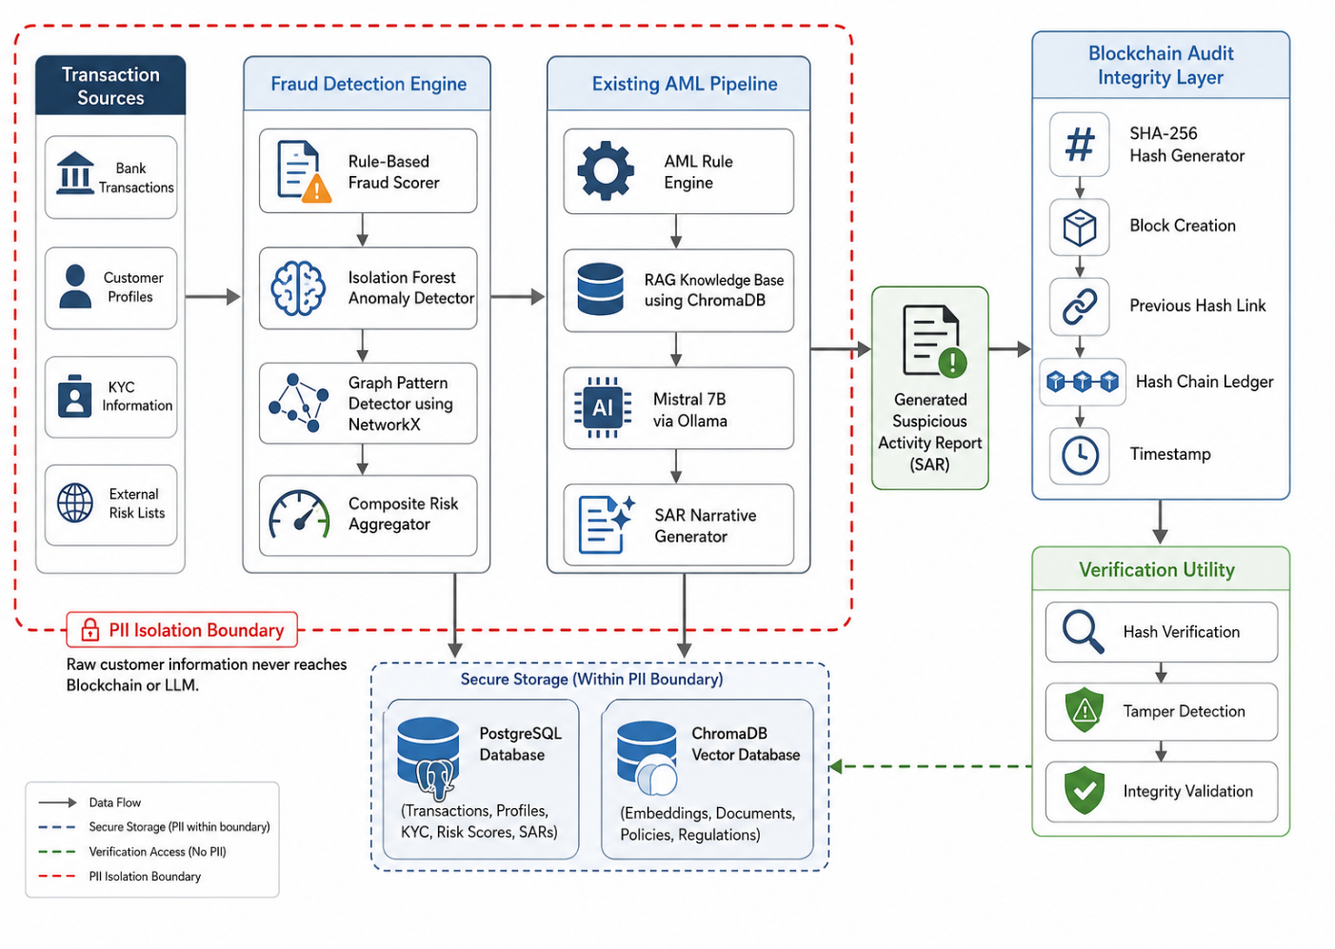

Technology Stack:

Backend: FastAPI Fraud Detection scikit-learn (Isolation Forest), NetworkX, pandas · Compliance Rules: Python, YAML RAG/LLM: ChromaDB, Mistral 7B via Ollama · Database PostgreSQL Audit Ledger: Python, SHA256 hashing (with an optional web3.py + local testnet extension) · Evaluation Dataset: PaySim / IBM AMLSim (synthetic, publicly available AML datasets, since real bank data is not accessible for academic use).

Methodology

The project will be delivered in phases: first, selecting the datasets and conducting a literature review of the AML detection patterns; second, implementing the rule-based scorer in a working baseline, followed by the AML anomaly scorer (Isolation Forest) and the AML graph detector (NetworkX); third, the integration of the anomaly scorers in a composite risk score to be fed to the AML rule engine; fourth, the creation of the PII isolation layer and RAG pipeline (prompt pinning with SHA256); fifth, the implementation of the hash-chained audit ledger and a corresponding verification utility; and last, end-to-end testing and evaluation.

The system is implemented in six stages, each with a specific algorithm or technique:
Stage 1: Rule-Based Fraud Scoring
Deterministic rules encode known laundering patterns directly as threshold logic, configured in YAML so new rules can be added without code changes.
Algorithm — Structuring Detection:
- For each account, collect all transactions within a rolling time window (e.g., 24 hours).
- Sum the total transaction amount in the window.
- Count transactions falling just under the regulatory reporting threshold (e.g., within 5% below $10,000).
- If the near-threshold count ≥ 3 AND the total exceeds the threshold, flag as structuring with a confidence score proportional to the near-threshold ratio.
Similar rule logic is applied for velocity anomalies (transaction count in a window exceeds N× the account's historical average) and jurisdiction risk (counterparty located in a flagged high-risk region list).

Stage 2: Unsupervised Anomaly Detection (Isolation Forest)
Since labeled fraud data is unavailable, an unsupervised method is used to catch patterns the rules don't anticipat
e.
Algorithm:
- Engineer per-transaction features: average transaction amount, standard deviation of amount, transaction count in the last 24 hours, number of unique counterparties in the last 7 days, hour-of-day, and z-score of the current amount against the account's historical distribution.
- Build an ensemble of n isolation trees. Each tree recursively partitions the data by selecting a random feature and a random split value between its min and max.
- For each data point, compute the path length the number of splits needed to isolate it alone in a leaf node.
- Anomalies require fewer splits to isolate (they sit far from dense regions), so points with short average path length across all trees receive a high anomaly score.
- Set the contamination parameter (expected anomaly fraction, e.g., 2%) based on the known injection rate in the synthetic dataset, and use it to convert path-length scores into a binary/continuous anomaly score.

Stage 3: Graph-Based Pattern Detection (NetworkX)
Laundering patterns like layering and structuring rings are only visible at the network level, not the single-transaction level.
Algorithm:
- Construct a directed graph where each node is an account and each edge is a transaction, weighted by amount and timestamped.
- Cycle detection: run a cycle-finding algorithm (e.g., Johnson's algorithm via nx.simple_cycles) restricted to cycles of length ≤ 6 and where all edges fall within a bounded time window (e.g., 30 days) — this filters out coincidental long-term cycles and keeps only cycles consistent with deliberate layering.
- Fan-in/fan-out detection: compute in-degree and out-degree for every node. Flag a node as a "collection point" if in-degree exceeds a threshold (e.g., >15) while out-degree stays low, and as a "distribution point" if the reverse holds.
- To limit computational cost on large graphs, restrict cycle search to strongly connected components first, since a cycle can only exist within one.
Stage 4: Composite Risk Aggregation

The three detection layers are combined into a single score per case:
composite_score = w1 × rule_score + w2 × normalized_anomaly_score + w3 × graph_score
Weights (e.g., w1 = 0.35, w2 = 0.25, w3 = 0.40) are chosen so graph-based flags — the hardest pattern type to disguise — carry the most weight, and are tuned empirically against precision/recall on the labeled synthetic dataset.

Stage 5: Retrieval-Augmented Narrative Generation
- De-identify the case: strip or mask PII (names, account numbers) before any data leaves the internal boundary.
- Retrieve relevant regulatory/rule context from ChromaDB using the triggered rule types and risk factors as the query.
- Pass the retrieved context plus de-identified case summary to Mistral 7B (served via Ollama) with a schema-enforcing prompt that requires exactly five paragraphs: (i) introduction, (ii) subject/account information, (iii) suspicious activity description, (iv) supporting evidence/reasoning tied to the specific triggered rules, (v) conclusion.
- Hash the exact prompt used (SHA256) and store it alongside the generated narrative for reproducibility.

Stage 6: Blockchain-Backed Audit Logging
- For each finalized SAR, compute narrative_hash = SHA256(narrative_text).
- Construct a block containing: case ID, narrative hash, composite risk score, triggered rules, timestamp, and the hash of the previous block (prev_hash).
- Compute the block's own hash over all these fields, and append it to the chain.
- Verification algorithm: to check integrity, walk the chain from block 1 to N, and at each step (a) recompute the block's hash from its stored fields and confirm it matches the stored hash, and (b) confirm the stored previous hash matches the actual hash of the previous block. Any mismatch at block i proves tampering occurred at or after that block.

Evaluation Plan

A synthetic transaction set will be used to evaluate the system that includes a known fraud/laundering pattern, with a focus on the precision, recall, and F1-score of the fraud detection engine (per layer and overall), the validity of the audit ledger in detecting a deliberately tampered SAR record (recomputing the hash chain), and the validation of the narrative output against the required five paragraph regulatory schema.

Expected Outcomes

A working AML compliance pipeline that demonstrates fraud detection performance on synthetic data is measurable, a working tamper-detection demo is provided, a full technical report with architecture diagrams for academic evaluation and for portfolios.

FF No 180

Group No. | TY CS K9
Activity | Review Schedule | Progress Review Report submitted | Signature of Guide
Review 1 | Mid Sem. Semester | Yes / No
Review 2 | End of Semester | Yes / No

Format of Progress Review Report:

Review No.: 1 Group No.: TY CS K09 Date:

Progress Review Report

Signature of Guide:

Review No.: 2 Group No.: TY CS K09 Date:

Progress Review Report

Signature of Guide:

