

***Dissertation on***

**“Intelligent Concept Acquisition System - An AI-Driven**

**Platform for Concept Mastery and Personalized**

**Knowledge Enhancement.”**

*Submitted in partial fulfillment of the requirements for the award of the*

*degree of*

**Bachelor of Technology**

**in**

**Computer Science & Engineering**

**UE22CS320B – Capstone Project Phase - 2**

***Submitted by:***

|  |  |
| --- | --- |
| **Naveen Radhakrishnan**  **Nitish Kumar**  **Rohit Yakkundi**  **Sharan Surpur** | **PES2UG22CS344**  **PES2UG22CS374**  **PES2UG23CS819**  **PES2UG23CS821** |

*Under the guidance of*

|  |
| --- |
| **Prof. Sheela Devi**  Designation  PES University |

**January - May 2025**

**DEPARTMENT OF COMPUTER SCIENCE AND ENGINEERING**

FACULTY OF ENGINEERING

**PES UNIVERSITY**

(Established under Karnataka Act No. 16 of 2013)

Electronic City, Hosur Road, Bengaluru – 560 100, Karnataka, India

**PES UNIVERSITY**

(Established under Karnataka Act No. 16 of 2013)

Electronic City, Hosur Road, Bengaluru – 560 100, Karnataka, India

**FACULTY OF ENGINEERING**

**CERTIFICATE**

*This is to certify that the dissertation entitled*

**‘Intelligent Concept Acquisition System - An AI-Driven**

**Platform for Concept Mastery and Personalized**

**Knowledge Enhancement.’**

*is a bonafide work carried out by*

|  |  |
| --- | --- |
| **Naveen Radhakrishnan**  **Nitish Kumar**  **Rohit Yakkundi**  **Sharan Surpur** | **PES2UG22CS344**  **PES2UG22CS374**  **PES2UG23CS819**  **PES2UG23CS821** |

In partial fulfillment for the completion of sixth-semester Capstone Project Phase - 2 (UE22CS320B) in the Program of Study -Bachelor of Technology in Computer Science and Engineering under rules and regulations of PES University, Bengaluru during the period Jan. 2025 – May. 2025. It is certified that all corrections/suggestions indicated for internal assessment have been incorporated in the report. The dissertation has been approved as it satisfies the 6th-semester academic requirements in respect of project work.

|  |  |  |
| --- | --- | --- |
| Signature  **Prof. Sheela Devi** Designation | Signature  **Dr. Sandesh B J**  Chairperson | Signature  **Dr. B K Keshavan**  Dean of Faculty |

**External Viva**

|  |  |
| --- | --- |
| **Name of the Examiners**  **1.** ____Dr. Geetha D________  **2.** Dr. Chandrashekhar P Chavan | **Signature with Date**  __________________________    __________________________ |

**DECLARATION**

We hereby declare that the Capstone Project Phase - 2 entitled **“Intelligent Concept Acquisition System - An AI-Driven Platform for Concept Mastery and Personalized Knowledge Enhancement.”** has been carried out by us under the guidance of **Prof. Sheela Devi** and submitted in partial fulfillment of the course requirements for the award of the degree of **Bachelor of Technology** in **Computer Science and Engineering** of **PES University, Bengaluru** during the academic semester January – May 2025. The matter embodied in this report has not been submitted to any other university or institution for the award of any degree.

|  |  |  |
| --- | --- | --- |
| **SRN** | **Name** | **Signature** |
| PES2UG22CS344 | Naveen Radhakrishnan |  |
| PES2UG22CS374 | Nitish Kumar |  |
| PES2UG23CS819 | Rohit Yakkundi |  |
| PES2UG23CS821 | Sharan Surpur |  |

**ACKNOWLEDGEMENT**

I would like to express my gratitude to **Prof. Sheela Devi ,** Department of Computer Science and Engineering, PES University, for her continuous guidance, assistance, and encouragement throughout the development of this UE22CS320B - Capstone Project Phase – 2

I am grateful to all Capstone Project Coordinators, for organizing, managing, and helping with the entire process.

I take this opportunity to thank Dr. Sandesh B J, Professor & Chairperson, Department of Computer Science and Engineering, PES University, for all the knowledge and support I have received from the department. I would like to thank Dr. B.K. Keshavan, Dean of Faculty, PES University for his help.

I am deeply grateful to Dr. M. R. Doreswamy, Chancellor, PES University, Prof. Jawahar Doreswamy, Pro-Chancellor, PES University, Dr. Suryaprasad J, Vice-Chancellor, PES University, and Prof. Nagarjuna Sadineni, Pro-Vice Chancellor, PES University, for providing me with various opportunities and enlightenment every step of the way. Finally, Phase 1 of the project could not have been completed without the continual support and encouragement I have received from my family and friends.

**ABSTRACT**

The growing demand for personalized education has highlighted the shortcomings of traditional learning platforms, which often lack adaptive assessment tools and interactive feedback systems. This project introduces an AI-powered learning platform that revolutionizes self-study by enabling students to upload study materials, which the AI analyzes, extracts key concepts, and generates targeted assessment questions.

The system intelligently adapts based on student performance, adjusting question difficulty, scheduling study sessions, and providing real-time feedback to enhance concept retention. By bridging knowledge gaps through customized learning paths, this solution empowers students to track progress, refine their understanding, and achieve academic success efficiently.

**TABLE OF CONTENTS**

|  |  |  |
| --- | --- | --- |
| **Chapter No.** | **Title** | **Page No.** |
|  | **INTRODUCTION** | **01** |
|  | **PROBLEM DEFINITION** | **02** |
|  | **DATA**  **4.1 Overview**  **4.2 Dataset**  **4.3 Data Preprocessing** |  |
|  | **DESIGN DETAILS**  **4.1 Novelty**  **4.2 Innovativeness**  **4.3 Interoperability**  **4.4 Performance**  **4.5 Security**  **4.6 Reliability**  **4.7 Maintainability**  **4.8 Portability**  **4.9 Legacy to Modernization**  **4.10 Reusability**  **4.11 Application Compatibility**  **4.12 Resource Utilization** |  |
|  | **HIGH LEVEL SYSTEM DESIGN /SYSTEM ARCHITECTURE** |  |
|  | **DESIGN DESCRIPTION**  **6.1 Master Class Diagram**  **6.2. ER Diagram / Swimlane Diagram / State Diagram**  **6.3 User Interface Diagrams**  **6.4. Report Layouts**  **6.5. External Interfaces**  **6.6. Packaging and Deployment Diagram** |  |
|  | **TECHNOLOGIES USED** |  |
|  | **IMPLEMENTATION AND PSEUDOCODE** |  |
|  | **CONCLUSION OF CAPSTONE PROJECT PHASE - 2** |  |
|  | **PLAN OF WORK FOR CAPSTONE PROJECT PHASE - 3** |  |
| **REFERENCES/BIBLIOGRAPHY** | |  |
| **APPENDIX A DEFINITIONS, ACRONYMS, AND ABBREVIATIONS** | |  |
| **APPENDIX B USER MANUAL (OPTIONAL)** | |  |

**LIST OF TABLES**

|  |  |  |
| --- | --- | --- |
| **Table No.** | **Title** | **Page No.** |
|  |  |  |
|  |  |  |

**LIST OF FIGURES**

|  |  |  |
| --- | --- | --- |
| **Figure No.** | **Title** | **Page No.** |
|  |  |  |
|  |  |  |

**CHAPTER 1**

**INTRODUCTION**

In the rapidly evolving educational landscape, there is a growing emphasis on personalized learning approaches that adapt to individual needs. Traditional assessment methods often fail to identify specific conceptual gaps, leading to a one-size-fits-all approach in education.

This project, the Intelligent Concept Acquisition System (ICAS), is designed to bridge this gap by enabling students to self-assess their understanding through targeted quizzes. The system analyzes user performance, identifies weak concepts, and provides visual feedback to guide personalized improvement.

Leveraging AI techniques and data visualization, ICAS aims to enhance learning outcomes by transforming passive assessment into active knowledge reinforcement. The platform is lightweight, accessible, and easily adaptable for schools, coaching centers, and self-learners.

**Chapter 2**

**Problem Definition**

Learners often struggle to recognize which specific concepts they have not fully mastered, especially when relying solely on grades or overall scores. Traditional assessments do not provide actionable insights into conceptual weaknesses.

The core problem is:

“How can we enable learners to identify and improve weak conceptual areas through automated, personalized feedback?”

ICAS addresses this by evaluating quiz responses at a concept level, generating visual performance metrics, and offering guided feedback. The platform transforms raw performance data into meaningful insights for both students and educators.

**Chapter 3**

**Data**

* 1. **Overview**The current version of the Intelligent Concept Acquisition System (ICAS) operates without a dedicated training database or external datasets. Instead, the system uses user-provided documents as the primary source of information. These documents are processed in real-time to extract relevant concepts and generate questions for evaluation and learning reinforcement.

At this stage, no pre-trained models or large-scale datasets are used. However, the system has been designed with extensibility in mind, allowing for future integration of educational datasets such as the ALIN 2022 dataset to enhance its personalization and recommendation capabilities.

* 1. **Dataset**
  2. **Data Preprocessing**

**Chapter 4**

**Design Details**

**4.1 Novelty**

The Intelligent Concept Acquisition System (ICAS) is unique in its ability to transform user-uploaded educational documents into dynamic learning sessions without relying on a predefined dataset. Instead of using traditional static quizzes or rigid learning paths, ICAS interprets textual content, extracts key concepts, generates context-aware questions, and tracks the learner’s understanding in real-time. This allows learners to receive immediate feedback tailored to their own study materials, making the system highly personalized and novel in its application.

**4.2 Innovativeness**

ICAS introduces innovation by integrating document parsing, concept mapping, question generation, and progress tracking into a seamless workflow. The system’s use of session-based learning analytics helps provide users with targeted reinforcement based on weak areas, and its modular design allows easy extension with NLP models, adaptive difficulty scaling, or gamification in future iterations.

**4.3 Interoperability**

The architecture of ICAS supports easy integration with external tools and formats. It is built using open technologies like Python, Streamlit, and Pandas, and can be adapted to accept inputs in various formats such as PDFs, DOCX, and text files. In future enhancements, the system can interface with APIs from LMS platforms or AI models, ensuring compatibility across educational ecosystems.

**4.4 Performance**

The system is optimized for fast performance, as it processes documents and user interactions in real-time with minimal computational overhead. It avoids complex model training or heavyweight data operations, resulting in near-instantaneous question generation and progress visualization. This makes ICAS usable even on low-resource devices, including standard laptops or education lab machines.

**4.5 Security**

ICAS does not store user data permanently or transmit it to external servers. All processing is session-based and remains in-memory, reducing exposure to data breaches or misuse. The document content uploaded by users is used strictly for generating questions during the session, which aligns well with data privacy expectations in academic settings.

**4.6 Reliability**

By utilizing Streamlit's session management features, ICAS maintains user progress and responses accurately during a learning session. Failures are minimized through exception handling and fallback logic during question generation and evaluation. The design ensures consistent behavior across different types of inputs and interactions.

**4.7 Maintainability**

The system follows good software engineering practices, including modularity, clear class definitions, and separation of concerns. The use of a well-defined `ProgressTracker` class and other functional abstractions ensures that developers can easily modify or extend the system. This makes the codebase maintainable and adaptable for academic or commercial expansion.

**4.8 Portability**

ICAS is highly portable. It can be deployed on Windows, Linux, or macOS platforms with Python installed. Being built on Streamlit, it can also be containerized with Docker or hosted on platforms like Streamlit Cloud or Heroku, requiring minimal configuration changes for different environments.

**4.9 Legacy to Modernization**

This system enables the modernization of traditional study practices by digitizing and enhancing existing educational documents. Instead of relying solely on passive reading, ICAS turns old study materials into interactive content, giving legacy documents new educational value and making them more engaging and measurable.

**4.10 Reusability**

The components of ICAS—such as document parsing, question generation, and concept tracking—are decoupled and reusable in other contexts. For example, the progress tracker can be repurposed for online courses or tutoring apps, while the question generator can be integrated into quiz bots or adaptive learning platforms.

**4.11 Application Compatibility**

ICAS is built to integrate smoothly into larger ecosystems. It can be extended to export progress reports, sync with classroom dashboards, or connect with AI-based tutoring systems. Its modular structure supports APIs and other interfaces needed for broader application use.

**4.12 Resource Utilization**

The system is designed to operate within constrained environments, consuming minimal CPU and memory. It does not require specialized hardware or GPU acceleration, making it ideal for deployment in schools, universities, or home setups without significant infrastructure.

1. **HIGH LEVEL SYSTEM DESIGN /SYSTEM ARCHITECTURE**

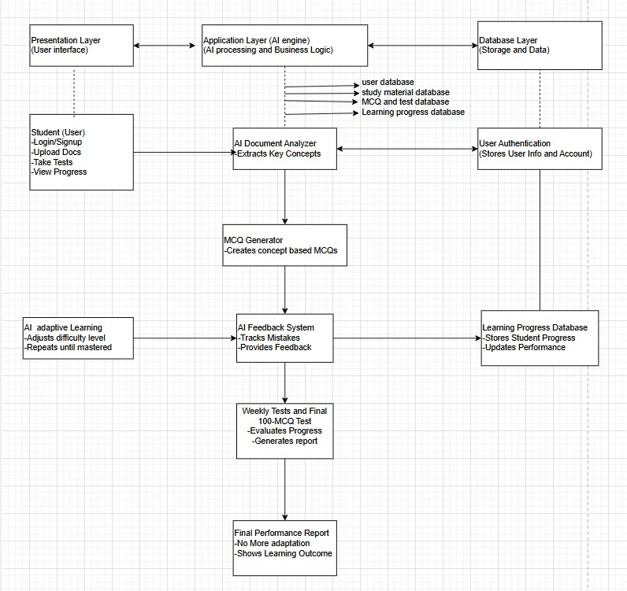

1. **DESIGN DESCRIPTION**
   1. **Master Class Diagram**

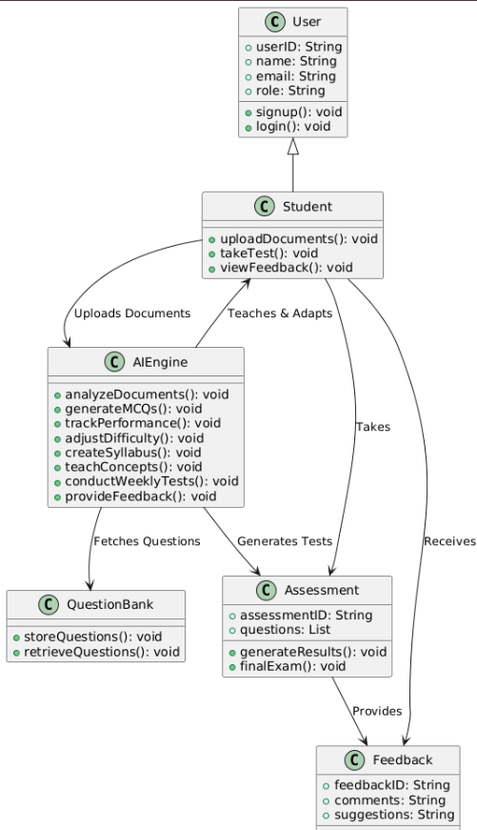

**6.2. ER Diagram / Swimlane Diagram / State Diagram**

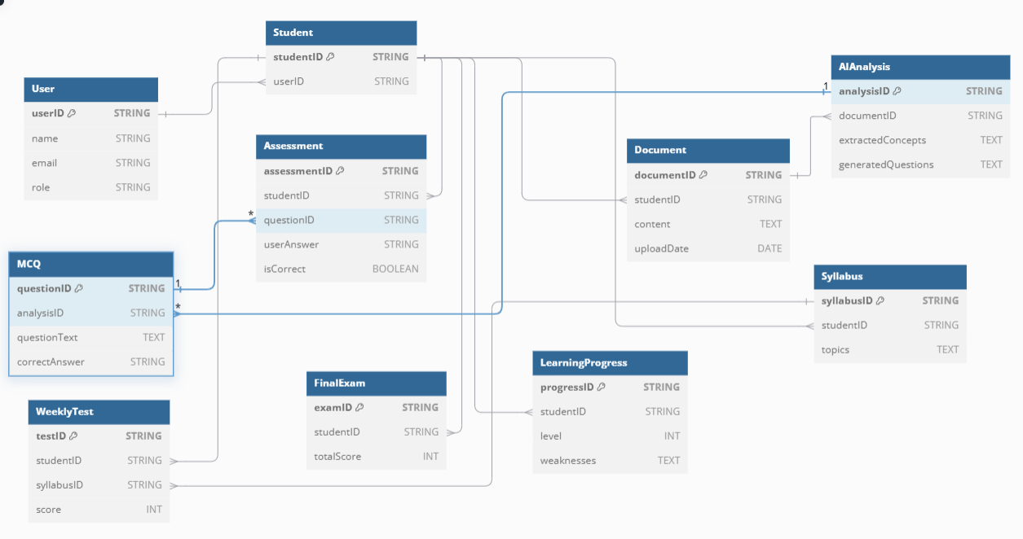

**6.3. User Interface Diagrams**

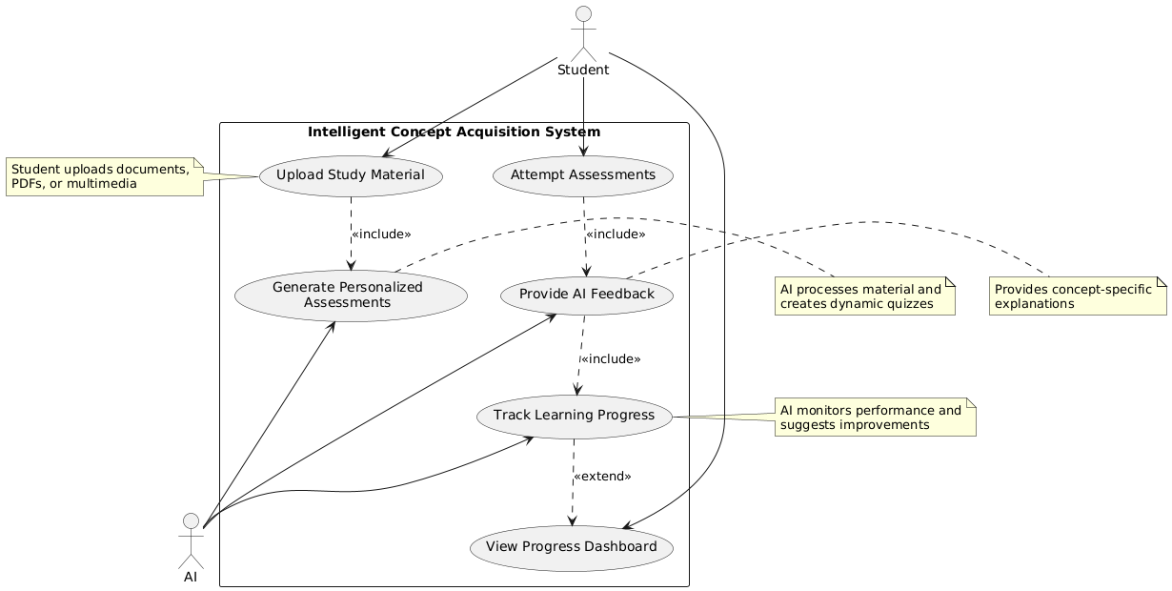

**6.4. Report Layouts**

**6.5. External Interfaces**

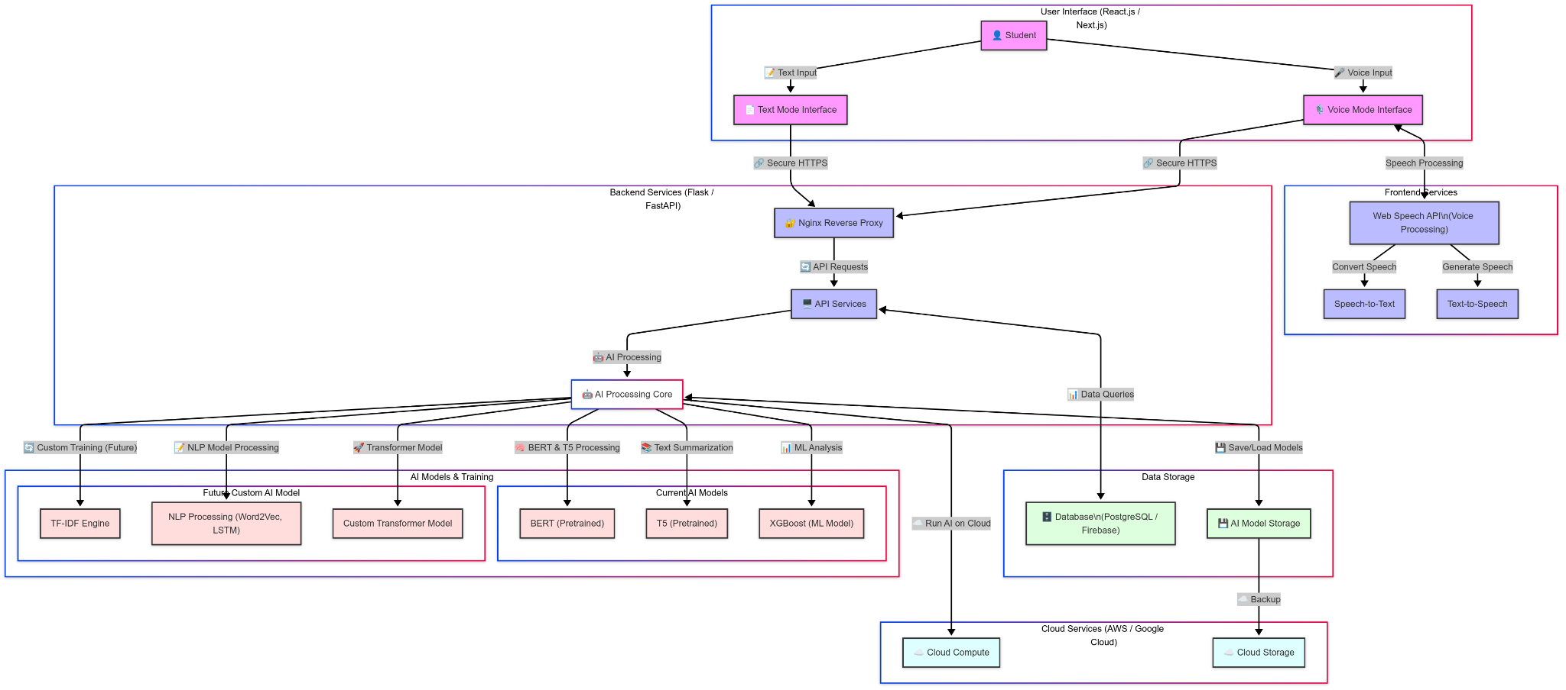

**6.6. Packaging and Deployment Diagram**

**Chapter 7**

**Technologies used**