**DEPARTMENT OF MECHANICAL ENGINEERING UNIVERSITY OF VISVESVARAYA COLLEGE OF ENGINEERING**

**(A First State Autonomous Public University on IIT Model)**

**K.R. Circle, Bengaluru 560001**



**CERTIFICATE**

This is to certify that the Internship/ professional work has been successfully carried out at **V Smart Health Care Device** & Industries by **Pradeep S** bearing the **USN: P25UV23T069010**, Bonafide student of University of Visvesvaraya College of Engineering (UVCE)/University in partial fulfilment of the requirements for the award of postgraduate degree of Master of Technology in specification of Machine Design during the academic year **2024-2025.** It is certified that all correction/suggestions indicated for Internal assessment have been incorporated in the report. The Internship report has been approved as it satisfies the academic requirements in respect of Internship work for the said degree.

# (Signature of Guide) (Signature of the Chairman)

**Dr. H G HANUMANTARAJU Dr. H C CHITTAPPA**

Professor, Professor and Chairman

Department of Mechanical Engineering, Department of Mechanical Engineering U.V.C.E, Bengaluru. U.V.C.E, Bengaluru.

# Signature with Date

**CERTIFICATE**

**DEPARTMENT OF MECHANICAL ENGINEERING UNIVERSITY OF VISVESVARAYA COLLEGE OF ENGINEERING**

**(A First State Autonomous Public University on IIT Model)**

**K.R. Circle, Bengaluru 560001**



**DECLARATION**

I, **Pradeep S,** Bearing USN **P25UV23T069010**, student of **Master of Technology, Machine Design, Department of Mechanical Engineering, University of Visvesvaraya College of Engineering**, Bengaluru, hereby declare that the internship has been independently carried out by me. V Smart Health Care Device submitted as a partial fulfilment for the award of Master of Technology in postgraduate degree in Machine Design from UVCE 2024-2025. This is work has not been submitted by us in part or full to any other University or Institute for the award of any degree. I also declare that the internship has not been submitted previously for the award of any degree by me, to any institution.

**Pradeep S, P25UV23T069010**

**Executive Summary**

This report presents an overview of my internship experience at V Smart Health Care Device and other Co-ordinate Industries. The internship spanned over a period of Eight weeks i.e. two months, during which I worked as an intern in the domain their company products and development. This report outlines the organization, provides insights into the skills acquired, learning outcomes, internship experience, and concludes with a summary of the overall experience.

**UNIVERSITY OF VISVESVARAYA COLLEGE OF ENGINEERING**

(A First State Autonomous Public University on IIT Model)

**DEPARTMENT OF MECHANICAL ENGINEERING**

**K.R. Circle, Bengaluru 560001**



An Internship report on

**V SMART HEALTH CARE DEVICE**

Submitted by

**Pradeep S – P25UV23T069010**

in partial fulfilment of 3rd semester for award of

**MASTER OF TECHNOLOGY**

In

**MACHINE DESIGN**

Under the Guidance of

**Dr. H.G. HANUMANTHARAJU**

Professor, Department of Mechanical Engineering

**TABLE OF CONTENTS**

|  |  |  |
| --- | --- | --- |
| **CHAPTER NO** | **TITLE** | **PAGE NO** |
| **1**  **2**  **3**  **4** | **ABOUT THE ORGANISATION AREA OF STUDY**   1. **ASSEMBLY** 2. **FABRICATION** 3. **LASER CUTTING** 4. **PUNCHING** 5. **WELDING** 6. **BENDING** 7. **POWDER COATING** 8. **INJECTION MOULDING LEARNED TIPS**   **OUTCOMES** | **1**  **2 – 11**  **12**  **13** |

**CHAPTER – 1**

**ABOUT THE ORGANIZATION**

V Smart Health Care Device is one of the trusted Dermatology Equipment Manufacturers in Bangalore. Our product range includes Cosmetology Equipment and Homecare Equipment’s. The machines that you get from us are of superior quality and are widely tested. To ensure that these will remain stagnant when it comes to excellent performance in the practical world. Our dermatology equipment is backed by clinical studies and real-world results, demonstrating its effectiveness in improving skin health and appearance. Customers can trust that our equipment delivers the results they desire, backed by scientific evidence and patient testimonials.

We are a leading Infant Radiant Warmer Suppliers in Karnataka. We are a company that you can always trust when it comes to investing in high-quality dermatology equipment is a long- term investment in the success of a dermatology practice. We’ve been engaged in offering [Hydra Facial Machine,](https://www.vsmarthealthcare.com/hydra-facial-machine.html) Derma Chair, [Diode Laser](https://www.vsmarthealthcare.com/diode-laser.html), Pico Laser, Cry lipolysis, MNRF, HIFU Machine, [CO2 Fractional Laser Machine,](https://www.vsmarthealthcare.com/co2-fractional-laser-machine.html) UV Therapy Unit, Nd Yag Laser, [Infant](https://www.vsmarthealthcare.com/infant-phototherapy-unit.html) [Phototherapy Unit,](https://www.vsmarthealthcare.com/infant-phototherapy-unit.html) Surgical Loupes, Dialysis Chair, Led OT Light in different specifications. Our equipment is built to last, offering durability and reliability for years to come. Customers can trust that our equipment will continue to deliver exceptional performance and results over time.

Noted among the top-notch Dialysis Chair Wholesalers in India. From acne treatment to anti- aging therapies, our dermatology and beauty care equipment offers comprehensive solutions for a wide range of skin concerns. Dermatologists can rely on our equipment to effectively address various skin conditions and achieve optimal results for their patients.



**Fig 1.1 Organisation logo**

1. **ASSEMBLY**
2. **FABRICATION**
3. **LASER CUTTING**
4. **PUNCHING**
5. **WELDING**
6. **BENDING**
7. **POWDER COATING**

**CHAPTER – 2 AREA OF STUDY**

1. **INJECTION MOULDING**
2. **ASSEMBLY**

Assembly refers to the process of putting together various parts or components to form a finished product. It’s a key step in manufacturing, where individual components are combined to create a final product ready for use or distribution. Assembly can take place in many industries, including automotive, electronics, furniture manufacturing, and even consumer goods.

1. **FABRICATION**

Fabrication generally refers to the process of creating products or structures by assembling various materials through different techniques. The term can be applied to many industries, including manufacturing, construction, and even arts and crafts. There are different fabrication types. They are:

* 1. Manufacturing Fabrication
  2. Construction Fabrication
  3. Sheet Metal Fabrication
  4. Textile Fabrication
  5. Artistic Fabrication

Key Considerations in Fabrication:

* + - Materials: Choosing the right material is essential to ensure that the final product performs as expected. This could involve metals (steel, aluminium), plastics, composites, wood, or fabric.
    - Precision: Fabrication often requires high levels of precision to ensure that all parts fit together correctly and meet design specifications.
    - Tools & Equipment: Specialized tools like CNC machines, welding machines, and 3D printers are often used in fabrication processes.

1. **LASER CUTTING**

Laser cutting is a popular and highly precise method of cutting or engraving materials using a focused laser beam. It’s commonly used in industries such as manufacturing, automotive, aerospace, electronics, and even art. This technique offers high precision, efficiency, and versatility when working with various materials, such as metals, plastics, wood, glass, and textiles.

# How Laser Cutting Works:

Laser cutting involves using a laser to melt, burn, or vaporize a material in a controlled manner. The laser is focused into a beam and directed onto the material’s surface, where it either melts, burns, or vaporizes a narrow path, creating a cut. The process can be adjusted for different material types and thicknesses.

# Main Components of Laser Cutting:

* **Laser Source:** The type of laser used (CO2, Fiber, or Nd:YAG lasers) depends on the material and thickness being cut.
* **CO2 Lasers:** Typically used for cutting non-metallic materials (e.g., wood, plastics, textiles).
* **Fiber Lasers:** Ideal for cutting metals, such as stainless steel, aluminium, and brass.
* **Nd:YAG Lasers:** Used for high-precision applications and materials like metals and ceramics.
* **Laser Beam:** The focused laser beam is the core cutting tool. The energy in the beam is concentrated to generate enough heat to cut through materials.
* **Assist Gas:** A stream of gas, often oxygen, nitrogen, or compressed air, is blown at the cutting area to:
* Cool the material.
* Blow away molten material or debris.
* Improve cut quality by controlling oxidation (especially when cutting metals).
* **Cutting Head:** This directs the laser beam to the material. It typically contains lenses to focus the beam and allow for precise cutting control.
* **Material:** Various materials can be cut depending on the type of laser used. Popular materials include metals (stainless steel, aluminium, carbon steel), plastics (acrylic, PVC), wood, and textiles.

# Types of Lasers Cutting:

* Fusion Cutting: The material is melted using the laser, and the molten material is blown away by the assist gas. Commonly used for cutting metals.
* Flame Cutting: The laser ignites the material, causing it to burn and oxidize. This method is used primarily for materials like steel and requires oxygen as the assist gas.
* **Vaporization Cutting:** The laser heats the material until it vaporizes, leaving a clean cut. This method is ideal for materials that are difficult to cut with traditional methods.
* **Melt and Blow Cutting:** A combination of melting and blowing the molten material away, typically used for metals.

# Advantages of Laser Cutting:

* 1. Precision and Accuracy
  2. Minimal Material Waste
  3. No Physical Contact
  4. Versatility
  5. Complex Shapes
  6. Clean Edges
  7. Automation

# Limitations of Laser Cutting:

1. **Material Thickness:** While laser cutting is suitable for thin to medium-thick materials, very thick materials (especially metals) may require more power, slower speeds, and result in higher operational costs.
2. **Cost:** High-quality laser cutting machines can be expensive, both in terms of initial investment and maintenance. Operating costs can also be higher due to energy consumption and the need for specialized gases and optics.
3. **Heat**-Affected Zone (HAZ): The area around the cut can become heat-affected, which may lead to slight changes in material properties or appearance, especially for heat- sensitive materials.
4. **Speed:** For some materials, laser cutting can be slower compared to other traditional cutting methods like plasma or waterjet cutting.

Considerations for Laser Cutting:

* + **Material Type and Thickness:** The choice of laser (CO2, Fiber, or Nd:YAG) and cutting parameters will depend on the material and its thickness. For instance, CO2 lasers are ideal for thicker materials like wood and plastic, while Fiber lasers are better for metals.
  + **Cutting Speed:** Depending on the material, the laser’s power settings, and the assist gas, the speed of cutting can vary. Slower cutting speeds can improve precision but may not be ideal for high-volume production.
  + **Safety:** Since laser cutting involves powerful lasers, safety precautions are important, including protective eyewear and ventilation systems to handle fumes generated during cutting.

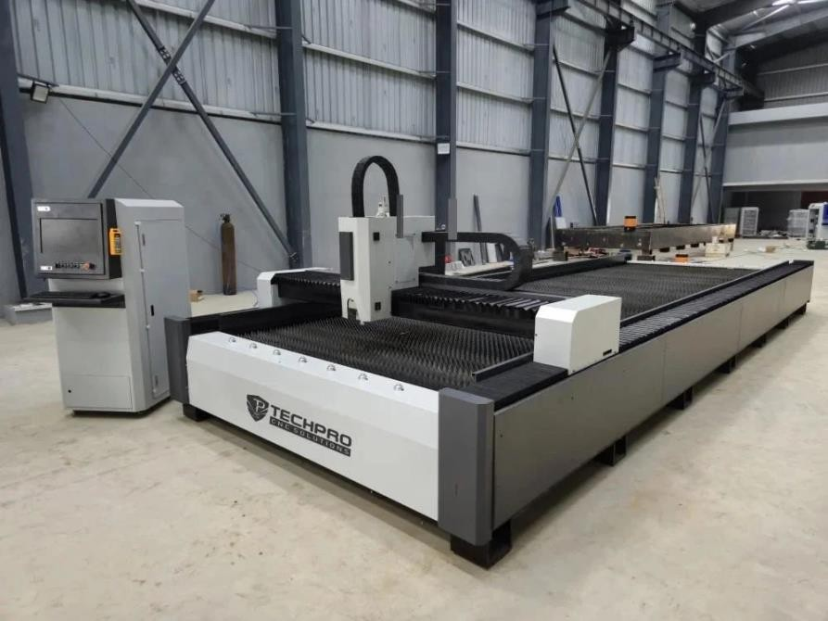

**LASER CUTTING MACHINE**

1. **PUNCHING**

**Punching** is a manufacturing process used to create holes or cutouts in a material, typically sheet metal or plastic, by applying a high force through a punch and die set. The punch creates a hole or shape in the material by forcing the material into the die cavity. Punching is commonly used in industries such as automotive, electronics, construction, and metalworking for producing parts like brackets, panels, and other components.

# How Punching Works:

* 1. **Setup**: The material (usually sheet metal) is placed between a punch (a tool that exerts force) and a die (a tool that shapes the material as the punch strikes).
  2. **Punching Action**: When the punching machine (like a press or hydraulic machine) activates, the punch moves downward and forces the material into the die. The force shears the material, creating a hole or cutout.
  3. **Ejection**: After the punch has completed the cut, the piece is ejected from the die, and the process can be repeated.

# Key Components of the Punching Operation:

* **Punch**: The tool that applies the force to the material, typically shaped to the desired hole or cutout size. It is usually made of hardened steel or another durable material.
* **Die**: The counterpart to the punch, the die is a cavity or opening that gives shape to the punched hole or part. It is also made from hardened steel or tool steel for longevity and precision.
* **Material**: Sheet metal, plastic, or other materials that are fed into the punching machine. The thickness of the material often dictates the type of punch and die needed.
* **Press Machine**: This is the machine that holds the punch and die and provides the force necessary for punching. Types of presses include mechanical presses, hydraulic presses, and pneumatic presses, each with different mechanisms for generating force.

# Considerations in Punching Operations:

* **Material Thickness**: Thicker materials may require higher punching forces and may lead to more wear on the tools.
* **Tolerances**: While punching provides good precision, complex shapes or tight tolerances may require additional finishing operations, such as grinding or laser cutting.
* **Tooling and Setup**: The tooling (punch and die) must be designed for the specific part, and the setup time can vary based on part complexity and machine type.
* **Part Orientation**: In automated punching operations, optimizing part placement and orientation on the material sheet is crucial to minimize material waste and maximize productivity.

Punching is a widely used and efficient manufacturing operation that is essential for producing a range of products in various industries. Whether creating simple holes, intricate shapes, or even embossed designs, punching offers advantages like speed, precision, and cost-effectiveness, especially in high-volume production.

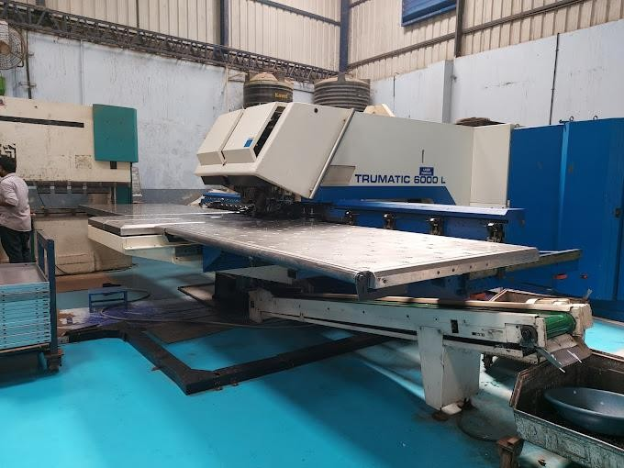

**PUNCHING MACHINE**

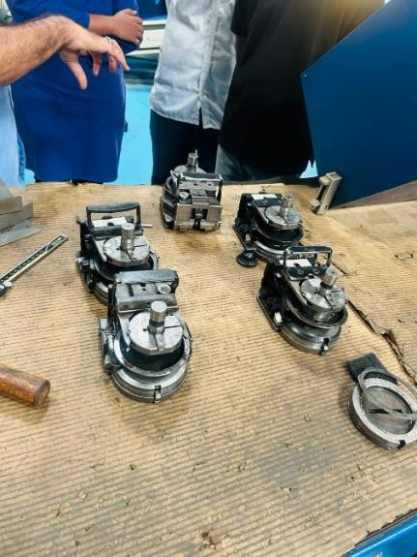

**DIE TOOL**

1. **WELDING**

**Welding** is a manufacturing process that involves joining two or more materials (usually metals or thermoplastics) by applying heat, pressure, or both. The process causes the material to melt at the joining point, allowing it to fuse together as it cools and solidifies. Welding is used in various industries, including automotive, aerospace, construction, and shipbuilding, for creating durable and strong connections between components.

# How the Welding Process Works:

The basic idea behind welding is to create a localized heat source that melts the material at the joint, allowing it to flow and bond. Some welding processes also add a filler material to reinforce the joint. Once the material cools and solidifies, the joint is formed.

The specific method used for welding depends on factors like the type of material, the thickness of the materials being welded, the desired strength of the joint, and whether or not a filler material is required.

Welding is a fundamental and versatile process in modern manufacturing, offering strong, permanent, and durable connections between materials. From simple, low-cost processes like arc welding to high-tech methods like laser welding, the choice of welding method depends on factors like material type, joint configuration, precision, and cost.

1. **BENDING**

**Bending** is a manufacturing process that involves the deformation of a material, usually metal, to create a specific angle or shape. The material is bent without breaking by applying force through a press brake or other bending equipment. The process is commonly used in the sheet metal industry to create parts like brackets, panels, frames, and other structural components.

# How Bending Works:

Bending occurs when a material (typically sheet metal or plate) is subjected to compressive forces that cause the material to flex and take on a new shape. The material is forced over a die, and a punch applies the bending force, creating a bend at the point where the force is applied.

# Key Components of the Bending Operation:

* 1. **Material**: The material being bent is typically sheet metal or a thin plate of steel, aluminium, brass, copper, or other metals. The thickness of the material often determines the type of bending machine and tooling needed.
  2. **Bending Machine**: Bending operations are commonly performed on machines like **press brakes**, **manual or hydraulic benders**, or **CNC bending machines**, depending on the complexity and precision required.
  3. **Die and Punch**: In many bending operations, a punch applies the bending force to the material, while the die provides a cavity or support for the material. The shape and design of the die and punch affect the final bend angle and shape.
  4. **Material Properties**: The material’s properties, such as thickness, hardness, and tensile strength, will affect how well it bends and its ability to return to its original shape (known as "spring back").

Bending is a critical process in metalworking that allows manufacturers to shape materials into a wide range of products, from simple brackets to complex curves. The choice of bending method depends on the material, the shape, and the required precision.

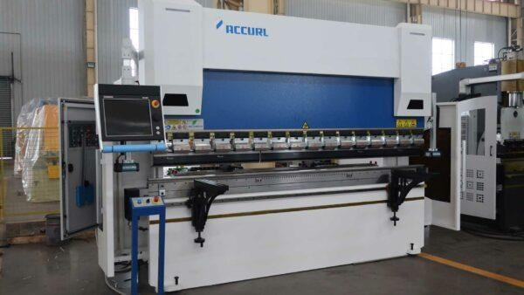

**BENDING MACHINE**

1. **POWDER COATING**

**Powder coating** is a popular finishing process used to apply a protective and decorative layer of coating to a variety of materials, particularly metals. This process involves applying a dry powder to the surface of the workpiece, which is then cured under heat to form a durable and attractive coating. Unlike traditional liquid painting, powder coating is an environmentally friendly and efficient way to finish products with excellent results.

# How Powder Coating Works:

* 1. **Preparation**:
     + **Surface Cleaning**: The first step in powder coating is preparing the surface of the object. This involves cleaning the workpiece to remove oils, dirt, rust, or other contaminants that could affect the adhesion of the coating. Common cleaning methods include sandblasting, chemical cleaning, or using a phosphating process.
     + **Pre-treatment**: After cleaning, the surface may undergo a treatment process like applying a chemical primer or a conversion coating (such as a zinc phosphate or chromate conversion) to improve adhesion and corrosion resistance.

# Application:

* + - **Electrostatic Spray Application**: The dry powder is typically applied to the object using a spray gun that imparts an electrostatic charge to the powder particles. The part being coated is grounded, causing the charged powder particles to be attracted to the surface. This creates an even layer of powder over the surface.

# Curing:

* 1. **Cooling**:
* **Types of Powder**: The powder itself is made of fine particles of pigment and resin, which can vary based on the desired finish. The powder can be composed of thermosetting resins (which cure when heated) or thermoplastic resins (which melt and fuse upon heating). Common powders include epoxy, polyester, polyurethane, and acrylic-based formulations.
* **Electrostatic Application**: The electrostatic spray gun charges the powder particles as they exit the nozzle. These particles are attracted to the object being coated, creating an even, uniform layer on its surface. The thickness of the powder coating layer depends on factors like the distance of the spray gun from the surface, the electrostatic charge, and the speed of application.
* After the powder is applied, the object is placed in an oven where it is heated to a specific temperature (typically between 160°C and 210°C, or 320°F to 410°F) for a set period. This curing process causes the powder to melt and chemically bond to the surface, forming a smooth, hard, and durable finish.
* The heat causes the thermosetting powder to undergo a chemical crosslinking process, making it a strong, long-lasting finish. In the case of thermoplastic powders, they melt and fuse together when heated but do not undergo a chemical change.
* Once the curing process is complete, the coated workpiece is removed from the oven and allowed to cool. The cooling process helps solidify the coating, making it hard and durable.

# Advantages of Powder Coating:

* 1. Durability
  2. Environmental Benefits
  3. Cost-Effective
  4. Wide Range of Finishes
  5. Corrosion Resistance
  6. High Efficiency
  7. No Drips or Runs

Powder coating is a highly effective and environmentally friendly method for providing durable, long-lasting, and attractive finishes to a wide range of products. Its benefits include high resistance to wear, chipping, and corrosion, making it ideal for applications

in automotive, industrial, and consumer goods. The process is versatile, offering a variety of finishes and colours, and is cost-efficient for high-volume production.

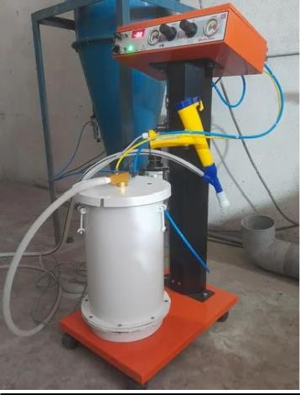

**POWDER COATING EQUIPMENT**

* 1. **INJECTION MOULDING**

**Injection moulding** is a widely used manufacturing process that involves injecting molten material (often plastic) into a mould to create a specific shape or part. It is commonly used for producing high volumes of precise and complex parts, such as automotive components, household items, medical devices, and consumer electronics. This process is particularly known for its ability to produce parts with high repeatability and intricate details.

# How Injection Moulding Works:

1. **Material Selection**:
   * The most commonly used material in injection moulding is plastic, although metals, ceramics, and even some rubber materials can also be used. These materials are typically provided in the form of small pellets or granules, which are fed into the injection moulding machine.

# Heating and Melting:

* + The plastic pellets or granules are first fed into the **hopper**, which is a container that holds the material. The material is then transported into a heated **barrel** where it is gradually melted using heat and mechanical friction. The barrel is equipped with a **screw** that rotates and pushes the material through the barrel to the injection nozzle.

# Injection into the Mold:

* + Once the plastic is melted to the appropriate viscosity, it is injected under high pressure into a closed mould cavity. The **injection system** forces

# Cooling:

1. **Ejection**:

the molten material into the mould through a nozzle and runners, filling the cavity. This process happens rapidly, typically within a few seconds.

* After the mould cavity is filled with molten material, the part is allowed to cool and solidify. The cooling process is essential because it helps the part maintain its shape and ensures that it is hardened enough to be removed from the mould without distortion.
* Once the part has cooled and solidified, the mould is opened, and the part is ejected using an **ejector pin**. The ejection process may involve applying a small force to remove the part from the mould without damaging the part or the mould itself.

# Trimming and Finishing:

* + After ejection, the part may have excess material, such as flash (excess plastic that escapes from the mould), which must be removed. This can be done manually or with automated trimming and finishing tools. The part may also undergo secondary processes like painting, assembly, or additional quality checks.

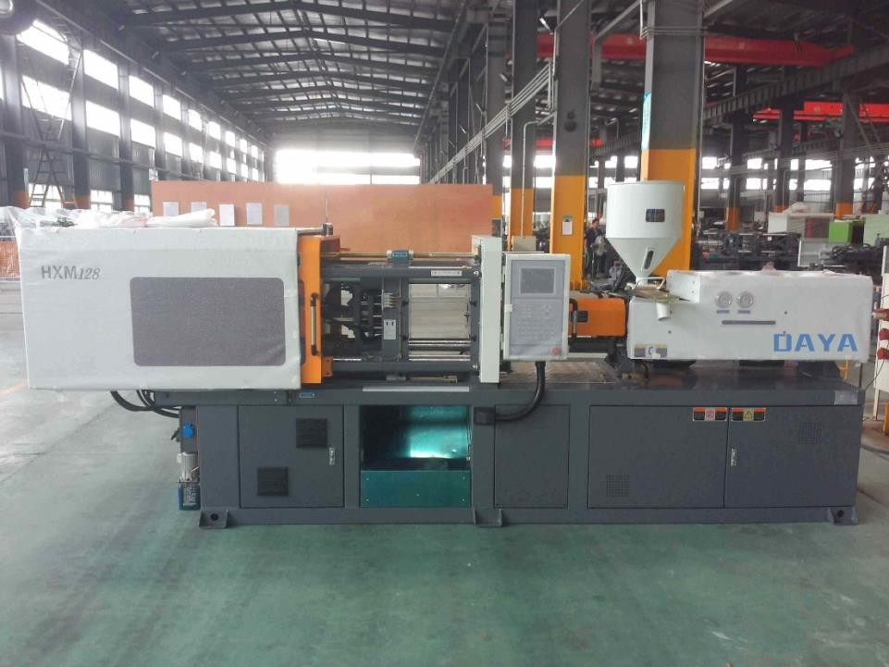

**INJECTION MOULDIND MACHINE**

**CHAPTER – 3 LEARNED TIPS**

* **Process Optimization**: Always focus on process optimization for higher efficiency and cost-effectiveness. This might involve adjusting parameters, utilizing automation, or refining the design to simplify production.
* **Quality Control**: Implementing strict quality control at every stage (assembly, fabrication, cutting, etc.) can prevent defects from escalating and reduce waste.
* **Material Selection**: Tailor your process choice to the material. For example, injection moulding is excellent for plastics, while welding is more suited for metals.
* **Automation**: When feasible, use automation for consistency and speed. This is particularly useful in assembly, fabrication, and injection moulding to enhance repeatability and reduce human error.

By understanding these processes deeply and utilizing these tips, you'll be able to make informed decisions on how to manufacture parts efficiently while ensuring quality and minimizing waste.

**CHAPTER – 4 OUTCOMES**

* **Process Optimization**: Each of these processes can be optimized to reduce waste, increase efficiency, and ensure product quality. Whether through precise cutting (laser cutting), customized part creation (fabrication), or high-speed production (punching), you learn how to leverage the right process for specific needs.
* **Material Compatibility**: You gain insights into selecting the right materials for each process. For example, plastics are suited for injection moulding, while metals are ideal for welding and fabrication.
* **Efficiency Gains**: Automated processes (such as laser cutting and injection moulding) allow for higher production volumes with fewer errors. Understanding these methods leads to more efficient manufacturing and higher throughput.
* **Design for Manufacturability**: The processes you learn highlight the importance of designing products with the manufacturing process in mind. For example, understanding injection moulding helps in designing parts that are easier to mould, and knowing bending limits prevents material failures.
* **Quality Control and Precision**: The processes provide a foundation for ensuring the final product meets strict quality and performance standards. For example, powder coating ensures durability and aesthetics, while welding ensures structural integrity.
* **Customization and Flexibility**: Whether through fabrication or bending, you understand how each process allows for customization of parts, making it easier to meet specific client needs or project requirements.