CD ASSIGNMENT-2 AST

NAME : DARSHAN KUMAR K R SRN : PES2UG22CS157

SEC : ‘C’

**Output Screenshots**

1. test_input_1.c

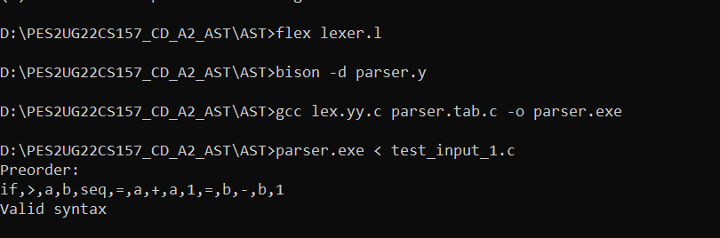

1. test_input_2.c

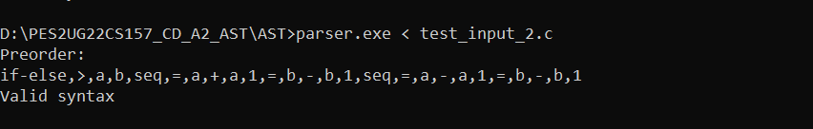

1. test_input_3.c

