CD Assignment-2 Intermediate code generator

NAME : DARSHAN KUMAR K R SRN : PES2UG22CS157

SEC : C

Output Screenshots

1. Test_input_1.c

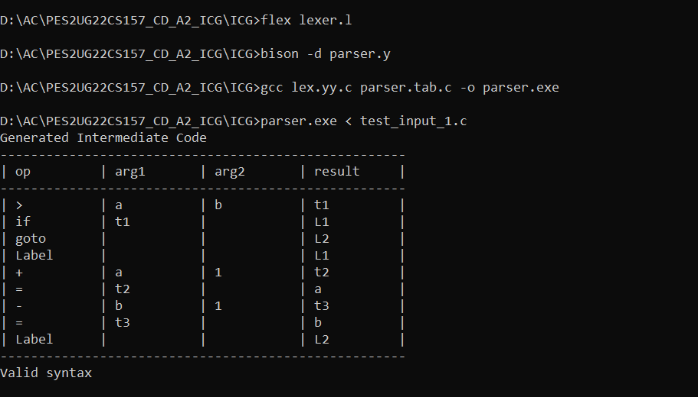

1. 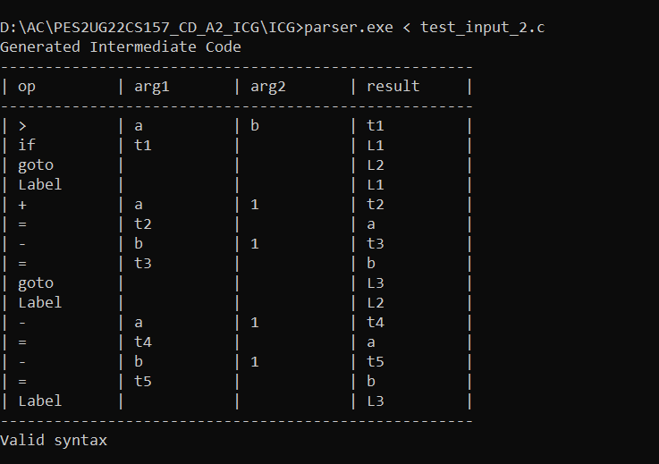Test_input_2.c