Topics: Confidence Intervals

- For each of the following statements, indicate whether it is True/False. If false, explain why.

- The sample size of the survey should at least be a fixed percentage of the population size in order to produce representative results.

- The sampling frame is a list of every item that appears in a survey sample, including those that did not respond to questions.

- Larger surveys convey a more accurate impression of the population than smaller surveys.
Ans :
- True , Because sample should not be very small comparing to the population size therefore it should be least fo fixed percentage

- False, The sampling frame refers to a list of an item which responds to the question and not the ones which do not respond to the questions.

- True, Becouse larger the sample size more the accuracy

- PC Magazine asked all of its readers to participate in a survey of their satisfaction with different brands of electronics. In the 2004 survey, which was included in an issue of the magazine that year, more than 9000 readers rated the products on a scale from 1 to 10. The magazine reported that the average rating assigned by 225 readers to a Kodak compact digital camera was 7.5. For this product, identify the following:

A. The population = All the reader of PC Magazine
B. The parameter of interest = Rating
C. The sampling frame = Readers that rated the product(around 9000)
D. The sample size = 225
E. The sampling design = Voluntary response
F. Any potential sources of bias or other problems with the survey or sample =
Selection of the readers , selection of the issue which will contain the survey

- For each of the following statements, indicate whether it is True/False. If false, explain why.

- If the 95% confidence interval for the average purchase of customers at a department store is $50 to $110, then $100 is a plausible value for the population mean at this level of confidence.

- If the 95% confidence interval for the number of moviegoers who purchase concessions is 30% to 45%, this means that fewer than half of all moviegoers purchase concessions.

- The 95% Confidence-Interval for μ only applies if the sample data are nearly normally distributed.

I.
Ans :
TRUE
Reason:
The 95% confidence interval for the average purchase of customers at a
department store is $50 to $110. Which means that there is a 95% chance
that the population mean will fall between $50 and $110. Hence, as $100 falls

between $50 and $110, it is a plausible value for the population mean at this
confidence level.

II.
Ans :
TRUE
Reason:
The 95% confidence interval for the number of moviegoers who purchase
concessions is 30% to 45%, this means that there is a 95% chance that only
30 to 45 % of moviegoers purchase concessions, which is less than
50%. Hence, we can infer that fewer than half of all the moviegoers purchase
concessions.

III.
.
Ans :
TRUE

- What are the chances that ?

- ¼
- ½
- ¾
- 1

Ans : B

The probability of getting a sample mean greater than μ (population mean) is 50%,
as long as your sampling distribution follows a normal distribution (this occurs if the
population distribution is normal or the sample size is large).

- In January 2005, a company that monitors Internet traffic (WebSideStory) reported that its sampling revealed that the Mozilla Firefox browser launched in 2004 had grabbed a 4.6% share of the market.

- If the sample were based on 2,000 users, could Microsoft conclude that Mozilla has a less than 5% share of the market?

- WebSideStory claims that its sample includes all the daily Internet users. If that’s the case, then can Microsoft conclude that Mozilla has a less than 5% share of the market?

I.

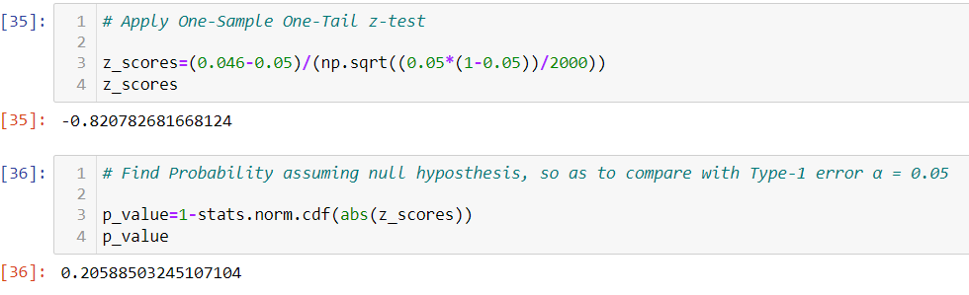
Ans :

Null Hypothesis: Mozilla has more than 5 percent or equal to 5 percent share of
the market
Alternate hypothesis: Mozilla has less than 5 percent share of the market.
Apply-one-sample one-tail z-test.
Hence ,Mozilla has more than or equal to 5% share of the market.

II.

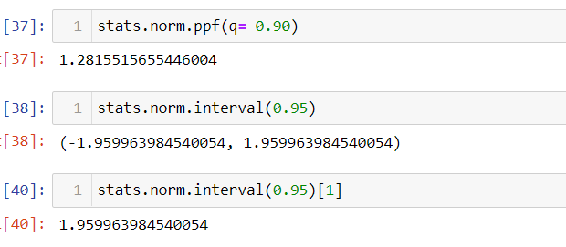
Ans :

Now it is claimed by WebSideStory that their sample contains all the internet
users using daily. Thus it means 4.6 percent share of market shows the entire
population.So, we conclude that the Mozilla has a share in the ,market of less
than 5 percent.

- A book publisher monitors the size of shipments of its textbooks to university bookstores. For a sample of texts used at various schools, the 95% confidence interval for the size of the shipment was 250 ± 45 books. Which, if any, of the following interpretations of this interval are correct?

- All shipments are between 205 and 295 books.

- 95% of shipments are between 205 and 295 books.

- The procedure that produced this interval generates ranges that hold the population mean for 95% of samples.

- If we get another sample, then we can be 95% sure that the mean of this second sample is between 205 and 295.

- We can be 95% confident that the range 160 to 340 holds the population mean.

Ans :

- INCORRECT

- CORRECT

- CORRECT

- CORRECT

- INCORRECT

- Which is shorter: a 95% z-interval or a 95% t-interval for μ if we know that σ =s?

- The z-interval is shorter
- The t-interval is shorter
- Both are equal
- We cannot say

Ans :

Option A is correct
95% confidence interval for mean is shorter for z-interval because t-critical is greater
than z-critical value. Yes ,z-interval is always shorter because t-critical value cannot be
smaller than z-critical value.

Questions 8 and 9 are based on the following: To prepare a report on the economy,
analysts need to estimate the percentage of businesses that plan to hire additional
employees in the next 60 days.
Questions 8 and 9 are based on the following: To prepare a report on the economy, analysts need to estimate the percentage of businesses that plan to hire additional employees in the next 60 days.

- How many randomly selected employers (minimum number) must we contact in order to guarantee a margin of error of no more than 4% (at 95% confidence)?

- 600
- 400
- 550
- 1000

Ans :

Option A

Z-score at 95% confidence level=1.96
Margin of error ,M=4%=0.4
According to the formula ,M=Z*sqrt((p*(1-p)/n))…solving this ,we get n=600(take p=0.5
for minimum value)

- Suppose we want the above margin of error to be based on a 98% confidence level. What sample size (minimum) must we now use?

- 1000
- 757
- 848
- 543

Ans :

Option C

At 98% confidence level ,Z=2.326.putting this value in the above formula, we get
n=848

