Q1.Write a SQL statement to rename the table countries to country_new.

Here is the list of tables. tablename | tableowner

---------------+------------

orders | postgres

employees | postgres

job_history | postgres

jobs | postgres

locations | postgres

regions | postgres

countries | postgres

Ans–

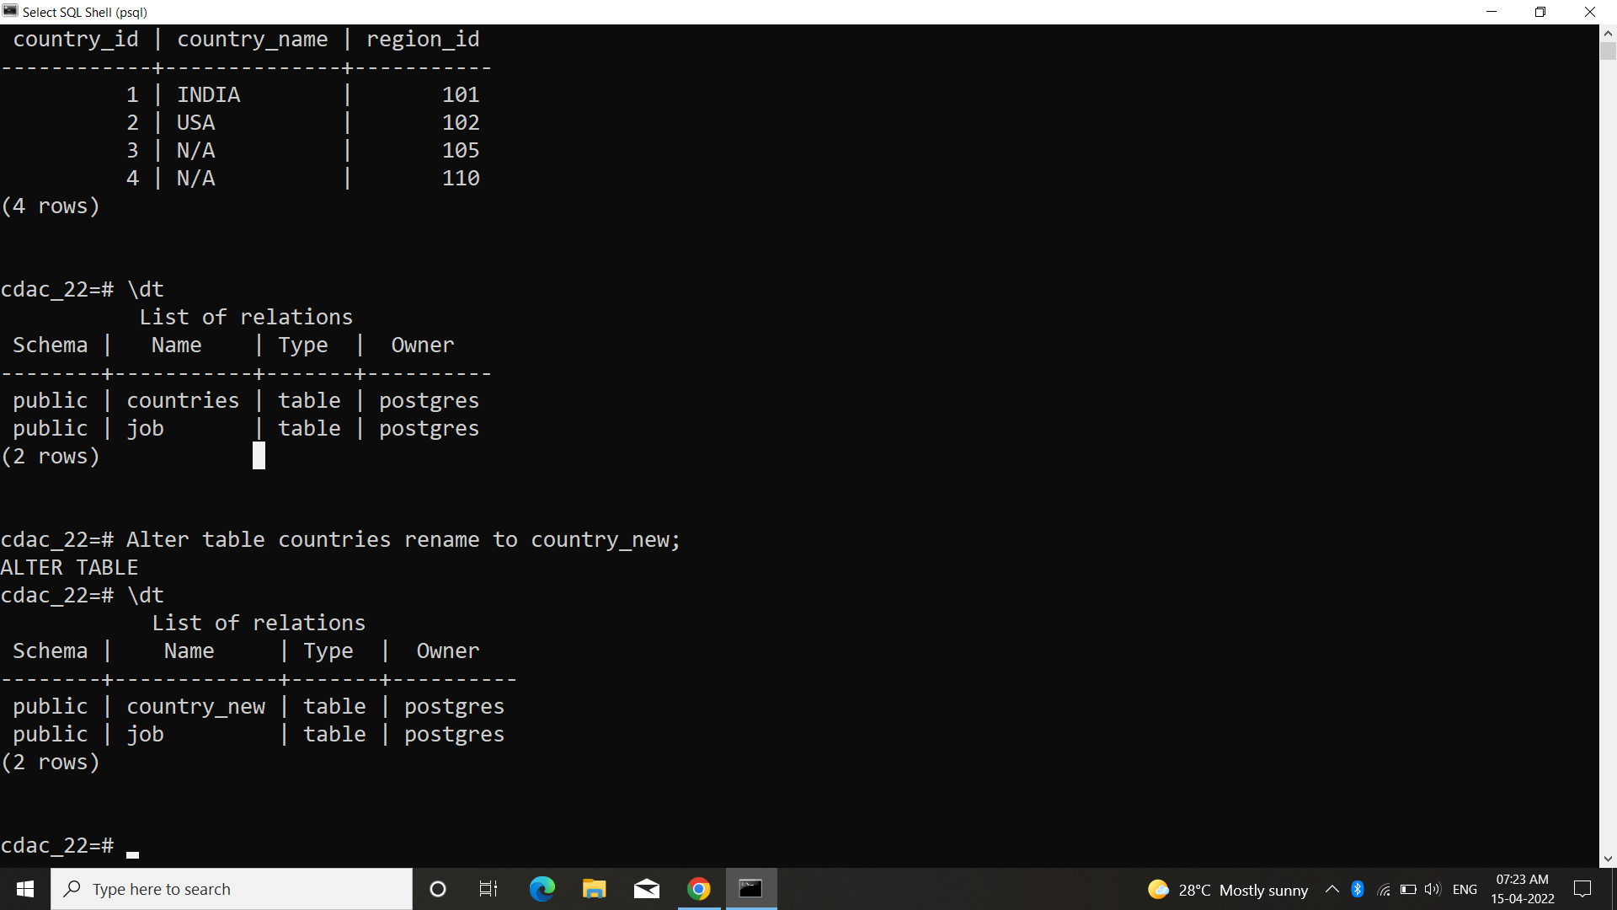

Q.2 Write a SQL statement to add a column region_id to the table locations.

Here is the structure of the table locations.

postgres=# \d locations

Column | Type | Modifiers

----------------+-----------------------+-----------

location_id | numeric(4,0) |

street_address | character varying(40) |

postal_code | character varying(12) |

city | character varying(30) |

state_province | character varying(25) |

country_id | character varying(2) |

Ans–

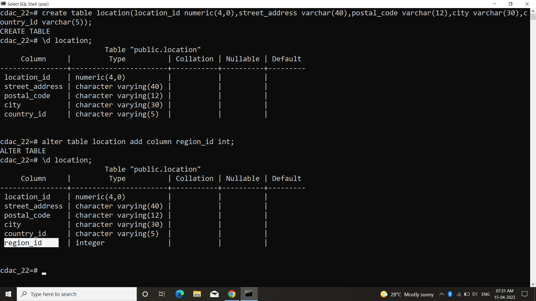

Q.3– Write a SQL statement to change the data type of the column region_id to text in the table locations.

Ans–

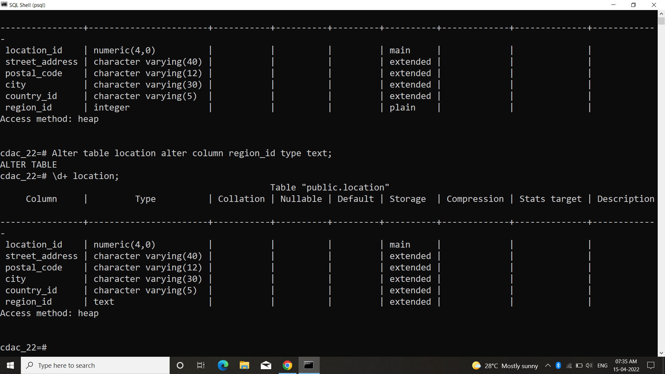

Q.4– Write a SQL statement to drop the column city from the table locations.

Ans–

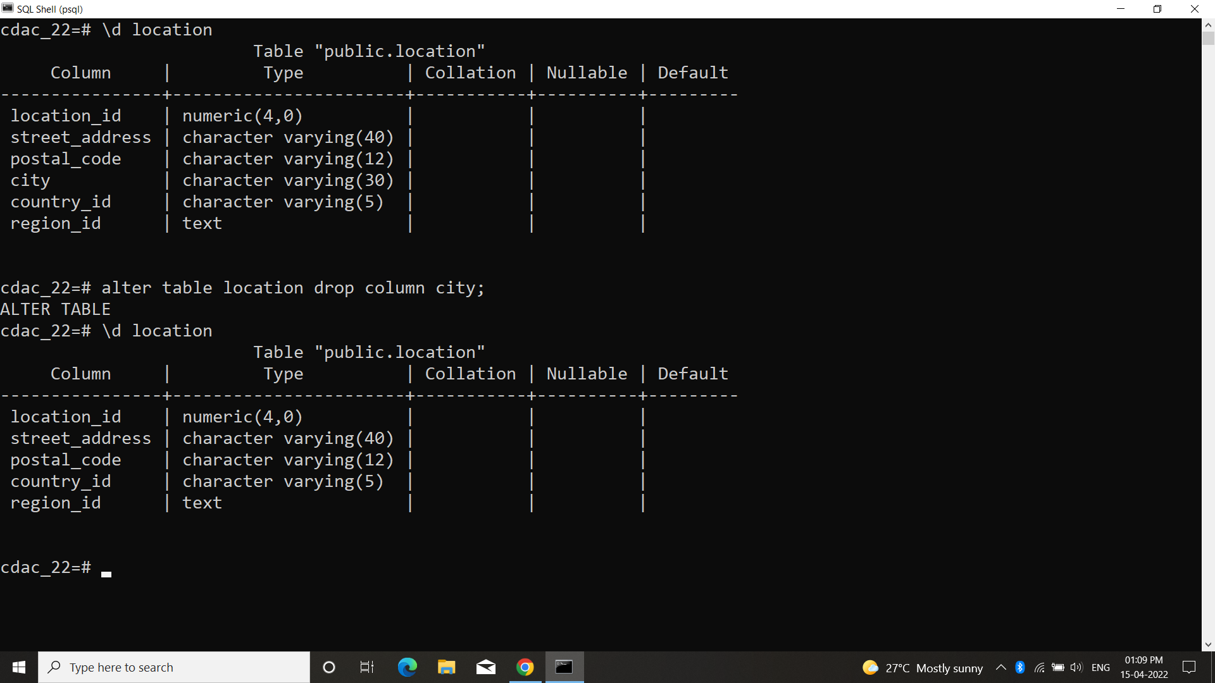

Q5–Write a SQL statement to add a primary key for the columns location_id in the

locations table. Here is the structure of the table locations.

postgres=# \d locations

Column | Type | Modifiers

----------------+-----------------------+-----------

location_id | numeric(4,0) |

street_address | character varying(40) |

postal_code | character varying(12) |

city | character varying(30) |

state_province | character varying(25) |

country_id | character varying(2) |

