1. Write a MongoDB query to display all the documents in the collection restaurants.

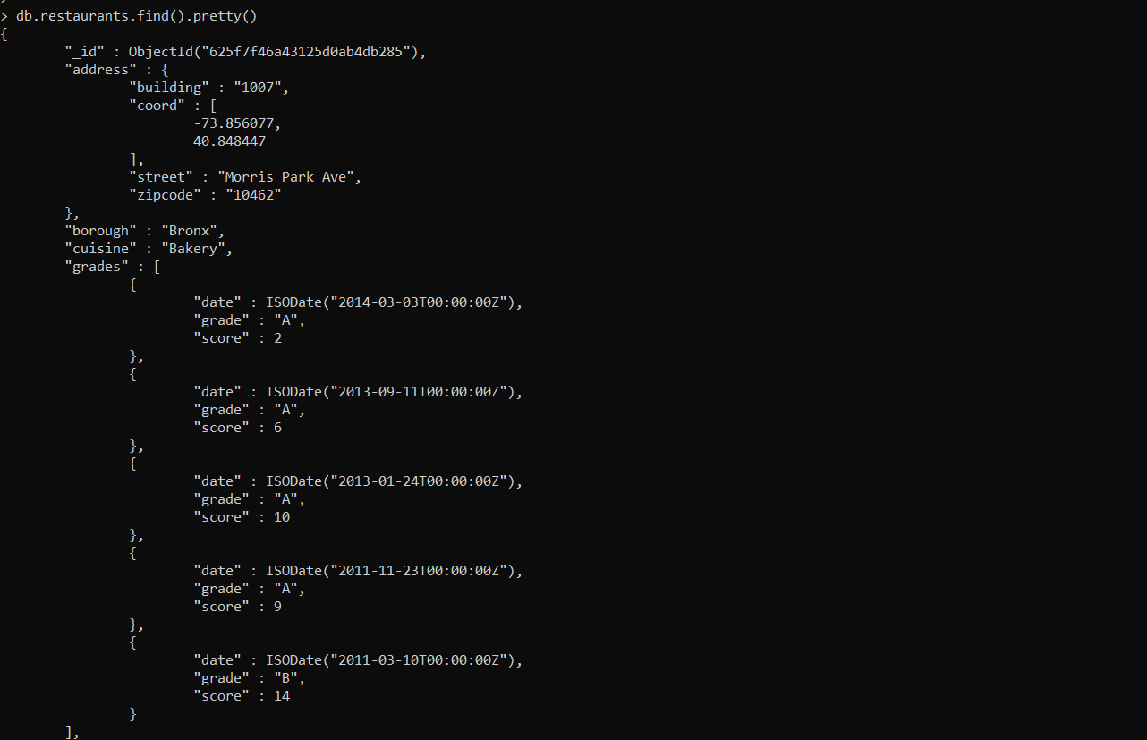

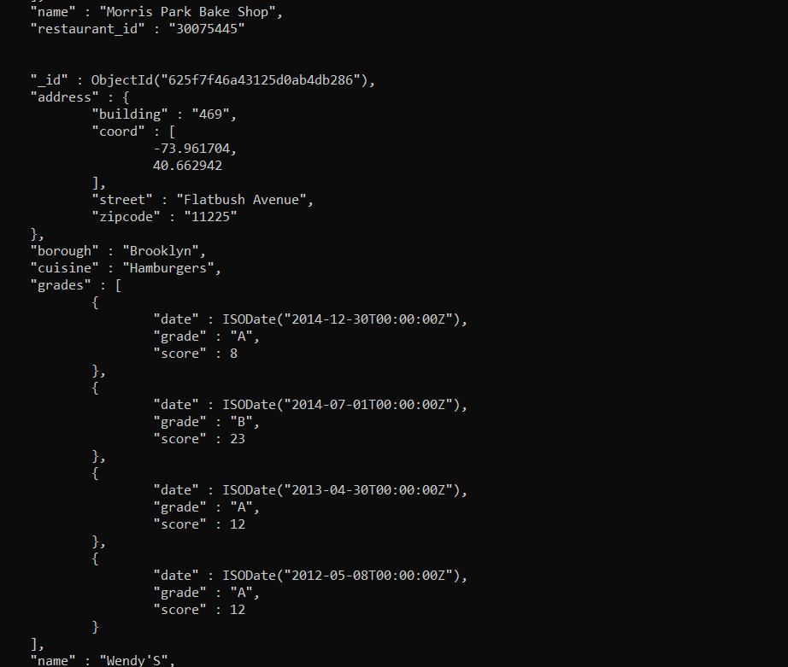

1. Write a MongoDB query to display the fields restaurant_id, name, borough and cuisine for all the documents in the collection restaurant.

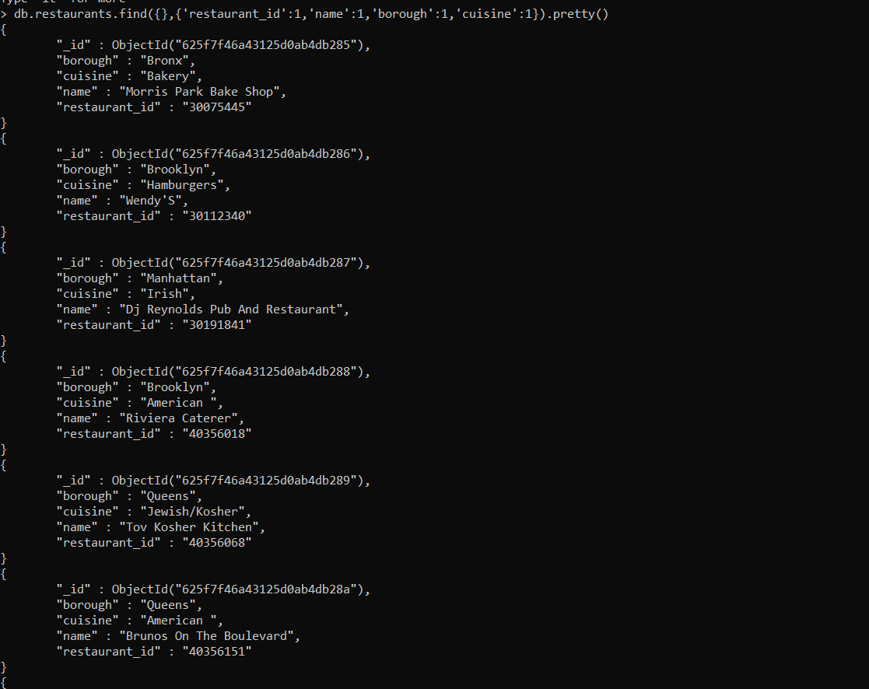

db.restaurants.find({},{'restaurant_id':1,'name':1,'borough':1,'cuisine':1}).pretty()

{

"_id" : ObjectId("625f7f46a43125d0ab4db285"),

"borough" : "Bronx",

"cuisine" : "Bakery",

"name" : "Morris Park Bake Shop",

"restaurant_id" : "30075445"

}

{

"_id" : ObjectId("625f7f46a43125d0ab4db286"),

"borough" : "Brooklyn",

"cuisine" : "Hamburgers",

"name" : "Wendy'S",

"restaurant_id" : "30112340"

}

{

"_id" : ObjectId("625f7f46a43125d0ab4db287"),

"borough" : "Manhattan",

"cuisine" : "Irish",

"name" : "Dj Reynolds Pub And Restaurant",

"restaurant_id" : "30191841"

}

{

"_id" : ObjectId("625f7f46a43125d0ab4db288"),

"borough" : "Brooklyn",

"cuisine" : "American ",

"name" : "Riviera Caterer",

"restaurant_id" : "40356018"

}

{

"_id" : ObjectId("625f7f46a43125d0ab4db289"),

"borough" : "Queens",

"cuisine" : "Jewish/Kosher",

"name" : "Tov Kosher Kitchen",

"restaurant_id" : "40356068"

}

{

"_id" : ObjectId("625f7f46a43125d0ab4db28a"),

"borough" : "Queens",

"cuisine" : "American ",

"name" : "Brunos On The Boulevard",

"restaurant_id" : "40356151"

}

{

"_id" : ObjectId("625f7f46a43125d0ab4db28b"),

"borough" : "Staten Island",

"cuisine" : "Jewish/Kosher",

"name" : "Kosher Island",

"restaurant_id" : "40356442"

}

{

"_id" : ObjectId("625f7f46a43125d0ab4db28c"),

"borough" : "Brooklyn",

"cuisine" : "Delicatessen",

"name" : "Wilken'S Fine Food",

"restaurant_id" : "40356483"

}

{

"_id" : ObjectId("625f7f46a43125d0ab4db28d"),

"borough" : "Brooklyn",

"cuisine" : "American ",

"name" : "Regina Caterers",

"restaurant_id" : "40356649"

}

{

"_id" : ObjectId("625f7f46a43125d0ab4db28e"),

"borough" : "Brooklyn",

"cuisine" : "Ice Cream, Gelato, Yogurt, Ices",

"name" : "Taste The Tropics Ice Cream",

"restaurant_id" : "40356731"

}

{

"_id" : ObjectId("625f7f46a43125d0ab4db28f"),

"borough" : "Bronx",

"cuisine" : "American ",

"name" : "Wild Asia",

"restaurant_id" : "40357217"

}

{

"_id" : ObjectId("625f7f46a43125d0ab4db290"),

"borough" : "Brooklyn",

"cuisine" : "American ",

"name" : "C & C Catering Service",

"restaurant_id" : "40357437"

}

{

"_id" : ObjectId("625f7f46a43125d0ab4db291"),

"borough" : "Brooklyn",

"cuisine" : "Chinese",

"name" : "May May Kitchen",

"restaurant_id" : "40358429"

}

{

"_id" : ObjectId("625f7f46a43125d0ab4db292"),

"borough" : "Manhattan",

"cuisine" : "American ",

"name" : "1 East 66Th Street Kitchen",

"restaurant_id" : "40359480"

}

{

"_id" : ObjectId("625f7f46a43125d0ab4db293"),

"borough" : "Brooklyn",

"cuisine" : "Jewish/Kosher",

"name" : "Seuda Foods",

"restaurant_id" : "40360045"

}

{

"_id" : ObjectId("625f7f46a43125d0ab4db294"),

"borough" : "Brooklyn",

"cuisine" : "Ice Cream, Gelato, Yogurt, Ices",

"name" : "Carvel Ice Cream",

"restaurant_id" : "40360076"

}

{

"_id" : ObjectId("625f7f46a43125d0ab4db295"),

"borough" : "Queens",

"cuisine" : "Ice Cream, Gelato, Yogurt, Ices",

"name" : "Carvel Ice Cream",

"restaurant_id" : "40361322"

}

{

"_id" : ObjectId("625f7f46a43125d0ab4db296"),

"borough" : "Brooklyn",

"cuisine" : "Delicatessen",

"name" : "Nordic Delicacies",

"restaurant_id" : "40361390"

}

{

"_id" : ObjectId("625f7f46a43125d0ab4db297"),

"borough" : "Manhattan",

"cuisine" : "American ",

"name" : "Glorious Food",

"restaurant_id" : "40361521"

}

{

"_id" : ObjectId("625f7f46a43125d0ab4db298"),

"borough" : "Brooklyn",

"cuisine" : "American ",

"name" : "The Movable Feast",

"restaurant_id" : "40361606"

}

1. Write a MongoDB query to display the fields restaurant_id, name, borough and cuisine, but exclude the field _id for all the documents in the collection restaurant.

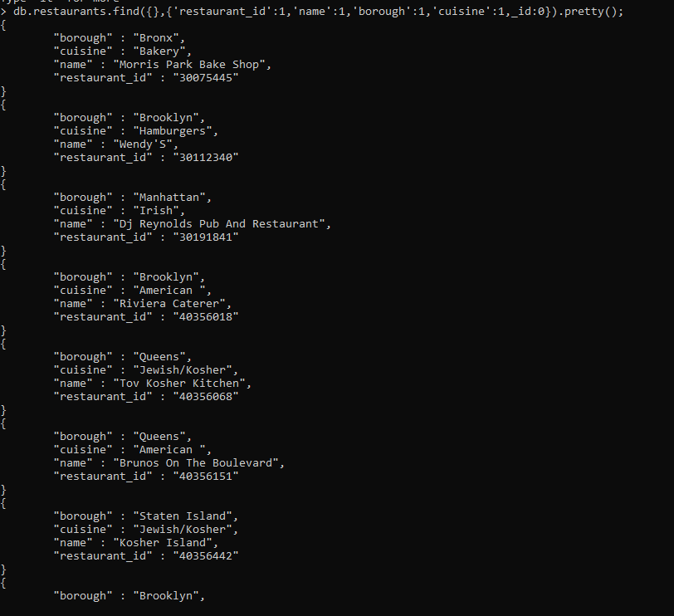

1. Write a MongoDB query to display the fields restaurant_id, name, borough and zip code, but exclude the field _id for all the documents in the collection restaurant.

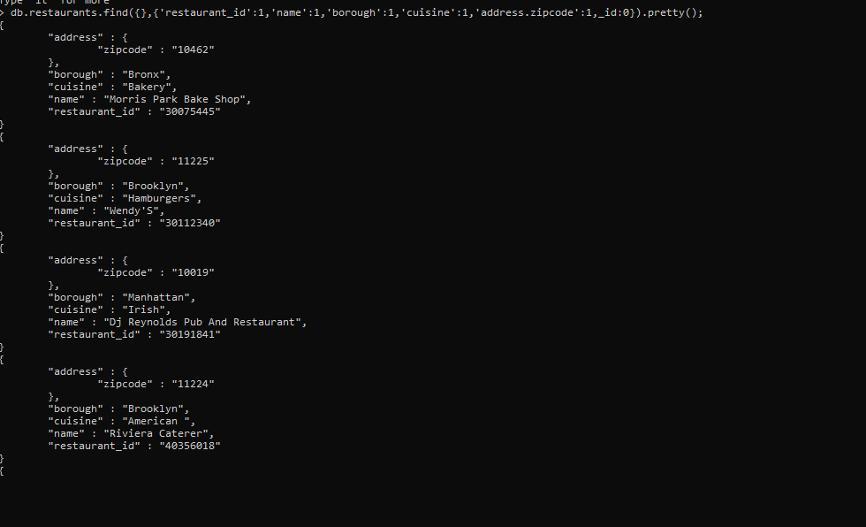

1. Write a MongoDB query to display all the restaurant which is in the borough Bronx.

> db.restaurants.find({"borough":"Bronx"}).pretty()

{

"_id" : ObjectId("625f7f46a43125d0ab4db285"),

"address" : {

"building" : "1007",

"coord" : [

-73.856077,

40.848447

],

"street" : "Morris Park Ave",

"zipcode" : "10462"

},

"borough" : "Bronx",

"cuisine" : "Bakery",

"grades" : [

{

"date" : ISODate("2014-03-03T00:00:00Z"),

"grade" : "A",

"score" : 2

},

{

"date" : ISODate("2013-09-11T00:00:00Z"),

"grade" : "A",

"score" : 6

},

{

"date" : ISODate("2013-01-24T00:00:00Z"),

"grade" : "A",

"score" : 10

},

{

"date" : ISODate("2011-11-23T00:00:00Z"),

"grade" : "A",

"score" : 9

},

{

"date" : ISODate("2011-03-10T00:00:00Z"),

"grade" : "B",

"score" : 14

}

],

"name" : "Morris Park Bake Shop",

"restaurant_id" : "30075445"

}

{

"_id" : ObjectId("625f7f46a43125d0ab4db28f"),

"address" : {

"building" : "2300",

"coord" : [

-73.8786113,

40.8502883

],

"street" : "Southern Boulevard",

"zipcode" : "10460"

},

"borough" : "Bronx",

"cuisine" : "American ",

"grades" : [

{

"date" : ISODate("2014-05-28T00:00:00Z"),

"grade" : "A",

"score" : 11

},

{

"date" : ISODate("2013-06-19T00:00:00Z"),

"grade" : "A",

"score" : 4

},

{

"date" : ISODate("2012-06-15T00:00:00Z"),

"grade" : "A",

"score" : 3

}

],

"name" : "Wild Asia",

"restaurant_id" : "40357217"

}

{

"_id" : ObjectId("625f7f46a43125d0ab4db2a4"),

"address" : {

"building" : "1006",

"coord" : [

-73.84856870000002,

40.8903781

],

"street" : "East 233 Street",

"zipcode" : "10466"

},

"borough" : "Bronx",

"cuisine" : "Ice Cream, Gelato, Yogurt, Ices",

"grades" : [

{

"date" : ISODate("2014-04-24T00:00:00Z"),

"grade" : "A",

"score" : 10

},

{

"date" : ISODate("2013-09-05T00:00:00Z"),

"grade" : "A",

"score" : 10

},

{

"date" : ISODate("2013-02-21T00:00:00Z"),

"grade" : "A",

"score" : 9

},

{

"date" : ISODate("2012-07-03T00:00:00Z"),

"grade" : "A",

"score" : 11

},

{

"date" : ISODate("2011-07-11T00:00:00Z"),

"grade" : "A",

"score" : 5

}

],

"name" : "Carvel Ice Cream",

"restaurant_id" : "40363093"

}

{

"_id" : ObjectId("625f7f46a43125d0ab4db2a8"),

"address" : {

"building" : "1236",

"coord" : [

-73.8893654,

40.81376179999999

],

"street" : "238 Spofford Ave",

"zipcode" : "10474"

},

"borough" : "Bronx",

"cuisine" : "Chinese",

"grades" : [

{

"date" : ISODate("2013-12-30T00:00:00Z"),

"grade" : "A",

"score" : 8

},

{

"date" : ISODate("2013-01-08T00:00:00Z"),

"grade" : "A",

"score" : 10

},

{

"date" : ISODate("2012-06-12T00:00:00Z"),

"grade" : "B",

"score" : 15

}

],

"name" : "Happy Garden",

"restaurant_id" : "40363289"

}

{

"_id" : ObjectId("625f7f46a43125d0ab4db2ba"),

"address" : {

"building" : "277",

"coord" : [

-73.8941893,

40.8634684

],

"street" : "East Kingsbridge Road",

"zipcode" : "10458"

},

"borough" : "Bronx",

"cuisine" : "Chinese",

"grades" : [

{

"date" : ISODate("2014-03-03T00:00:00Z"),

"grade" : "A",

"score" : 10

},

{

"date" : ISODate("2013-09-26T00:00:00Z"),

"grade" : "A",

"score" : 10

},

{

"date" : ISODate("2013-03-19T00:00:00Z"),

"grade" : "A",

"score" : 10

},

{

"date" : ISODate("2012-08-29T00:00:00Z"),

"grade" : "A",

"score" : 11

},

{

"date" : ISODate("2011-08-17T00:00:00Z"),

"grade" : "A",

"score" : 13

}

],

"name" : "Happy Garden",

"restaurant_id" : "40364296"

1. Write a MongoDB query to display the first 5 restaurant which is in the borough Bronx.

db.restaurants.find({borough:"Bronx"}).limit(5).pretty()

7.Write a MongoDB query to display the next 5 restaurants after skipping first 5 which are in the borough Bronx.

db.restaurants.find({borough:"Bronx"}).limit(5).skip(5).pretty()

1. Write a MongoDB query to find the restaurants who achieved a score more than 90.

db.restaurant.find({'grades.score':{$gt:90}}).pretty();

9. Write a MongoDB query to find the restaurants that achieved a score, more than 80 but less than 100.

db.restaurants.find({"grades.score":{$gt:80,$lt:100}}).pretty())

10. Write a MongoDB query to find the restaurants which locate in latitude value less than -95.754168.

 db.restaurants.find({'address.coord':{$lt:-95.754168}}).pretty()

11. Write a MongoDB query to find the restaurants that do not prepare any cuisine of 'American' and their grade score more than 70 and latitude less than -65.754168.

> db.restaurants.find(

... {$and:

... [

... {"cuisine" : {$ne :"American "}},

... {"grades.score" : {$gt : 70}},

... {"address.coord" : {$lt : -65.754168}}

... ]

... }

... ).pretty();

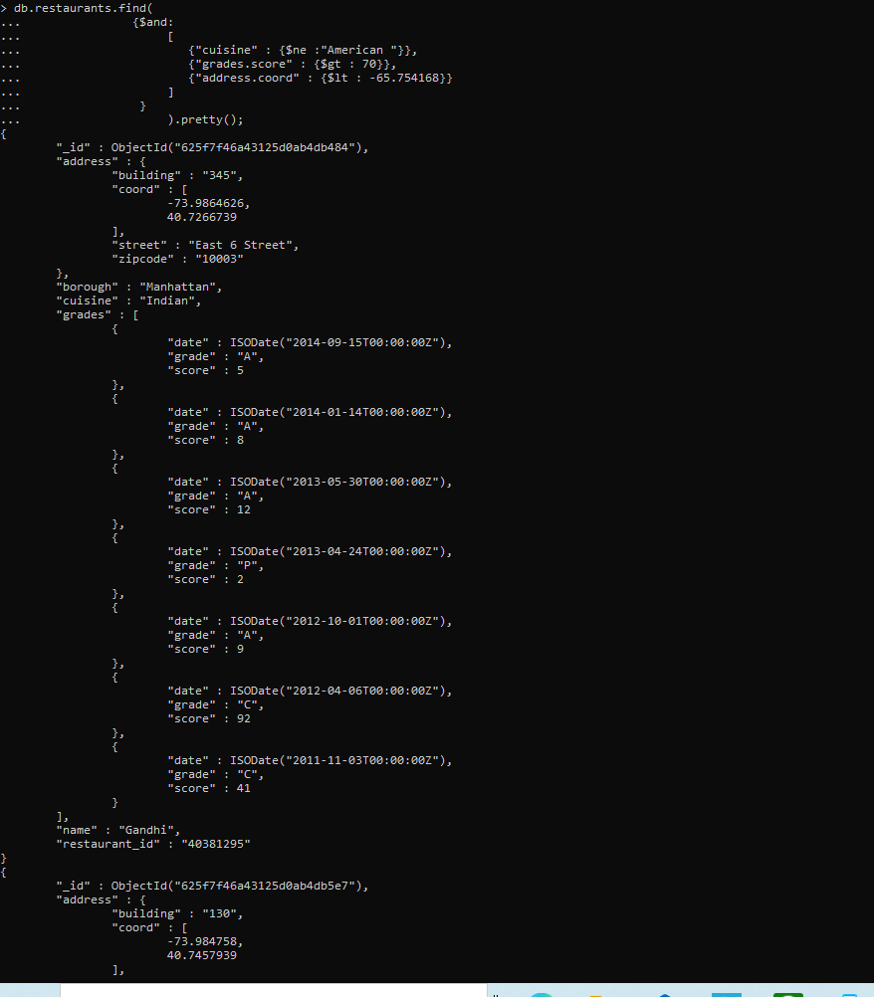

12. Write a MongoDB query to find the restaurants which do not prepare any cuisine of 'American' and achieved a score more than 70 and located in the longitude less than -65.754168.

Note : Do this query without using $and operator.

db.restaurants.find({cuisine:{$ne:"American "},"grades.score":{$gt:70},"address.coord":{$lt:-65.754168}}).pretty()

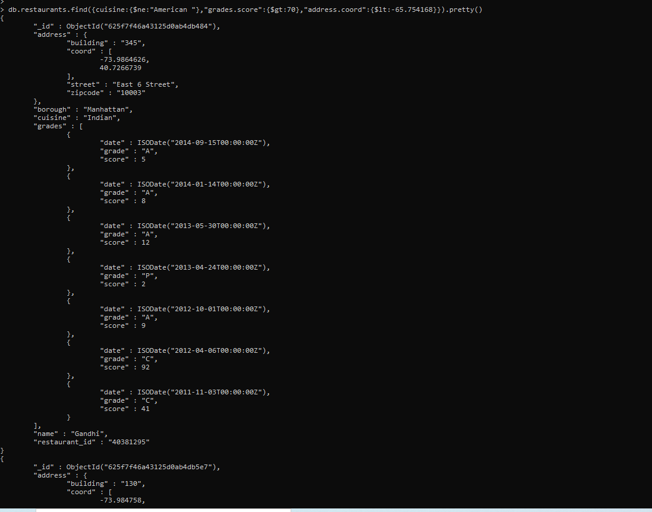

13. Write a MongoDB query to find the restaurants which do not prepare any cuisine of 'American ' and achieved a grade point 'A' not belongs to the borough Brooklyn. The document must be displayed according to the cuisine in descending order.

db.restaurants.find({$and : [{"cuisine" : {$ne : "American "}}, {"grades.grade" : "A"}, {"borough" : {$ne : "Brooklyn "}}]}).sort({cuisine : -1}).pretty()

14. Write a MongoDB query to find the restaurant Id, name, borough and cuisine for those restaurants which contain 'Wil' as first three letters for its name.

15. Write a MongoDB query to find the restaurant Id, name, borough and cuisine for those restaurants which contain 'ces' as last three letters for its name.

16. Write a MongoDB query to find the restaurant Id, name, borough and cuisine for those restaurants which contain 'Reg' as three letters somewhere in its name.

17. Write a MongoDB query to find the restaurants which belong to the borough Bronx and prepared either American or Chinese dish.

18. Write a MongoDB query to find the restaurant Id, name, borough and cuisine for those restaurants which belong to the borough Staten Island or Queens or Bronxor Brooklyn.

19. Write a MongoDB query to find the restaurant Id, name, borough and cuisine for those restaurants which are not belonging to the borough Staten Island or Queens or Bronxor Brooklyn.

20. Write a MongoDB query to find the restaurant Id, name, borough and cuisine for those restaurants which achieved a score which is not more than 10.

21. Write a MongoDB query to find the restaurant Id, name, borough and cuisine for those restaurants which prepared dish except 'American' and 'Chinees' or restaurant's name begins with letter 'Wil'.

22. Write a MongoDB query to find the restaurant Id, name, and grades for those restaurants which achieved a grade of "A" and scored 11 on an ISODate "2014-08-11T00:00:00Z" among many of survey dates..

23. Write a MongoDB query to find the restaurant Id, name and grades for those restaurants where the 2nd element of grades array contains a grade of "A" and score 9 on an ISODate "2014-08-11T00:00:00Z".

24. Write a MongoDB query to find the restaurant Id, name, address and geographical location for those restaurants where 2nd element of coord array contains a value which is more than 42 and upto 52..

25. Write a MongoDB query to arrange the name of the restaurants in ascending order along with all the columns.

26. Write a MongoDB query to arrange the name of the restaurants in descending along with all the columns.

27. Write a MongoDB query to arranged the name of the cuisine in ascending order and for that same cuisine borough should be in descending order.

28. Write a MongoDB query to know whether all the addresses contains the street or not.

29. Write a MongoDB query which will select all documents in the restaurants collection where the coord field value is Double.

30. Write a MongoDB query which will select the restaurant Id, name and grades for those restaurants which returns 0 as a remainder after dividing the score by 7.

31. Write a MongoDB query to find the restaurant name, borough, longitude and attitude and cuisine for those restaurants which contains 'mon' as three letters somewhere in its name.

32. Write a MongoDB query to find the restaurant name, borough, longitude and latitude and cuisine for those restaurants which contain 'Mad' as first three letters of its name.