**1.** From the following tables, write a SQL query to find the first name, last name, department number, and department name for each employee.

SELECT e.first_name, e.last_name, d.department_id, d.department_name,

FROM employees e INNER JOIN departments d ON e.department_id = d.department_id;

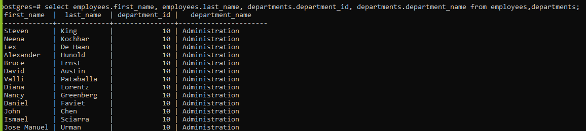

**2.** From the following tables, write a SQL query to find the first name, last name, department, city, and state province for each employee.

SELECT e.first_name, e.last_name, d.department_name, l.city, l.state_province FROM employees e INNER JOIN departments d ON e.department_id = d.department_id INNER JOIN locations l ON d.location_id = l.location_id;

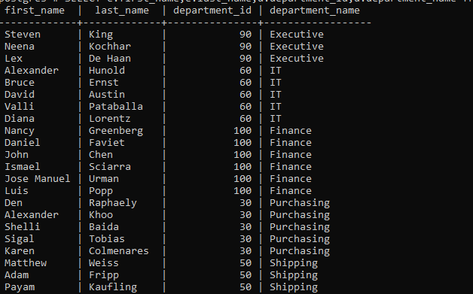

**3.** From the following table, write a SQL query to find the first name, last name, salary, and job grade for all employees.

select e.first_name,e.last_name,e.salary,j.grade_level

from employees e join job_grades j on e.salary

between j.lowest_sal and j.highest_sal;

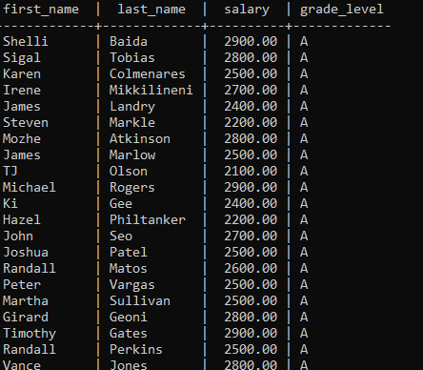

**4.** From the following tables, write a SQL query to find all those employees who work in department ID 80 or 40. Return first name, last name, department number and department name.

select e.first_name,e.last_name,d.department_name,l.city,l.state_province

from employees e join departments d on e.department_id=d.department_id

join locations l on l.location_id=d.location_id

where d.department_id in (80,40);

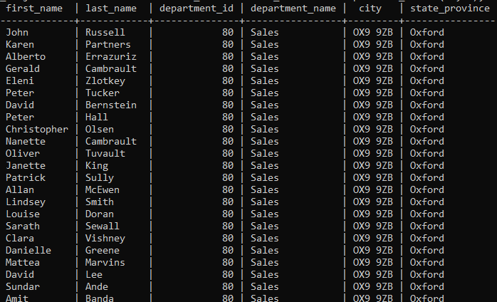

**5.** From the following tables, write a SQL query to find those employees whose first name contains a letter ‘z’. Return first name, last name, department, city, and state province.