The maxima of the power spectrum decrease linearly on log-log scale:

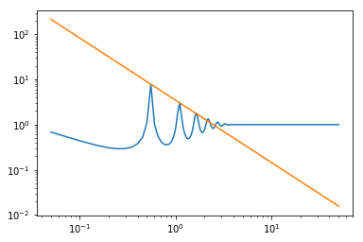

We want to obtain the slope of this line as a function of the various parameters. In order to do so, we will need a relatively simple expression for the power spectrum (and therefore the characteristic function).

Before attempting to simplify the expression of the power spectrum, I calculated a quick numerical approximation of what this line’s parameters should be. Using the first two maxima of approximately (2π/Δ, 7.86) and (4π/Δ, 3.01) where Δ = 11.4, if the peaks descend according to a power-law function of w, f(w)=A/wB, where A and B are constants, then the preceding two points yield B = 1.38 (negative slope of the line) and A = 3.45.

First attempt at simplifying power spectrum:

If we ignore the w2 term in the exponent of the characteristic function and let the number of terms (M) tend to infinity, then the characteristic function can be expressed in terms of clausen functions. Plotting the new power spectrum in python did not yield a good comparison with the original power spectrum:

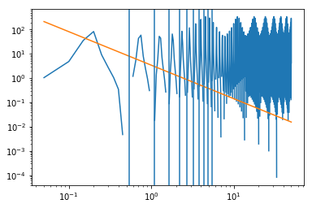The orange line shows the direction of the original spectrum’s maxima; the vertical lines are where the original maxima were.

For now, given this poor comparison to the original spectrum, we conclude that the w2 term should not be ignored, and do not attempt to simplify algebra of clausen function expression.

Second attempt at simplifying power spectrum:

If we let β =0.5 (close to the approximate value of 0.8) and let M tend to infinity, the characteristic function can be written in terms of a polylogarithm function. Plotting the new spectrum yields a similar enough result to the original spectrum:

The orange line shows the direction of the original spectrum’s maxima; the vertical lines are where the original maxima were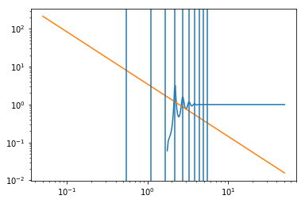. Note:

1. The peaks are shifted to the right and are closer together. This may be accounted for by the adjustment of parameters.

2. Behaviour before peaks is different than original spectrum but we are not primarily concerned with this region.

This plot suggests that we should attempt to simplify the expression for the power spectrum using the new expression for the characteristic function, involving the polylogarithm function. We wish to consider any useful limiting behaviours or asymptotic expansions.

-> In reading <https://en.wikipedia.org/wiki/Polylogarithm#Limiting_behavior> , I noticed the following limiting behavior which may prove useful:

After playing around with this limiting behaviour, I realized that s must satisfy Re(s)<1, which is not the case for our characteristic function (where s = 𝛾=α – β ≈2.9-0.8=2.1), so this limiting behaviour could not be used.

-> The same site shows asymptotic expansions for the polylogarithm function, but the mathematics seemed very complicated and beyond my current understanding. Perhaps this may be a useful avenue.

-> The base of the polylogarithm is 𝛾. If the following approximation is entertained, we may be able to arrive at a useful result: 𝛾 = α – β ≈2.9-0.8=2.1≈2. The polylogarithm is now a ‘dilogarithm’ which can be expressed as:

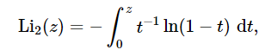 source: <https://dlmf.nist.gov/25.12>

Is there some way to simplify or use this integral in trying to simplify the characteristic function?