Figure 1 : Original Image
Figure 2 : Sigma Value – 1
Figure 3 : Sigma Value – 3
Figure 4 : Sigma Value – 10

Average[11,11] vs Gaussian(Sigma = 3) vs Disk(Radius = 20)

Average Smoothing reduces fine image details compared to Disk Filter and Gaussian Filter. However,Gaussian preserves the most details.



Effects:

Original – Gray Scale – Sepia – Pink







Compression:
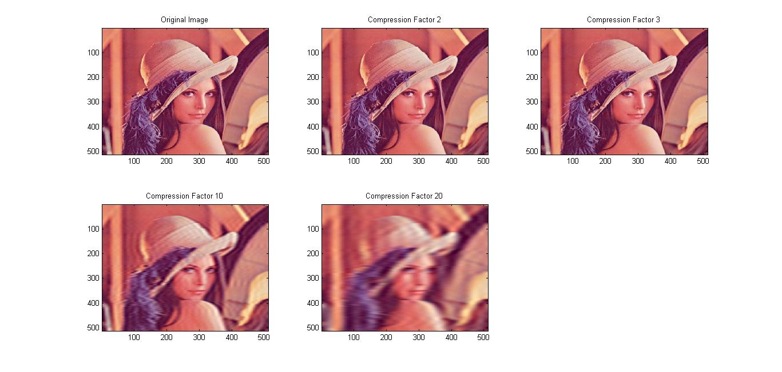
It is clearly visible that as the compression factor increases, the image quality decreases.

FOCUS :




Edge Detection :




